FlyingRC® AM32 Dual 40A 2 in 1 ESC
Product Manual
FlyingRC® is a globally-oriented professional brand of electronic devices. We specialize in the R&D and sales of drone electronics, core robot circuits and sensors. Our design team is based in Singapore, and our products are sold worldwide.

Since launched in 2023, FlyingRC® products have gained widespread recognition from customers as well as strong market response. As of April 2026, our cumulative sales volume has exceeded 46,000 units. Our products are widely applied in industries, robotics, emergency rescue, environmental protection & inspection, aerial photography, public security, retail and many other fields. Above all, we are committed to distinctive design and superior reliable quality.

Our Chief Technology Officer Liu Yuhan possesses outstanding expertise in circuit design. Over the past four years, he has designed more than 80 circuit projects and contributed 39 to open-source platforms. Moreover, he won the Design Award on the open-source platform X.JLC.com twice in 2023 and 2024, and has become the youngest certified designer on this platform.

He holds the NUS (National University of Singapore, rank 8th worldwide) Science and Technology Scholarship, and is currently majoring in Electronic Engineering with a focus on Aerospace Technology. In addition, all members of our technical team are graduates from prestigious universities with extensive professional product experience.

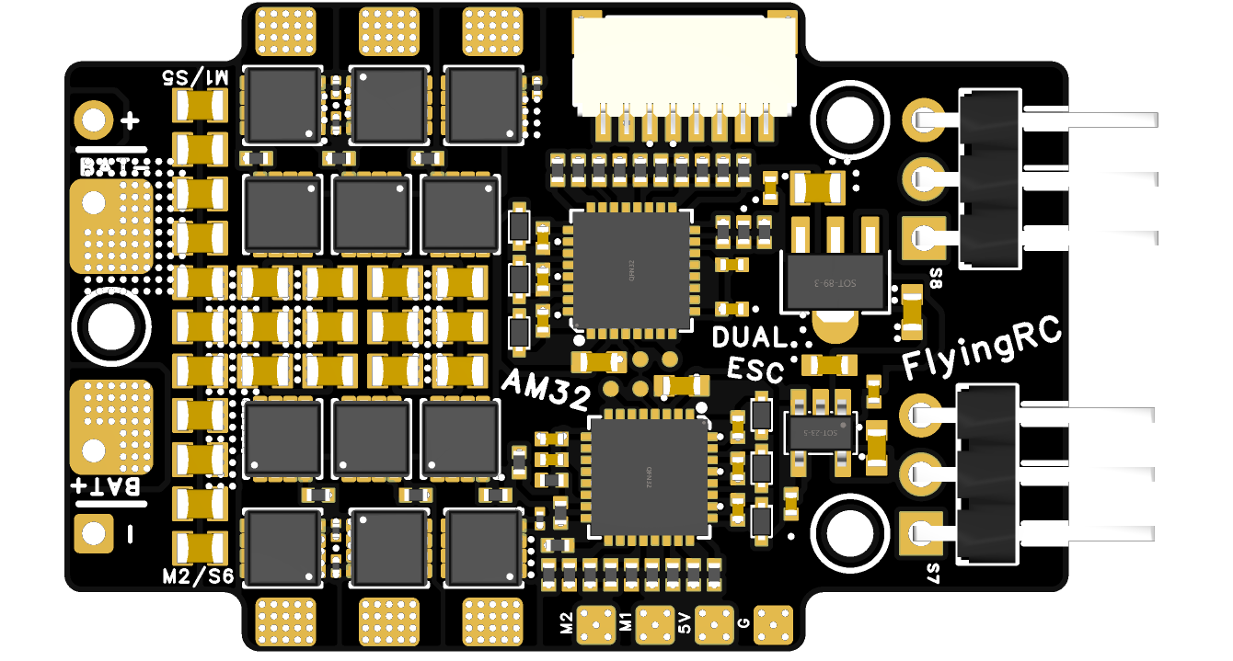
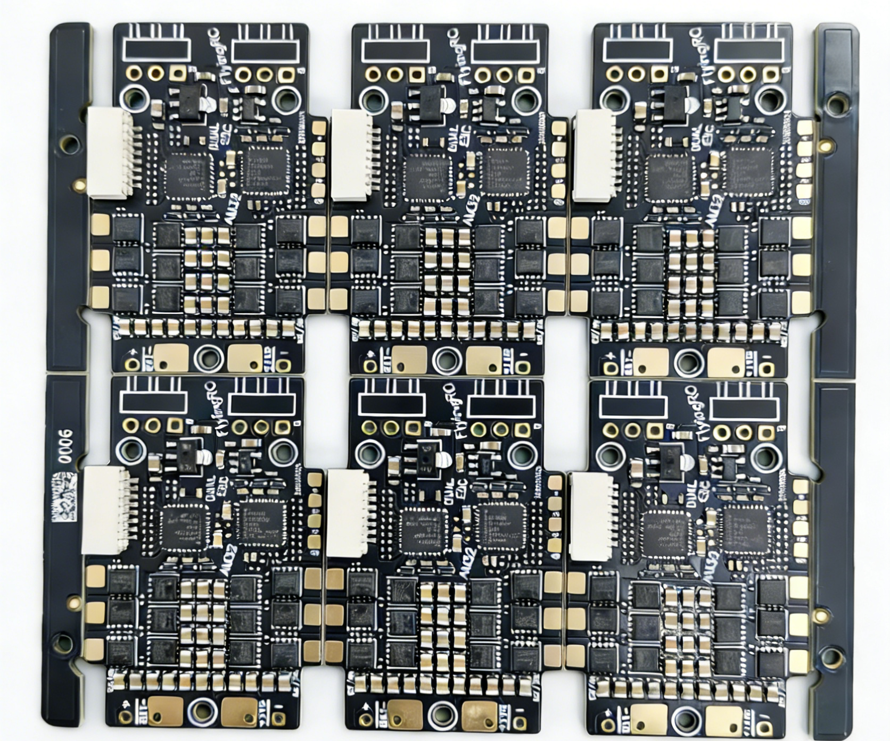
FlyingRC® Dual 40A ESC
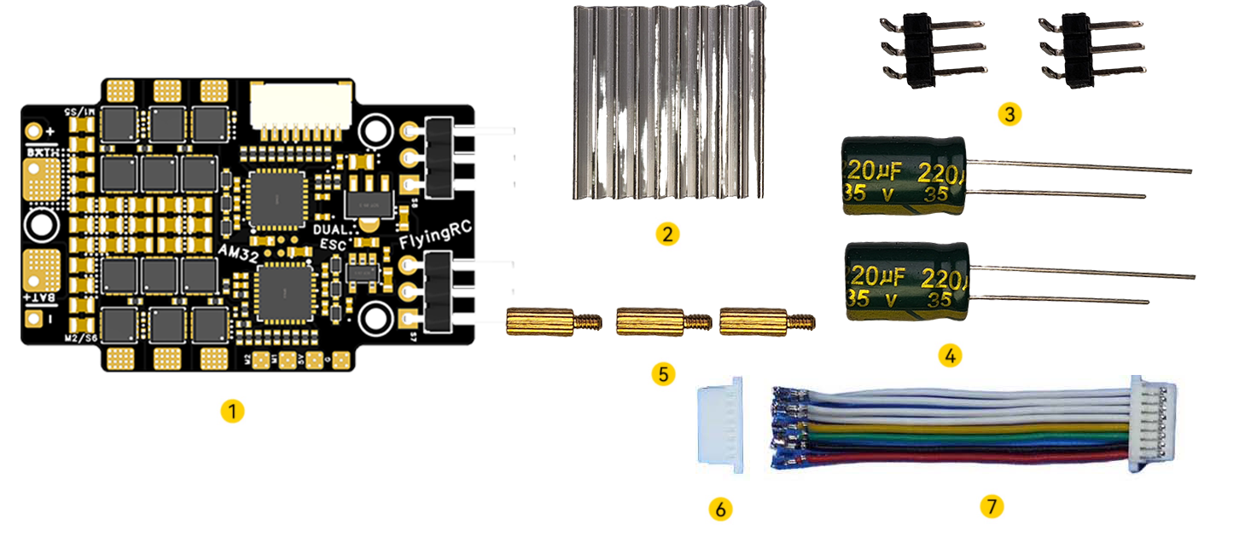
Package Contents:
1. ESC ×1
2. 35V 220μF Electrolytic Capacitor ×2
3. 20×20×4mm Aluminum Heatsink ×1
4. M2×7+7 Copper Standoff × 3
5. SH1.0 8P Single-End Ultra-Soft Silicone Wire (Length: 3.5cm) × 1
6. SH1.0 8P Crimp Terminal × 1
7. 3P 2.54mm Pitch Right-angle Gold-Plated Pin Header ×2

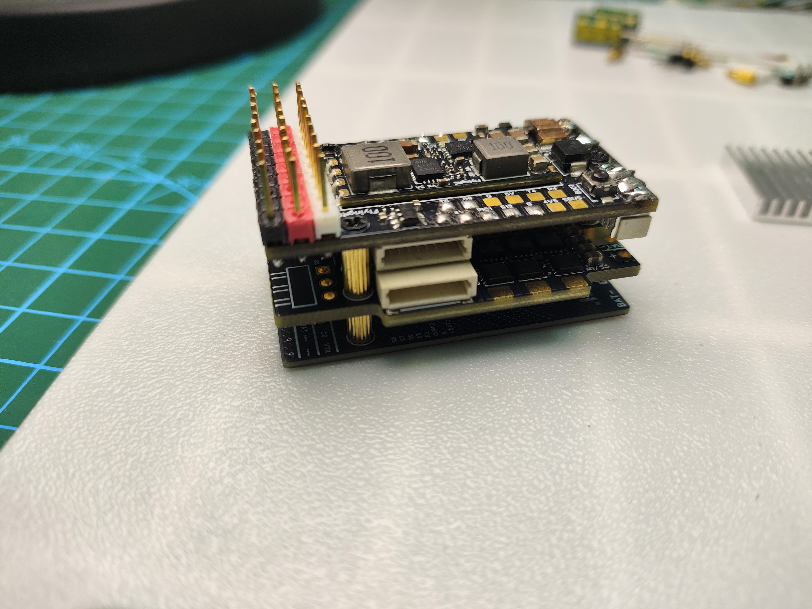
Connect to FlyingRC F4WSE PRO

Technical specifications
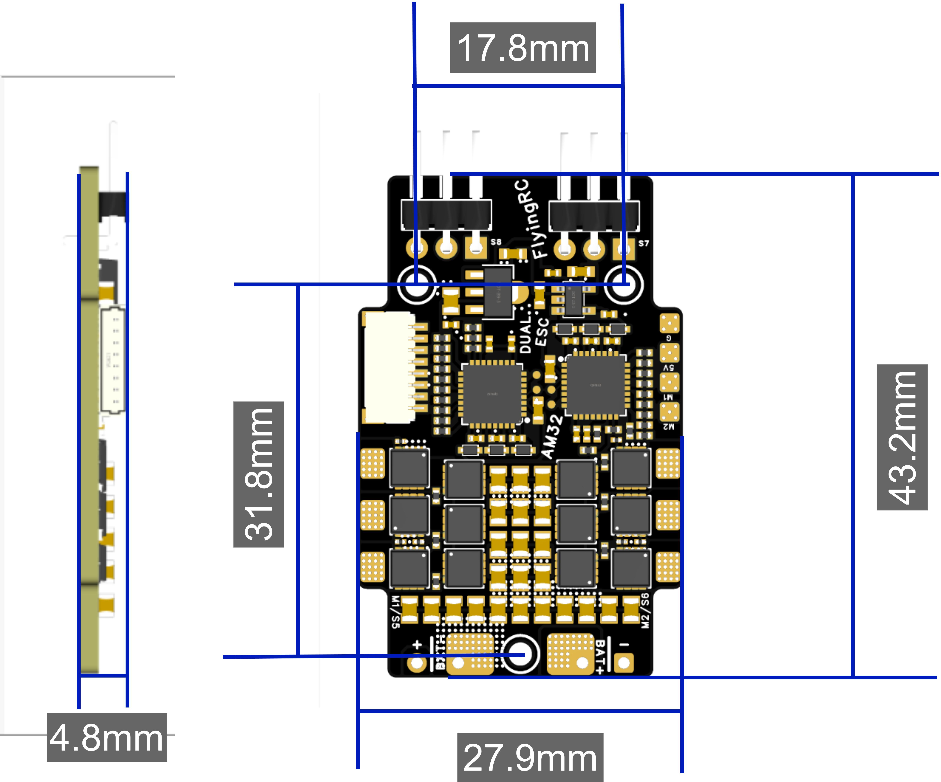

- Dual MCUs (QF32F4AK8U7×2) with integrated ID6288 gate drivers; MOSFETs: HYG022N04LS1C1×12
- Supports sine wave start-up for high torque at low speed
- Supports DSHOT150/300/600, OneShot, PWM & other protocols
- 6~30V DC IN（2~6S LiPo）；
- Dimensions & Weight：43.2mm*27.9mm*4.8mm, 7.0g
- Heavy Copper PCB with 6 layers (2oz inner & outer), total 12oz copper thickness

Basic Parameters |  | Voltage - Current
Model | FlyingRC® Dual 40A ESC | VBAT Input Range | 6-26V DC IN 2-6S LiPo
Dimensions | 43.2mm*27.9mm*4.8mm | Continuous Current | 40A (Test Condition：4S)
Weight | 7.0g | Burst Current | 50A for 5 Seconds (Test Condition：4S)
Core Components |  | Firmware
MCUs | 2×QF32F4AK8U7 32-bit | AM32 | Supports
Clock Frequency | 120MHz | Control Signal Input | Supports DSHOT150/300/600, OneShot, PWM and other protocols
Flash | 64 KB | Operating Environment
RAM | 16 KB | Operating Temperature Range | -10-100℃
Integrated Gate Drivers | 2×ID6288 | Storage Temperature Range | 0-40℃
MOSFETs/MOS | 12×HYG022N04LS1C1
Product Features
PCB Processes | The ESC adopts a 6-layer 2oz PCB with black solder mask, resin-filled vias, via-in-pad and immersion gold plating. It delivers premium-grade workmanship among similar products, ensuring outstanding continuous current handling capacity.
Streamlined Layout | Dual MCUs with ntegrated gate drivers reduce the PCB area occupied by non-power components, further boosting current handling capability.
MOSFETs / MOS | 12 HYG022N04LS1C1 N-MOSFETs deliver an ultra-low Rds(on) of only 2.0mΩ and a 40V voltage rating (critical for 6S support).
Wide Voltage Input | A dual-stage LDO step-down solution powers the gate drivers and MCUs, supporting a wide input voltage range of 2–6S.

- Product Features
- Dual MCUs with integrated gate drivers reduce the PCB area occupied by non-power components, further boosting current handling capability.
- Pre-flashed with AM32 firmware, the ESC delivers high low-speed torque when sine wave start and Stall Protection are enabled.
- The motor signal input supports both direct plug-in and pad soldering modes to meet diverse wiring requirements.
- 12 HYG022N04LS1C1 N-MOSFETs deliver an ultra-low Rds(on) of only 2.0mΩ and a 40V voltage rating (critical for 6S support). Compared with MOSFETs in similar ESCs, its on-resistance is significantly lower, greatly reducing heat generation.
- A dual-stage LDO step-down solution powers the gate drivers and MCUs, supporting a wide input voltage range of 2–6S. By contrast, competing ESCs only use a single LDO, leading to concentrated heat generation and a maximum input of only 4S.
- The ESC adopts a 6-layer 2oz PCB with black solder mask, resin-filled vias, via-in-pad and immersion gold plating. It delivers premium-grade workmanship among similar products, ensuring outstanding continuous current handling capacity. The positive and negative current-carrying sections of the PCB are designed with exposed copper openings for enhanced heat dissipation.

- Operation Instructions
- LAYOUT：

Motor Soldering Board

Motor Soldering Board

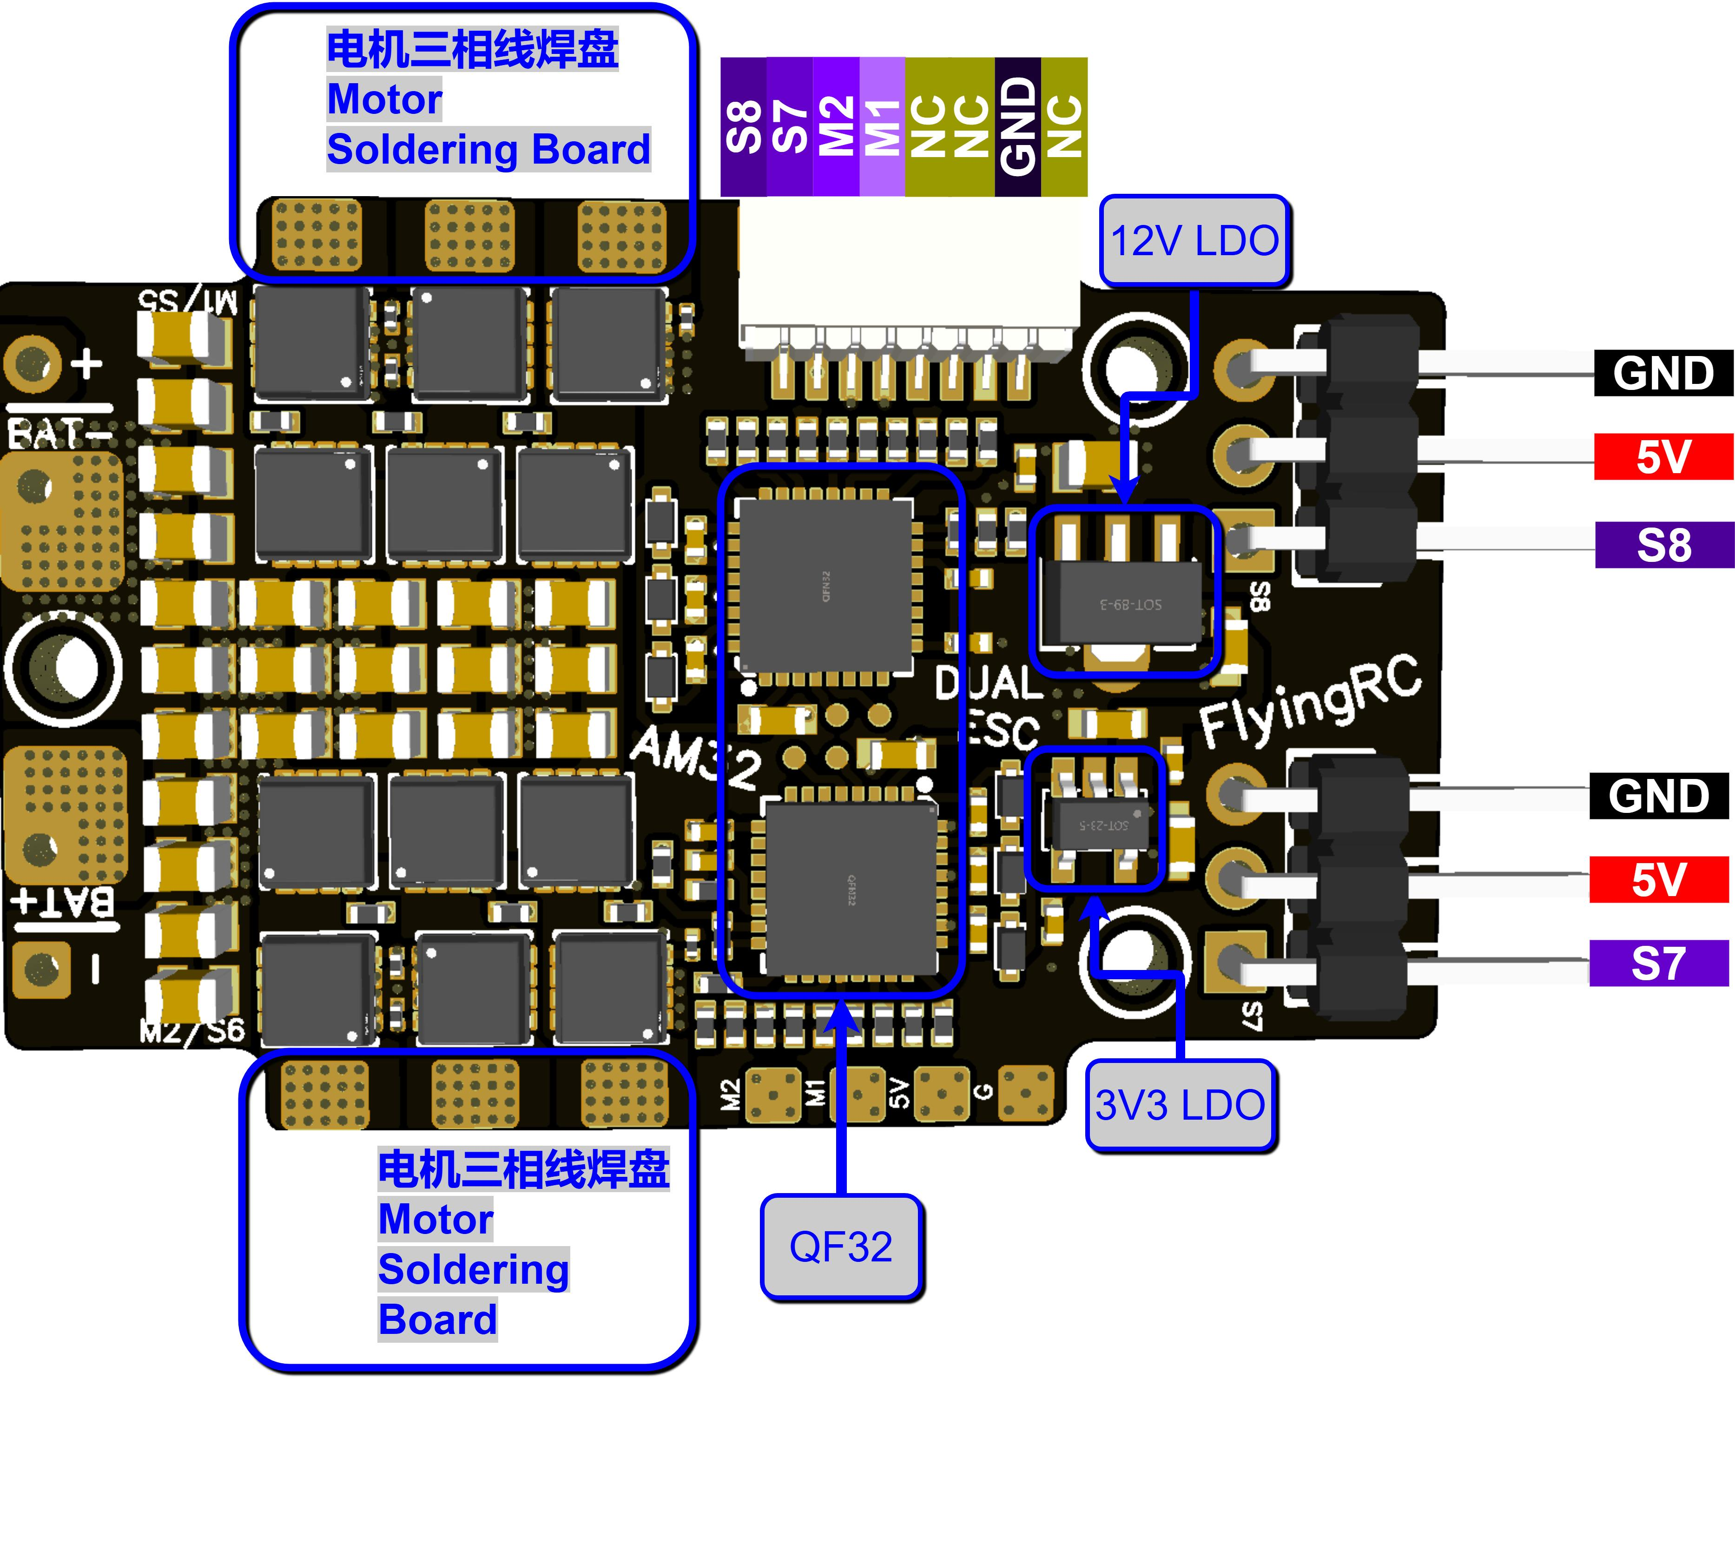
3D Rendering Diagram-Front View

Pad Definitions (Excluding Motor 3-Phase Pads)
Pad No. | Pad Name | Pad Definition
1 | BAT+ | Connect to battery/capacitor positive terminal
2 | BAT- | Connect to battery/capacitor negative terminal
3 | + | Connect to capacitor positive terminal
4 | - | Connect to capacitor negative terminal
5 | M2 | PWM/Dshot signal input
6 | M1 | PWM/Dshot signal input
6 | G | GND（Negative terminal）

Soldering:
For the ESC soldering video, please click: Soldering Video Tutorial

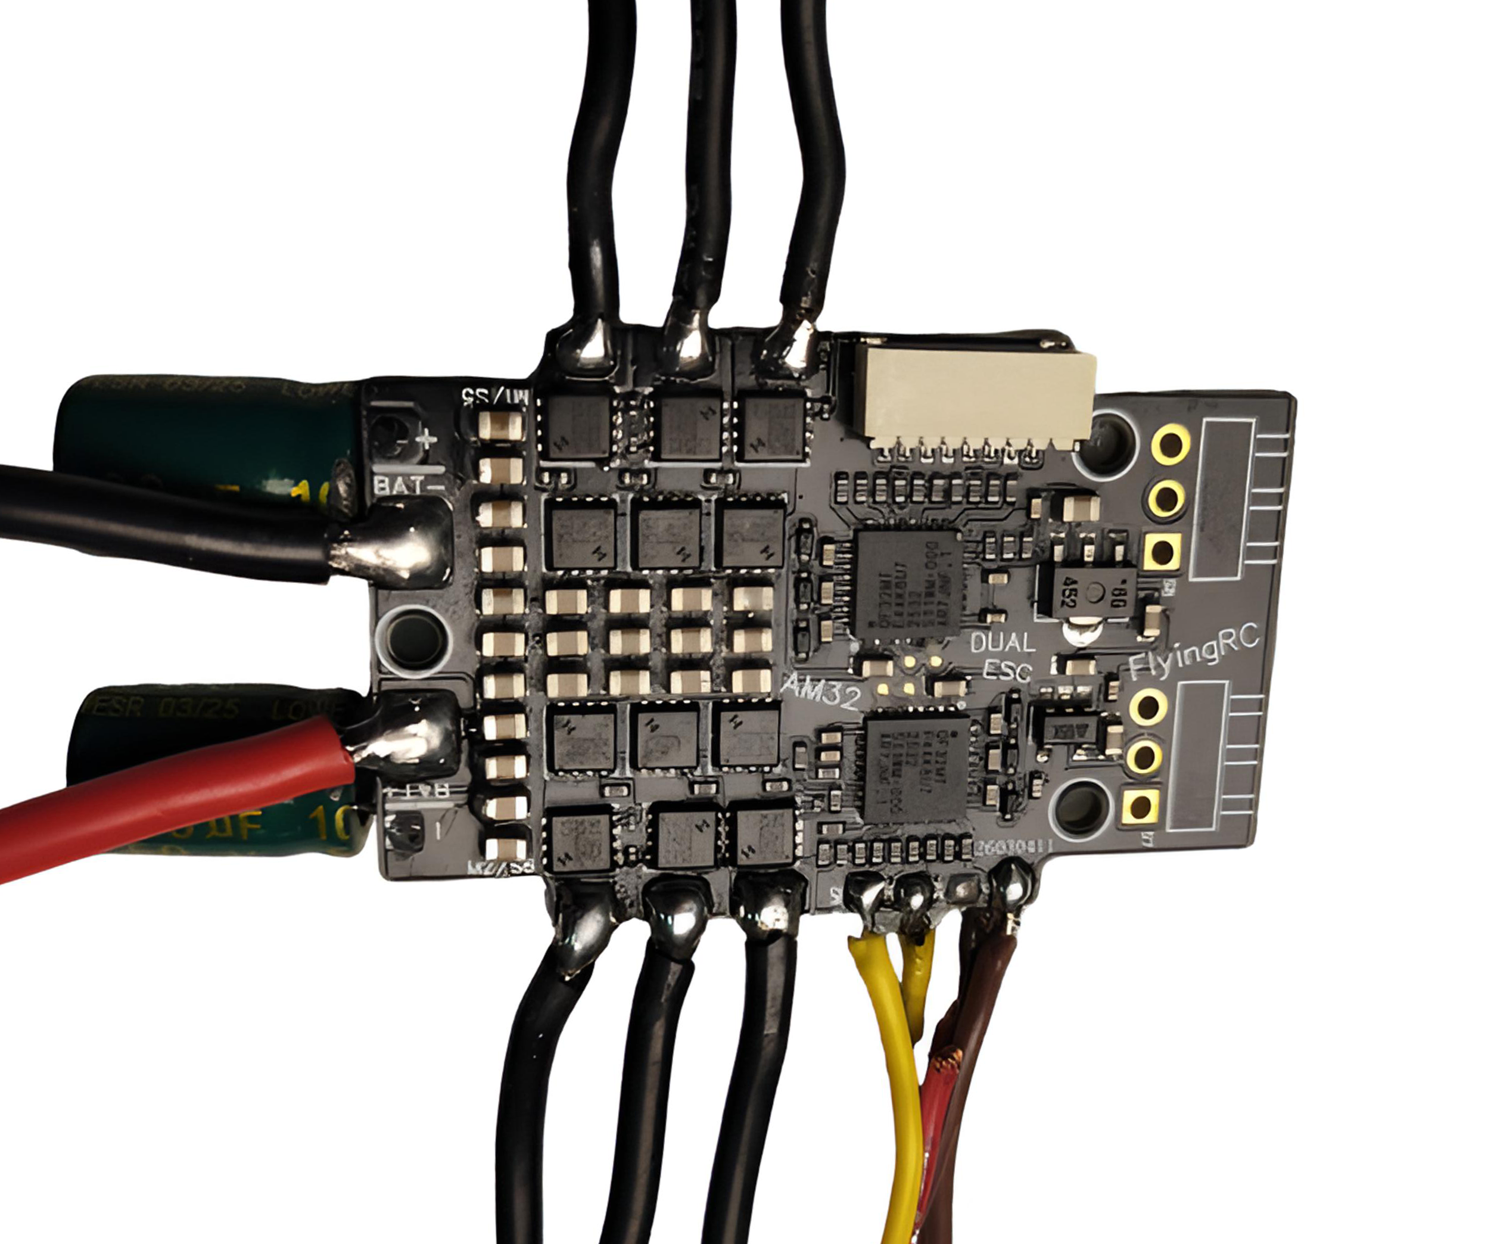
Soldering Completion Display 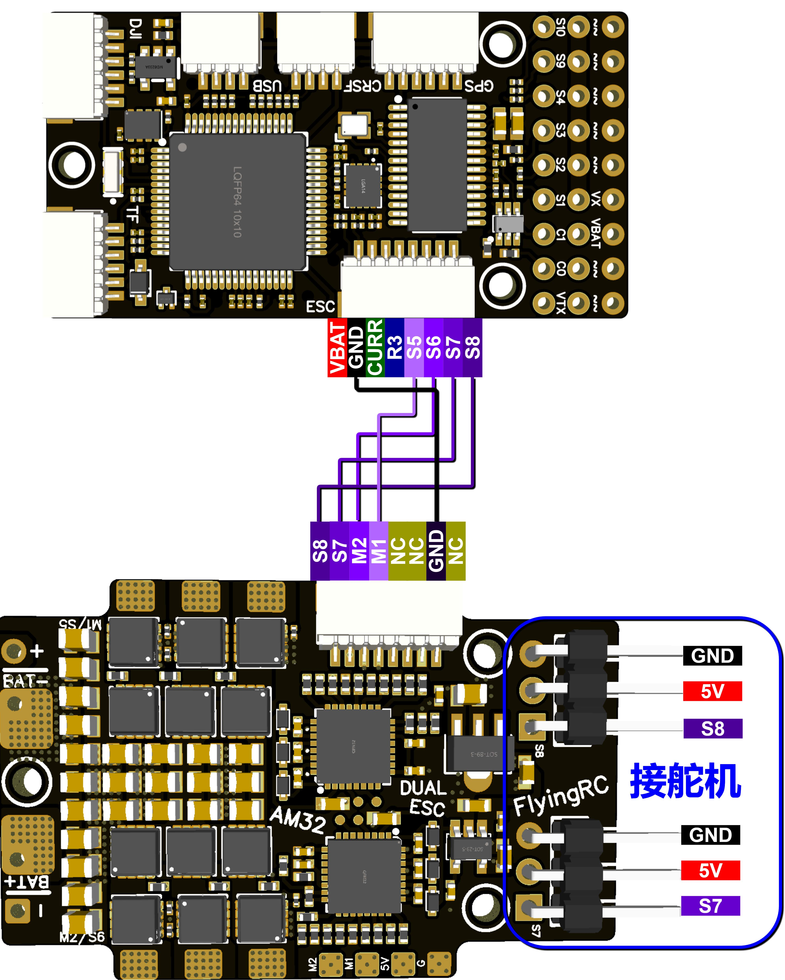

Wiring Diagram with FlyingRC F4WSE PRO

2.Firmware Update Instructions
Please close the BF ground station to release the flight controller port when using the ESC parameter adjustment software. When adjusting ESC parameters or flashing firmware, connect a power battery for power supply – the propellers MUST be removed first.

Please download AM32-ESC-Tools from the group files, extract it to your local device, and double-click to open SerialPortConnector.exe.
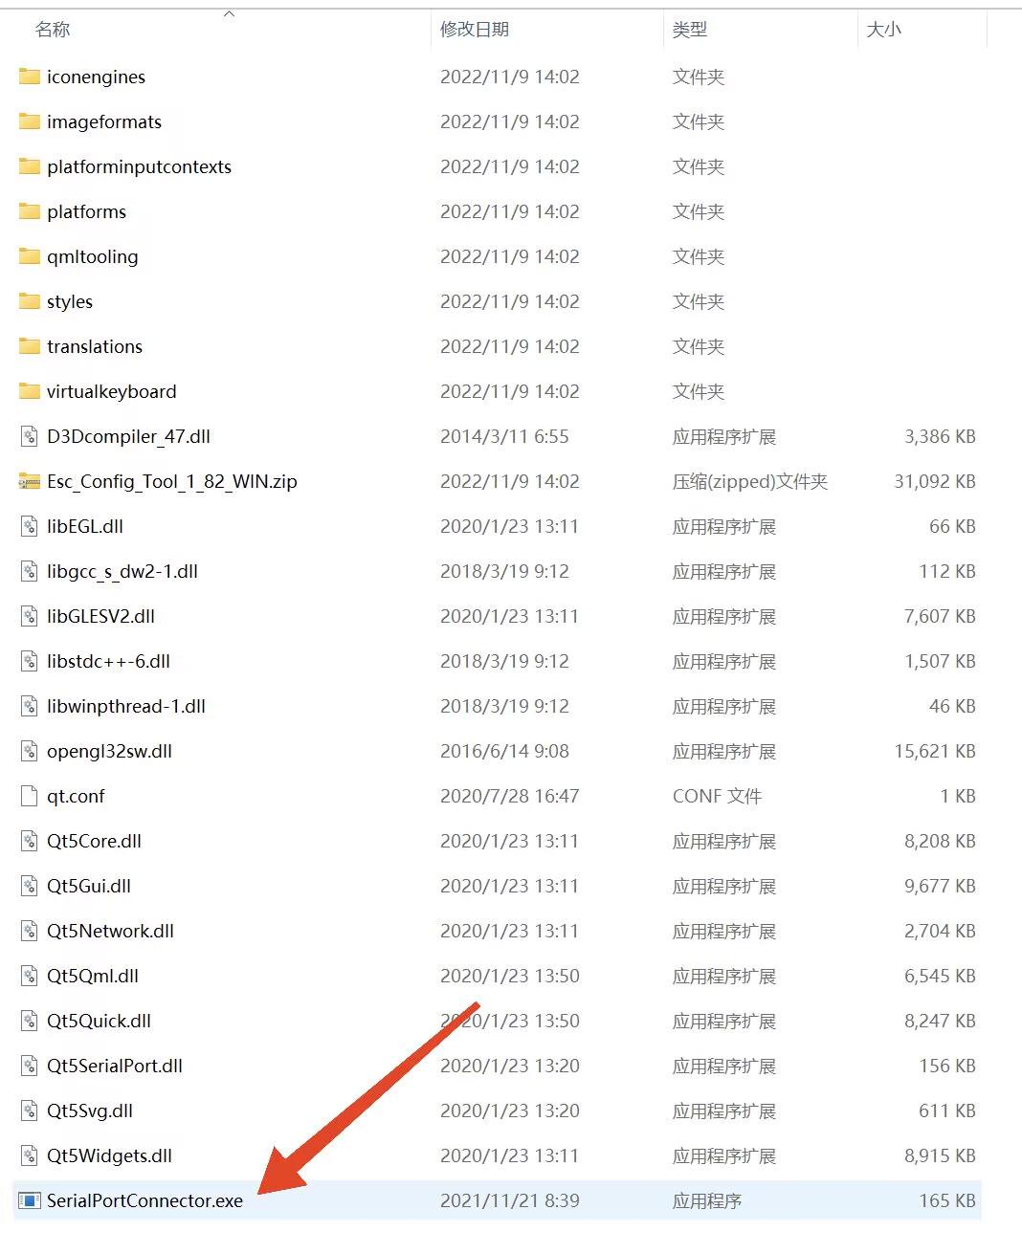
Locate the corresponding flight controller port number (COMx) in the bottom right corner of the ESC parameter adjustment software and click Connect. If no error prompt appears at this time, the ESC parameter adjustment software has successfully connected to the flight controller.
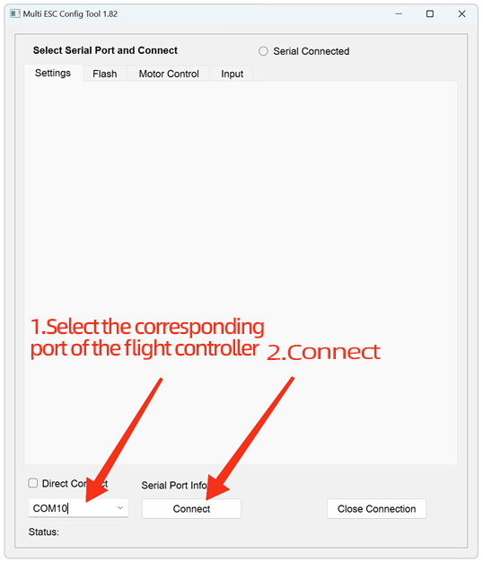

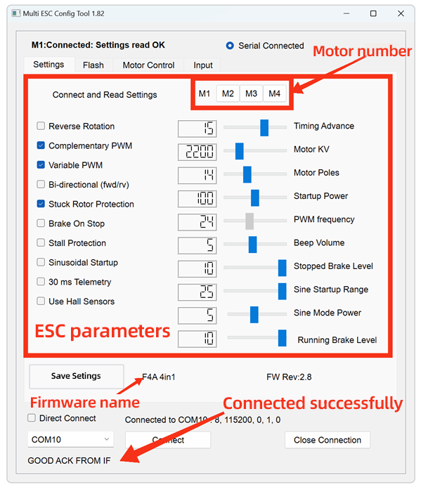

Before flashing the firmware, download the latest version of the ESC firmware in advance. Firmware download links (available on github or in the group files).
AM32_F4A_4IN1_F421

ESC Parameter Adjustment Software: Click on "Flash" (Firmware Flashing Page).
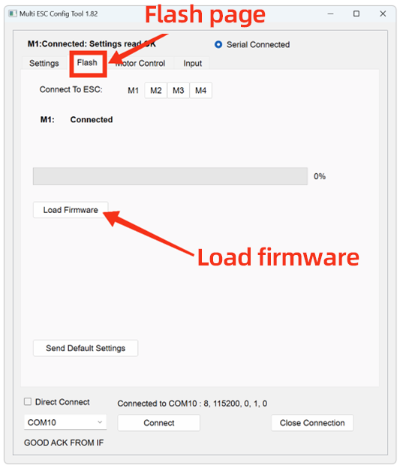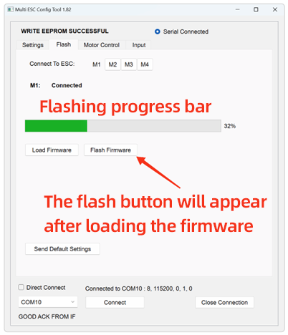

Click M1, then click "Load Firmware". In the pop-up window, locate the downloaded new ESC firmware file and double-click to confirm. Click "Flash Firmware" and wait patiently for the progress bar to complete. Click "Send Default Settings" to restore the ESC to its default parameters. *This step is not recommended to be skipped when updating firmware across multiple versions.
Repeat the above steps for M2, M3, and M4.

FlyingRC® Factory Default RC Crawler Parameters (Screenshot)
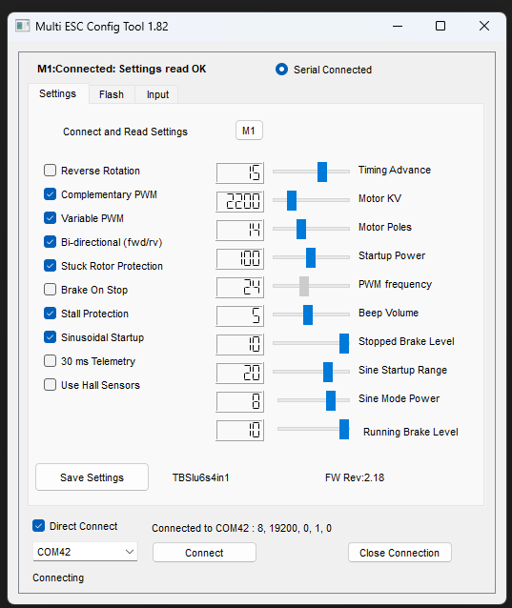
Rock Crawler Parameters
WARNING! Do NOT use the web-based parameter adjustment software. Using it to update firmware may damage the ESC MCU, and multiple such cases have been reported. Repairs for this issue will require factory return and incur a service fee.

3.Parameter Settings
For the Parameter Tuning Software and connection instructions, please refer to Section 2. Firmware Update Instructions.
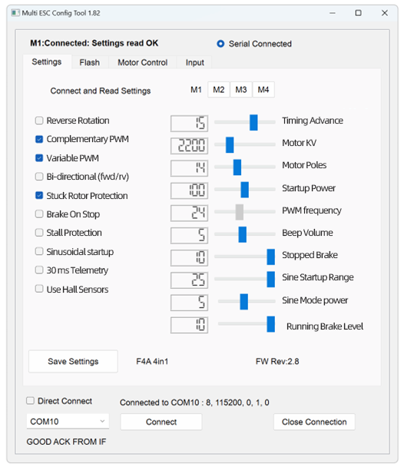
Parameter Explanation Diagram
Main parameters：
KV Value: Must be set close to the motor’s rated KV rating. Deviation from the actual KV value shall not exceed 30%. If the KV value setting deviates by more than 100%, the motor may fail to operate normally, and the ESC hardware may even be damaged.
Advance Angle: Forbidden to adjust.
Advanced users may optimize motor efficiency by adjusting the advance angle, but incorrect adjustment will damage the ESC, and such damage is usually irreparable.
Stall Protection: Can be enabled if using a low-KV motor (KV < 500), or must be enabled if using sine-wave startup.
Sine-Wave Startup: Not required for general FPV drones.

Notes：
1.All ESCs are pre-flashed with the latest official AM32 firmware and tested via multi-voltage rotation before shipment.
2.The factory firmware is AM32 version 2.8/2.18( the latest stable version is currently 2.18). firmware download link
Offline paramteter tuning software is required for firmware flashing.
3.ESCs generate significant heat during operation. To ensure efficient heat dissipation, it is strictly prohibited to apply heat-shrink tubing or waterproof treatment, as such protective measures will impede heat exchange between the ESC and the environment. Damage caused by this will not be covered under warranty.
4.When the ESC’s operating environment parameters (e.g., temperature, humidity, air pressure, ventilation) deviate from rated conditions, the current-carrying capacity of its internal power devices will be limited, and the maximum continuous operating current will fall below the nominal value. Sufficient heat dissipation measures must be implemented to ensure stable and reliable operation.
5.Take care to prevent the ESC from contacting other conductors (carbon fiber plates, battery plugs, other circuit boards) during installation, as external short circuits may cause damage.

Other FlyingRC® Products
 |  |  |  | - FlyingRC® F4WSE Pro - F405 Fixed-Wing Flight Controller  Upgraded Version | Enhanced Performance  Manual：https://www.kdocs.cn/l/cavm9EoVEq5A |  |  | 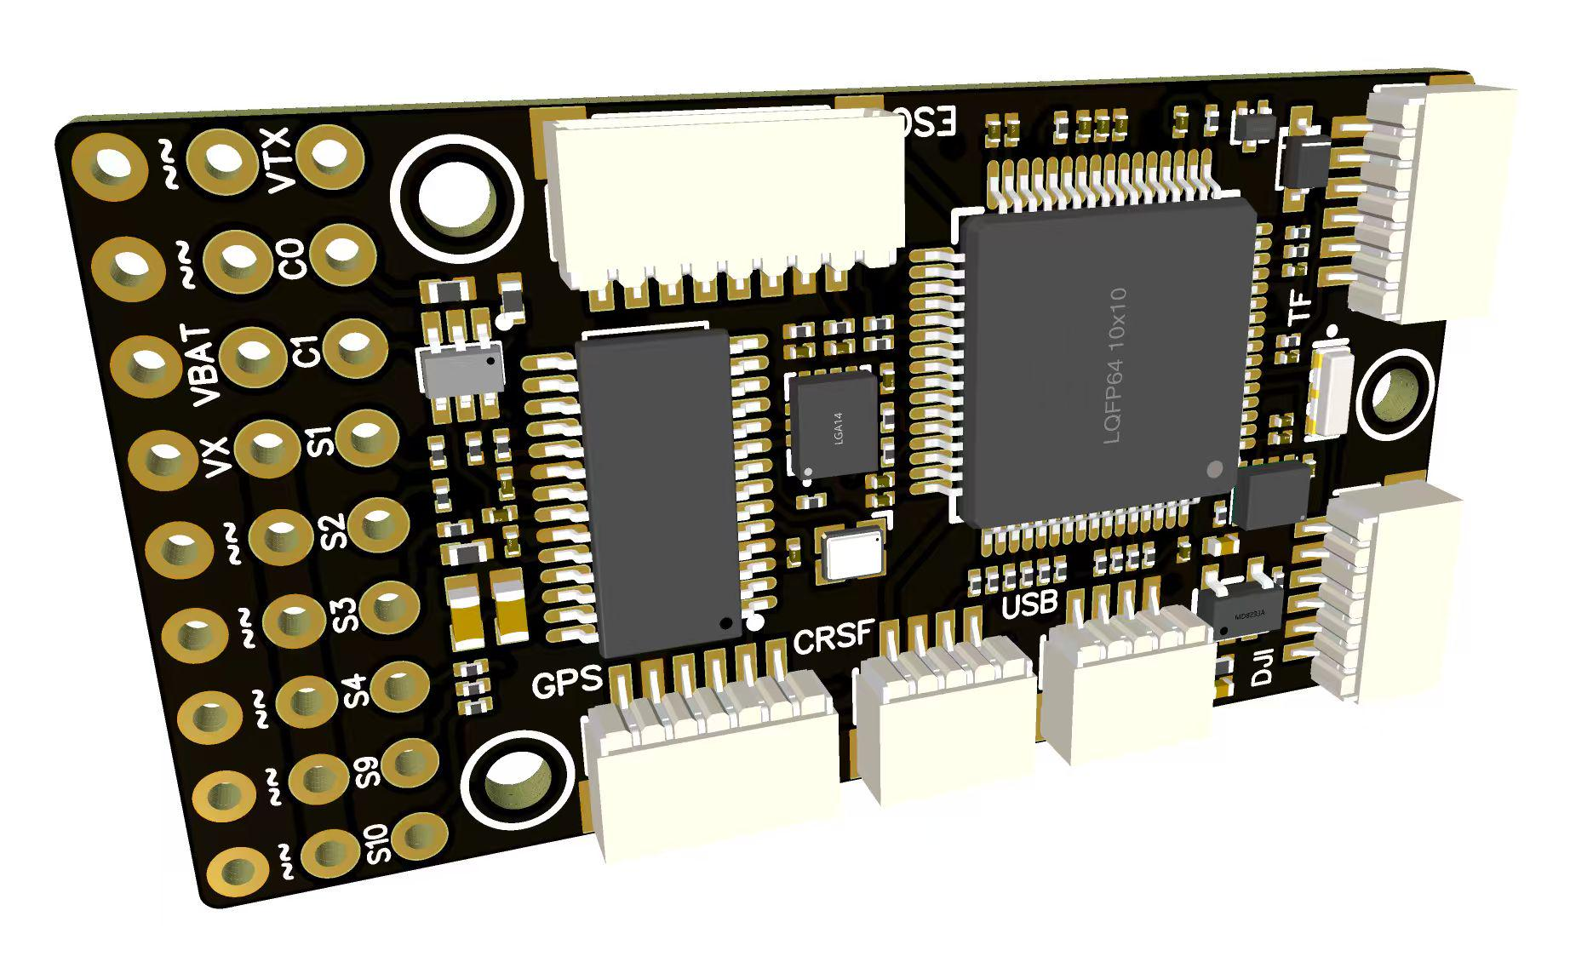
 |  |  | - FlyingRC® F4WSE MK1.5 - F405 Fixed-Wing Flight Controller  Classic model, unique design, highly acclaimed.  Manual：https://kdocs.cn/l/cpyd8MTS56DD |  |  | 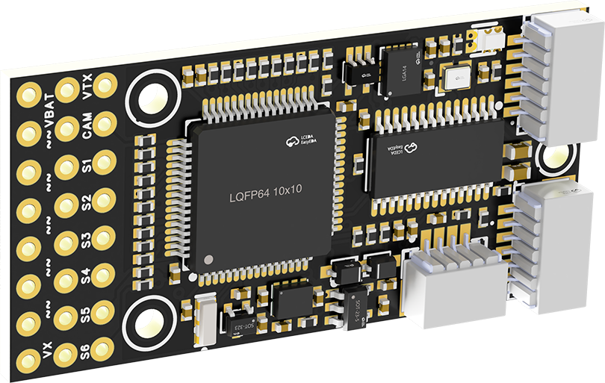
 |  |  |  | - FlyingRC® H7Wlite MK1 H743 Fixed-Wing Flight Controller  Flagship performance, full expansion, high-power BEC.  Manual：https://kdocs.cn/l/cpYaBiFKh8U1 |  |  | 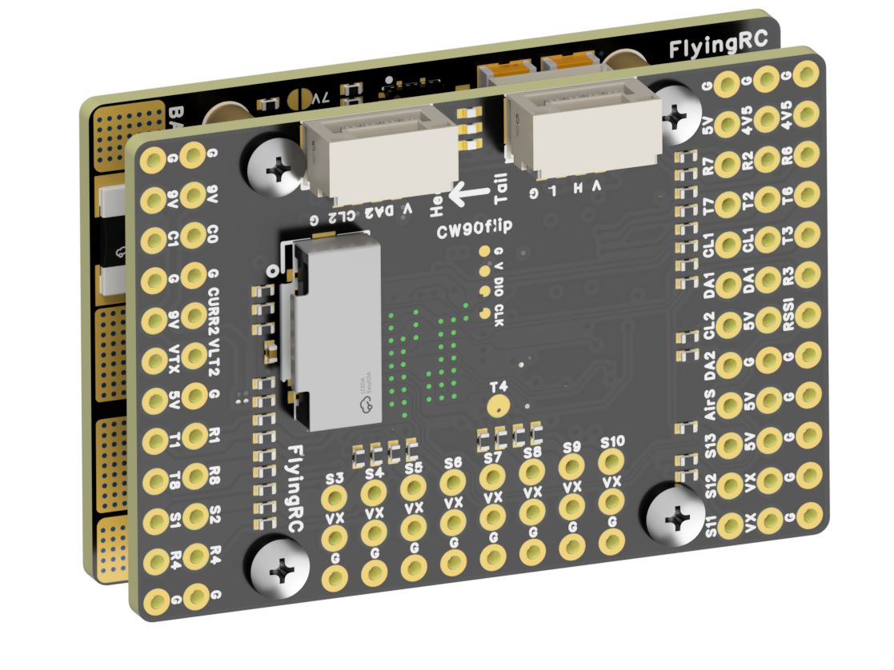
 |  |  |  | - FlyingRC® F4Wing Mini MK1 F405 Fixed-Wing Flight Controller  2025 bestseller, ultra-compact, smallest on the market, great value.  Manual：https://kdocs.cn/l/cdUIdmpSpW7J |  |  | 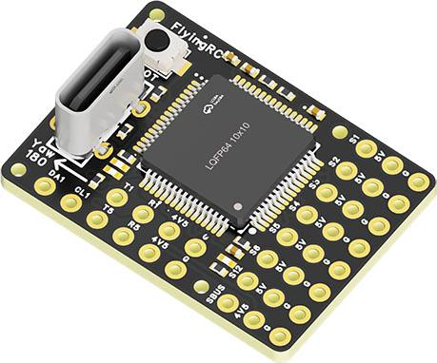
 | - FlyingRC® AM32 Dual ESC 40A 2-in-1 ESC  Unique design for dual-power aerial, land and water vehicles including drones.  Manual：https://www.kdocs.cn/l/cjwNtsKK6HeR |  |  |  | 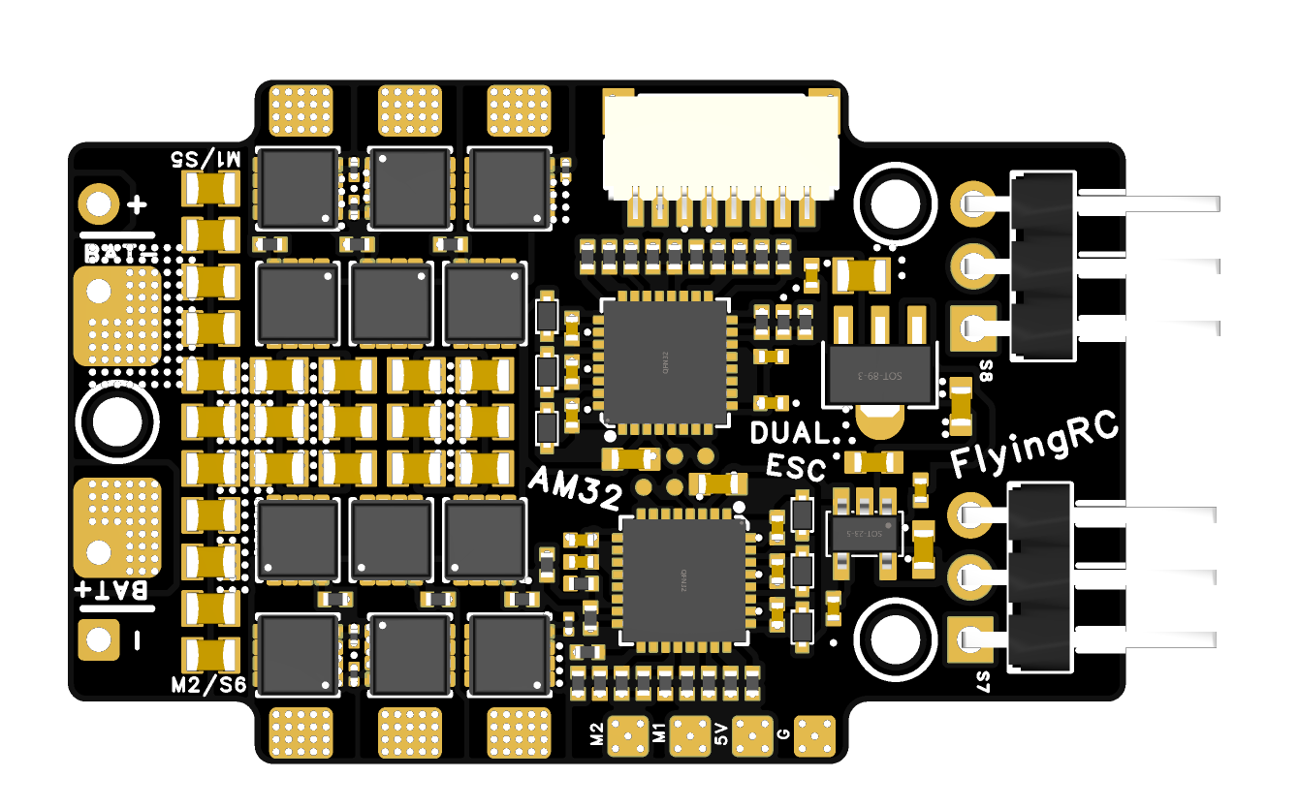
 |  |  | - FlyingRC® AM32 ESC V2.5 75A - Single ESC  Infineon gold-package MOSFETs, premium materials, superior heat dissipation.  Manual：https://kdocs.cn/l/cv6hUy67IdTJ |  |  |  | 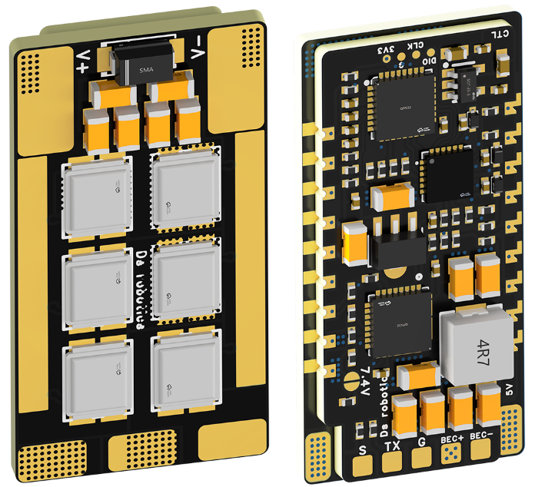
 |  |  | - FlyingRC® AM32 Mini ESC 40A V1.0 - Single ESC  Ultra-miniature, ideal for micro drones, high over-current capability, stable operation.  Manual：https://kdocs.cn/l/cqdLSysEyWFh |  |  |  |  | 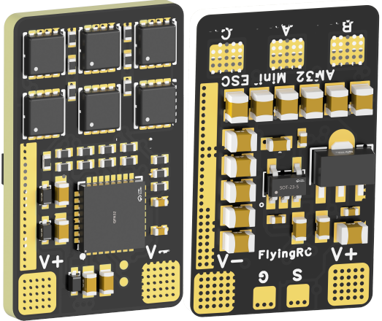
 |  |  | - FlyingRC® 10A 12S 440A Power Distribution Board for FPV Drones  Industry top choice, excellent quality and affordable price.  Manual：https://kdocs.cn/l/coel7OgrlCBP |  |  |  |  | 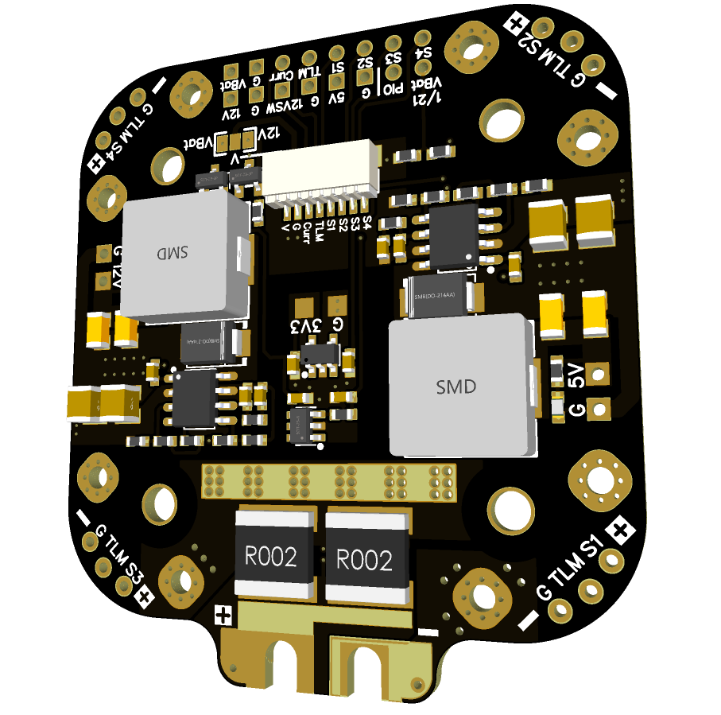
 |  |  | - FlyingRC® H7D Pro MK1 H743 FPV Flight Controller with Dual Gyro  Fully Upgraded & More Powerful  Manual：https://www.kdocs.cn/l/ctcekCy676Ez |  |  |  | 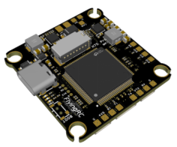
 |  |  | - FlyingRC® H7D MK1 H743 FPV Flight Controller with Dual Gyro  Powerful computing, stable and precise flight, rich interfaces, smooth control.  Manual：https://kdocs.cn/l/cqMh1I0RwAoD |  |  |  | 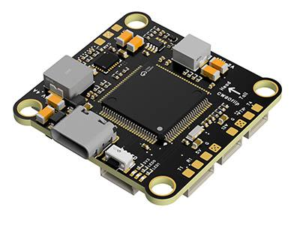
 |  |  | - FlyingRC® F420 MK1 F405 FPV Flight Controller (20/30.5mm Mounting)  Dual mounting holes, all connectors, no soldering required, compliant with Betaflight interface standards.  Manual：https://kdocs.cn/l/ctGeLiN9ZYKj |  |  |  | 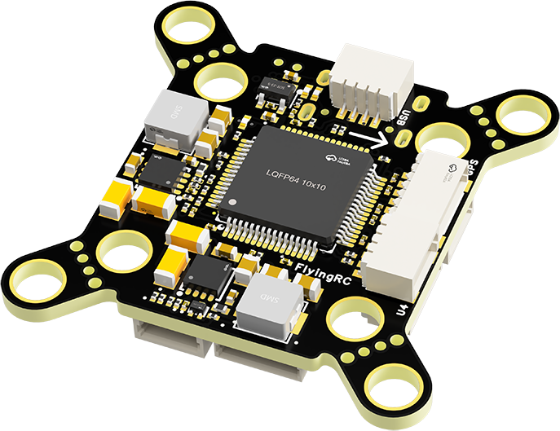
 |  | - FlyingRC® 4-in-1 75A V3.2 Gold-Sealed FPV ESC  Infineon gold-package MOSFETs, superior heat dissipation & over-current capability, premium choice.  Manual：https://kdocs.cn/l/ceLilc8Gaa21 |  |  |  |  | 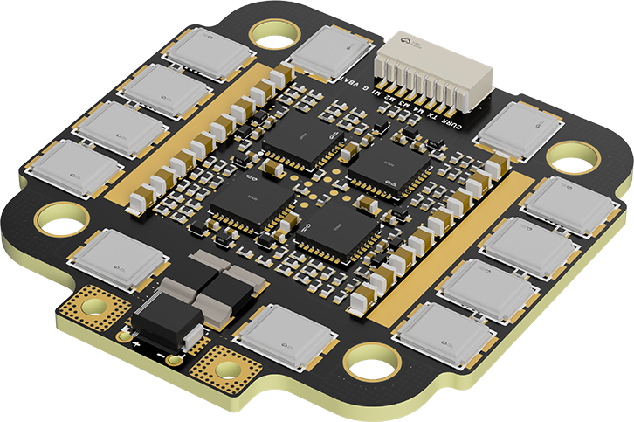
- FlyingRC® Stack Combo: H743 Flight Controller + 4-in-1 75A Gold-Sealed ESC  Professional flight choice, flagship materials & craftsmanship, reasonable price.  Manual：https://www.kdocs.cn/l/ctcekCy676Ez  https://kdocs.cn/l/ceLilc8Gaa21 |  |  |  |  |  |  | 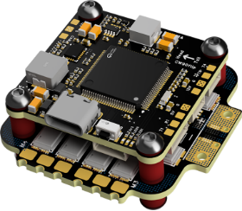
 |  | - FlyingRC® Stack Combo: F405 Flight Controller + 4-in-1 75A Gold-Sealed ESC  Best-selling combo, excellent performance, affordable price.  Manual：https://kdocs.cn/l/ctGeLiN9ZYKj  https://kdocs.cn/l/ceLilc8Gaa21 |  |  |  |  | 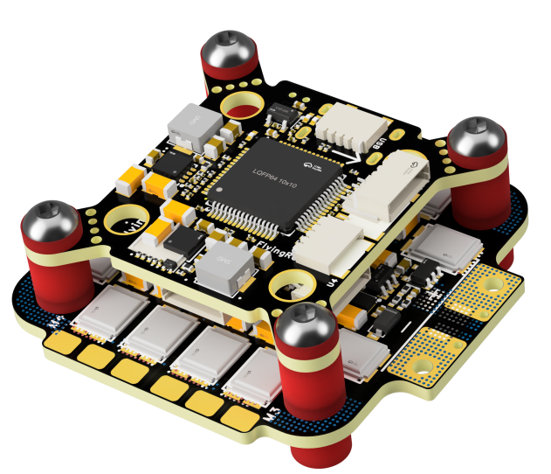
 |  | - FlyingRC® Stack Combo: H743 Flight Controller + 4-in-1 45A ESC  Winning combo: great performance, budget-friendly price  Manual：https://www.kdocs.cn/l/ctcekCy676Ez  https://kdocs.cn/l/ceLilc8Gaa21 |  |  |  |  | 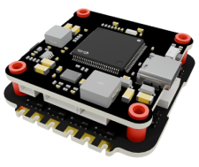
 |  | - FlyingRC® Stack Combo: F405 Flight Controller + 4-in-1 45A ESC  Hit combo, great value, budget-friendly  Manual：https://kdocs.cn/l/ctGeLiN9ZYKj  https://kdocs.cn/l/ceLilc8Gaa21 |  |  |  |  | 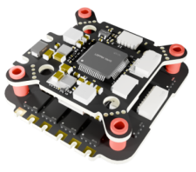
 |  | - FlyingRC® Stack Combo: F4WSE Pro - F405 Fixed-Wing Flight Controller + AM32 Dual ESC 40A 2-in-1 ESC  Unique Design • Exclusive Offer • Bestselling Bundle  Manual：https://www.kdocs.cn/l/cavm9EoVEq5A  https://www.kdocs.cn/l/cjwNtsKK6HeR |  |  |  |  | 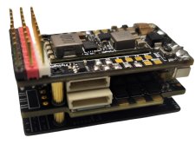
 | - FlyingRC® ELRS 2.4G Diversity Receiver  True diversity reception, temperature compensation, high-sensitivity reception.  Manual：https://kdocs.cn/l/cbvlOlShmsPS |  |  |  |  |  | 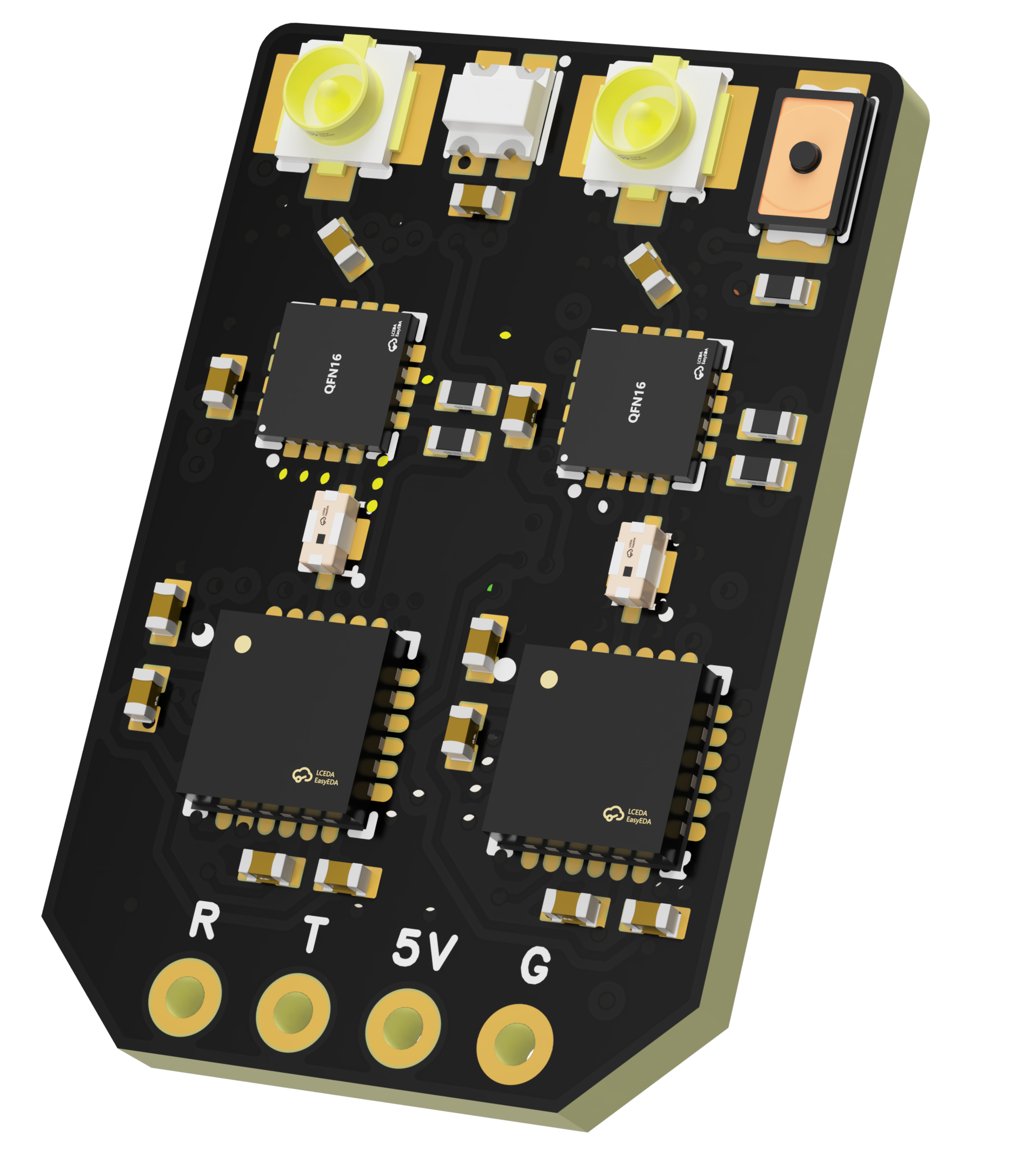
 | - FlyingRC® RM3100 SPI Module 罗盘模块  Ultra-high Resolution • Low Power • Industry Top Choice  Manual：https://www.kdocs.cn/l/cdGuHvBVyndC |  |  |  |  |  | 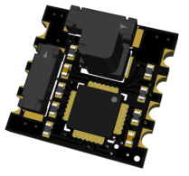
 | - FlyingRC® 10A 12S BEC Step-Down Module  Wide voltage input, high power, compact size, multiple voltages available, 10A continuous output.  Manual：https://kdocs.cn/l/clssNCKgNhLV |  |  |  |  |  | 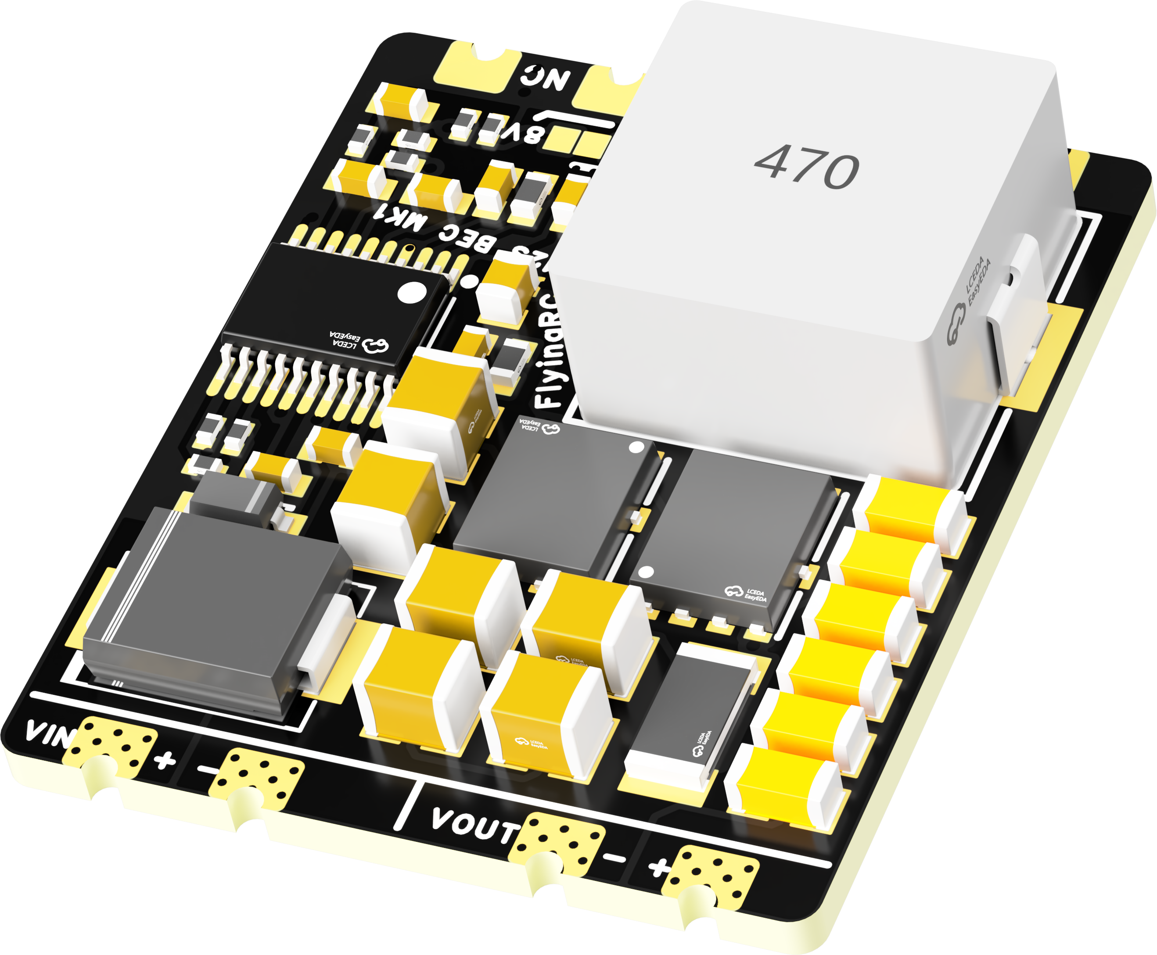
 | FlyingRC® 5A BEC Step-Down Module  Ultra-small size, multiple voltages available, 5A continuous output.  Manual：https://kdocs.cn/l/cb9VdNywqCKA |  |  |  |  |  | 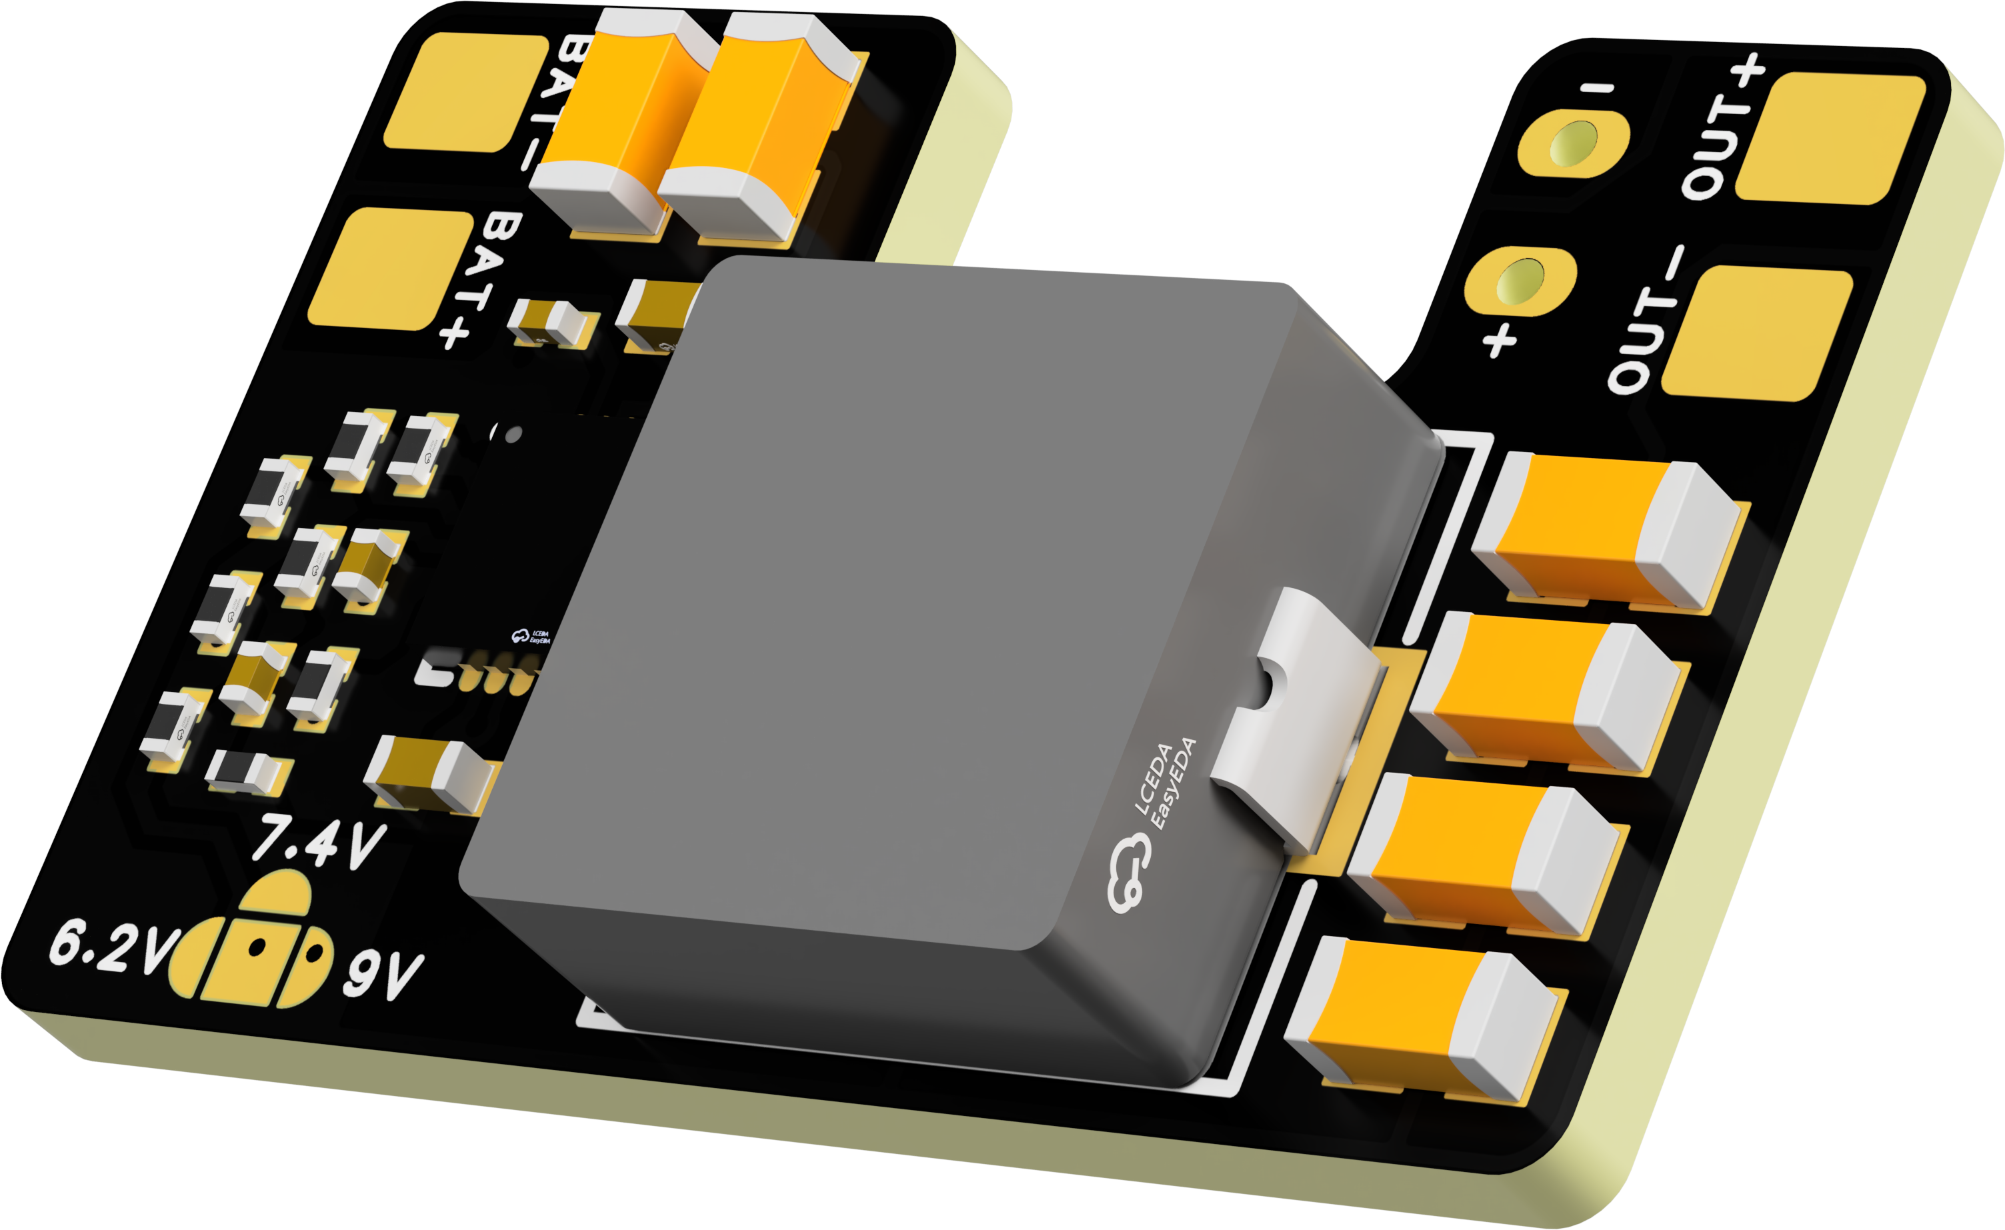
 | FlyingRC® Mini BEC For DJI O4  Easy wiring, ultra-small size, stable power supply.  Manual：https://www.kdocs.cn/l/ckkebieur37K |  |  |  |  |  | 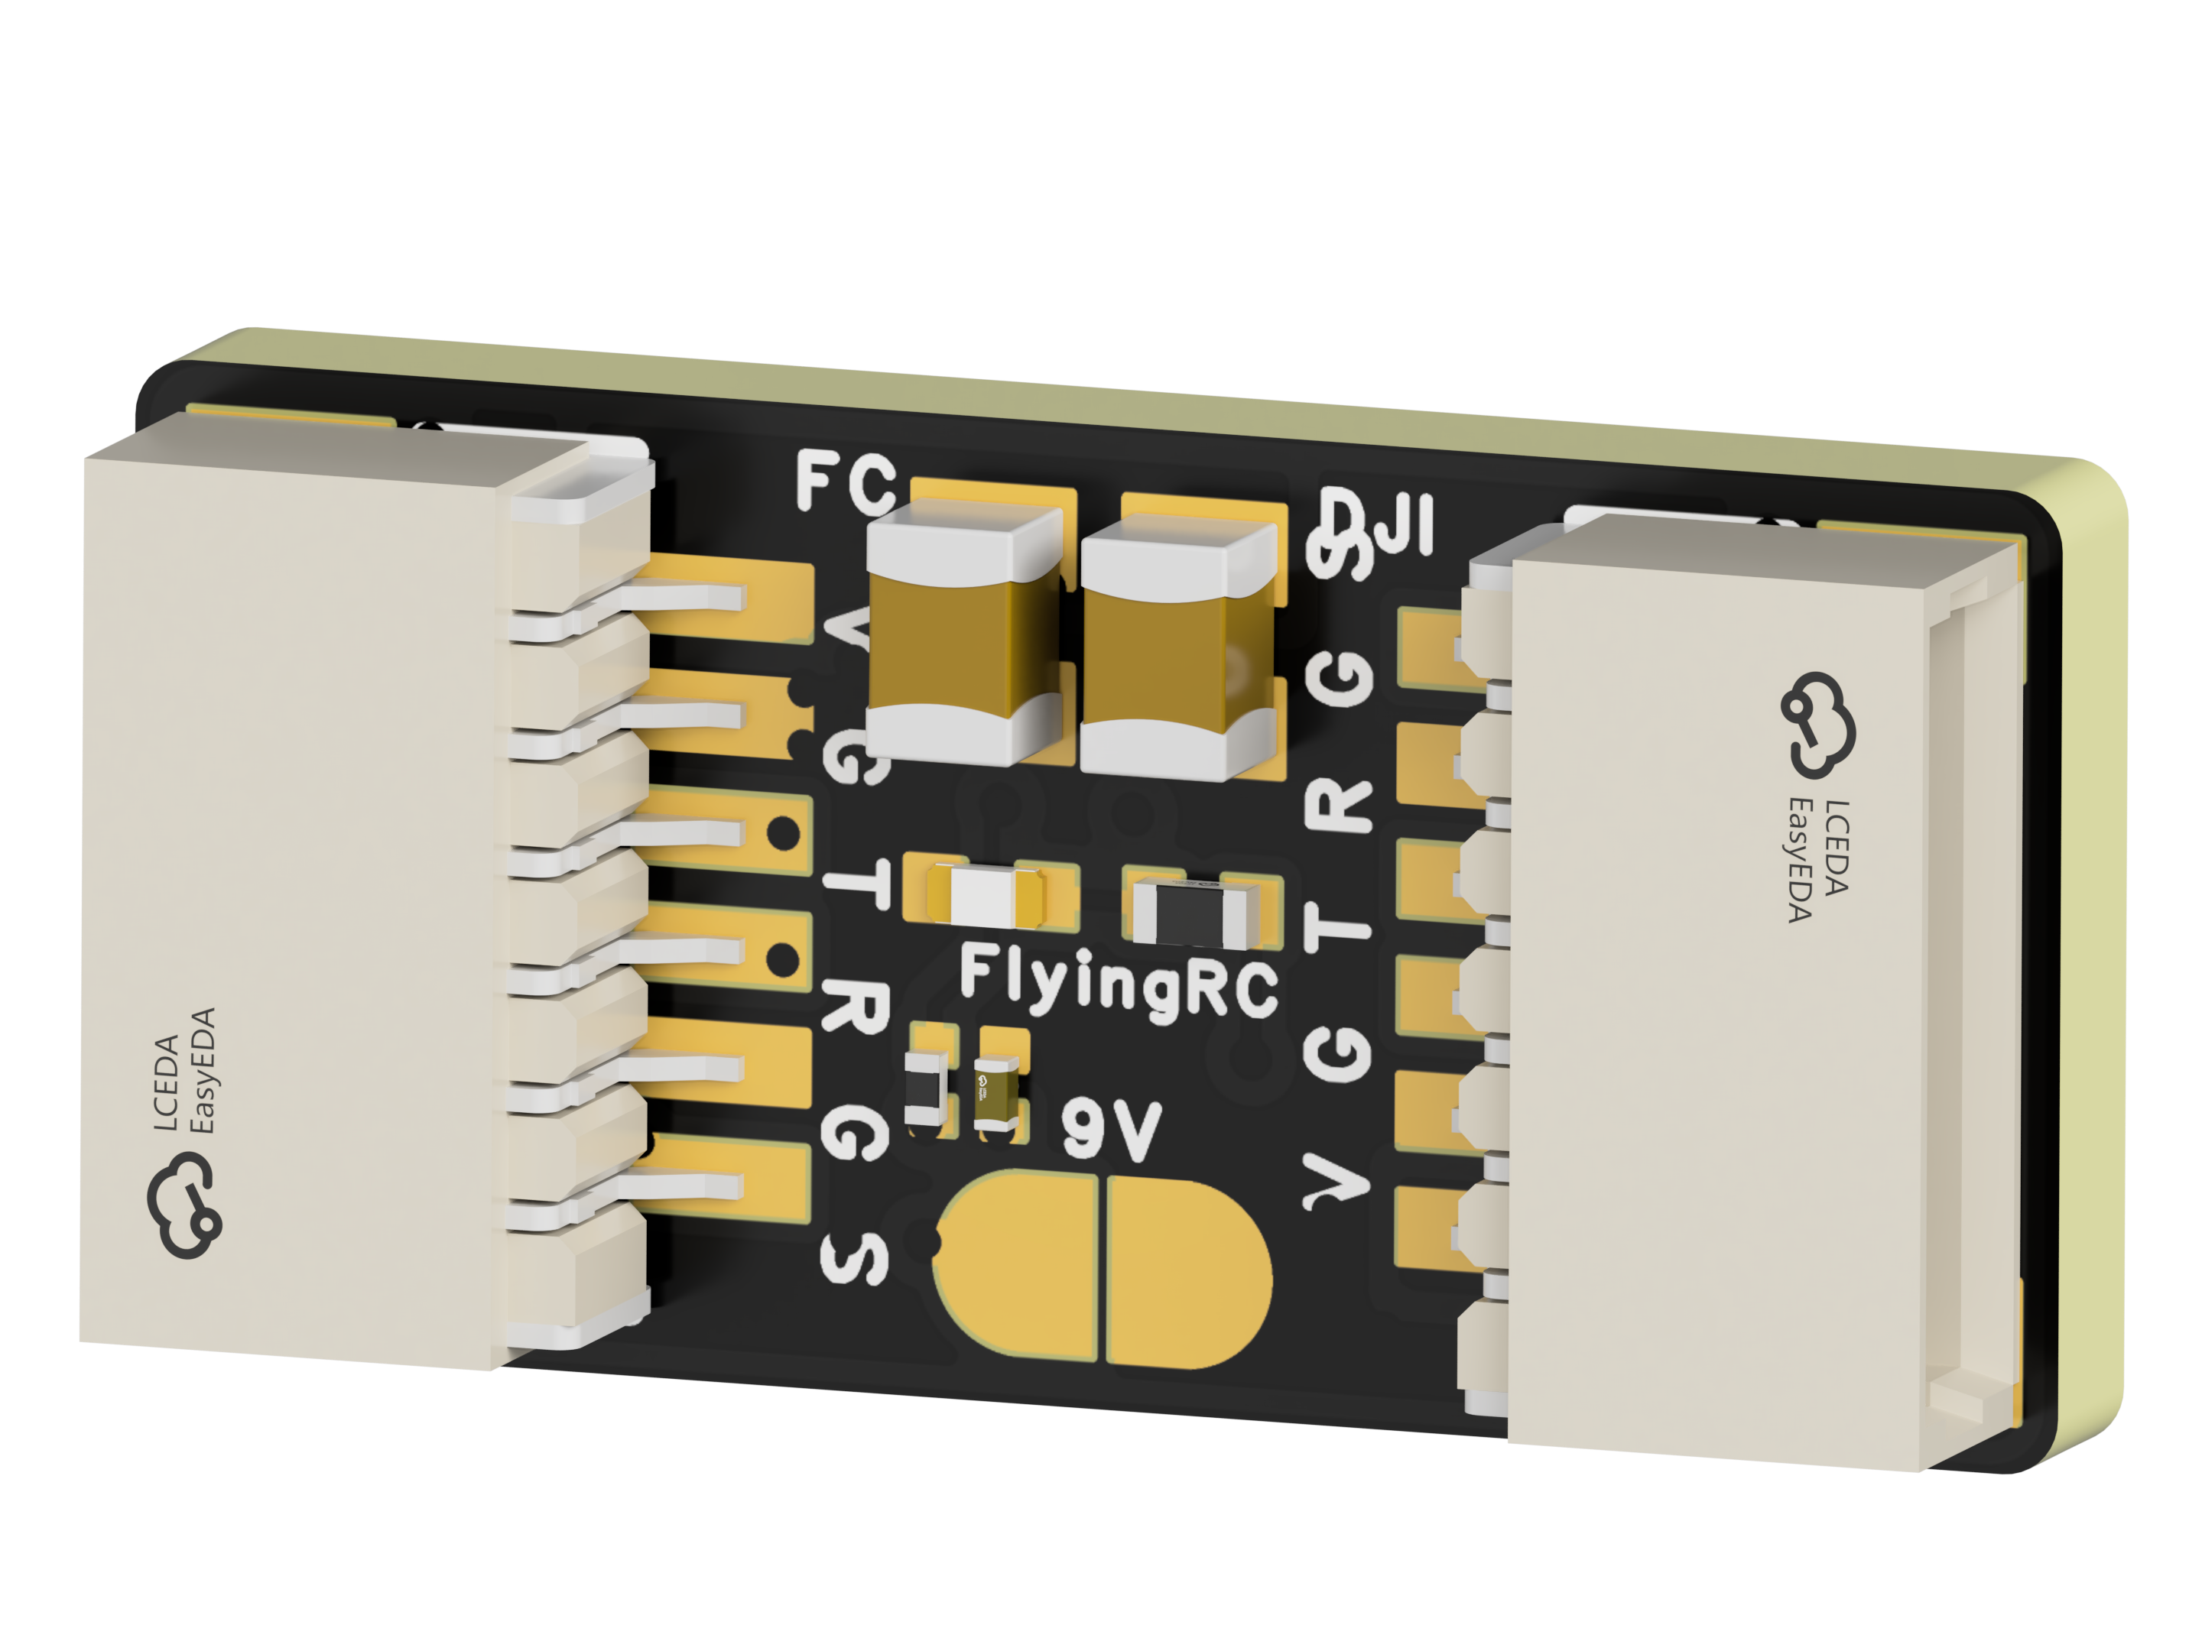
 | FlyingRC® CAN Bus Serial & PWM Expansion Board  Long-distance transmission, high speed, excellent stability.  Manual：https://www.kdocs.cn/l/cmxRyBnU4BXj |  |  |  |  |  | 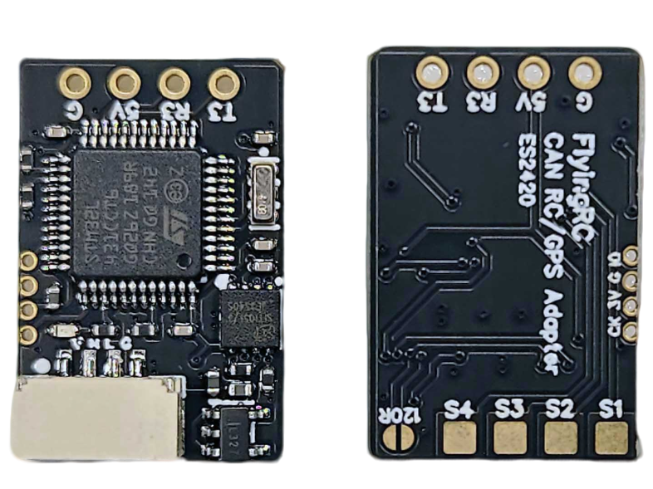
 | FlyingRC® AM3 2ESC Programmer  Supports BL, BL32, AM32. Simple and easy to use.  Manual：https://kdocs.cn/l/cogBSEBe67mE |  |  |  |  |  | 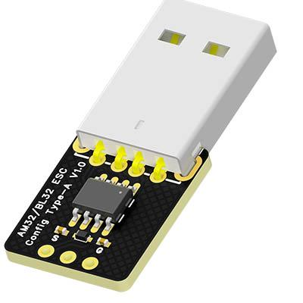
 | FlyingRC® Digital Airspeed Sensor without Pitot Tube  Integrated design, smallest on the market. MS4525D protocol, I2C interface.  Manual：https://www.kdocs.cn/l/clPvEEEcJgCC |  |  |  |  |  | 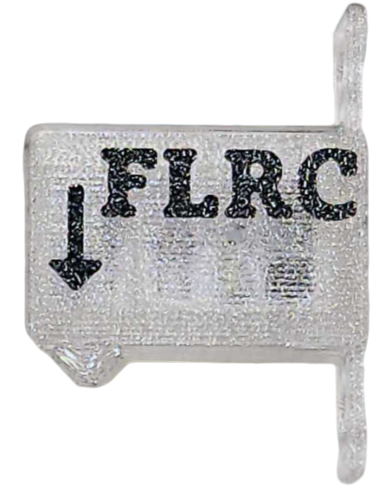
 | FlyingRC® U-Blox M10 GPS  Compatible with all open-source flight controllers.  Manual：https://www.kdocs.cn/l/cdSYQrzx74O8 |  |  |  |  |  | 