FlyingRC® AM32 75A Single ESC V2.5 Product Manual
FlyingRC® is a globally-oriented professional brand of electronic devices. We specialize in the R&D and sales of drone electronics, core robot circuits and sensors. Our design team is based in Singapore, and our products are sold worldwide.

Since launched in 2023, FlyingRC® products have gained widespread recognition from customers as well as strong market response. As of April 2026, our cumulative sales volume has exceeded 46,000 units. Our products are widely applied in industries, robotics, emergency rescue, environmental protection & inspection, aerial photography, public security, retail and many other fields. Above all, we are committed to distinctive design and superior reliable quality.

Our Chief Technology Officer Liu Yuhan possesses outstanding expertise in circuit design. Over the past four years, he has designed more than 80 circuit projects and contributed 39 to open-source platforms. Moreover, he won the Design Award on the open-source platform X.JLC.com twice in 2023 and 2024, and has become the youngest certified designer on this platform.

He holds the NUS (National University of Singapore, rank 8th worldwide) Science and Technology Scholarship, and is currently majoring in Electronic Engineering with a focus on Aerospace Technology. In addition, all members of our technical team are graduates from prestigious universities with extensive professional product experience.
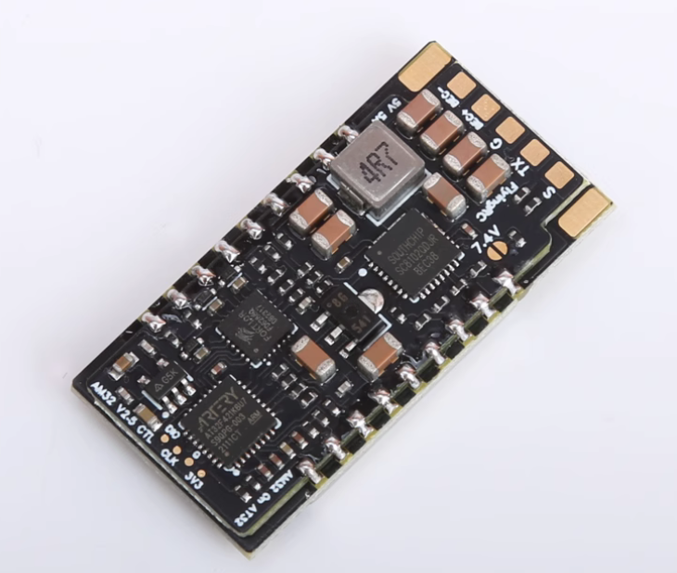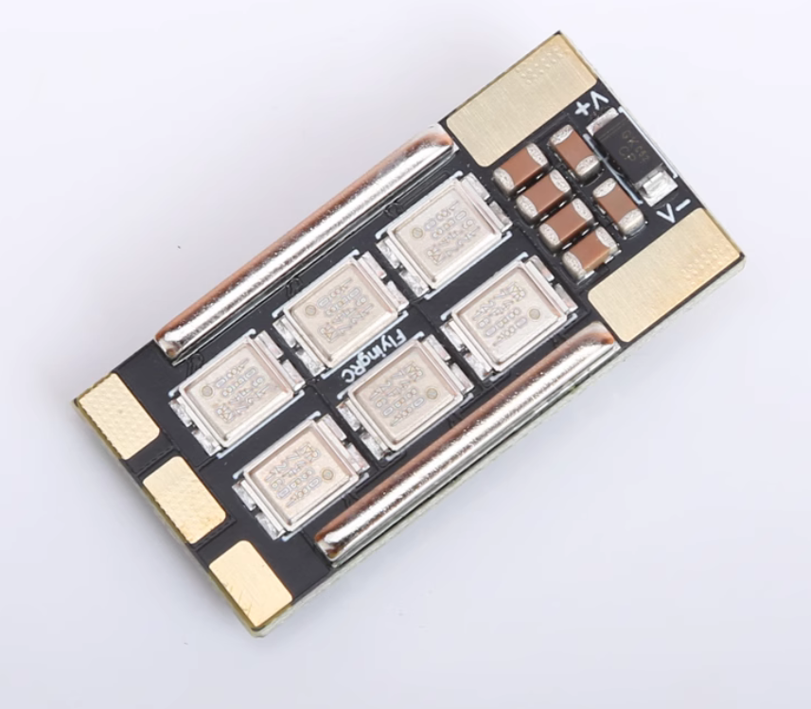
Technical Specifications：
- MCU AT32F421K8U7, Gate Driver FD6288/JSM6288Q, MOSFET IRF7480
- Sinusoidal Startup, high torque at low speed
- Supports multiple protocols: DSHOT150/300, OneShot, PWM, etc.
- Input voltage: 7–28V DC (2–6S LiPo)
- Onboard BEC (SC8102 solution): 5V/4A or 7V/3A, capable of powering RC car servos
- Dimensions & weight: 38mm×19mm×7.4mm, 8g

Basic Parameters |  | Voltage-Current
Model | FlyingRC® AM32 75A Single ESC | VBAT Input Range | 7-28V DC IN 2-6S LiPo
Dimensions | 38mm*19mm*7.4mm | Continuous Current | 75A (Test Condition：4S)
Weight | 8g | Burst Current | 85A (Test Condition：4S)
Main Components |  | Firmware
MCU | AT32F421K8U7 32-bit | AM32 | Supported
Clock Frequency | 120MHz | Control Signal Input | Supports DSHOT150, 300, 600, OneShot, PWM and other protocols
Flash | 64 KB
RAM | 16 KB
Gate Driver | FD6288/JSM6288Q | Operating Environment
MOSFETs/MOS | Infineon IRF7480 Gold-packaged MOSFETs | Operating Temperature Range | -10-100℃
BEC | SC8102 5V4A (Adjustable to 7V3A) | Storage Temperature Range | 0-40℃
Telemetry Feedback | RPM telemetry supported
LED Status Light | None
Product Features
PCB Processes | Featuring black solder mask, resin-filled vias, via-in-pad and immersion gold finish construction, the PCB boasts top-tier craftsmanship among similar products, laying a solid foundation for exceptional continuous current handling capability.
SMD Copper Strips | The power board is built with SMD square copper strips. The ESC's resistance is 60% lower than that of the previous generation with round copper strips, and at least 80% lower than designs without copper strips.
Gold-Packaged MOSFETs | Equipped with Infineon IRF7480 gold-packaged MOSFETs, the ESC features an ultra-low RDS(on) of only 0.95mΩ@10V and supports up to 330A drain current (ID) with double-sided cooling, handling high-current operation easily. Compared with conventional ESCs without gold-packaged MOSFETs, its on-resistance is significantly reduced, resulting in much lower heat generation. The metal casing is in direct contact with the MOSFET die for enhanced heat dissipation.

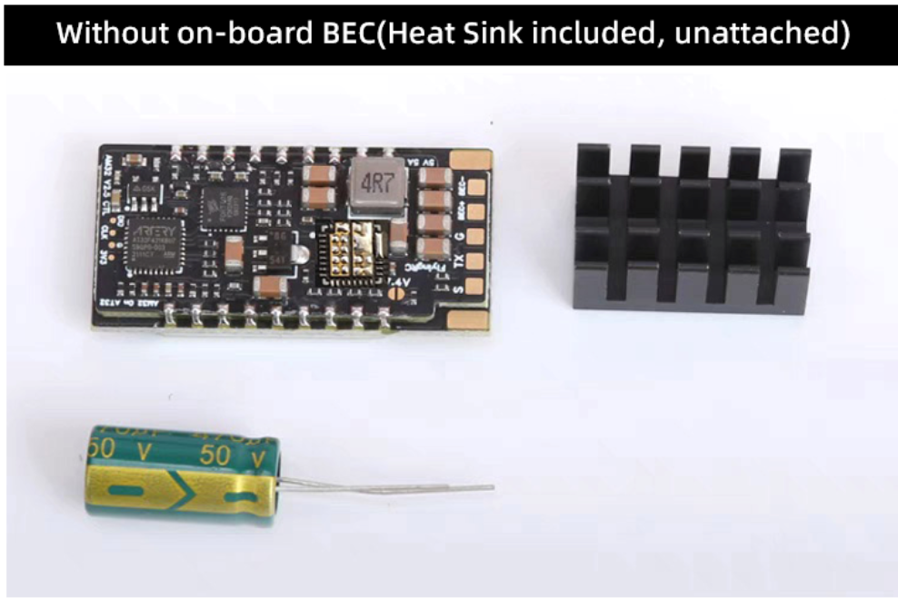
Package List：
75A ESC × 1 Heat Sink × 1
50V 470μF Electrolytic Capacitor × 1
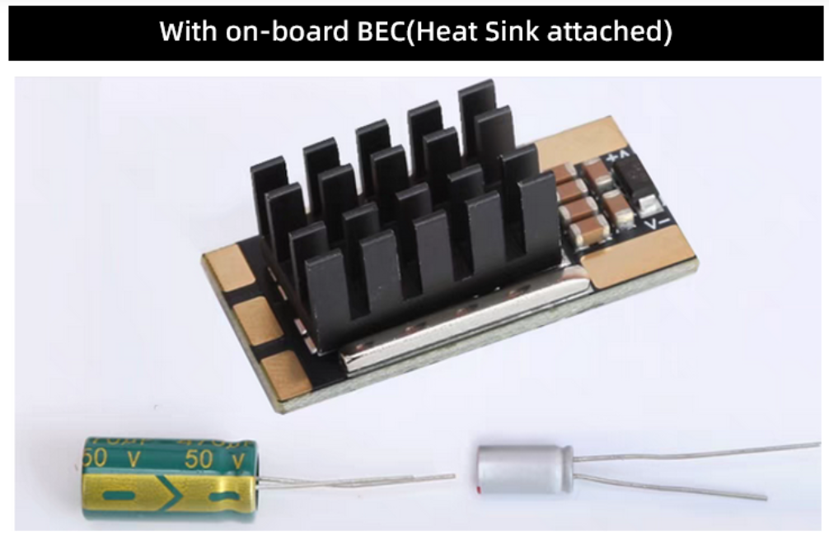
Package List：
75A ESC × 1 Heat Sink × 1
50V 470μF Electrolytic Capacitor × 1
10V 330μF Solid State Capacitor × 1
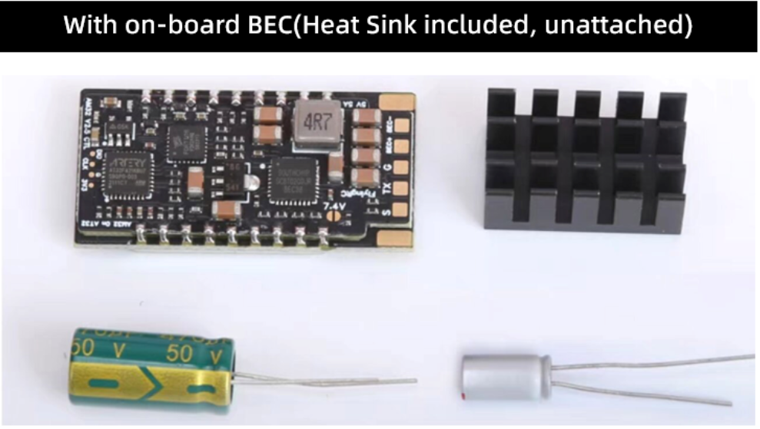
Package List：
75A ESC × 1 Heat Sink × 1
50V 470μF Electrolytic Capacitor × 1
10V 330μF Solid State Capacitor × 1

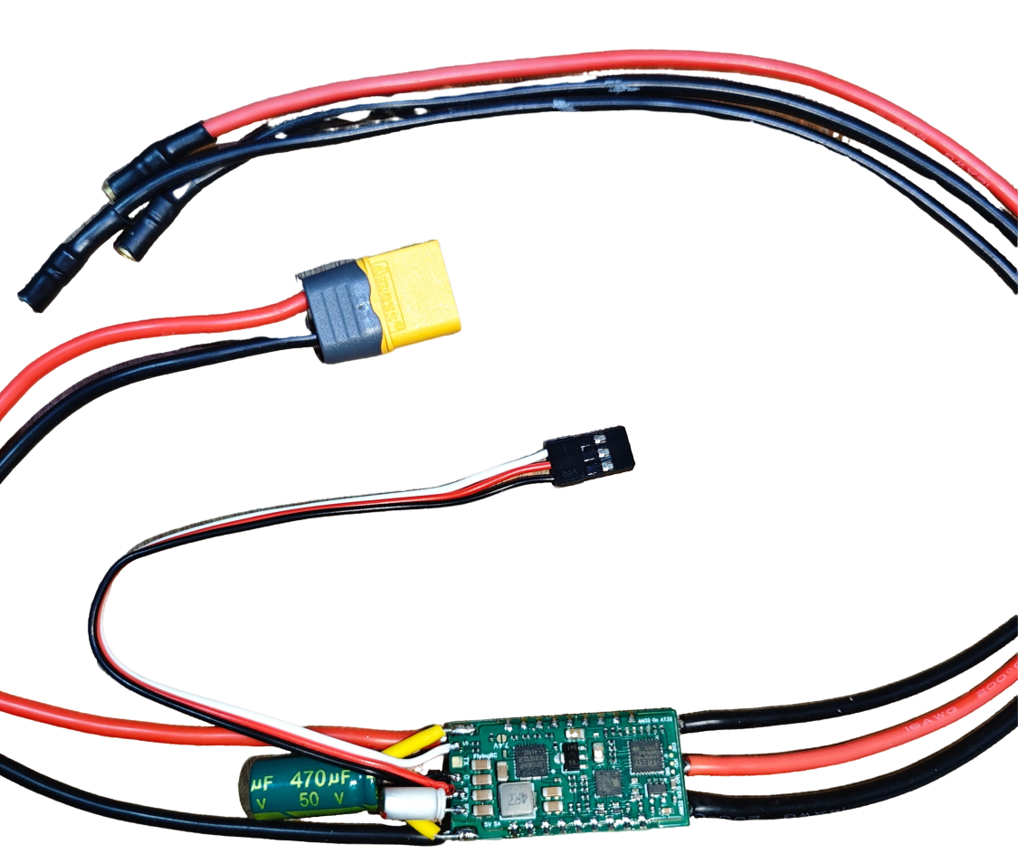
Soldered - With on-board BEC

Product Features：

- Compact size, ideal for small FPV drones. Gold-packaged MOSFETs feature low on-resistance and minimal heat generation, making the ESC also suitable for large aircraft.
- Powered by AM32 firmware, with sinusoidal startup and stall protection enabled, the ESC delivers powerful low-speed torque, perfect for RC crawlers and scale vehicles.
- Equipped with Infineon IRF7480 gold-packaged MOSFETs, the ESC delivers drastically lower on-resistance and minimal heat generation compared with comparable ESCs.
- The power board is built with SMD square copper strips. The ESC's resistance is 60% lower than that of the previous generation with round copper strips, and at least 80% lower than designs without copper strips.
- It provides industry-leading BEC current output among ESCs of the same form factor, supporting continuous 5V/4A or 7V/3.5A output.
- On-board TVS (transient voltage suppression) diodes effectively absorb surge voltages for enhanced ESC protection.

LAYOUT：

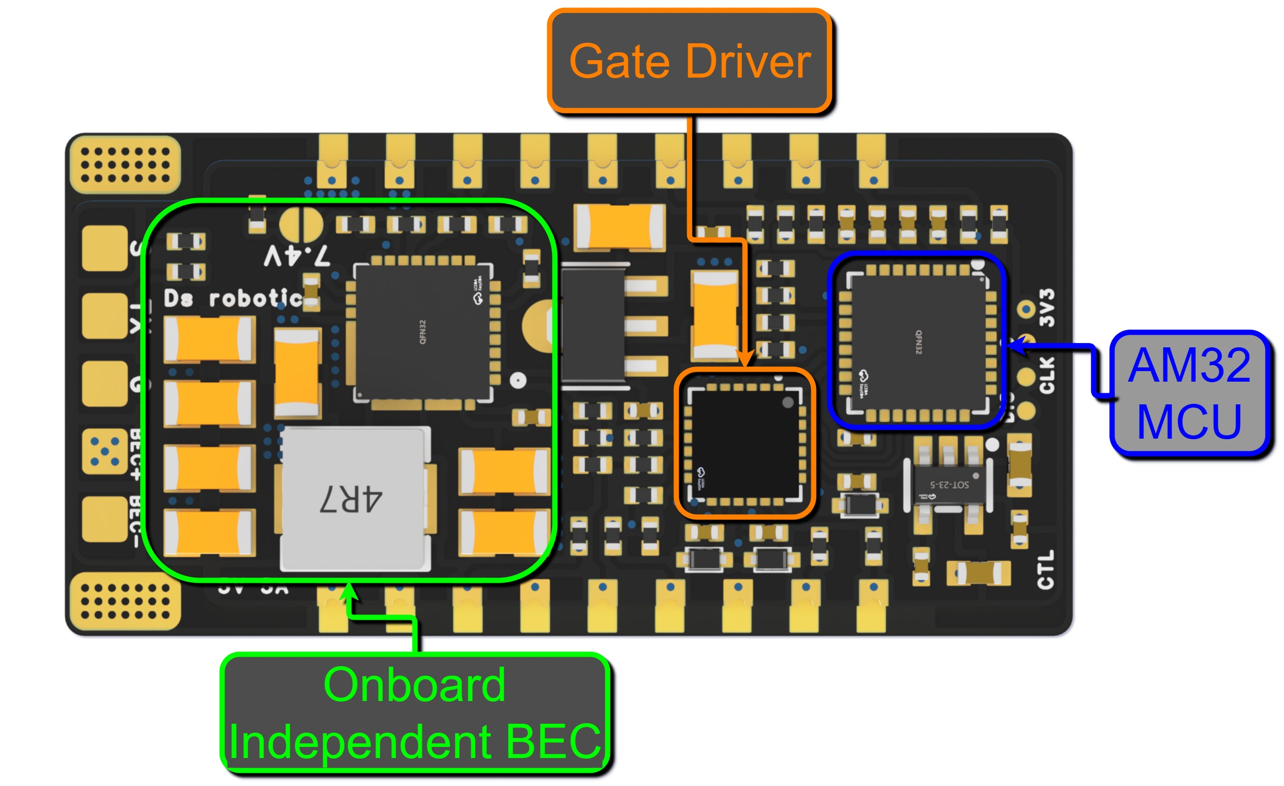
3D Schematic Diagram of ESC Control Board

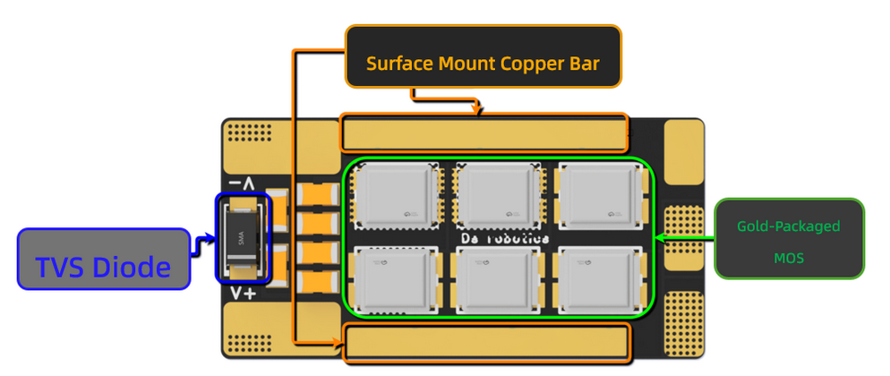
3D Schematic Diagram of ESC Power Board
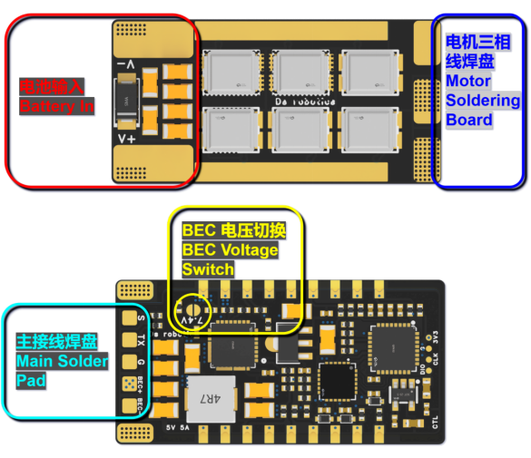
Pad Definition
Pad Number | Pad Name | Pad Definition
1 | S | PWM/Dshot Signal Input
2 | TX | ESC Telemetry TX
3 | G | GND (Ground)
4 | BEC+ | 5V / 7.4V BEC Positive
5 | BEC- | 5V / 7.4V BEC Negative
6 | 7.4V | Short this Pad for 7.4V BEC Output
7 | V+ | Battery Positive (+)
8 | V- | Battery Negative (-)
9 | - | Motor Phase Connections

Wiring Diagram：

FlyingRC® H7Wlite Flight Controller
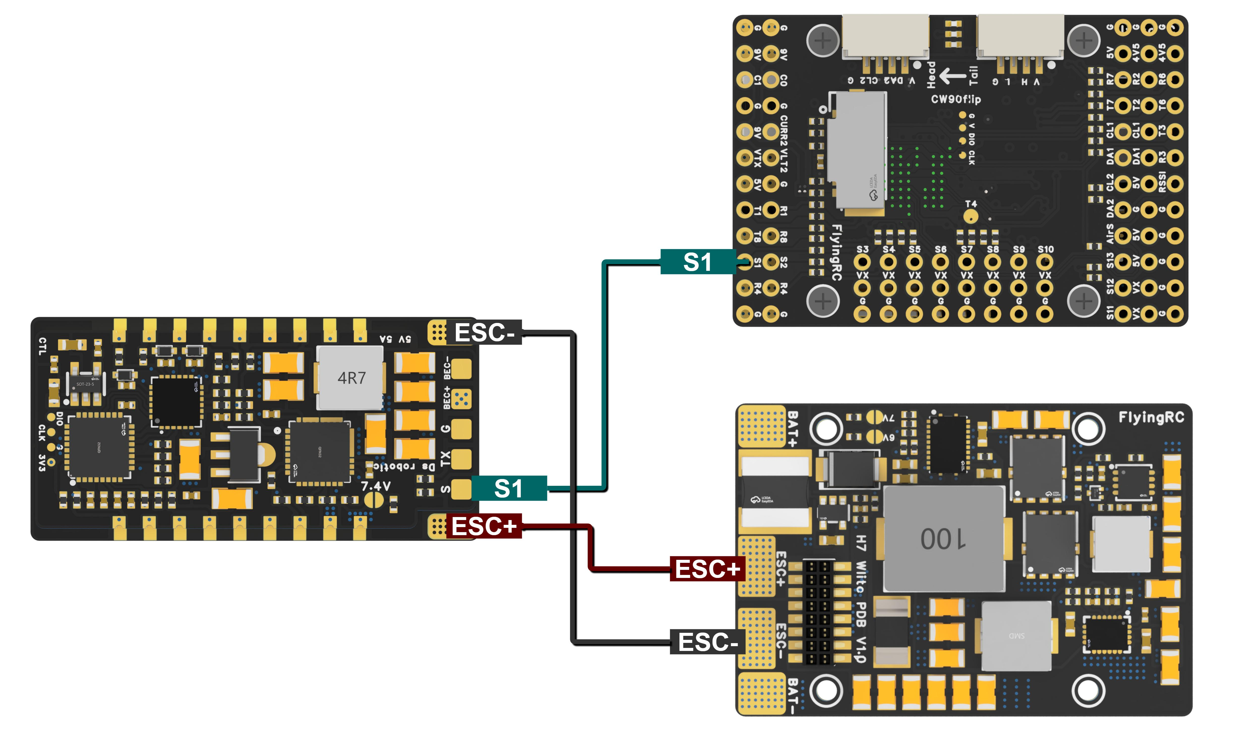
Wiring Diagram for Connection with FlyingRC® H7Wlite Flight Controller

FlyingRC® F4WSE PRO Flight Controller
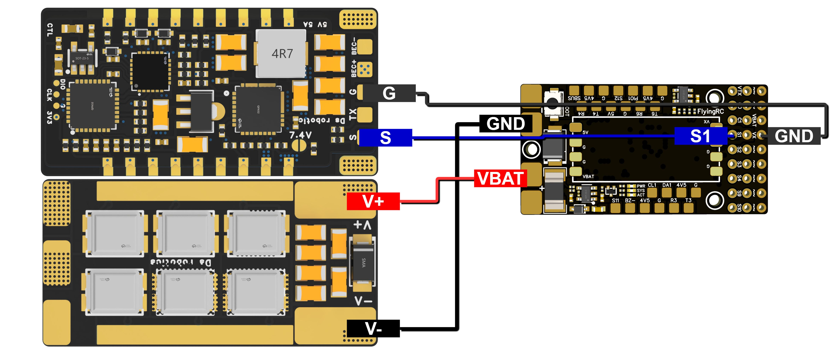
Wiring Diagram for Connection with FlyingRC® F4WSE PRO Flight Controller

FlyingRC® F4Wing Mini Flight Controller
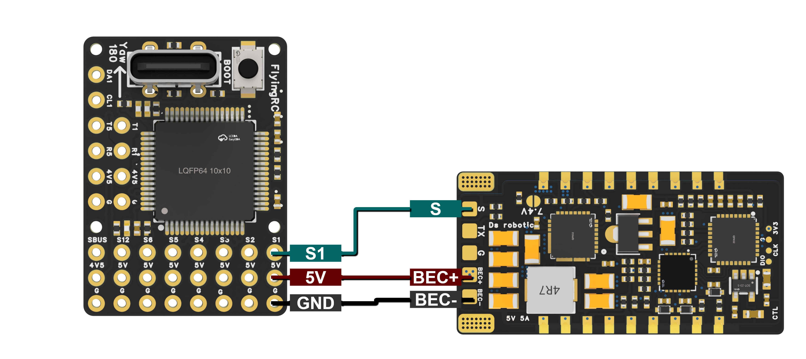
Wiring Diagram for Connection with FlyingRC® F4Wing Mini Flight Controller

FlyingRC® AM32 Parameter Programmer
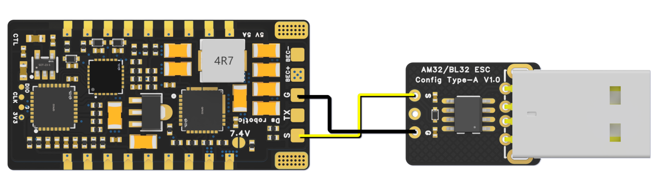

Wiring Diagram for Connection with FlyingRC® AM32 Parameter Programmer

Pre-use Preparation：
  - Attach Heat Sink (ESSENTIAL)

  - Prepare high‑quality thermal grease
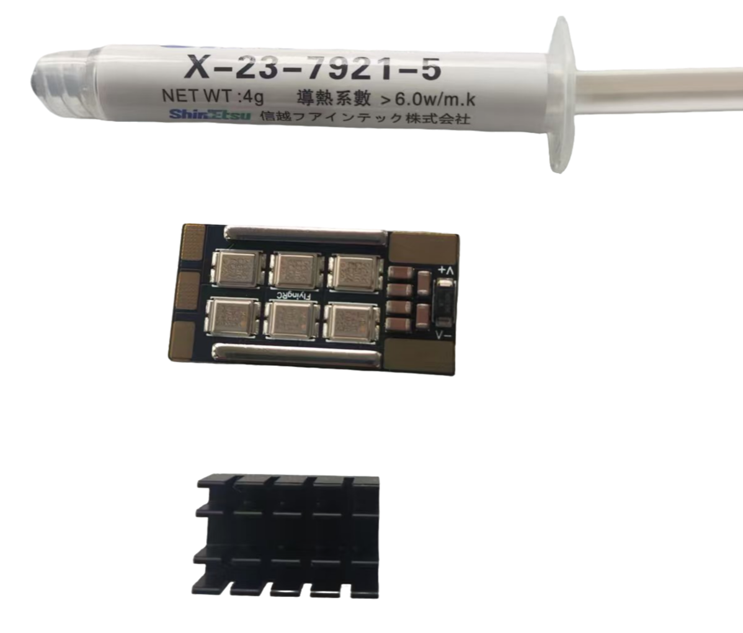

  - Apply an appropriate amount of thermal grease evenly to the six MOSFETs.
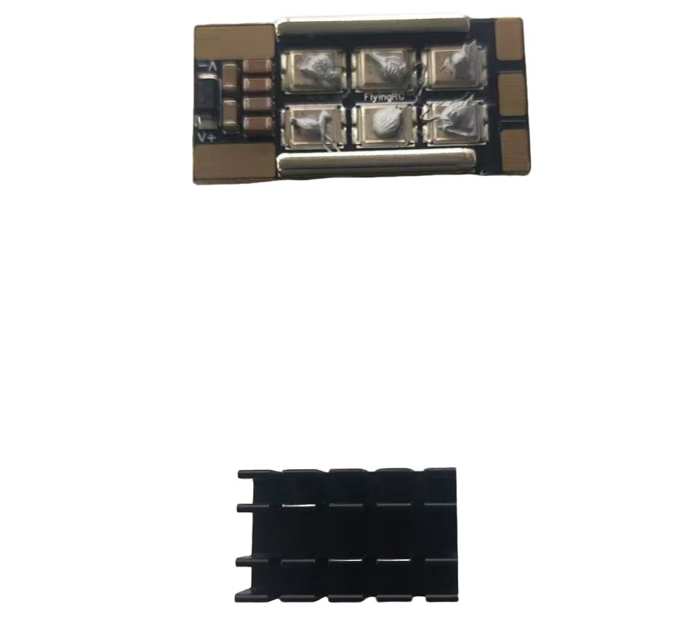

  - Press the heat sink onto the MOSFETs while sliding it slightly in all directions to ensure the thermal grease spreads evenly across the entire MOSFETs.
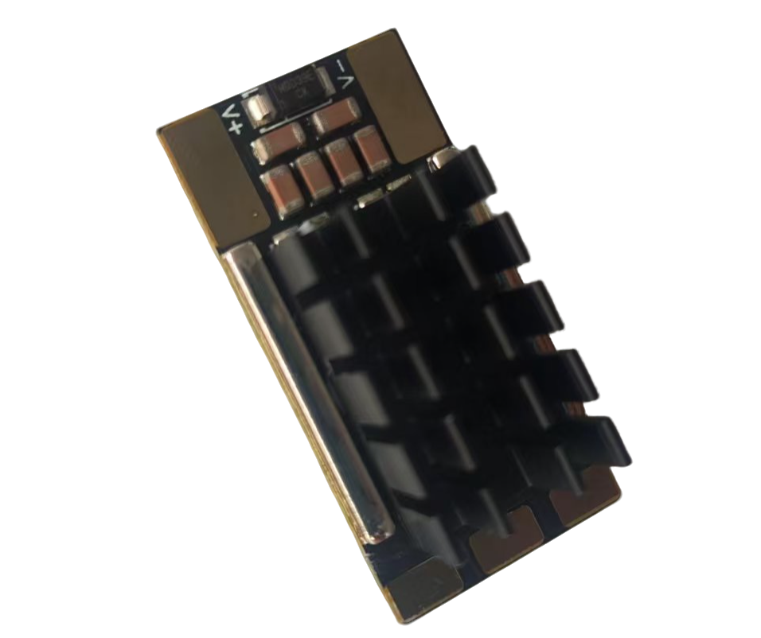

  - Prepare high‑quality thermal adhesive. For even application, a syringe is recommended to dispense the adhesive.
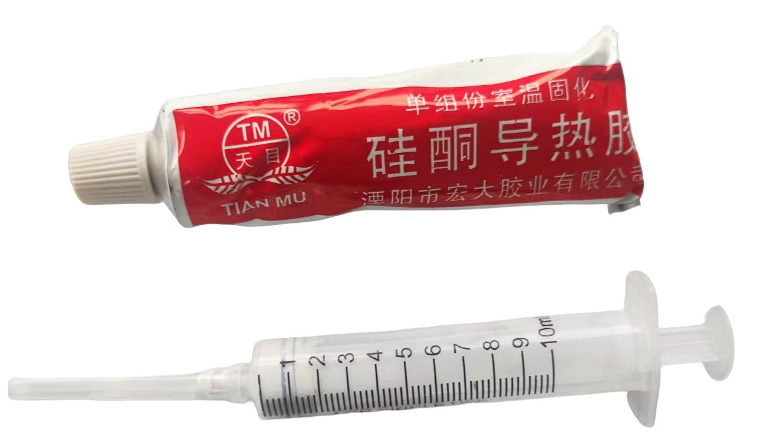
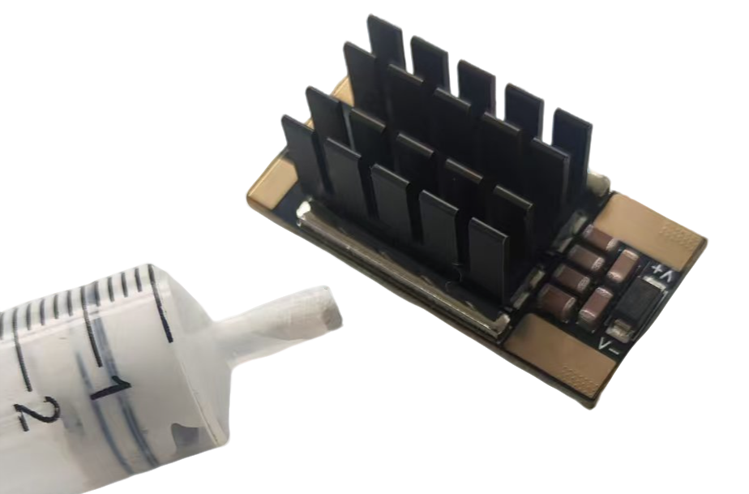
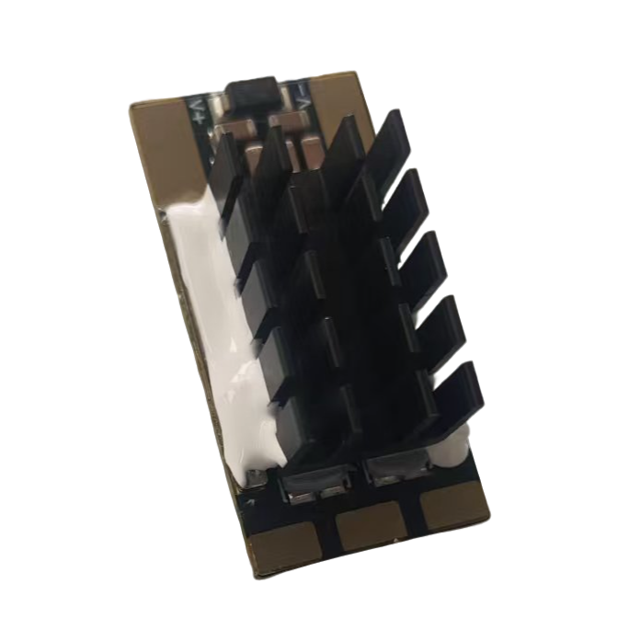
Reference image of properly installed heat sink.

  - Allow at least 2 hours for the adhesive to cure before operating the ESC. Curing time can be shortened using a hair dryer.

  - Tool and Consumable Preparation：
Digital soldering iron/soldering station (recommended T12 series or 936 series), solder wire (recommended 63% tin content), silicone wire (24–28AWG silicone wire for signal lines, 12–16AWG for power lines).

  - Welding capacitors to the ESC：
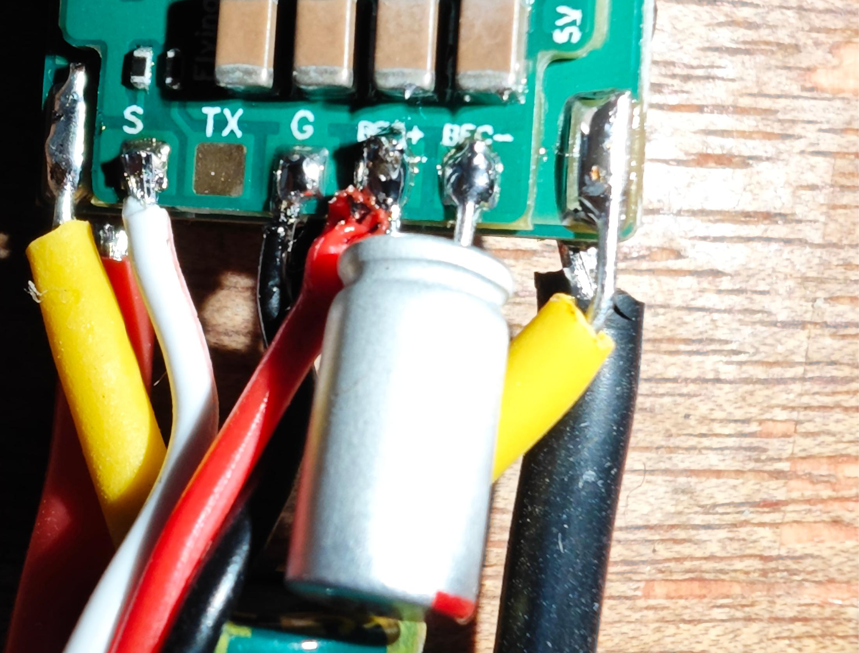

Weld the 10V 330uF solid-state capacitor included in the package to BEC+ and BEC-.

Note! Do not reverse the positive and negative poles of the capacitor (the red horizontal line on the capacitor top corresponds to the pin connected to BEC-).

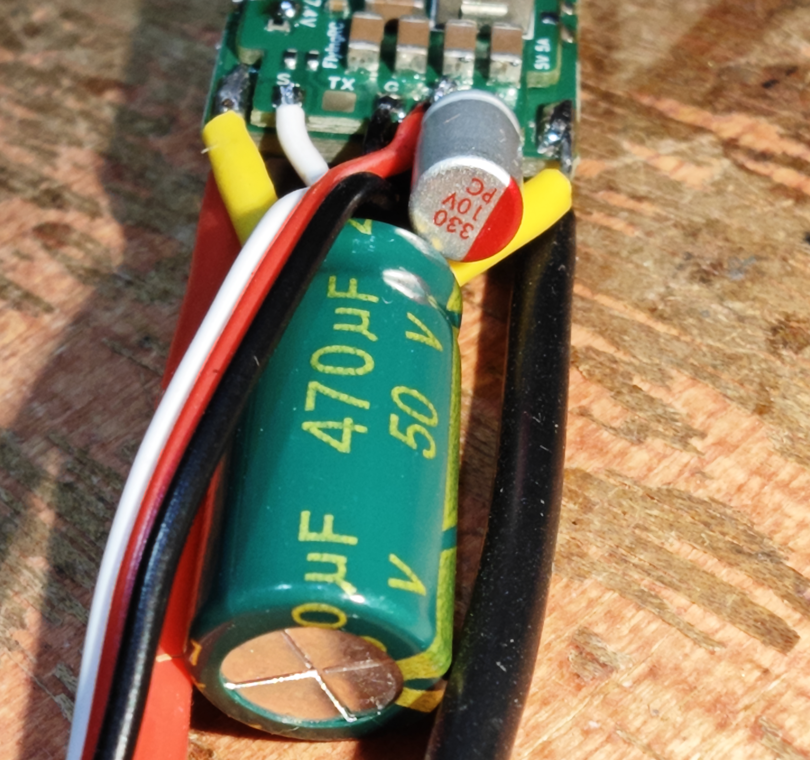

Weld the 50V 470uF solid-state capacitor included in the package to the two small solder pads on the reverse side of the power board.

Note! Do not misconnect the positive and negative poles of the capacitor (the yellow horizontal line on the capacitor casing corresponds to the pin connected to the negative solder pad).

  - Weld power lines and signal lines

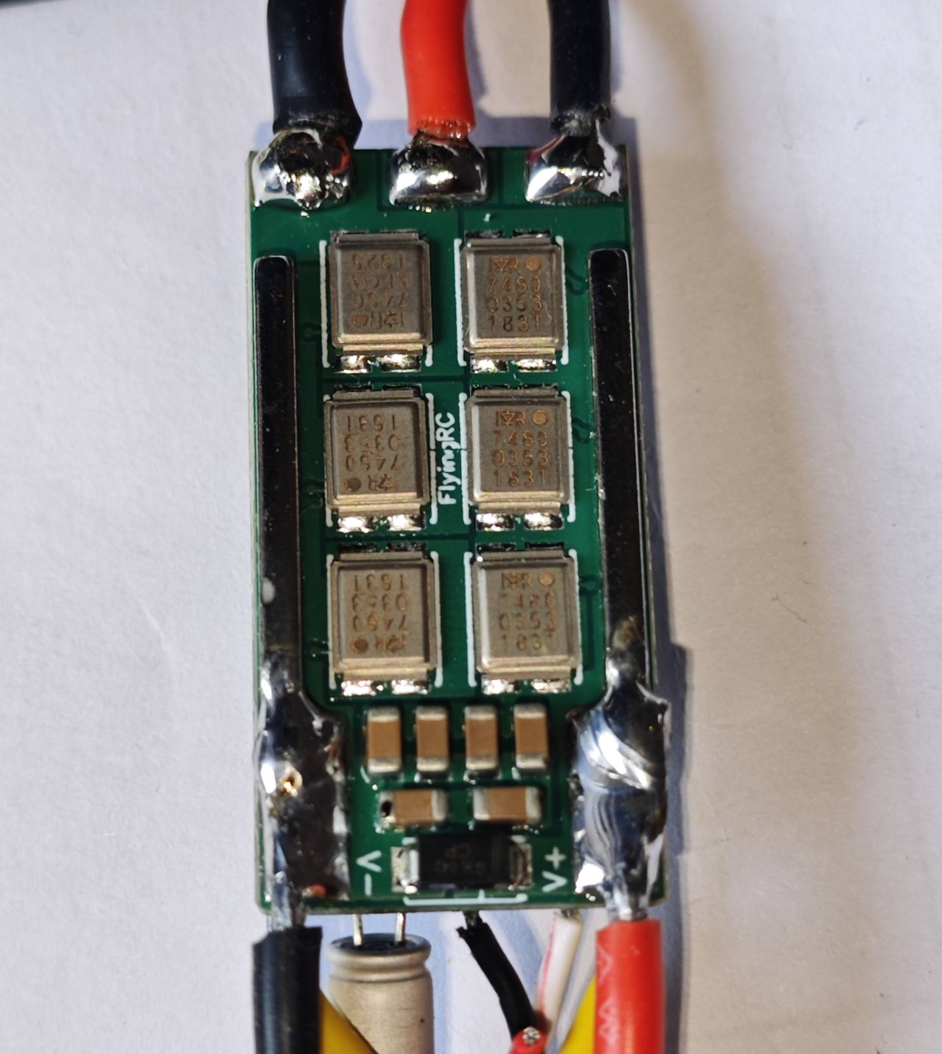

The lower black wire (negative) and red wire (positive) are connected to the power supply. The copper wire can be connected to the copper bar for better current-carrying performance.
The three upper wires are the three-phase lines of the motor, connected to the brushless motor.

Note! Ensure solder joints are full and free of short circuits with adjacent components!

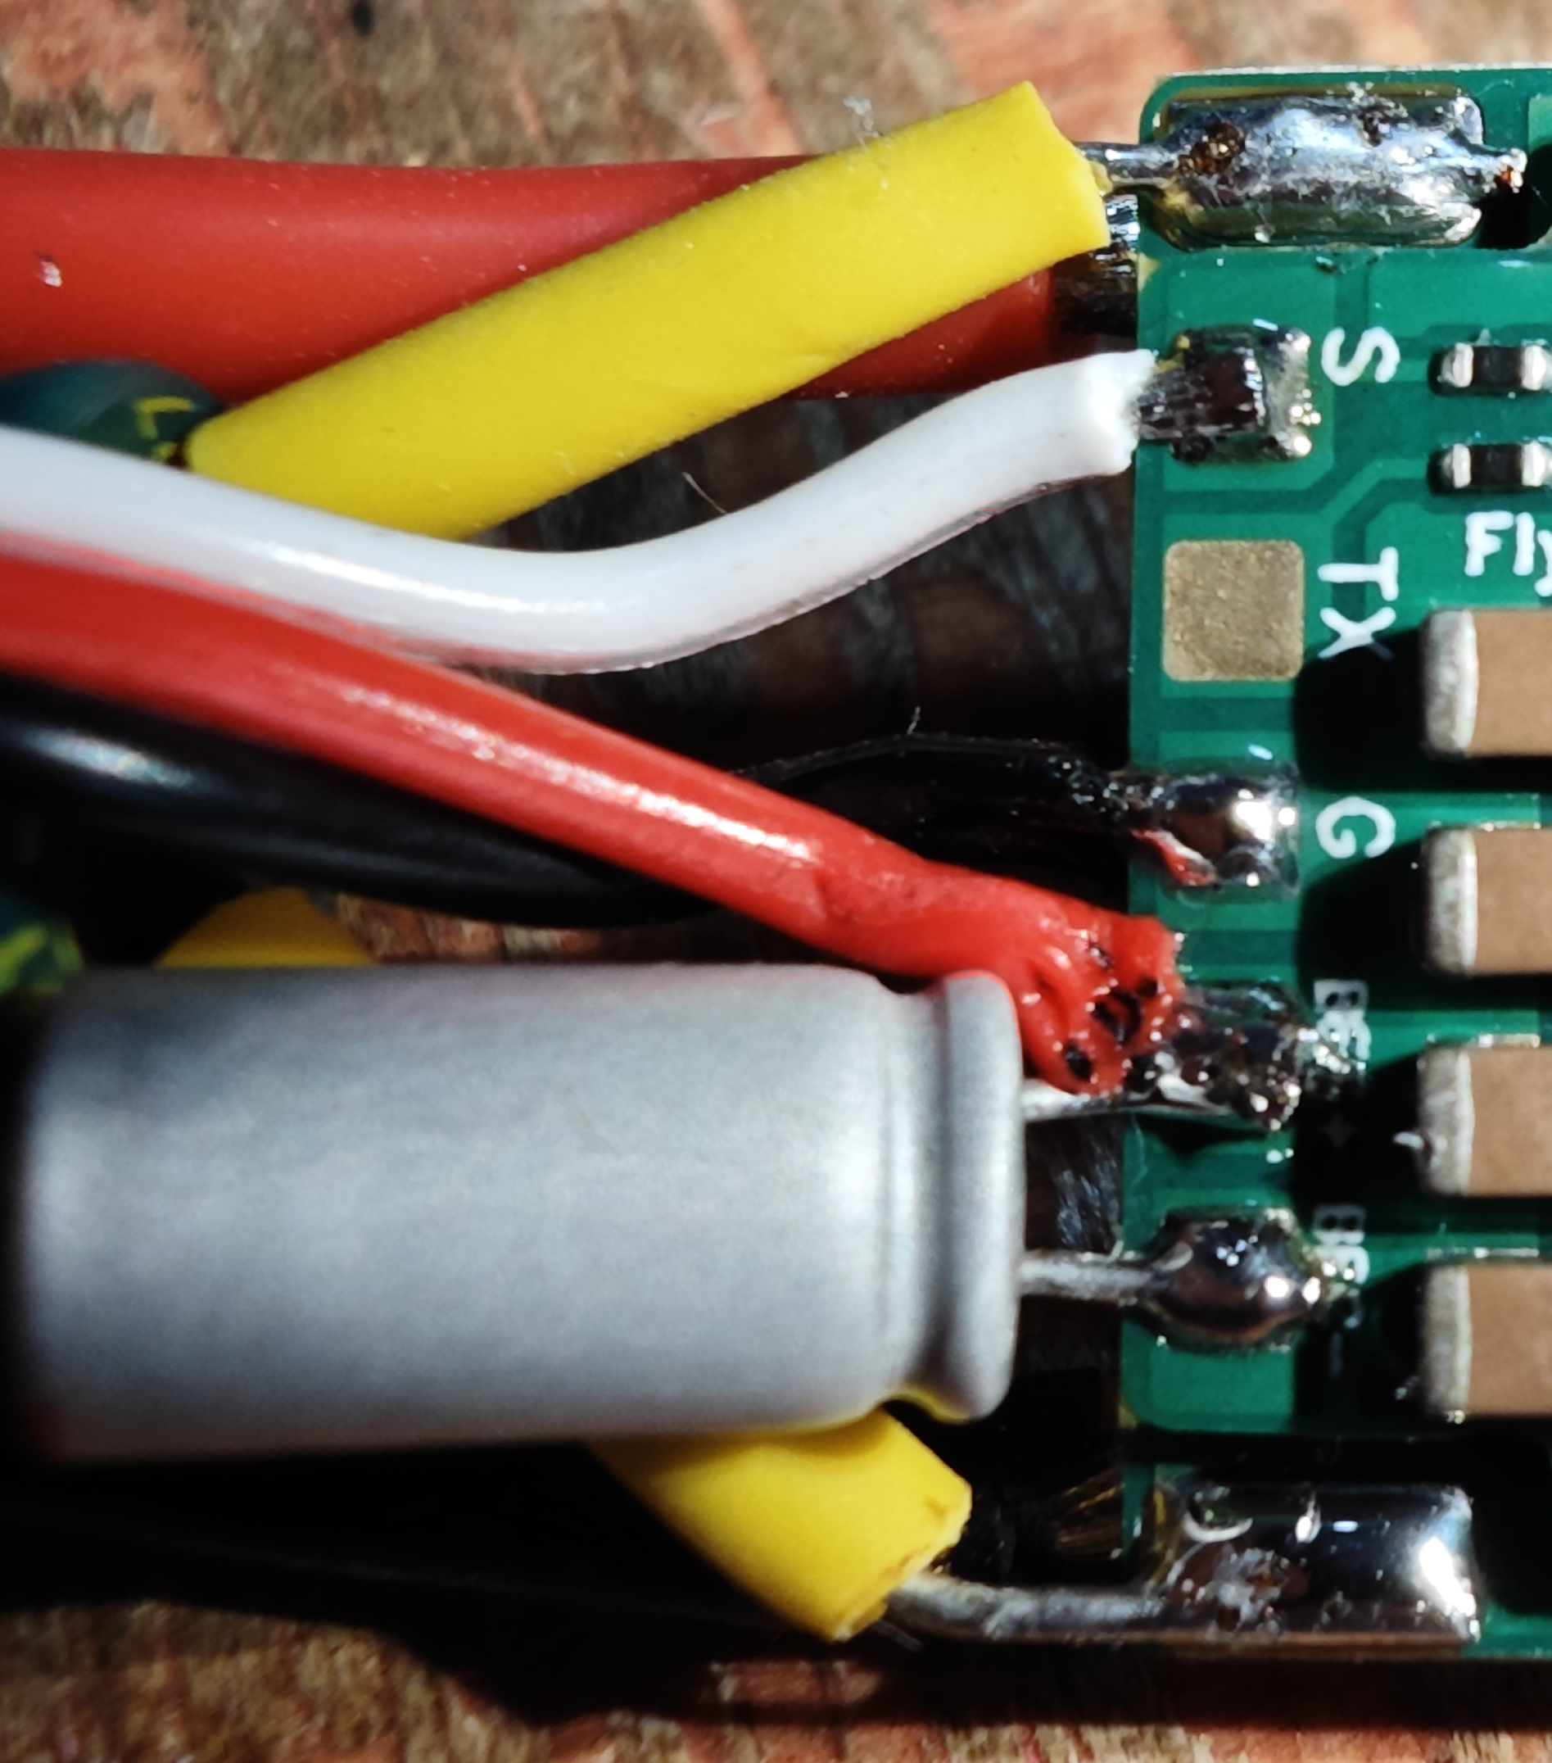
Wiring Diagram for the ESC with Onboard BEC
Note: White wire (signal line), black wire (negative pole), red wire (BEC output positive pole).

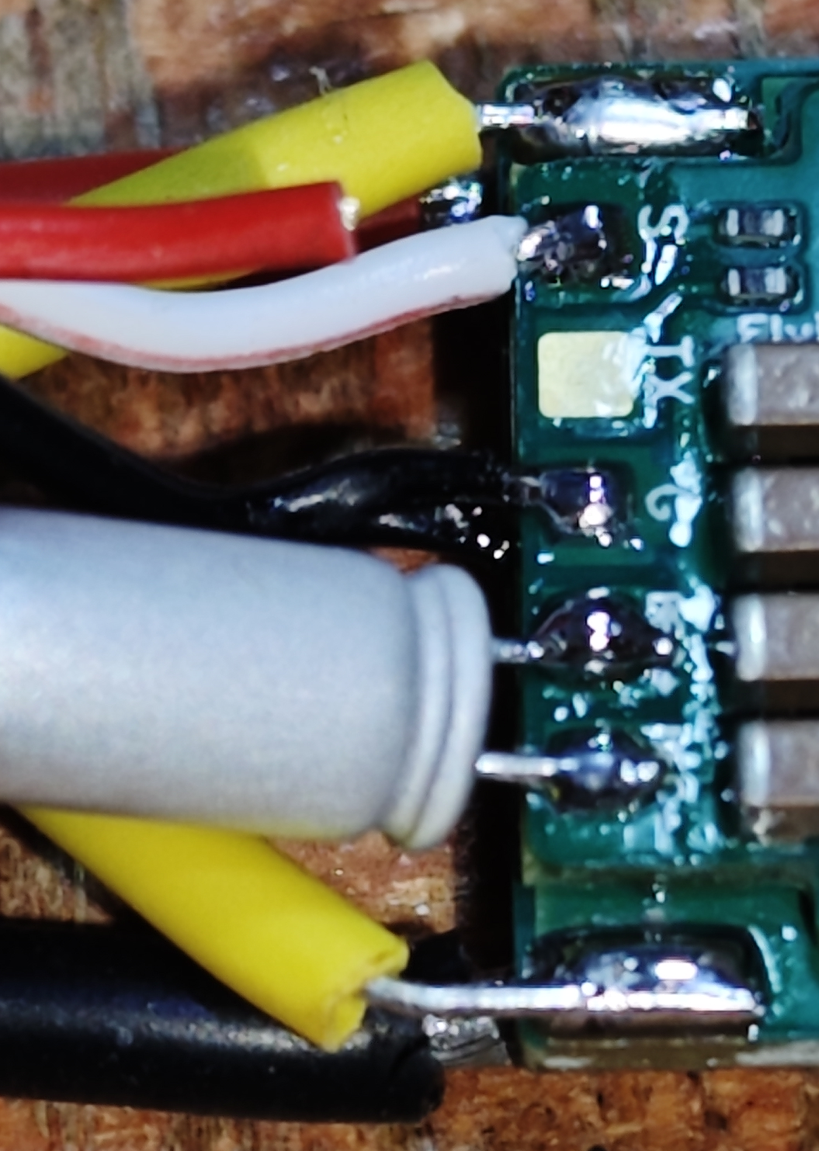
Wiring Diagram for the ESC Without Onboard BEC
Note: White wire (signal line), black wire (negative pole), red wire left unconnected.
(5)Firmware

The ESC comes pre‑flashed with AM32 V1.99 firmware at the factory with default parameters.

Some users report that AM32 V1.97 provides smoother performance for car applications; you may flash this version at your own discretion.
Latest Stable Firmware (as of 2023/08/18)：
AM32 V1.97 Tekko32F421
BootLoader：AT32F421 PB4，Note: Direct download may fail due to network issues; please download the entire code repository instead.
Latest Stable Firmware (as of 2025/10/11)：
AM32_TBS_6S_4IN1_F421_2.18
BootLoader：AM32_F421_BOOTLOADER_PB4_V15

Firmware Update Instructions
Close the Betaflight Configurator before using the ESC parameter tuning software to free up the flight controller port.
Propellers must be removed first. Power the ESC via a LiPo battery when tuning parameters or flashing firmware.
Download AM32-ESC-Tools from the group files, extract it locally, then double-click to run SerialPortConnector.exe.
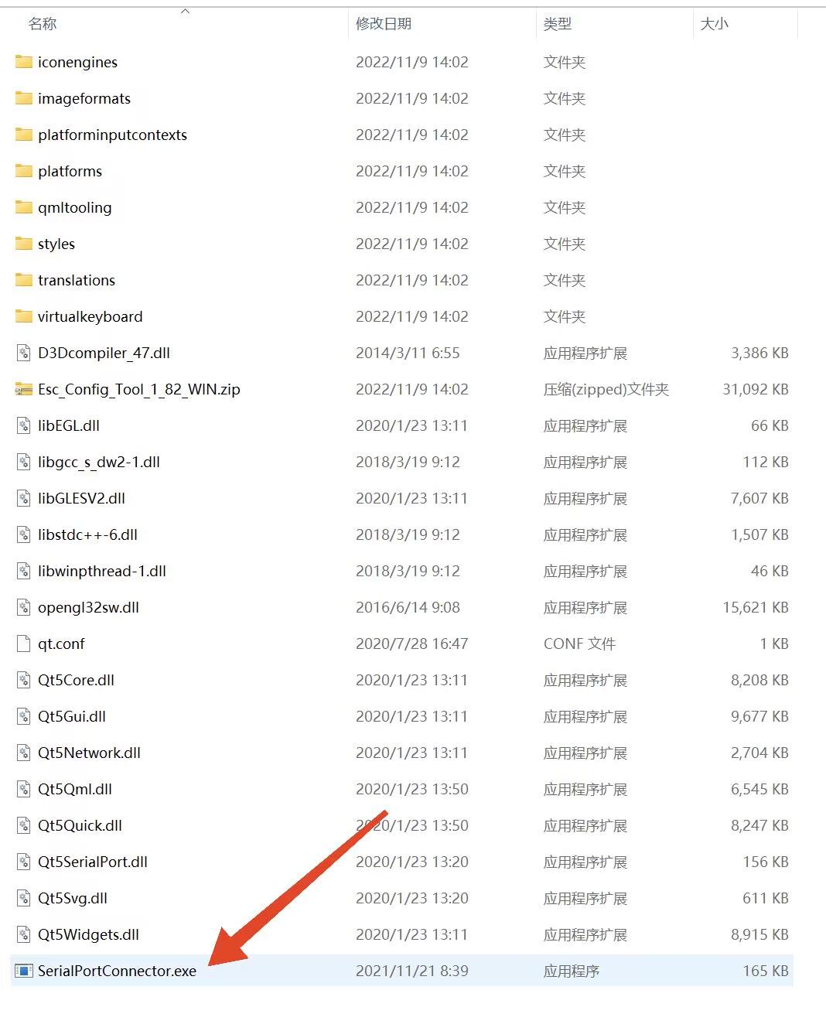
Locate the corresponding flight controller port number (COMx) in the bottom-right corner of the ESC parameter tuning software, then click Connect.
If no error message appears, the ESC tuning software has successfully connected to the flight controller.
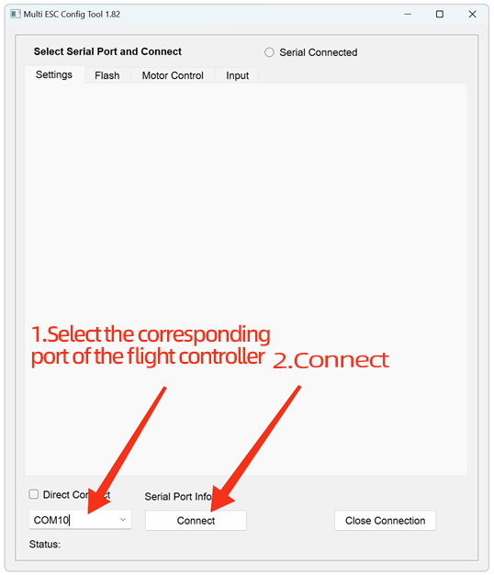
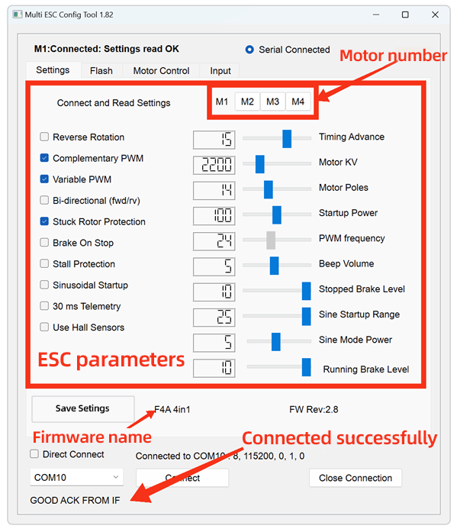
Before flashing the firmware, please download the latest ESC firmware in advance. The firmware can be obtained from github or the group file.

For the ESC parameter tuning software, navigate to the Flash page to proceed with firmware flashing.

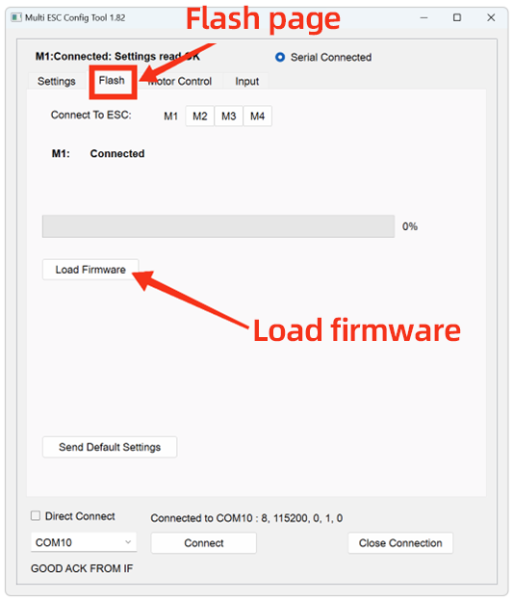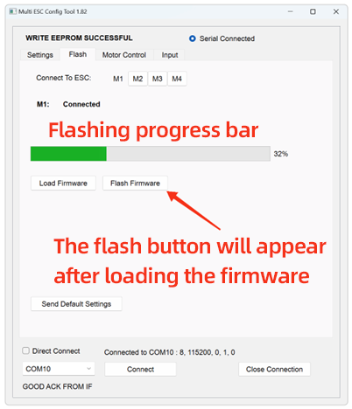
Click M1, then click “Load Firmware”.In the pop-up window, select the downloaded latest ESC firmware file and double-click to confirm. Click “Flash Firmware” and wait patiently for the progress bar to complete. Click “Send Default Settings” to restore the ESC to default parameters.*This step is strongly recommended when updating firmware across multiple versions.
Repeat the above steps for M2, M3 and M4.

FlyingRC® Factory Default Settings for RC Crawlers：
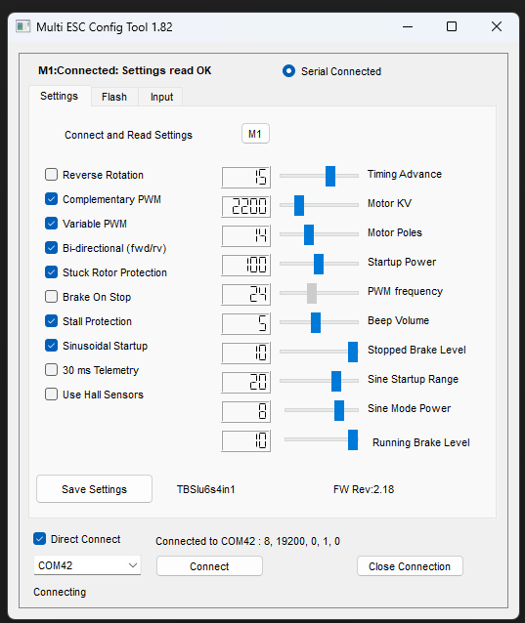
RC Crawler Parameters
WARNING!
Do NOT use the web-based parameter tuning software.
Updating firmware with it may damage the ESC MCU. Multiple such cases have been reported.
In this situation, the product will require paid factory repair.

Parameter settings： For the parameter tuning software and connection instructions, please refer to the "Firmware Update Instructions" section above.
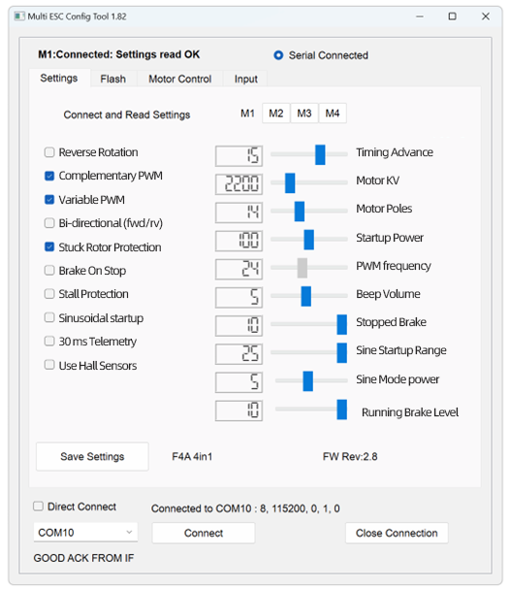
parameter setting page
Main Parameters：
KV Value: Must be set close to the motor’s rated KV rating. Deviation from the actual KV value shall not exceed 30%. If the KV value setting deviates by more than 100%, the motor may fail to operate normally, and the ESC hardware may even be damaged.
Advance Angle: Forbidden to adjust. Advanced users may optimize motor efficiency by adjusting the advance angle, but incorrect adjustment will damage the ESC, and such damage is usually irreparable.
Stall Protection: Can be enabled if using a low-KV motor (KV < 500), or must be enabled if using sine-wave startup.
Sine-Wave Startup: Not required for general FPV drones.
Notes：
1.All ESCs are pre-flashed with the latest official AM32 firmware and tested via multi-voltage rotation before shipment.
2.Offline paramteter tuning software is required for firmware flashing.
3.ESCs generate significant heat during operation. To ensure efficient heat dissipation, it is strictly prohibited to apply heat-shrink tubing or waterproof treatment, as such protective measures will impede heat exchange between the ESC and the environment. Damage caused by this will not be covered under warranty.
4.When the ESC’s operating environment parameters (e.g., temperature, humidity, air pressure, ventilation) deviate from rated conditions, the current-carrying capacity of its internal power devices will be limited, and the maximum continuous operating current will fall below the nominal value. Sufficient heat dissipation measures must be implemented to ensure stable and reliable operation.
5.Take care to prevent the ESC from contacting other conductors (carbon fiber plates, battery plugs, other circuit boards) during installation, as external short circuits may cause damage.

Other FlyingRC® Products

 |  |  |  | - FlyingRC® F4WSE Pro - F405 Fixed-Wing Flight Controller  Upgraded Version | Enhanced Performance  Manual：https://www.kdocs.cn/l/cavm9EoVEq5A |  |  | 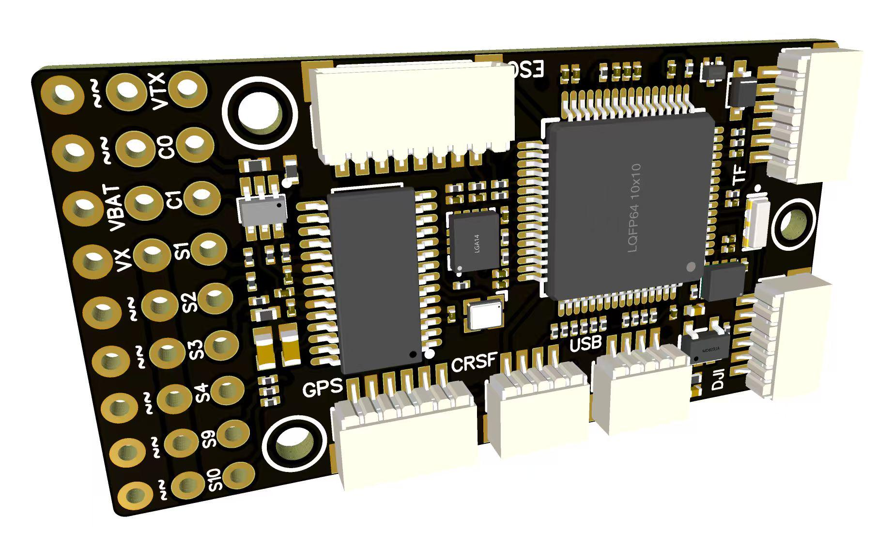
 |  |  | - FlyingRC® F4WSE MK1.5 - F405 Fixed-Wing Flight Controller  Classic model, unique design, highly acclaimed.  Manual：https://kdocs.cn/l/cpyd8MTS56DD |  |  | 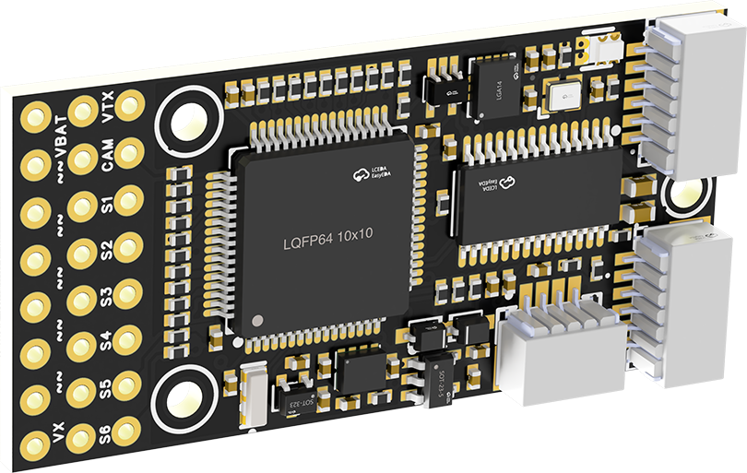
 |  |  |  | - FlyingRC® H7Wlite MK1 H743 Fixed-Wing Flight Controller  Flagship performance, full expansion, high-power BEC.  Manual：https://kdocs.cn/l/cpYaBiFKh8U1 |  |  | 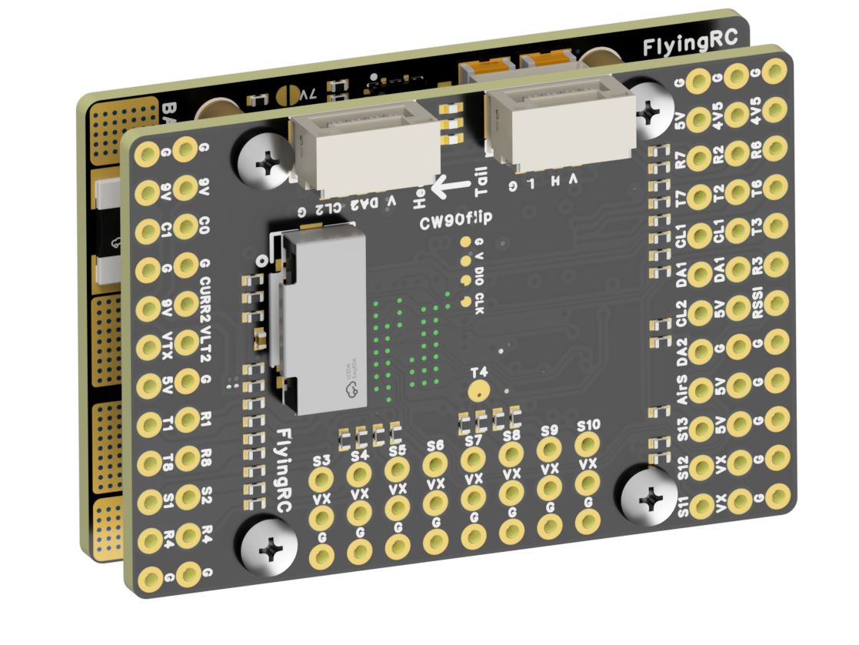
 |  |  |  | - FlyingRC® F4Wing Mini MK1 F405 Fixed-Wing Flight Controller  2025 bestseller, ultra-compact, smallest on the market, great value.  Manual：https://kdocs.cn/l/cdUIdmpSpW7J |  |  | 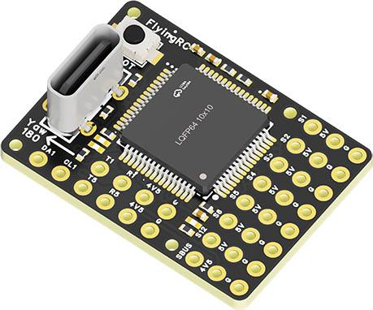
 | - FlyingRC® AM32 Dual ESC 40A 2-in-1 ESC  Unique design for dual-power aerial, land and water vehicles including drones.  Manual：https://www.kdocs.cn/l/cjwNtsKK6HeR |  |  |  | 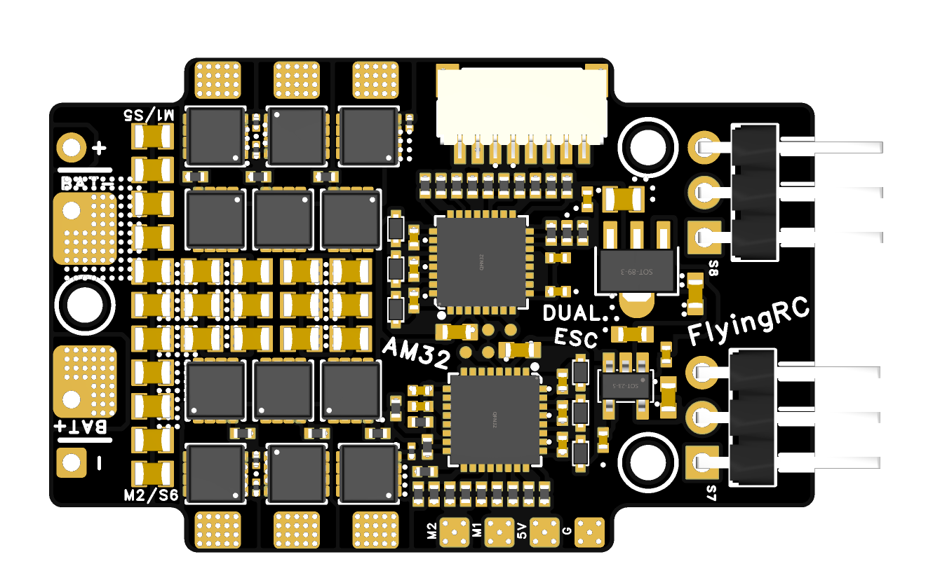
 |  |  | - FlyingRC® AM32 ESC V2.5 75A - Single ESC  Infineon gold-package MOSFETs, premium materials, superior heat dissipation.  Manual：https://kdocs.cn/l/cv6hUy67IdTJ |  |  |  | 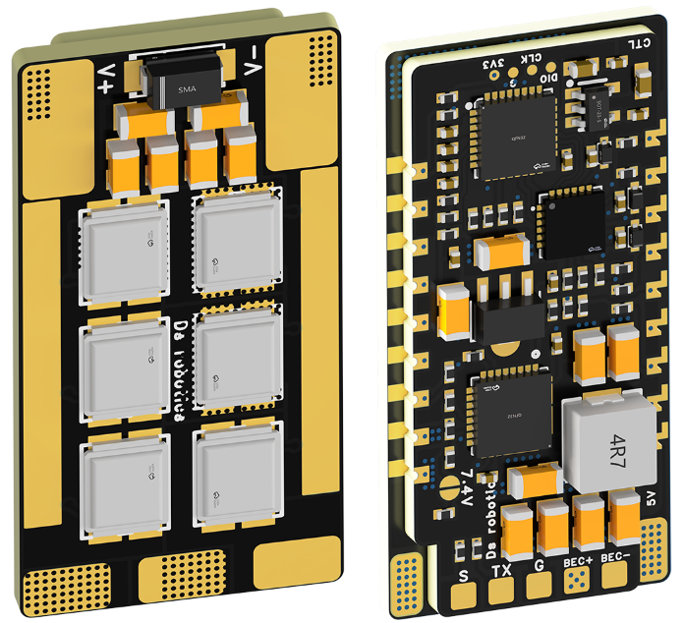
 |  |  | - FlyingRC® AM32 Mini ESC 40A V1.0 - Single ESC  Ultra-miniature, ideal for micro drones, high over-current capability, stable operation.  Manual：https://kdocs.cn/l/cqdLSysEyWFh |  |  |  |  | 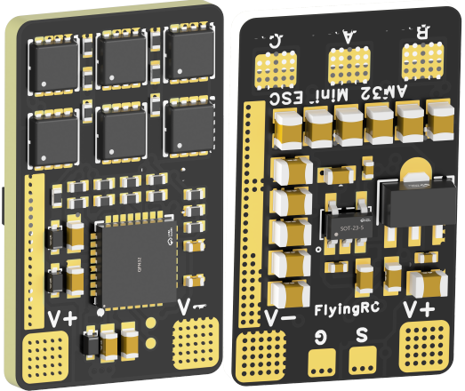
 |  |  | - FlyingRC® 10A 12S 440A Power Distribution Board for FPV Drones  Industry top choice, excellent quality and affordable price.  Manual：https://kdocs.cn/l/coel7OgrlCBP |  |  |  |  | 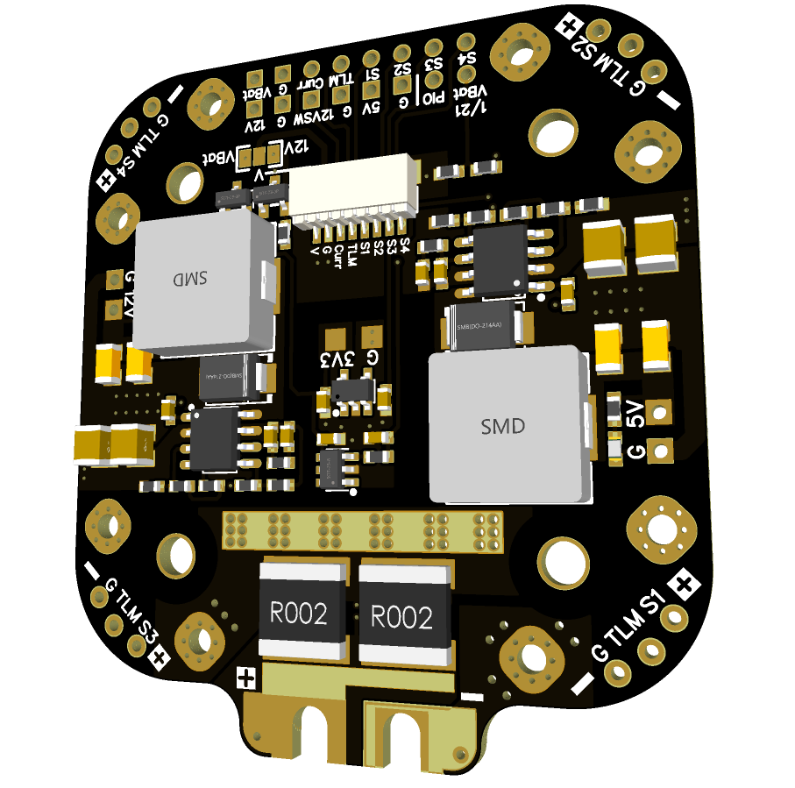
 |  |  | - FlyingRC® H7D Pro MK1 H743 FPV Flight Controller with Dual Gyro  Fully Upgraded & More Powerful  Manual：https://www.kdocs.cn/l/ctcekCy676Ez |  |  |  | 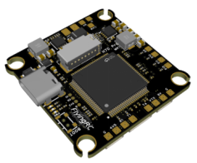
 |  |  | - FlyingRC® H7D MK1 H743 FPV Flight Controller with Dual Gyro  Powerful computing, stable and precise flight, rich interfaces, smooth control.  Manual：https://kdocs.cn/l/cqMh1I0RwAoD |  |  |  | 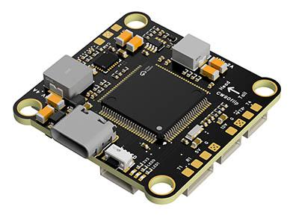
 |  |  | - FlyingRC® F420 MK1 F405 FPV Flight Controller (20/30.5mm Mounting)  Dual mounting holes, all connectors, no soldering required, compliant with Betaflight interface standards.  Manual：https://kdocs.cn/l/ctGeLiN9ZYKj |  |  |  | 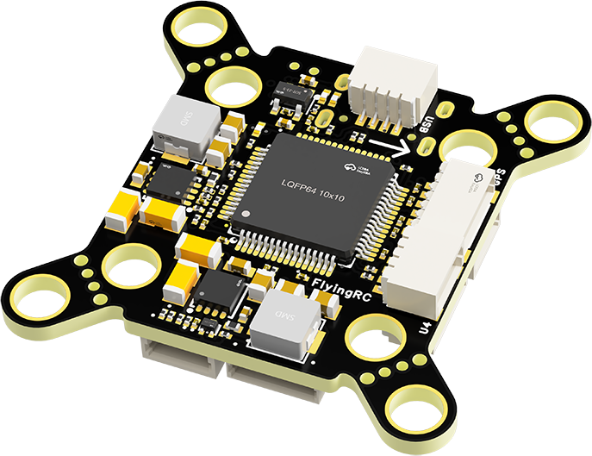
 |  | - FlyingRC® 4-in-1 75A V3.2 Gold-Sealed FPV ESC  Infineon gold-package MOSFETs, superior heat dissipation & over-current capability, premium choice.  Manual：https://kdocs.cn/l/ceLilc8Gaa21 |  |  |  |  | 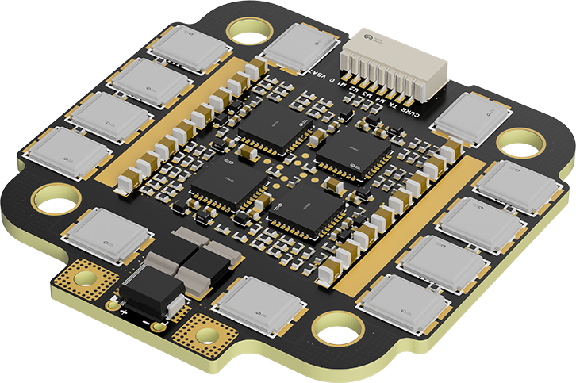
- FlyingRC® Stack Combo: H743 Flight Controller + 4-in-1 75A Gold-Sealed ESC  Professional flight choice, flagship materials & craftsmanship, reasonable price.  Manual：https://www.kdocs.cn/l/ctcekCy676Ez  https://kdocs.cn/l/ceLilc8Gaa21 |  |  |  |  |  |  | 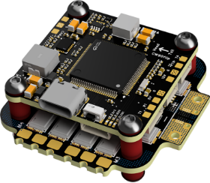
 |  | - FlyingRC® Stack Combo: F405 Flight Controller + 4-in-1 75A Gold-Sealed ESC  Best-selling combo, excellent performance, affordable price.  Manual：https://kdocs.cn/l/ctGeLiN9ZYKj  https://kdocs.cn/l/ceLilc8Gaa21 |  |  |  |  | 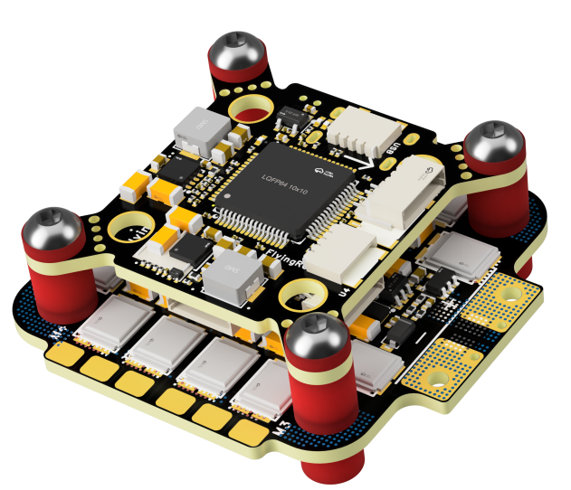
 |  | - FlyingRC® Stack Combo: H743 Flight Controller + 4-in-1 45A ESC  Winning combo: great performance, budget-friendly price  Manual：https://www.kdocs.cn/l/ctcekCy676Ez  https://kdocs.cn/l/ceLilc8Gaa21 |  |  |  |  | 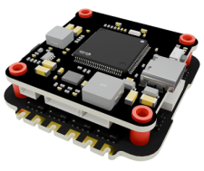
 |  | - FlyingRC® Stack Combo: F405 Flight Controller + 4-in-1 45A ESC  Hit combo, great value, budget-friendly  Manual：https://kdocs.cn/l/ctGeLiN9ZYKj  https://kdocs.cn/l/ceLilc8Gaa21 |  |  |  |  | 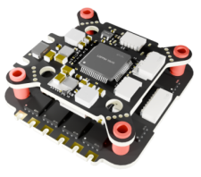
 |  | - FlyingRC® Stack Combo: F4WSE Pro - F405 Fixed-Wing Flight Controller + AM32 Dual ESC 40A 2-in-1 ESC  Unique Design • Exclusive Offer • Bestselling Bundle  Manual：https://www.kdocs.cn/l/cavm9EoVEq5A  https://www.kdocs.cn/l/cjwNtsKK6HeR |  |  |  |  | 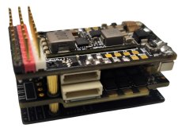
 | - FlyingRC® ELRS 2.4G Diversity Receiver  True diversity reception, temperature compensation, high-sensitivity reception.  Manual：https://kdocs.cn/l/cbvlOlShmsPS |  |  |  |  |  | 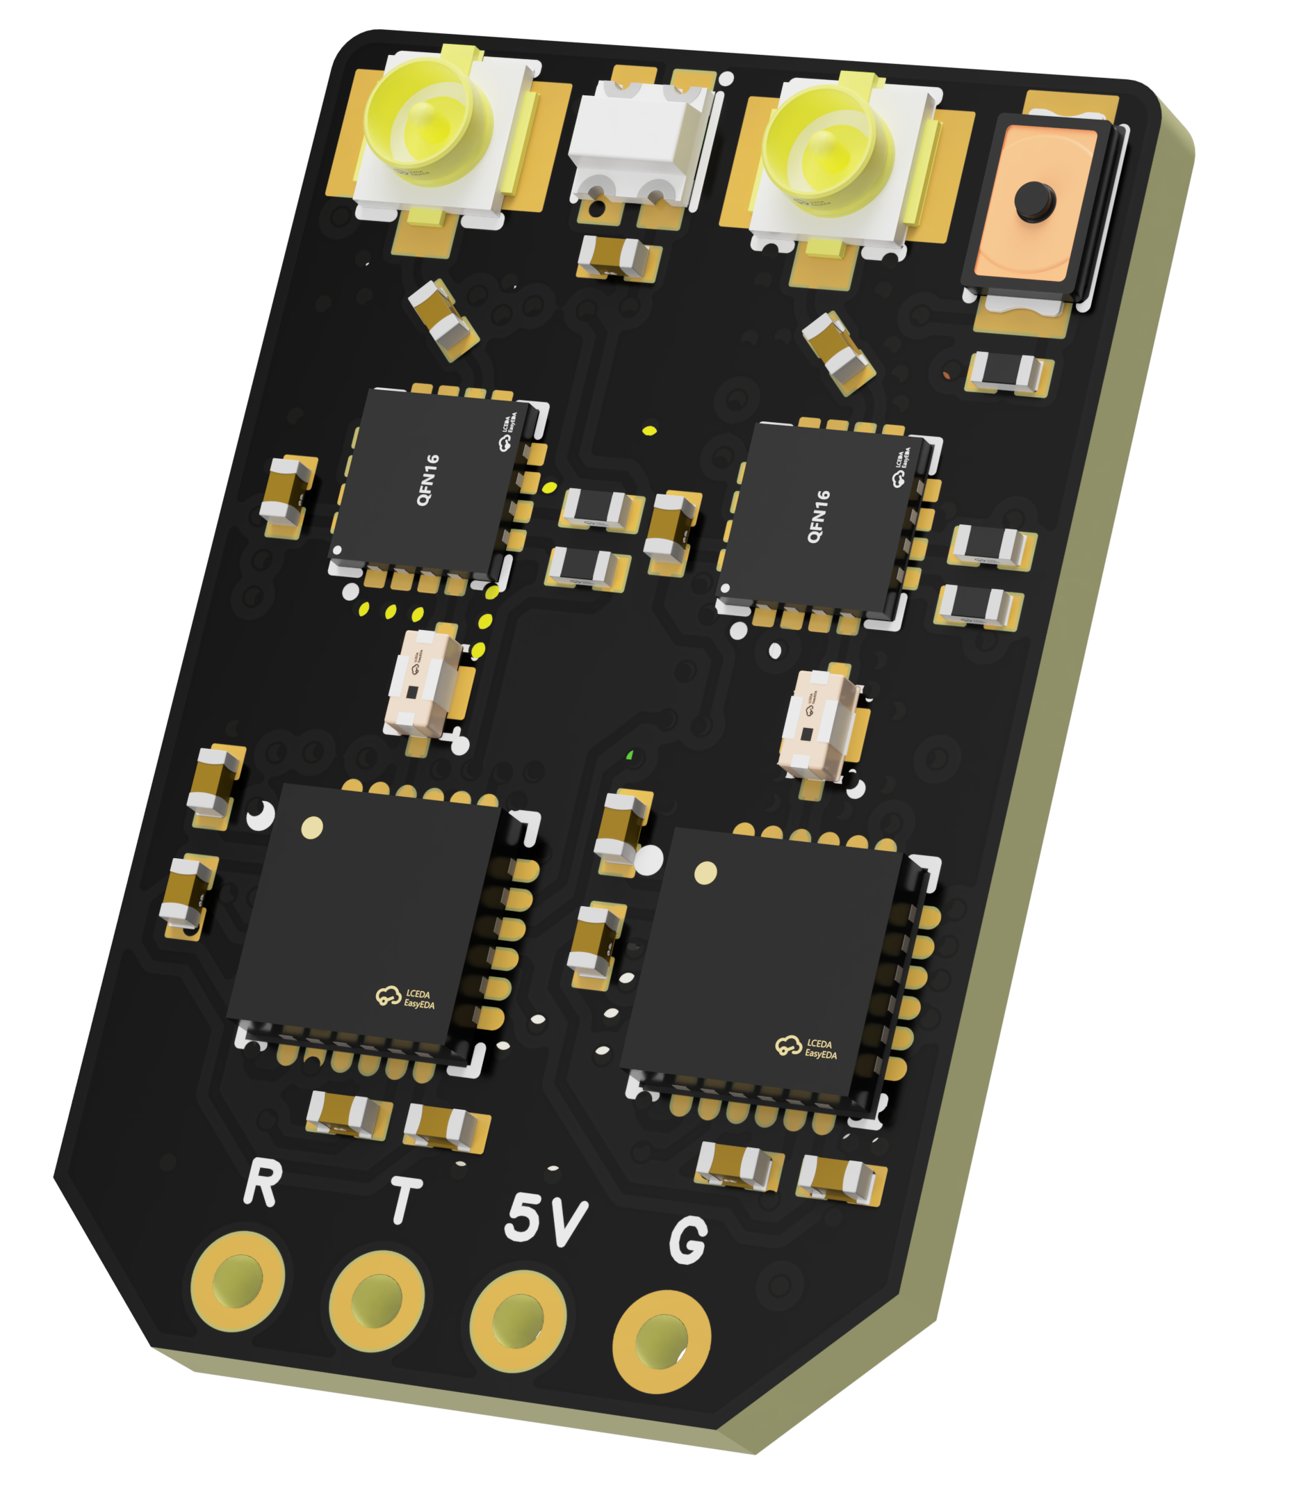
 | - FlyingRC® RM3100 SPI Module 罗盘模块  Ultra-high Resolution • Low Power • Industry Top Choice  Manual：https://www.kdocs.cn/l/cdGuHvBVyndC |  |  |  |  |  | 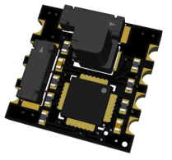
 | - FlyingRC® 10A 12S BEC Step-Down Module  Wide voltage input, high power, compact size, multiple voltages available, 10A continuous output.  Manual：https://kdocs.cn/l/clssNCKgNhLV |  |  |  |  |  | 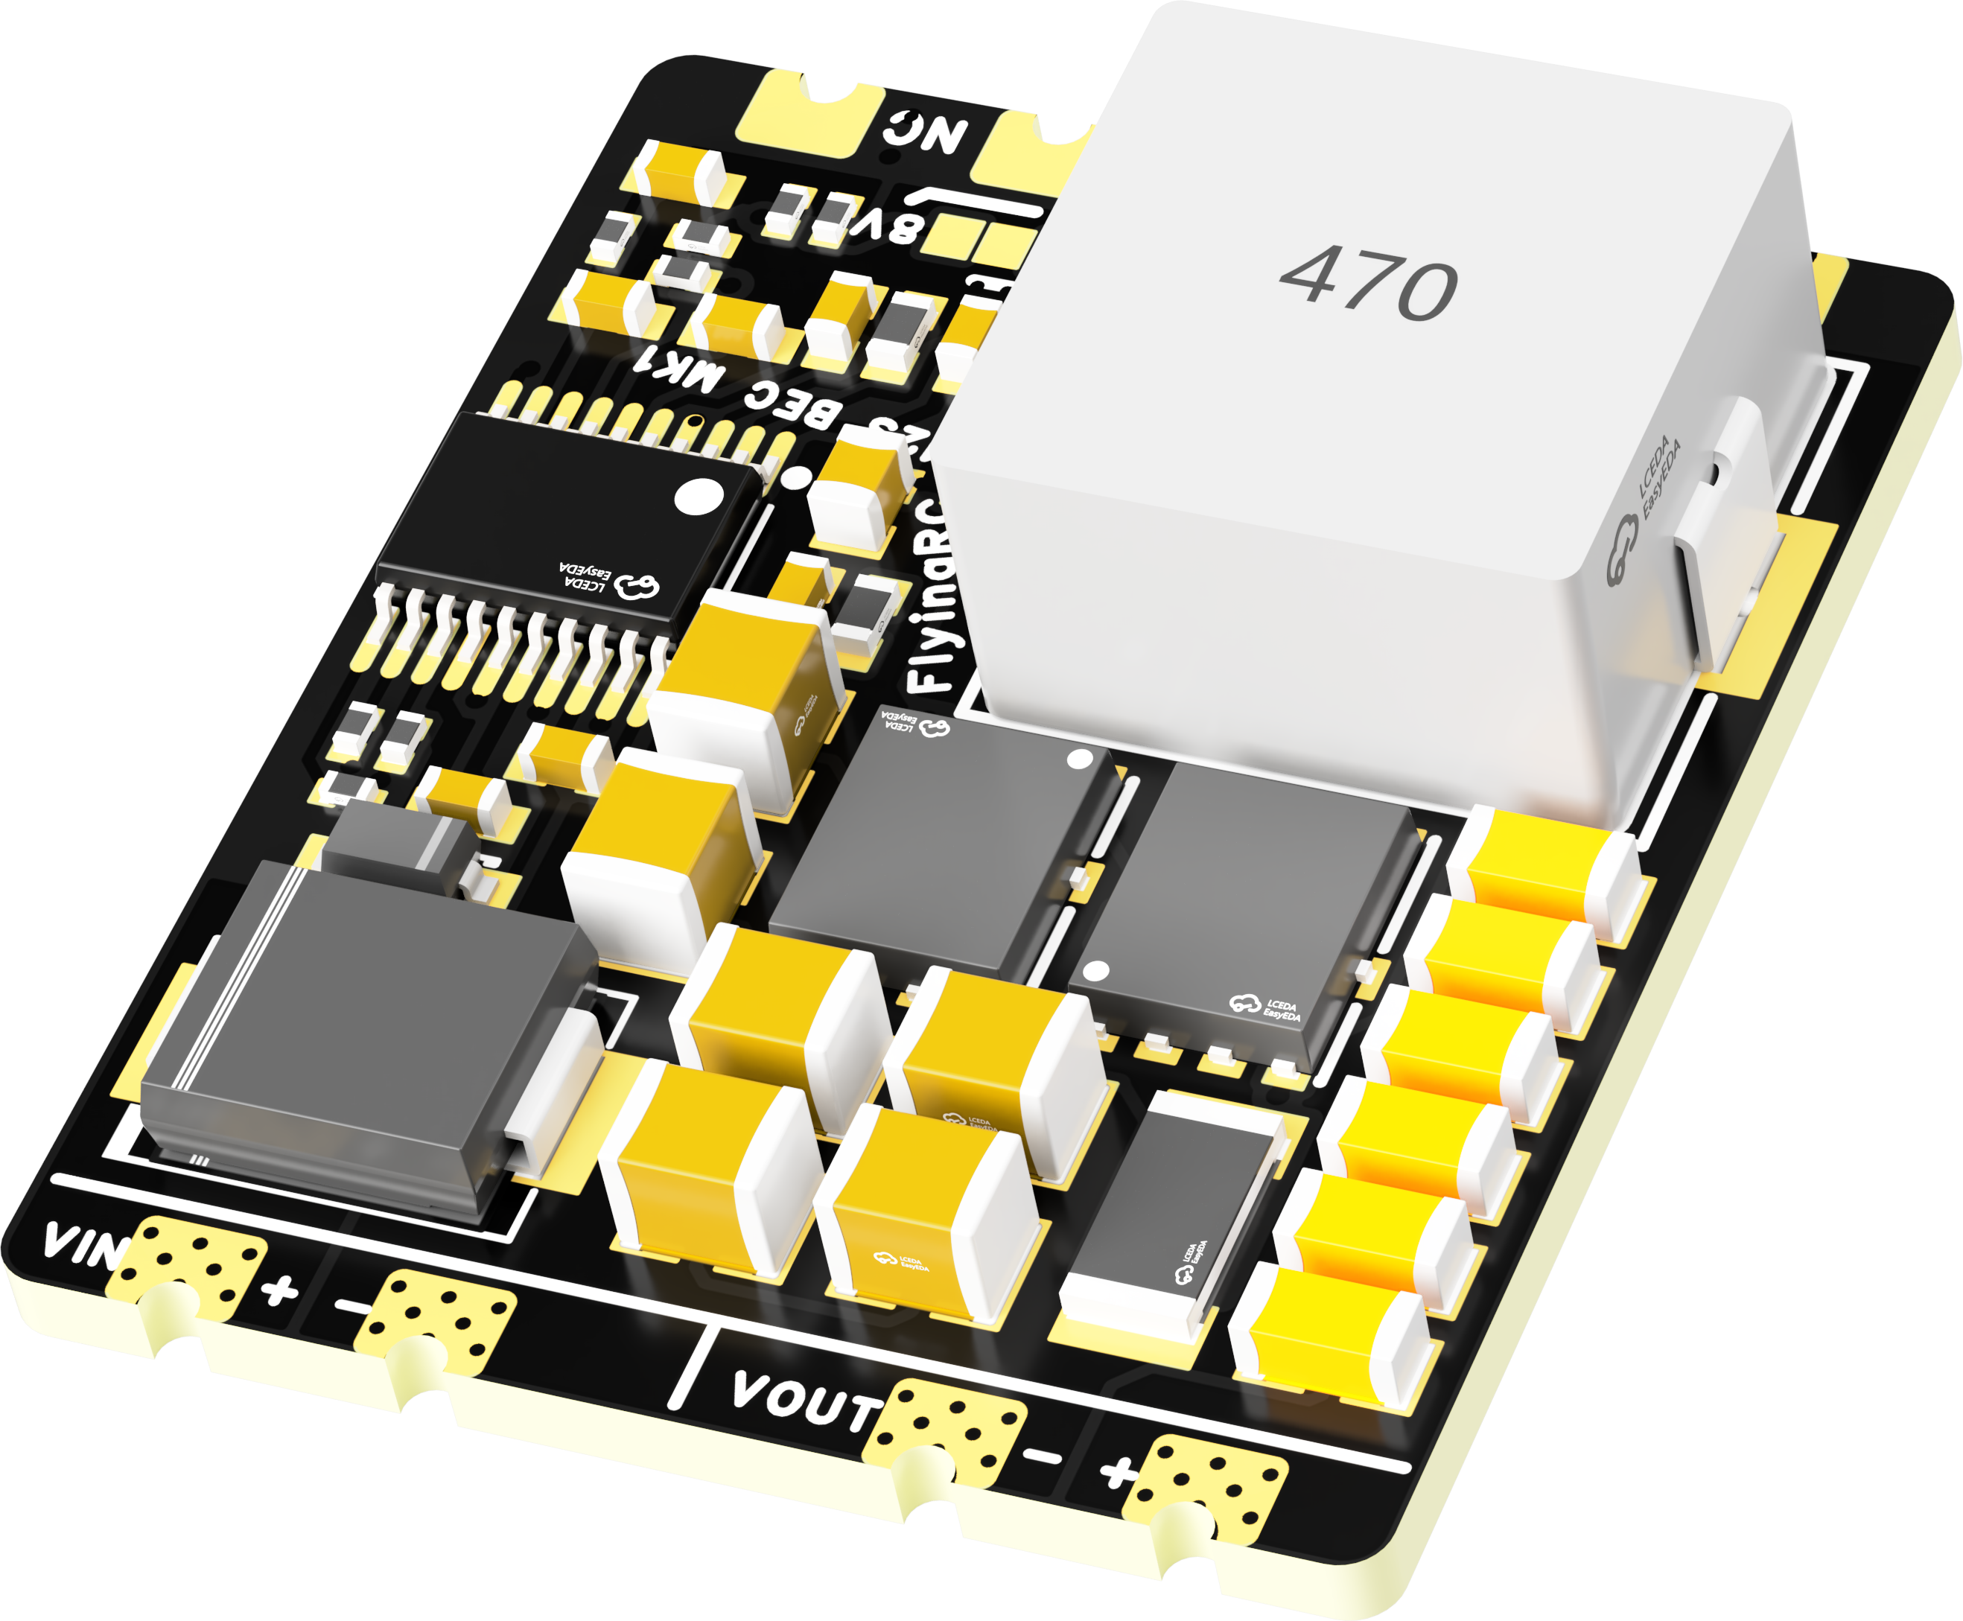
 | FlyingRC® 5A BEC Step-Down Module  Ultra-small size, multiple voltages available, 5A continuous output.  Manual：https://kdocs.cn/l/cb9VdNywqCKA |  |  |  |  |  | 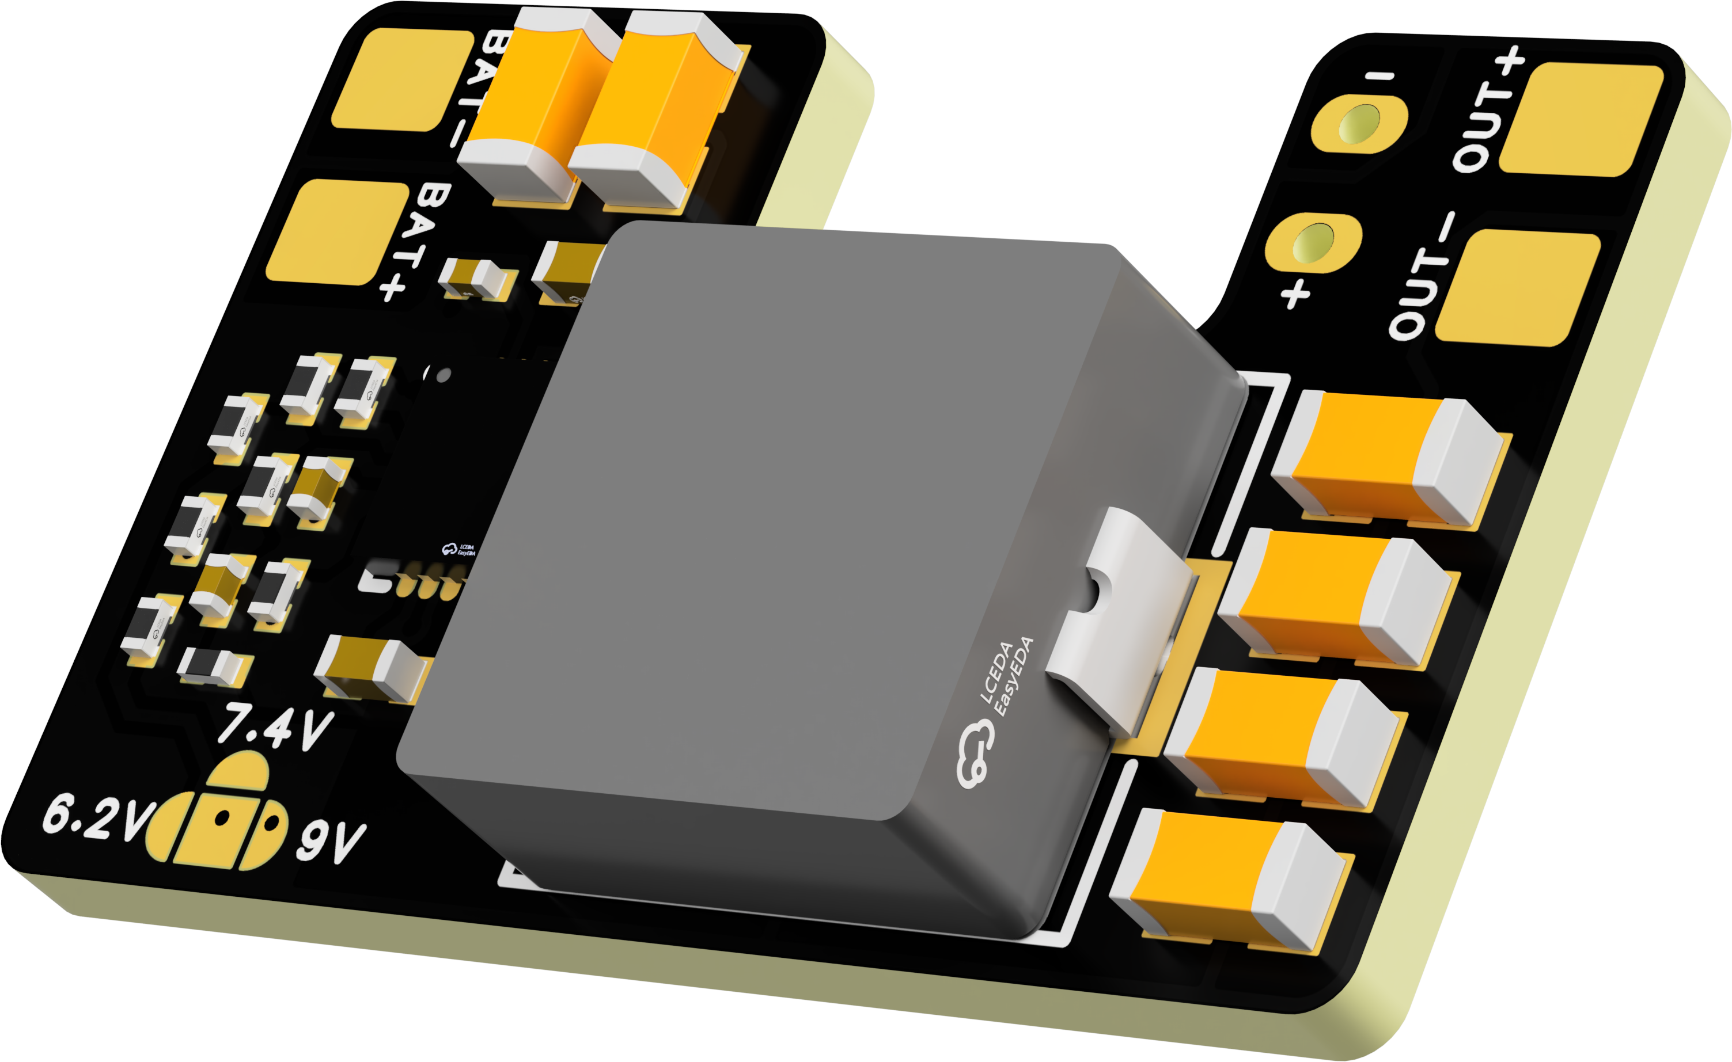
 | FlyingRC® Mini BEC For DJI O4  Easy wiring, ultra-small size, stable power supply.  Manual：https://www.kdocs.cn/l/ckkebieur37K |  |  |  |  |  | 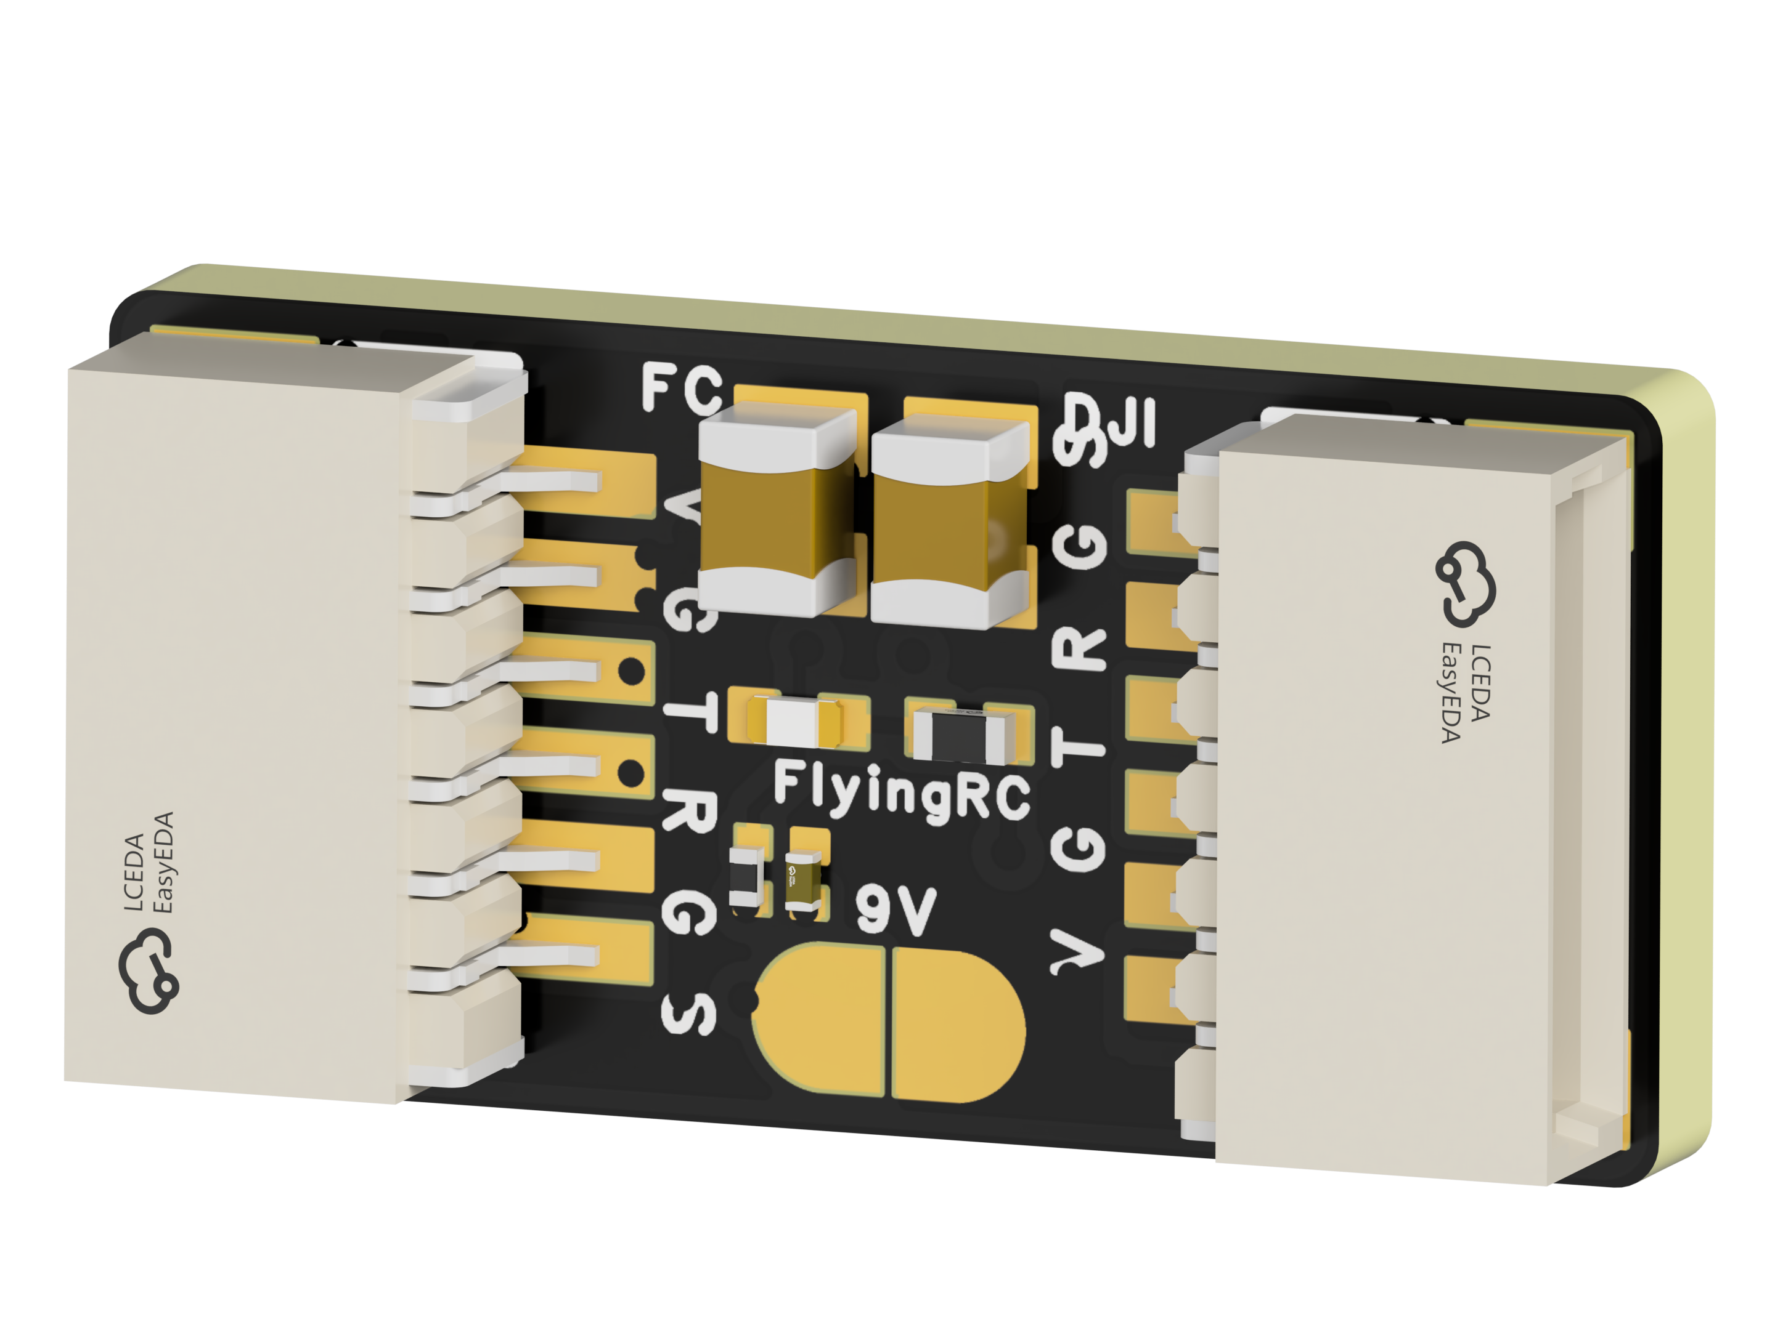
 | FlyingRC® CAN Bus Serial & PWM Expansion Board  Long-distance transmission, high speed, excellent stability.  Manual：https://www.kdocs.cn/l/cmxRyBnU4BXj |  |  |  |  |  | 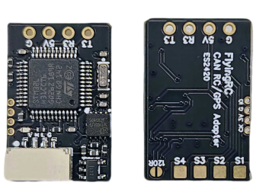
 | FlyingRC® AM3 2ESC Programmer  Supports BL, BL32, AM32. Simple and easy to use.  Manual：https://kdocs.cn/l/cogBSEBe67mE |  |  |  |  |  | 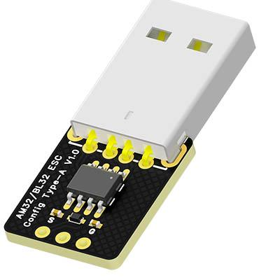
 | FlyingRC® Digital Airspeed Sensor without Pitot Tube  Integrated design, smallest on the market. MS4525D protocol, I2C interface.  Manual：https://www.kdocs.cn/l/clPvEEEcJgCC |  |  |  |  |  | 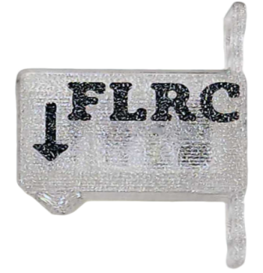
 | FlyingRC® U-Blox M10 GPS  Compatible with all open-source flight controllers.  Manual：https://www.kdocs.cn/l/cdSYQrzx74O8 |  |  |  |  |  | 