FlyingRC® Mini 40A Single ESC V1.0 Product Manual
FlyingRC® is a globally-oriented professional brand of electronic devices. We specialize in the R&D and sales of drone electronics, core robot circuits and sensors. Our design team is based in Singapore, and our products are sold worldwide.

Since launched in 2023, FlyingRC® products have gained widespread recognition from customers as well as strong market response. As of April 2026, our cumulative sales volume has exceeded 46,000 units. Our products are widely applied in industries, robotics, emergency rescue, environmental protection & inspection, aerial photography, public security, retail and many other fields. Above all, we are committed to distinctive design and superior reliable quality.

Our Chief Technology Officer Liu Yuhan possesses outstanding expertise in circuit design. Over the past four years, he has designed more than 80 circuit projects and contributed 39 to open-source platforms. Moreover, he won the Design Award on the open-source platform X.JLC.com twice in 2023 and 2024, and has become the youngest certified designer on this platform.

He holds the NUS (National University of Singapore, rank 8th worldwide) Science and Technology Scholarship, and is currently majoring in Electronic Engineering with a focus on Aerospace Technology. In addition, all members of our technical team are graduates from prestigious universities with extensive professional product experience.

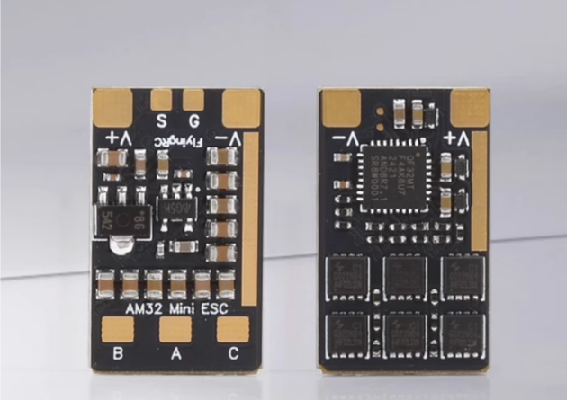

ESC Overview:
- MCU QF32F4AK8U7, integrated with Gate Driver ID6288 and MOSFET HYG022N04LS1C1.
- Supports Sine-Wave Startup and delivers high torque at low speed；
- Compatible with multiple protocols: DSHOT150/300/600, OneShot, PWM, etc.；
- Input voltage: 6–30V DC (2–6S LiPo)
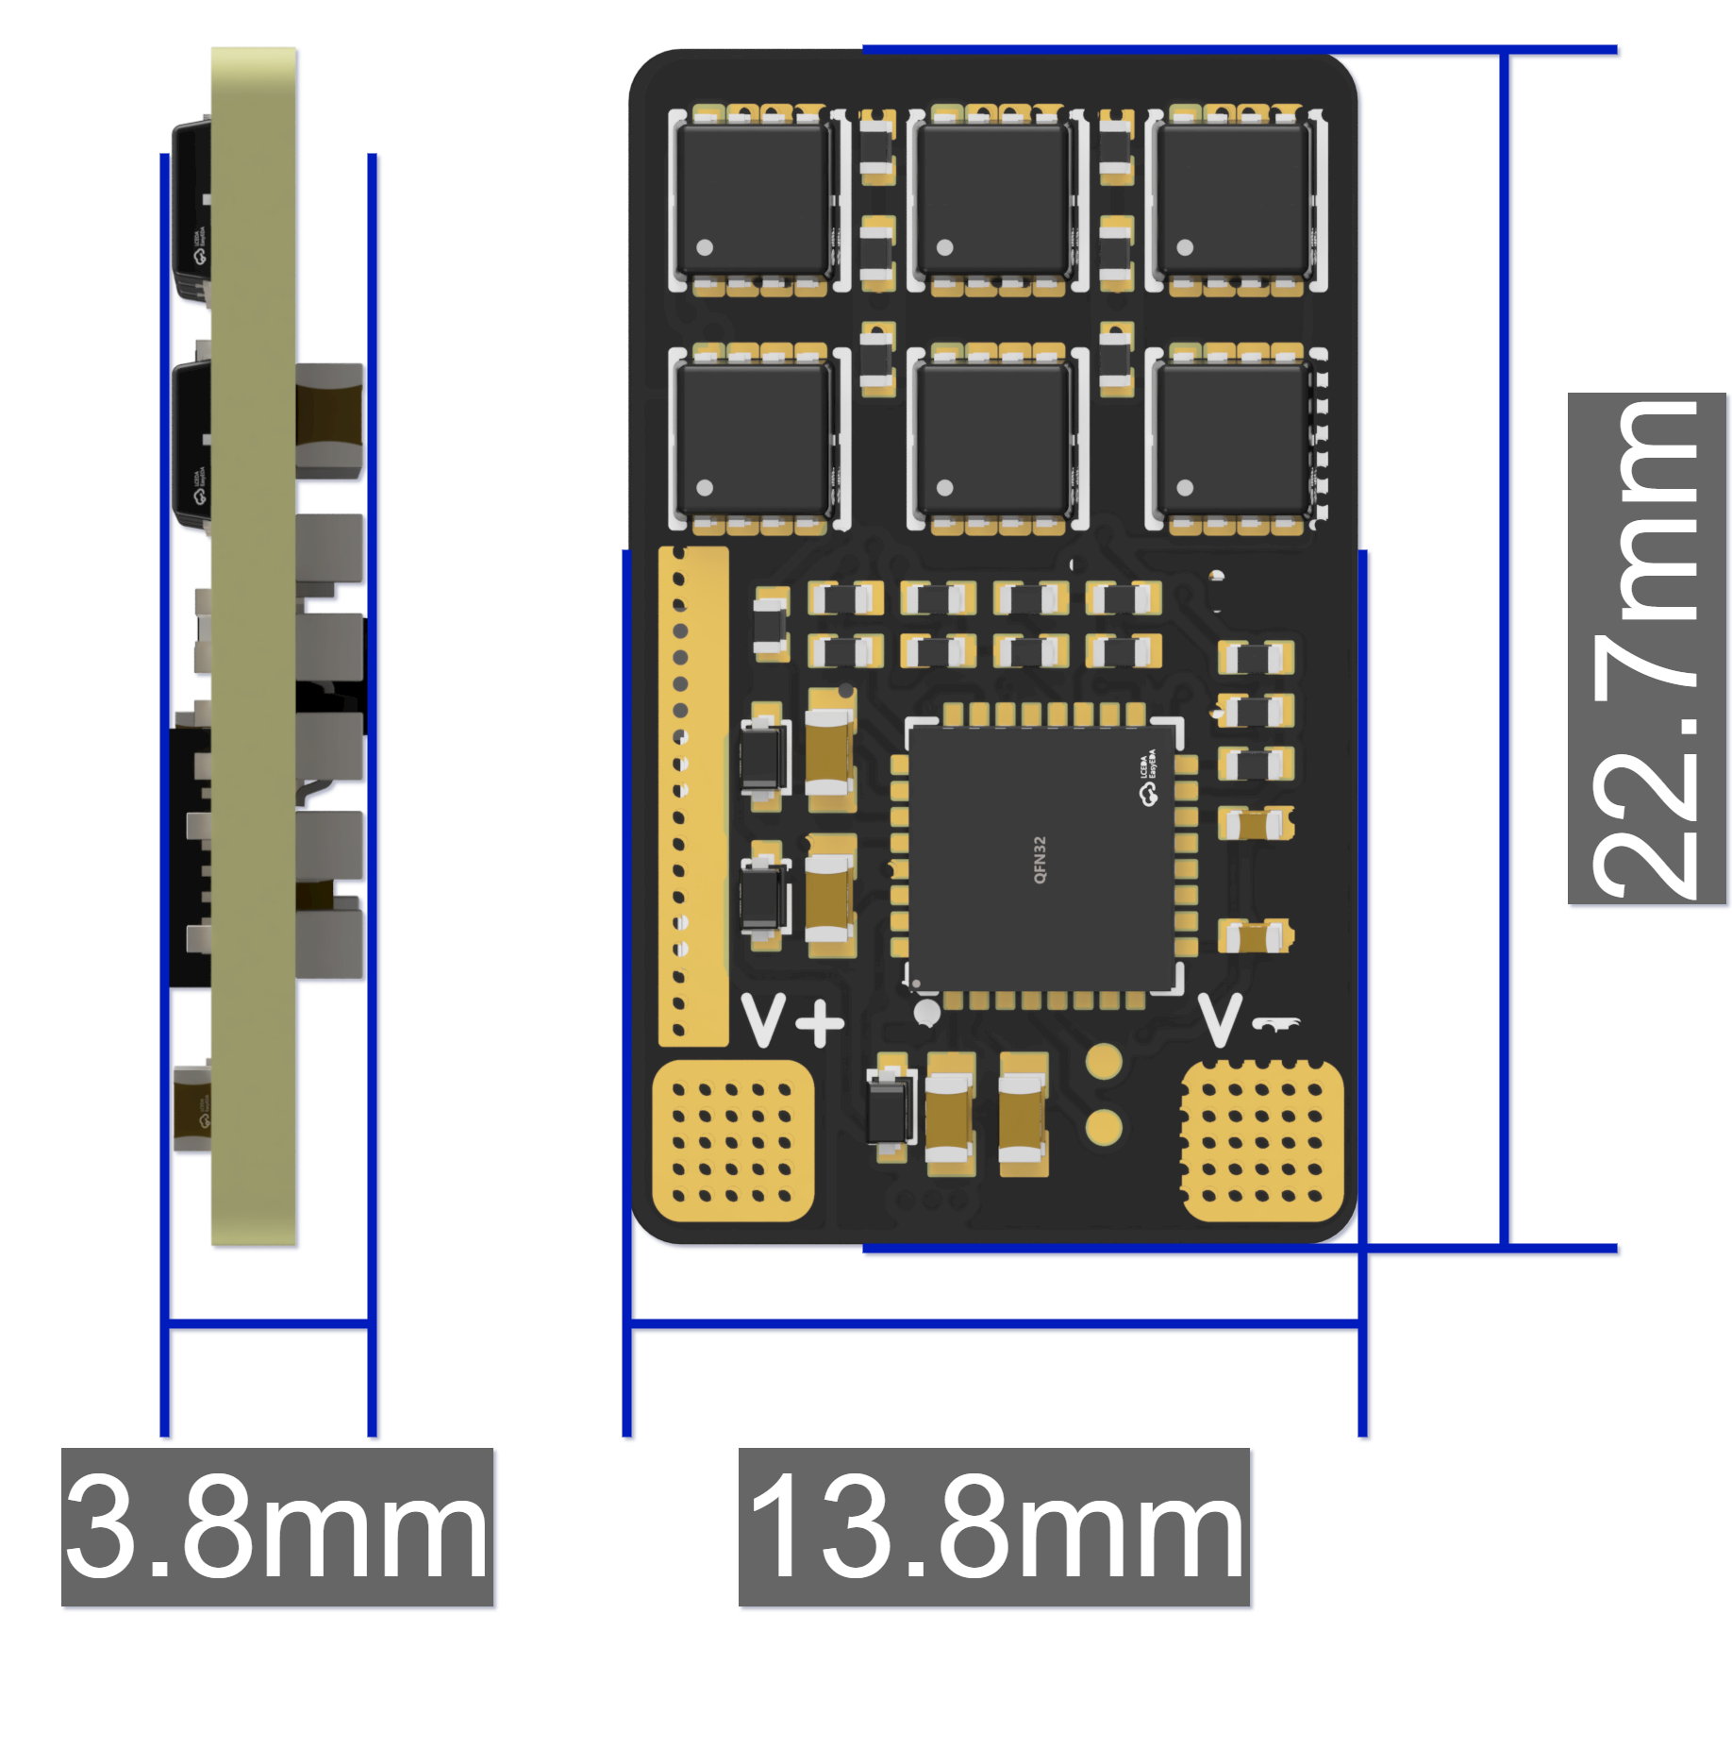
- Dimensions & weight: 22.7mm×13.8mm×3.8mm, 2.2g；
- Thick copper PCB: 6-layer board (2oz Inner/Outer, 12oz Total)；

Basic Parameters |  |  | Voltage-Current
Model | FlyingRC® Mini 40A ESC |  | VBAT Input Range | 6-30V DC IN 2-6S LiPo
Dimensions | 22.7mm*13.8mm*3.8mm |  | Continuous Current | 40A (Test Condition: 4S)
Weight: | 2.2g |  | Burst Current | 50A for 5s (Test Condition: 4S)
Key Components |  |  | Firmware
MCU | QF32F4AK8U7 32-bit |  | AM32 | Supported
Clock Speed | 120MHz |  | Control Signal Input | Supports DSHOT150, 300, 600, OneShot, PWM and other protocols
Flash | 64 KB |  | Operating Environment
RAM | 16 KB |  | Operating Temperature Range | -10-100℃
Integrated Gate Driver | ID6288 |  | Storage Temperature Range | 0-40℃
MOSFET/MOS | HYG022N04LS1C1
Product Features
PCB Processes |  | The PCB adopts a 6-layerr, 2oz copper stack with black solder mask, resin-filled vias, via-in-pad and immersion gold plating. It adopts top-tier craftsmanship in its class, laying a solid foundation for robust continuous current handling capability.
Ultra-Compact Size |  | Ultra-compact size, ideal for small and micro FPV drones. The MCU with an integrated gate driver reduces the PCB area occupied by non-power components, thus boosting current carrying capacity.
MOSFETs / MOS |  | Equipped with 6 HYG022N04LS1C1 N-MOSFETs, the ESC features an ultra-low Rds(on) of only 2.0mΩ and a 40V voltage rating (critical for 6S compatibility). These MOSFETs deliver lower on-resistance than those used on ordinary mini ESCs, effectively reducing overall heat generation.
Wide Voltage Input |  | A dual-stage LDO buck solution powers the gate driver and MCU, supporting 2–6S LiPo wide voltage input.. By contrast, most conventional mini ESCs only use a single-stage LDO, resulting in concentrated heat generation and a maximum input limit of 4S.
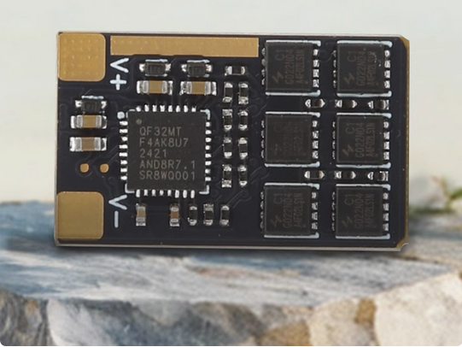
Product Features:
- Ultra-compact size, ideal for small and micro FPV drones. The MCU with an integrated gate driver reduces the PCB area occupied by non-power components, thus boosting current carrying capacity.
- Pre-flashed with AM32 firmware, the ESC delivers high low-speed torque when sine-wave startup and Stall Protection are enabled, making it ideal for mini RC cars.
- Equipped with 6 HYG022N04LS1C1 N-MOSFETs, the ESC features an ultra-low Rds(on) of only 2.0mΩ and a 40V voltage rating (critical for 6S compatibility). These MOSFETs deliver lower on-resistance than those used on ordinary mini ESCs, effectively reducing overall heat generation.
- A dual-stage LDO buck solution powers the gate driver and MCU, supporting 2–6S LiPo wide voltage input.. By contrast, most conventional mini ESCs only use a single-stage LDO, resulting in concentrated heat generation and a maximum input limit of 4S.
- 6-layer PCB with 2oz inner and outer copper (12oz total) adopts top-tier craftsmanship in its class, ensuring excellent continuous current output. Exposed copper layouts on positive and negative current paths further assist heat dissipation.

1.LAYOUT：
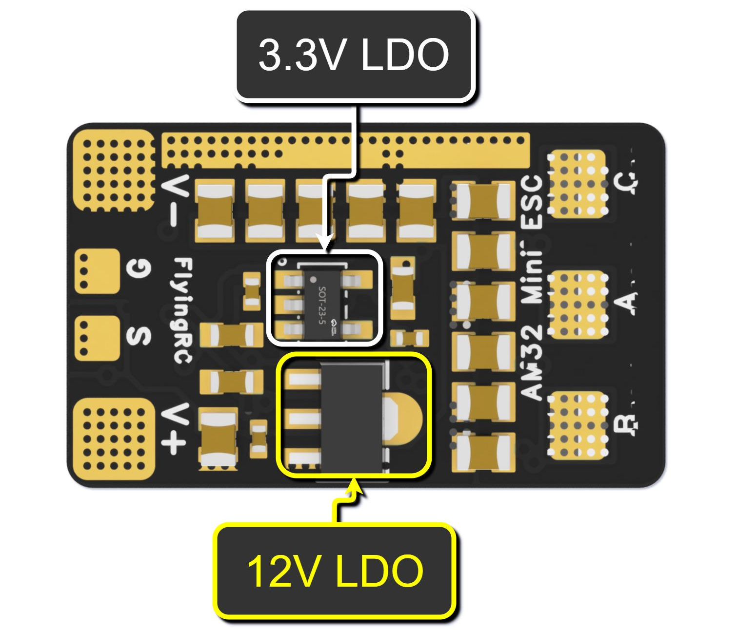
Front View 3D Rendering Diagram
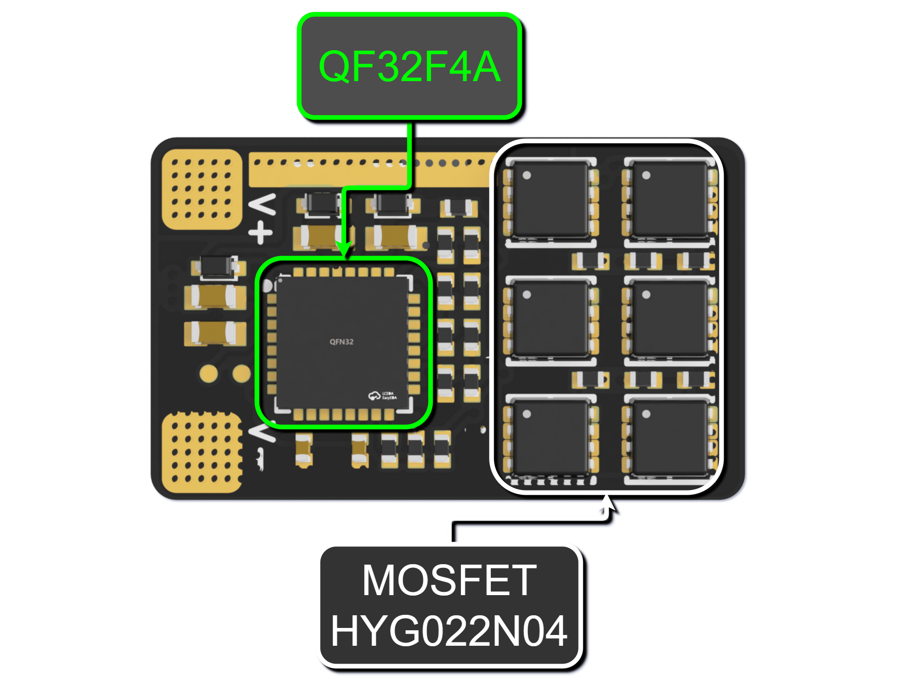
Rear View 3D Rendering Diagram
2.Preparations Before Use：

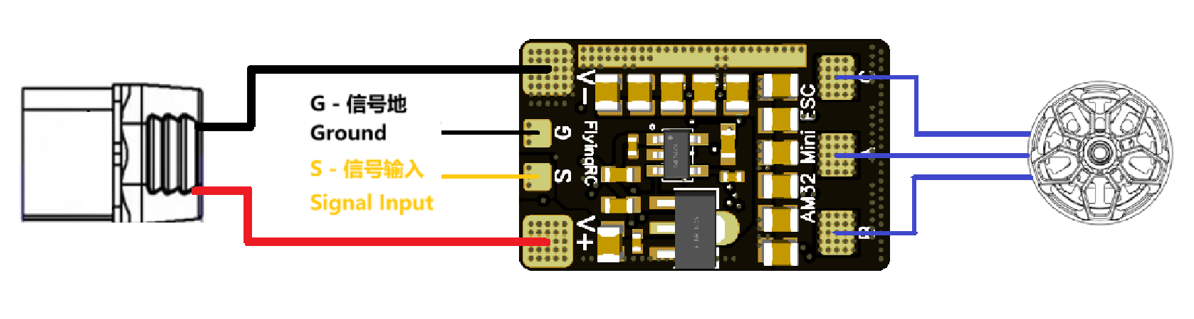
ESC Wiring Schematic

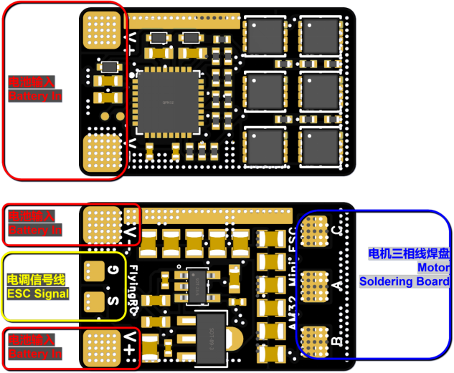

Pad Definition
Pad Number | Pad Name | Pad Definition
1 | S | PWM/Dshot Signal Input
2 | G | GND (Ground)
3 | V+ | Battery Positive (+)
4 | V- | Battery Negative (-)
5 | A | Motor Phase Connection
6 | B | Motor Phase Connection
7 | C | Motor Phase Connection

Welding Video Tutorial
Post-Welding image
3. Firmware Update
Close the Betaflight Configurator before using the ESC parameter tuning software to free up the flight controller port.
Propellers must be removed first. Power the ESC via a LiPo battery when tuning parameters or flashing firmware.
Download AM32-ESC-Tools from the group files, extract it locally, then double-click to run SerialPortConnector.exe.
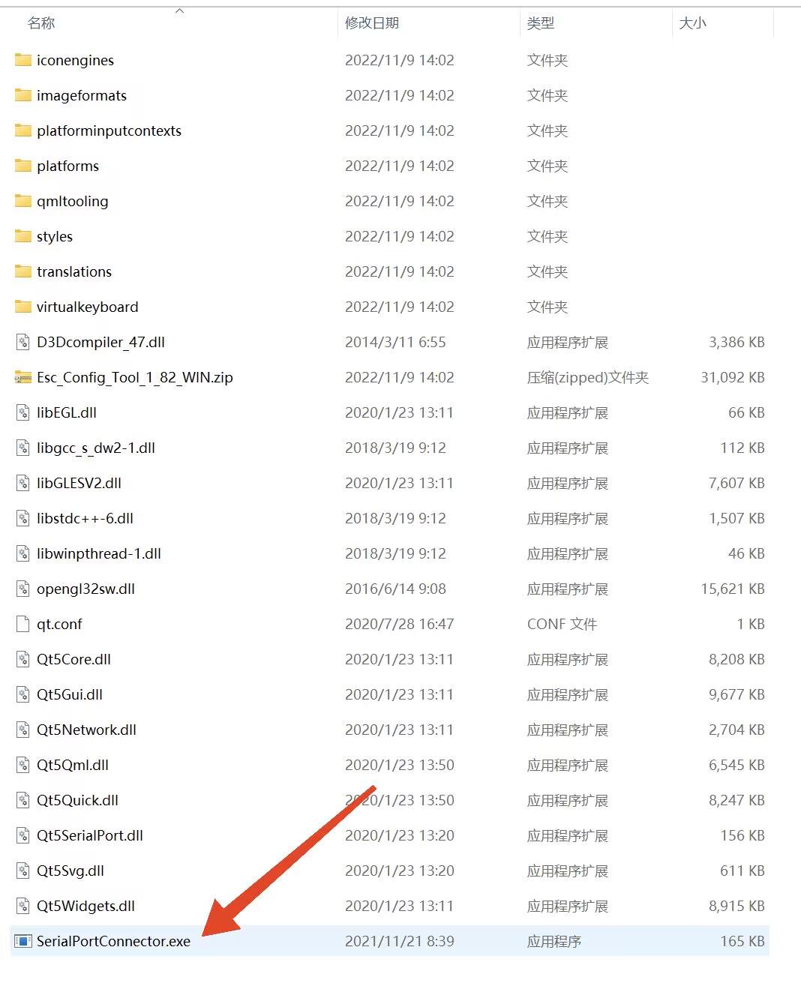
Locate the corresponding flight controller port number (COMx) in the bottom-right corner of the ESC parameter tuning software, then click Connect.
If no error message appears, the ESC tuning software has successfully connected to the flight controller.
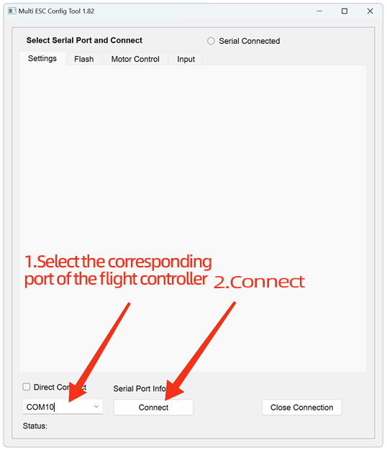
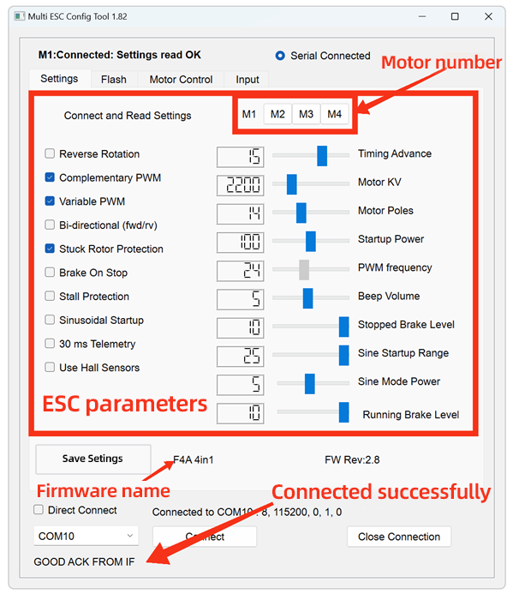
Before flashing the firmware, please download the latest ESC firmware in advance. The firmware can be obtained from github or the group file.

For the ESC parameter tuning software, navigate to the Flash page to proceed with firmware flashing.

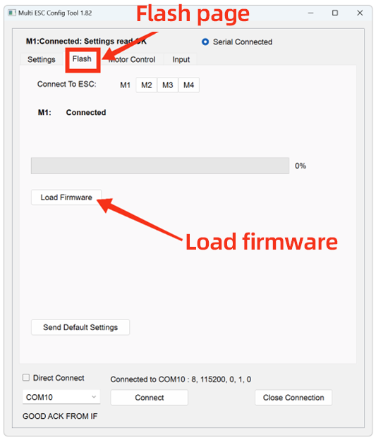
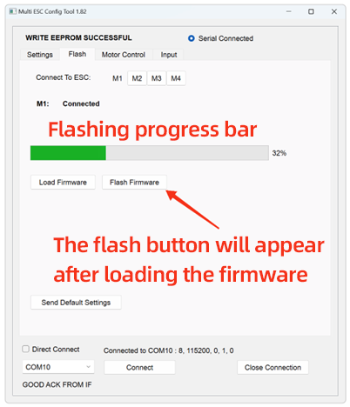
Click M1, then click “Load Firmware”.In the pop-up window, select the downloaded latest ESC firmware file and double-click to confirm. Click “Flash Firmware” and wait patiently for the progress bar to complete. Click “Send Default Settings” to restore the ESC to default parameters.*This step is strongly recommended when updating firmware across multiple versions. Repeat the above steps for M2, M3 and M4.
WARNING!
Do NOT use the web-based parameter tuning software.
Updating firmware with it may damage the ESC MCU. Multiple such cases have been reported.
In this situation, the product will require paid factory repair.

4.Parameter settings：For the parameter tuning software and connection instructions, please refer to the section 3 Firmware Update.
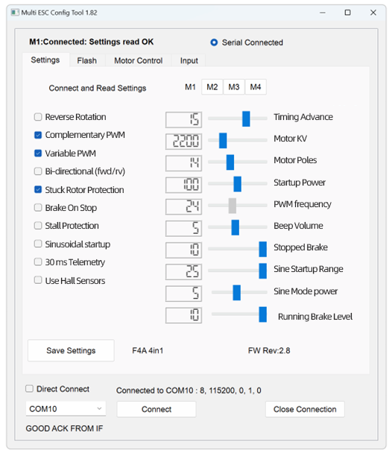
parameter setting page
Main Parameters：
KV Value: Must be set close to the motor’s rated KV rating. Deviation from the actual KV value shall not exceed 30%. If the KV value setting deviates by more than 100%, the motor may fail to operate normally, and the ESC hardware may even be damaged.
Advance Angle: Forbidden to adjust. Advanced users may optimize motor efficiency by adjusting the advance angle, but incorrect adjustment will damage the ESC, and such damage is usually irreparable.
Stall Protection: Can be enabled if using a low-KV motor (KV < 500), or must be enabled if using sine-wave startup.
Sine-Wave Startup: Not required for general FPV drones.

Notes：
1.All ESCs are pre-flashed with the latest official AM32 firmware and tested via multi-voltage rotation before shipment.
2.Offline paramteter tuning software is required for firmware flashing.
3.ESCs generate significant heat during operation. To ensure efficient heat dissipation, it is strictly prohibited to apply heat-shrink tubing or waterproof treatment, as such protective measures will impede heat exchange between the ESC and the environment. Damage caused by this will not be covered under warranty.
4.When the ESC’s operating environment parameters (e.g., temperature, humidity, air pressure, ventilation) deviate from rated conditions, the current-carrying capacity of its internal power devices will be limited, and the maximum continuous operating current will fall below the nominal value. Sufficient heat dissipation measures must be implemented to ensure stable and reliable operation.
5.Take care to prevent the ESC from contacting other conductors (carbon fiber plates, battery plugs, other circuit boards) during installation, as external short circuits may cause damage.
6.Burnt components can be returned to our factory for paid repair, while burnt PCBs cannot be repaired.

Other FlyingRC® Products
 |  |  |  | - FlyingRC® F4WSE Pro - F405 Fixed-Wing Flight Controller  Upgraded Version | Enhanced Performance  Manual：https://www.kdocs.cn/l/cavm9EoVEq5A |  |  | 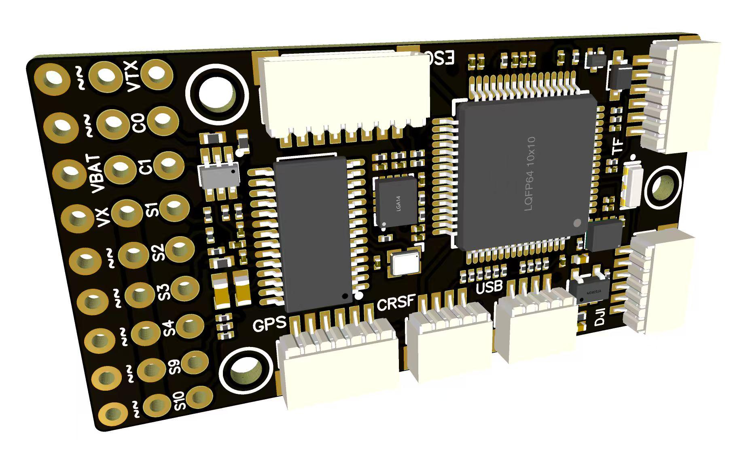
 |  |  | - FlyingRC® F4WSE MK1.5 - F405 Fixed-Wing Flight Controller  Classic model, unique design, highly acclaimed.  Manual：https://kdocs.cn/l/cpyd8MTS56DD |  |  | 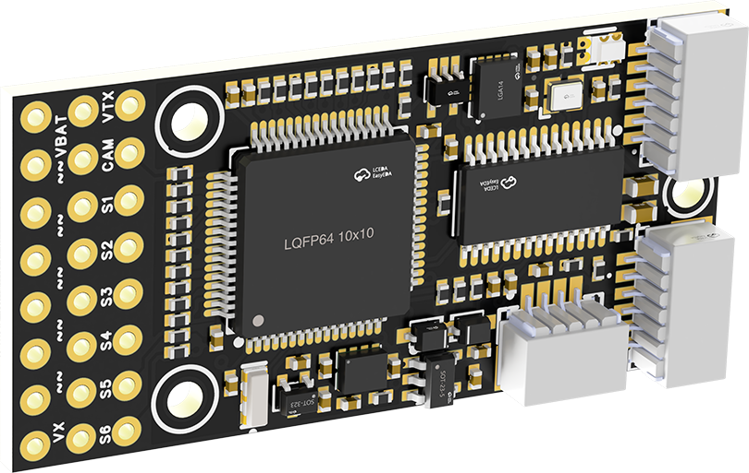
 |  |  |  | - FlyingRC® H7Wlite MK1 H743 Fixed-Wing Flight Controller  Flagship performance, full expansion, high-power BEC.  Manual：https://kdocs.cn/l/cpYaBiFKh8U1 |  |  | 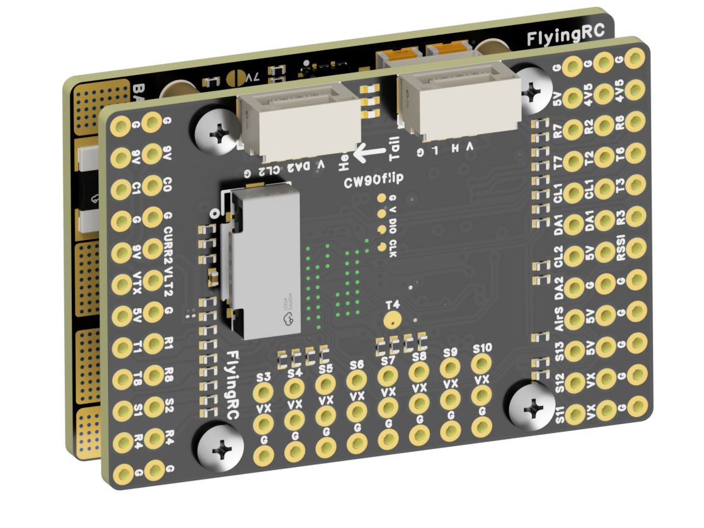
 |  |  |  | - FlyingRC® F4Wing Mini MK1 F405 Fixed-Wing Flight Controller  2025 bestseller, ultra-compact, smallest on the market, great value.  Manual：https://kdocs.cn/l/cdUIdmpSpW7J |  |  | 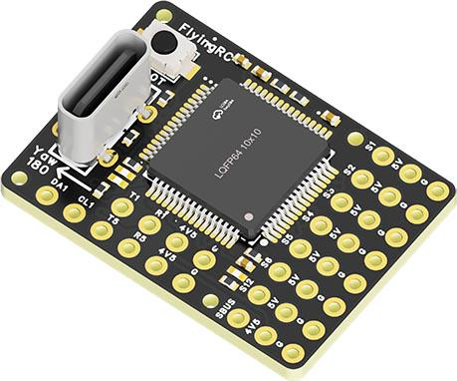
 | - FlyingRC® AM32 Dual ESC 40A 2-in-1 ESC  Unique design for dual-power aerial, land and water vehicles including drones.  Manual：https://www.kdocs.cn/l/cjwNtsKK6HeR |  |  |  | 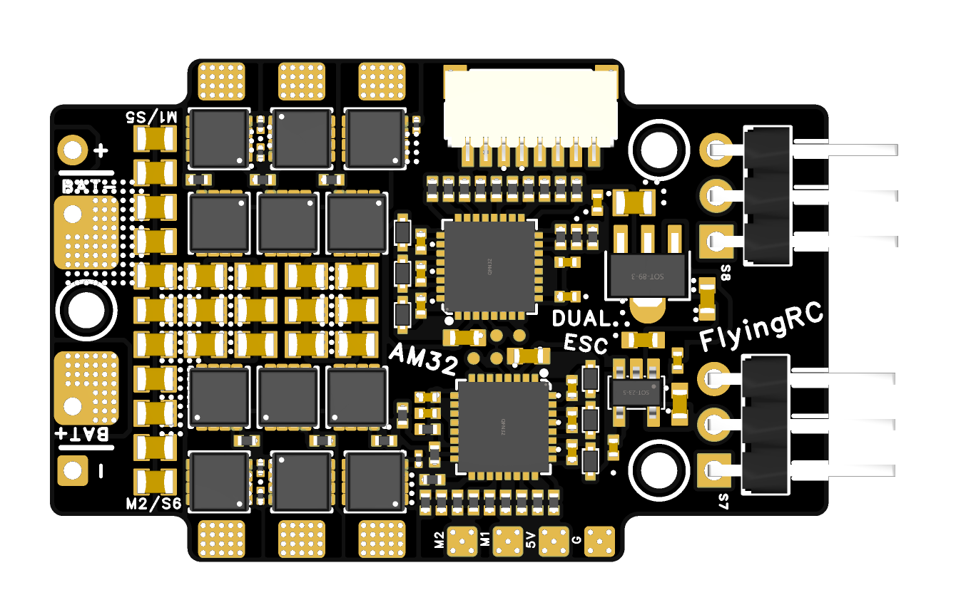
 |  |  | - FlyingRC® AM32 ESC V2.5 75A - Single ESC  Infineon gold-package MOSFETs, premium materials, superior heat dissipation.  Manual：https://kdocs.cn/l/cv6hUy67IdTJ |  |  |  | 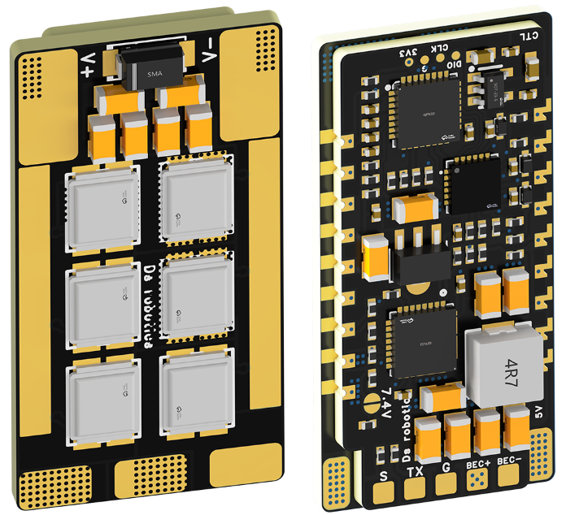
 |  |  | - FlyingRC® AM32 Mini ESC 40A V1.0 - Single ESC  Ultra-miniature, ideal for micro drones, high over-current capability, stable operation.  Manual：https://kdocs.cn/l/cqdLSysEyWFh |  |  |  |  | 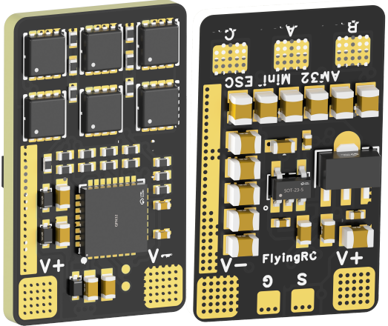
 |  |  | - FlyingRC® 10A 12S 440A Power Distribution Board for FPV Drones  Industry top choice, excellent quality and affordable price.  Manual：https://kdocs.cn/l/coel7OgrlCBP |  |  |  |  | 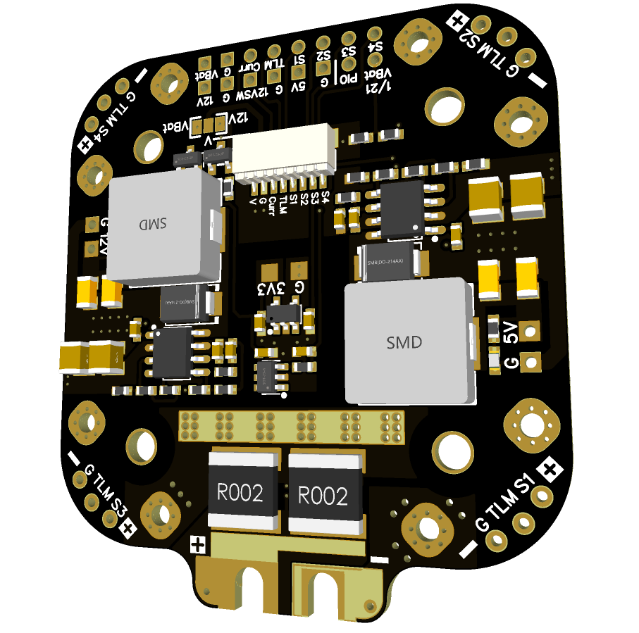
 |  |  | - FlyingRC® H7D Pro MK1 H743 FPV Flight Controller with Dual Gyro  Fully Upgraded & More Powerful  Manual：https://www.kdocs.cn/l/ctcekCy676Ez |  |  |  | 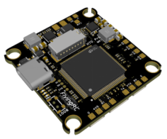
 |  |  | - FlyingRC® H7D MK1 H743 FPV Flight Controller with Dual Gyro  Powerful computing, stable and precise flight, rich interfaces, smooth control.  Manual：https://kdocs.cn/l/cqMh1I0RwAoD |  |  |  | 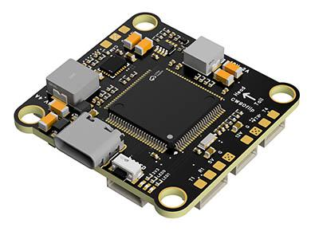
 |  |  | - FlyingRC® F420 MK1 F405 FPV Flight Controller (20/30.5mm Mounting)  Dual mounting holes, all connectors, no soldering required, compliant with Betaflight interface standards.  Manual：https://kdocs.cn/l/ctGeLiN9ZYKj |  |  |  | 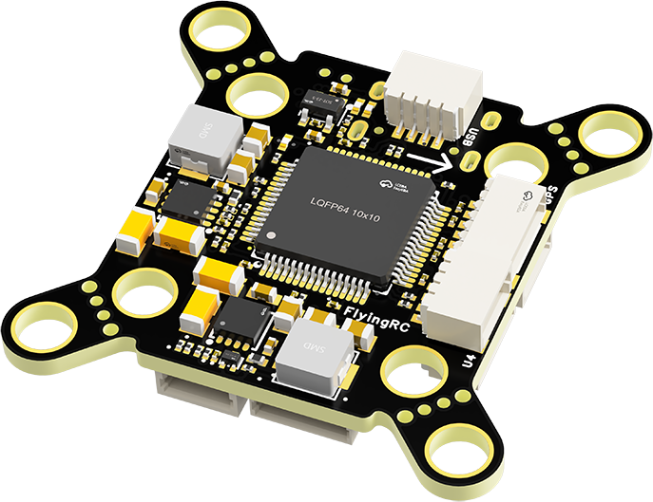
 |  | - FlyingRC® 4-in-1 75A V3.2 Gold-Sealed FPV ESC  Infineon gold-package MOSFETs, superior heat dissipation & over-current capability, premium choice.  Manual：https://kdocs.cn/l/ceLilc8Gaa21 |  |  |  |  | 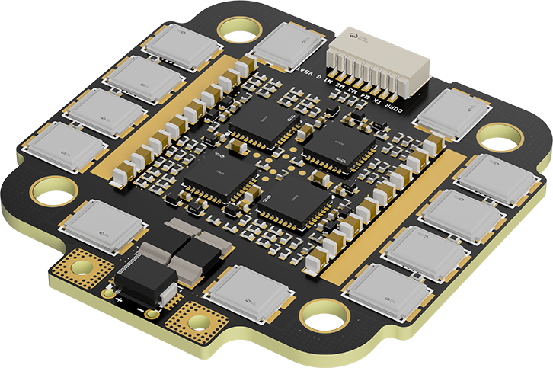
- FlyingRC® Stack Combo: H743 Flight Controller + 4-in-1 75A Gold-Sealed ESC  Professional flight choice, flagship materials & craftsmanship, reasonable price.  Manual：https://www.kdocs.cn/l/ctcekCy676Ez  https://kdocs.cn/l/ceLilc8Gaa21 |  |  |  |  |  |  | 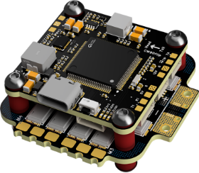
 |  | - FlyingRC® Stack Combo: F405 Flight Controller + 4-in-1 75A Gold-Sealed ESC  Best-selling combo, excellent performance, affordable price.  Manual：https://kdocs.cn/l/ctGeLiN9ZYKj  https://kdocs.cn/l/ceLilc8Gaa21 |  |  |  |  | 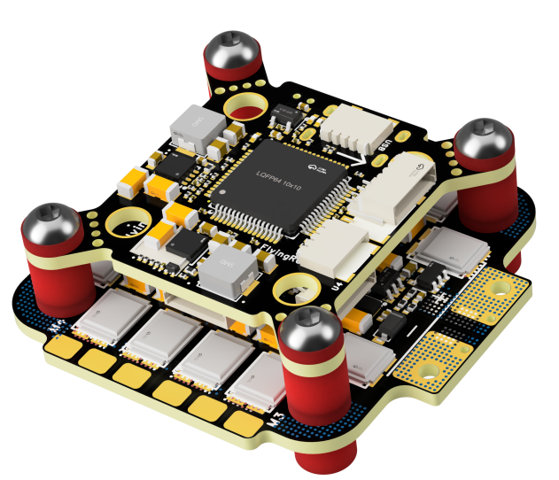
 |  | - FlyingRC® Stack Combo: H743 Flight Controller + 4-in-1 45A ESC  Winning combo: great performance, budget-friendly price  Manual：https://www.kdocs.cn/l/ctcekCy676Ez  https://kdocs.cn/l/ceLilc8Gaa21 |  |  |  |  | 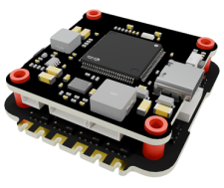
 |  | - FlyingRC® Stack Combo: F405 Flight Controller + 4-in-1 45A ESC  Hit combo, great value, budget-friendly  Manual：https://kdocs.cn/l/ctGeLiN9ZYKj  https://kdocs.cn/l/ceLilc8Gaa21 |  |  |  |  | 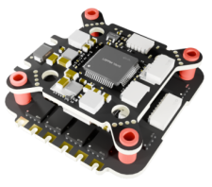
 |  | - FlyingRC® Stack Combo: F4WSE Pro - F405 Fixed-Wing Flight Controller + AM32 Dual ESC 40A 2-in-1 ESC  Unique Design • Exclusive Offer • Bestselling Bundle  Manual：https://www.kdocs.cn/l/cavm9EoVEq5A  https://www.kdocs.cn/l/cjwNtsKK6HeR |  |  |  |  | 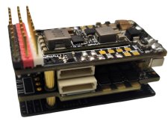
 | - FlyingRC® ELRS 2.4G Diversity Receiver  True diversity reception, temperature compensation, high-sensitivity reception.  Manual：https://kdocs.cn/l/cbvlOlShmsPS |  |  |  |  |  | 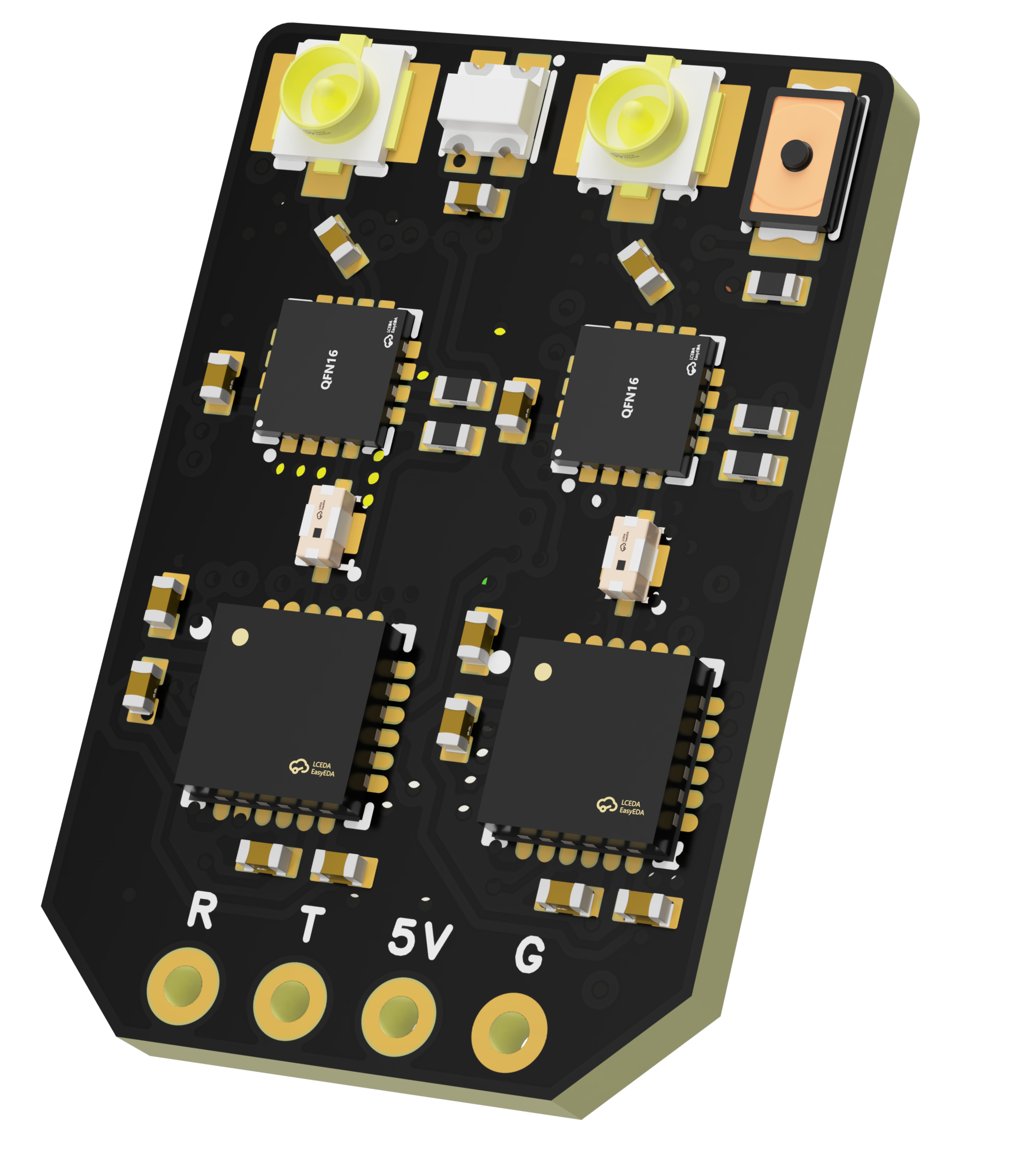
 | - FlyingRC® RM3100 SPI Module 罗盘模块  Ultra-high Resolution • Low Power • Industry Top Choice  Manual：https://www.kdocs.cn/l/cdGuHvBVyndC |  |  |  |  |  | 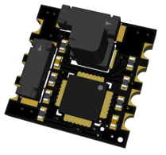
 | - FlyingRC® 10A 12S BEC Step-Down Module  Wide voltage input, high power, compact size, multiple voltages available, 10A continuous output.  Manual：https://kdocs.cn/l/clssNCKgNhLV |  |  |  |  |  | 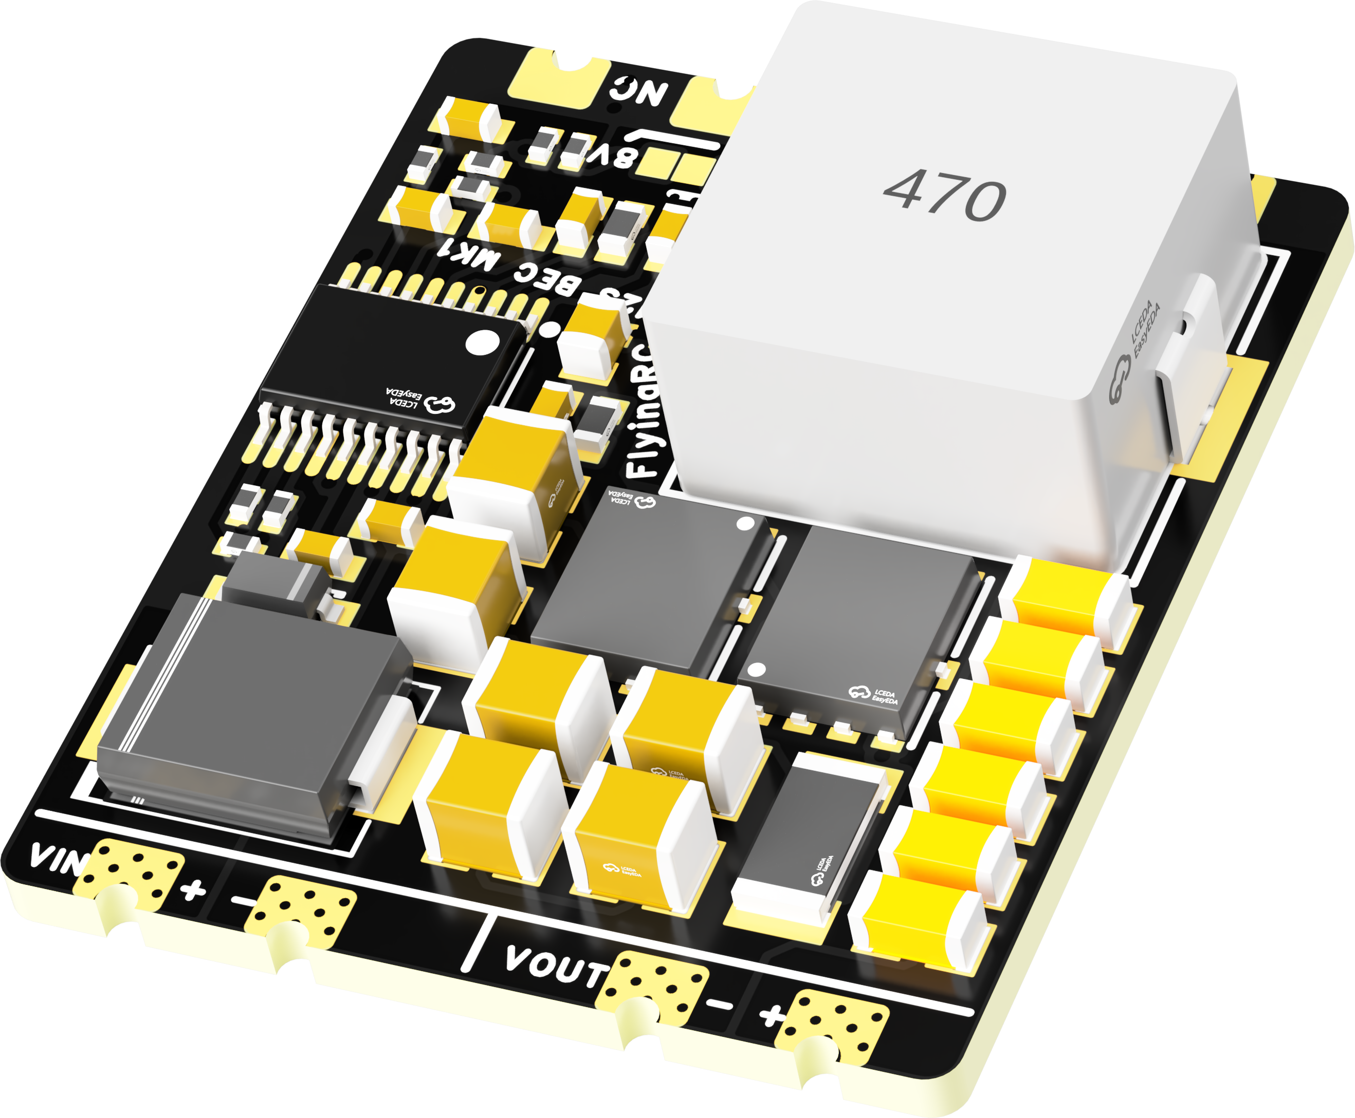
 | FlyingRC® 5A BEC Step-Down Module  Ultra-small size, multiple voltages available, 5A continuous output.  Manual：https://kdocs.cn/l/cb9VdNywqCKA |  |  |  |  |  | 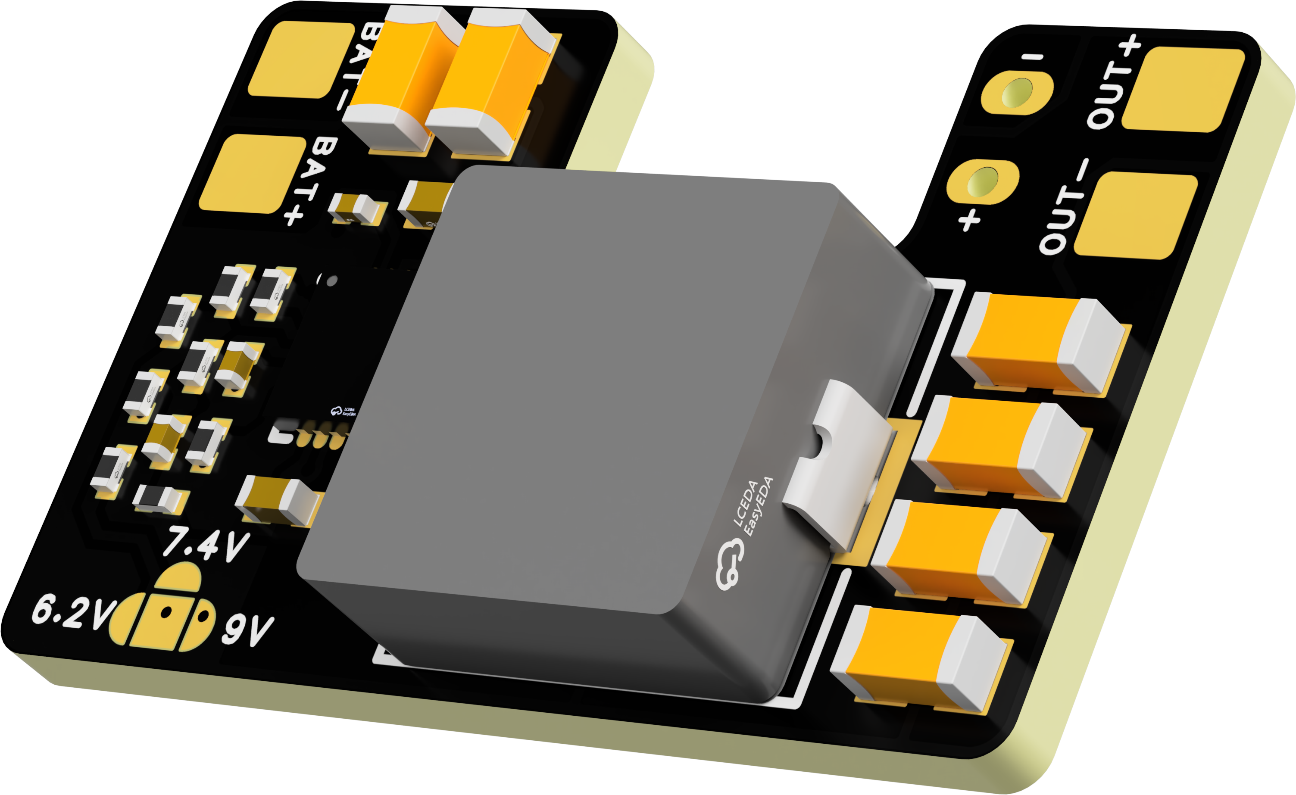
 | FlyingRC® Mini BEC For DJI O4  Easy wiring, ultra-small size, stable power supply.  Manual：https://www.kdocs.cn/l/ckkebieur37K |  |  |  |  |  | 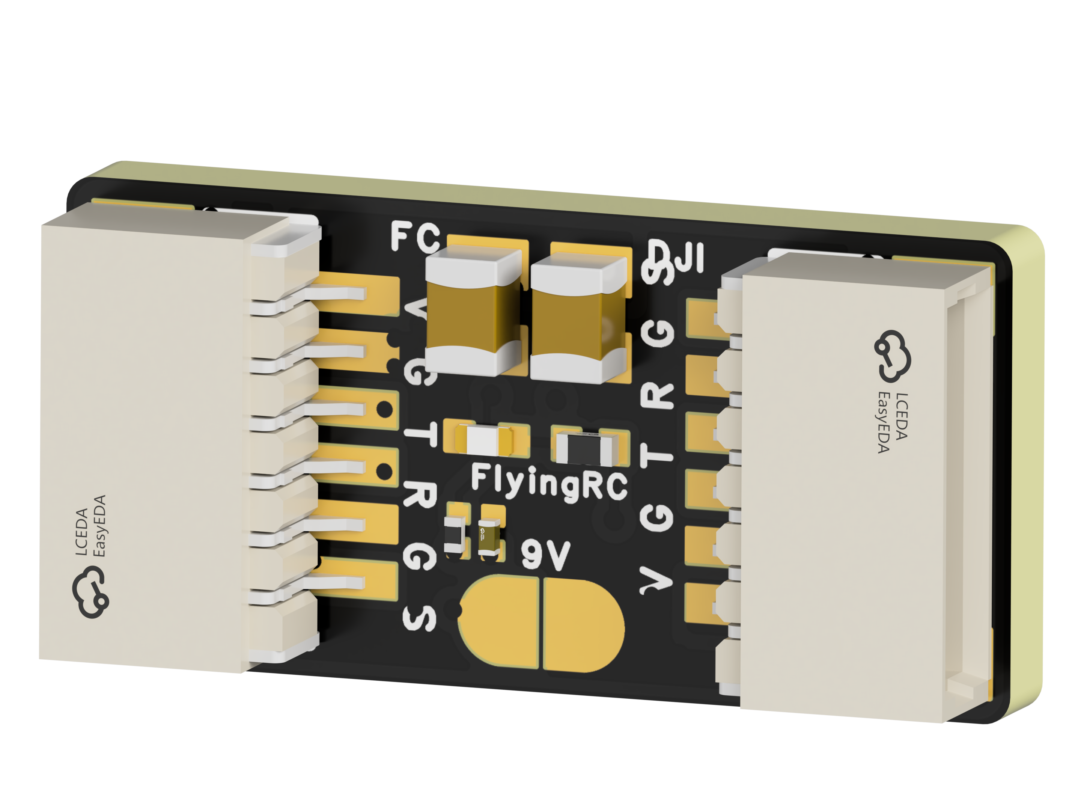
 | FlyingRC® CAN Bus Serial & PWM Expansion Board  Long-distance transmission, high speed, excellent stability.  Manual：https://www.kdocs.cn/l/cmxRyBnU4BXj |  |  |  |  |  | 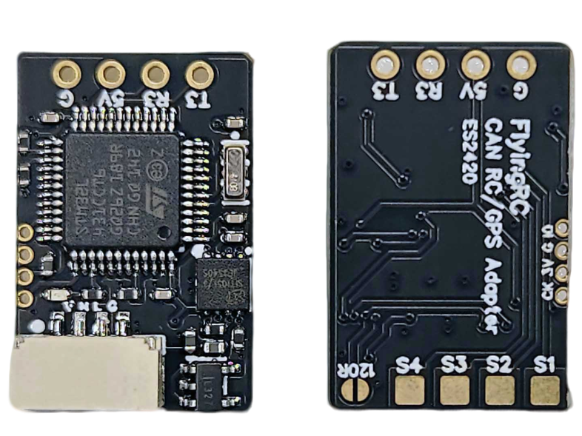
 | FlyingRC® AM3 2ESC Programmer  Supports BL, BL32, AM32. Simple and easy to use.  Manual：https://kdocs.cn/l/cogBSEBe67mE |  |  |  |  |  | 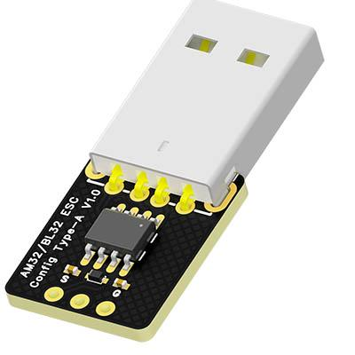
 | FlyingRC® Digital Airspeed Sensor without Pitot Tube  Integrated design, smallest on the market. MS4525D protocol, I2C interface.  Manual：https://www.kdocs.cn/l/clPvEEEcJgCC |  |  |  |  |  | 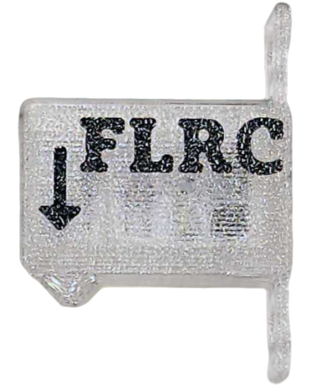
 | FlyingRC® U-Blox M10 GPS  Compatible with all open-source flight controllers.  Manual：https://www.kdocs.cn/l/cdSYQrzx74O8 |  |  |  |  |  | 