FlyingRC® F4D MK1 F405 FPV Drone Flight Controller (20/30.5mm Mounting) Product Manual
FlyingRC® is a globally-oriented professional brand of electronic devices. We specialize in the R&D and sales of drone electronics, core robot circuits and sensors. Our design team is based in Singapore, and our products are sold worldwide.

Since launched in 2023, FlyingRC® products have gained widespread recognition from customers as well as strong market response. As of April 2026, our cumulative sales volume has exceeded 46,000 units. Our products are widely applied in industries, robotics, emergency rescue, environmental protection & inspection, aerial photography, public security, retail and many other fields. Above all, we are committed to distinctive design and superior reliable quality.

Our Chief Technology Officer Liu Yuhan possesses outstanding expertise in circuit design. Over the past four years, he has designed more than 80 circuit projects and contributed 39 to open-source platforms. Moreover, he won the Design Award on the open-source platform X.JLC.com twice in 2023 and 2024, and has become the youngest certified designer on this platform.

He holds the NUS (National University of Singapore, rank 8th worldwide) Science and Technology Scholarship, and is currently majoring in Electronic Engineering with a focus on Aerospace Technology. In addition, all members of our technical team are graduates from prestigious universities with extensive professional product experience.

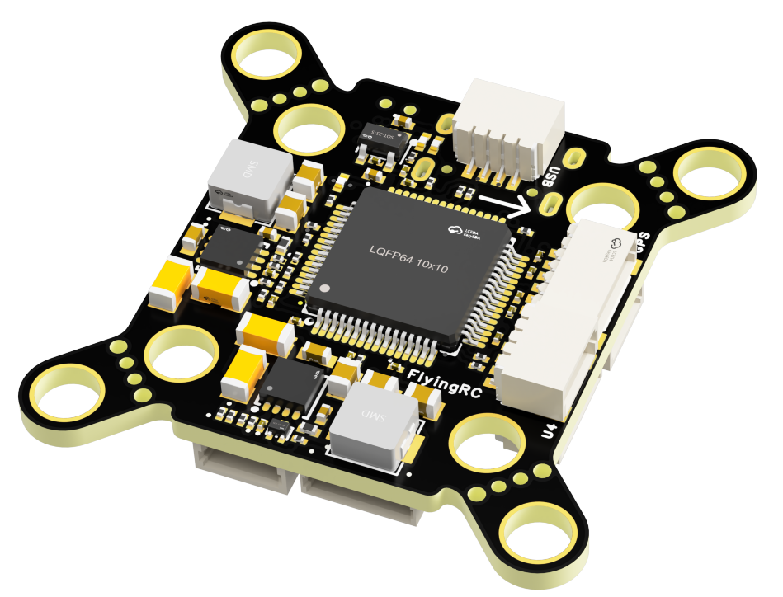

- Technical Specifications
- MCU: STM32F405RGT6; Gyroscope: ICM-42688-P; High-Precision Barometer: Goertek SPA06-003
- Analog/HD OSD，6xUARTs（only RX pin of UART3 is exposed），5xPWMs（4 ESC + 1LED），1xI2C，1xADC（Current Sensor），Onboard 5V3A/9V2A BEC
- Black Box: Onboard 16MB NOR Flash
- 7-28V DC Input (2-6S LiPo. Note: When using 2S or 3S LiPo batteries, the input voltage to the VTX BEC must be above 9.8V for stable output; 3S-6S LiPo is strongly recommended)
- Dual BEC(MP9943 + MP9943) : 5V 3A (for Devices) & 9V 2A (for VTX and Camera)
- Dimensions & Weight：36.6mm*36.6mm*8.0mm，6.3g， 28.1mm*31.1mm*8.0mm (after trimming mounting tabs)

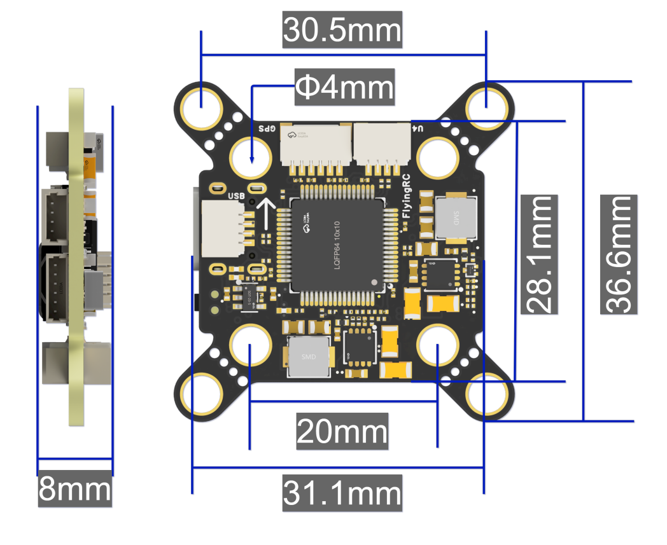

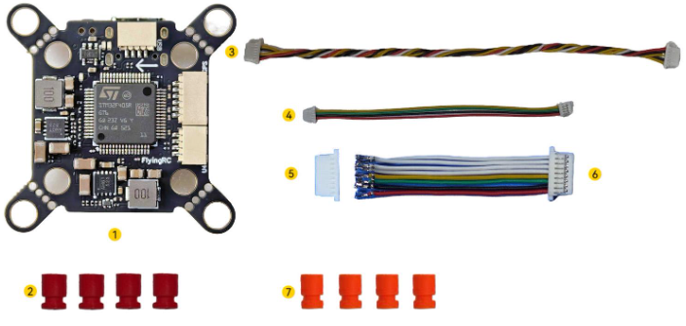

Package Contents:

1. 1 x FlyingRC F4D F405 Flight Controller
2. 4 x M3 Silicone Anti-Vibration Standoffs
3. 1 x 15cm DJI VTX 6-Pin Cable
4. 1 x 10cm SH1.0 4-Pin Ultra-Soft Silicone Cable
5. 1 x SH1.0 8-Pin Crimp Terminal
6. 1 x 3.5cm SH1.0 8-Pin 30AWG Ultra-Soft Silicone Cable
7. 4 x M2 Silicone Anti-Vibration Standoffs

- Product Features

- Equipped with STM32F405RGT6 MCU, supporting AP, BF, and INAV firmware; pre-flashed with BF firmware at factory.
- InvenSense 3rd-generation ICM-42688-P gyroscope offers higher accuracy and stability, optimized specifically for drones.
- Built-in high-precision Goertek SPA06-003 barometer.
- Compatible with 30.5mm M4 standard mounting holes (fits M3 screws with Anti-Vibration Standoffs) and 20mm M4 mounting holes (fits M2/M3 screws with Anti-Vibration Standoffs), supporting 2–12 inch FPV drones with excellent frame compatibility.
- 4+1 PWM outputs supporting 4-in-1 ESCs, 6 UARTs (only RX pin of UART3 exposed), and 1 I2C, providing rich interfaces.
- Full SH1.0 socket design: ESCs, receivers, GPS, analog VTX, analog cameras, HD VTX, and LED strips all connect via connectors, eliminating the difficulty of soldering small pads and solder bridging.
- Onboard 9V BEC for VTX and camera, switchable via PINIO1 (User1 in BF firmware), preventing VTX from overheating and burnout during bench testing.
- Onboard 16MB Flash ensures sufficient storage for multiple flight log records.
- Black solder mask, 1OZ copper thickness, 1μm immersion gold, resin plug holes, and via-in-pad technology. Assembled with JLCPCB SMT service for reliable and superior quality.

Basic Parameters |  | Sensors
Model | FlyingRC® F4D | IMU(Gyro & Accelerometer) | Invensense Gen 3 ICM-42688-P
Dimensions | 36.6*36.6*8.0  28.1*31.1/*8.0mm (after cutting) | Barometer | Goertek SPA06-003
Mounting Pattern | 30.5 / 20 mm | Magnetometer | No onboard magnetometer
Weight | 6.3g | Analog OSD | AT7465E
MCU |  | Power Output
MCU Chip | STM32F405RGT6 | BEC Chip Model | MP9943+MP9943
Clock Speed | 168 MHz | Onboard BEC (Devices) | 5V3A
Flash | 1 MB | Onboard BEC (VTX) | 9V2A
RAM | 192 KB
Interfaces |  | Firmware Support
UART | 6 UARTs | Betaflight | Supported (factory default)
 | UART3: RX only | INAV | Supported
PWM | 5 channels (including 1 LED channel) | Ardupilot | Supported
I2C | 1 | PX4 | Not supported
Current ADC Sampling | Supported
SWD Debug | Not available | Operating Environment
Buzzer Port | None | VBAT Input Range | 7-28V DC IN 2-6S LiPo
LED Strip Port | Supports WS2812 (requires soldering) | Power Input | Same as VBAT input range
USB-TYPE-C | Onboard direct plug | Operating Temperature | -10-100℃
Blackbox Storage | Onboard 16MB NOR Flash | Storage Temperature | 0-40℃
SBUS | Supported

3. Usage Instructions
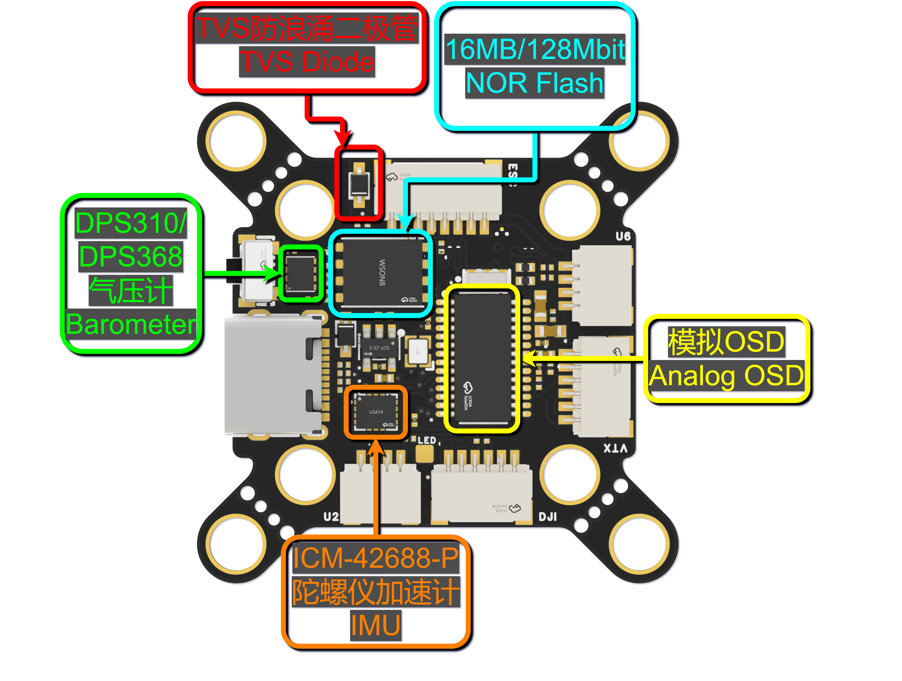
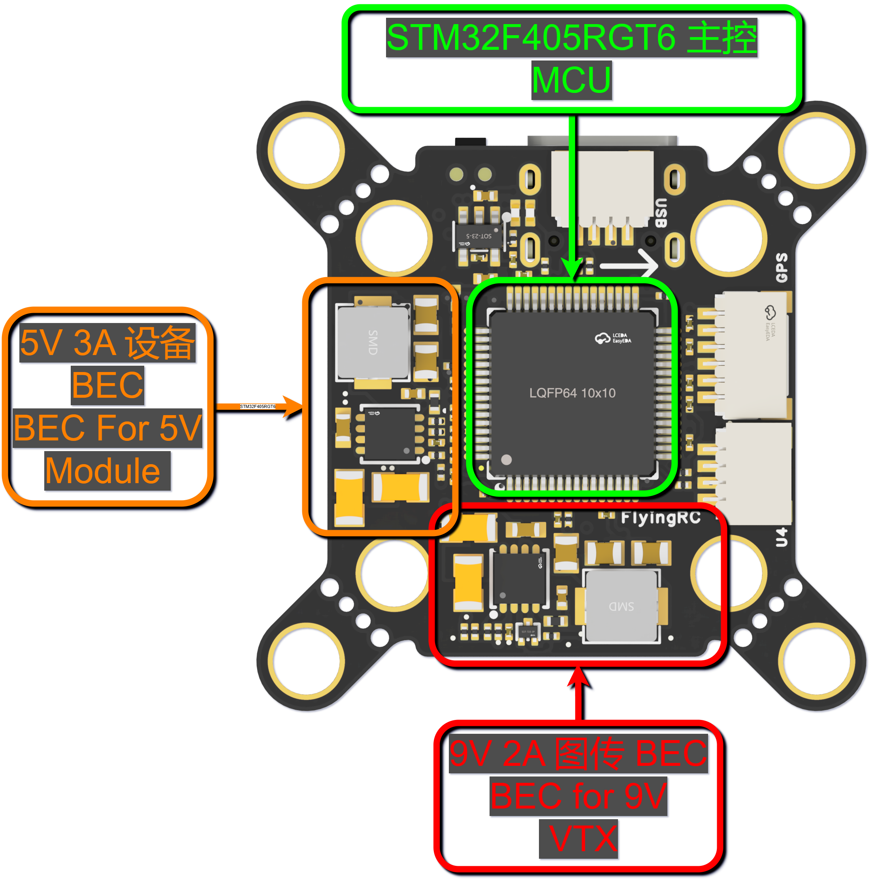
LAYOUT：
3D Diagram of the Flight Controller - Front Side
3D Diagram of the Flight Controller - Reverse Side
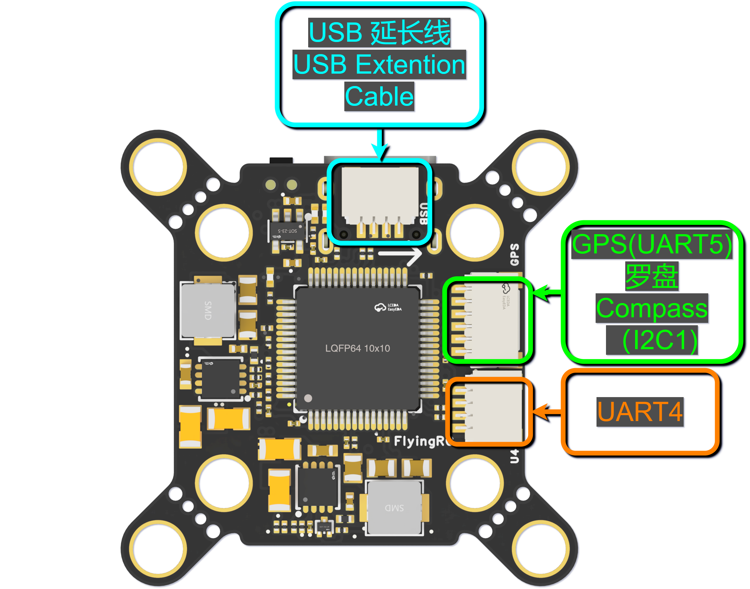
Connector Function Diagram - Front Side
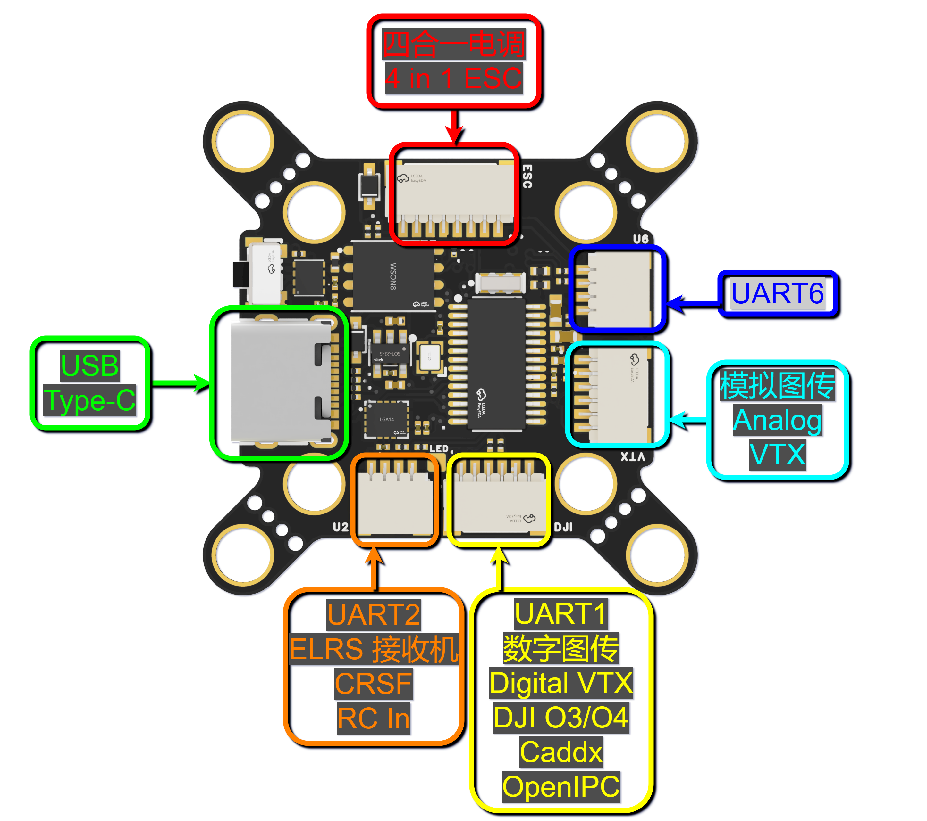
Connector & Pad Function Diagram - Reverse Side

Pre-Use Preparation
Note: Due to varying wire sequences between flight controllers and ESCs from different manufacturers, ensure the 8P ESC connection cable is made with the correct wire sequence matching your ESC. For wire sequence inquiries, please consult our customer group. Incorrect wire sequencing could result in the flight controller being burned out!!!

This product adopts the latest official Betaflight pin order. Reference: Betaflight Connector Standard (official documentation page)
When inserting the 8P female header, ensure both ends are perfectly parallel during insertion. Otherwise, edge pins may bend or be pushed out, resulting in socket failure!

Wiring Diagram (Applicable to BF, AP, and INAV firmware)：
Flight Controller Wiring Diagram
(Note: The ESC is V3.2 Version)
SH1.0 female connectors on the flight controller are marked with silkscreen labels.

The ESCs are currently available in two versions: V3.2 and V4.0, with different wiring orders.
V4.0 complies with the Betaflight (BF) wiring standard. Please note the visual differences between V3.2 and V4.0.

1.The 8P connector on V4.0 is marked with “Note Wiring Order”.

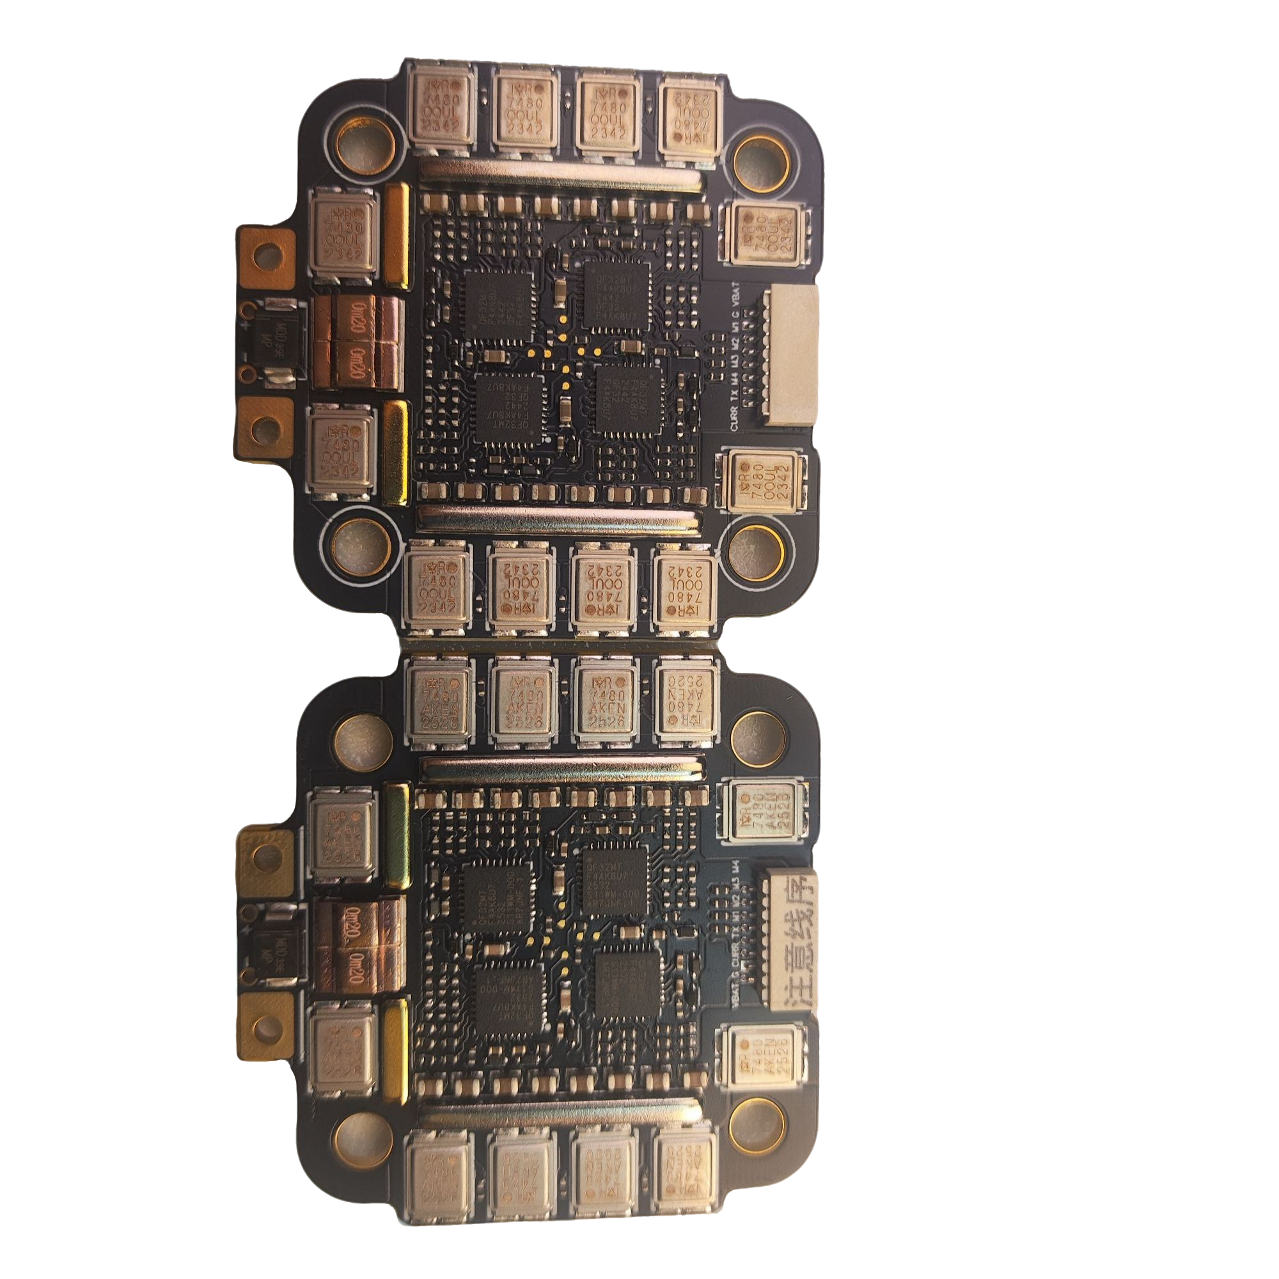
V3.2 V4.0

2.The version number is labeled on both variants.
3.V4.0 is marked with a serial number (S/N).
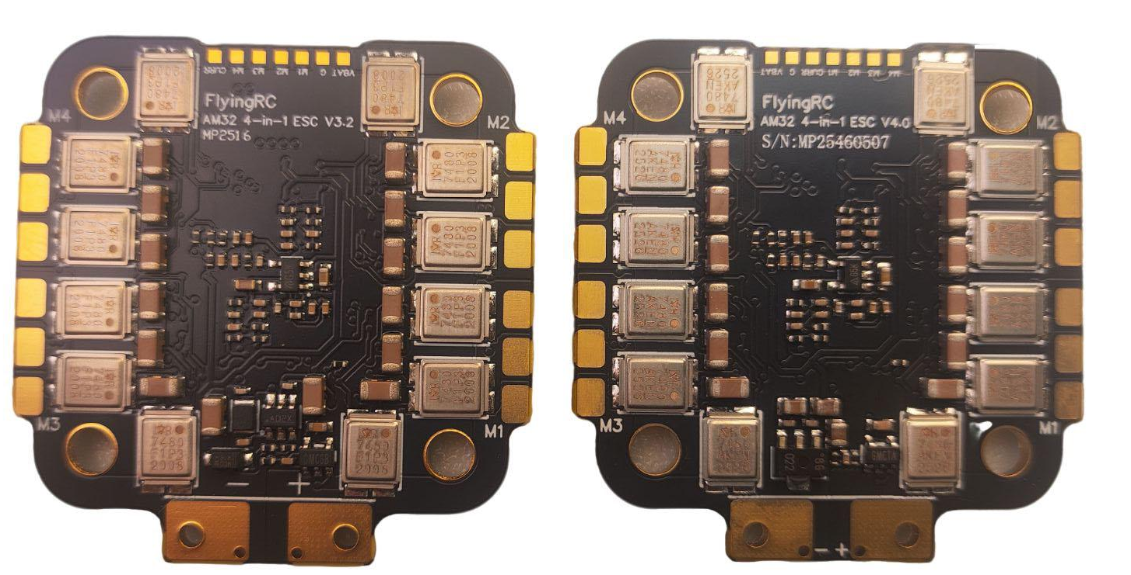
V3.2 V4.0

- ESC Connection
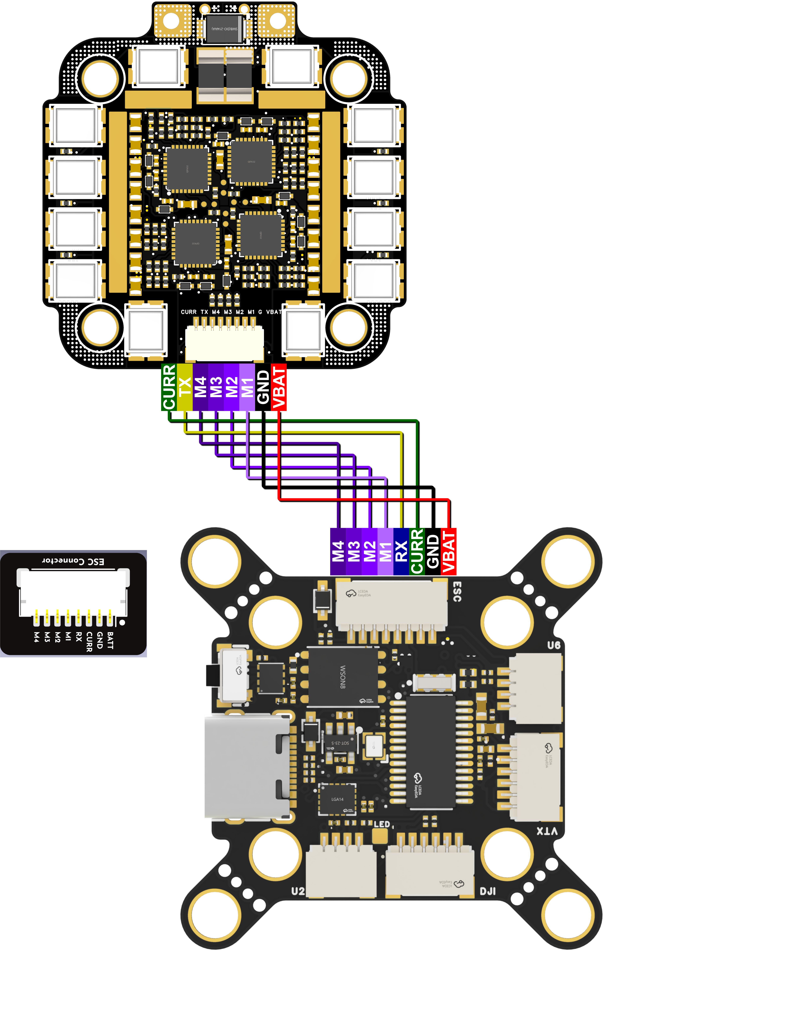
Connection with FlyingRC® 4IN1 75A Gold-Sealed ESC
(Note: The ESC is V3.2 Version)
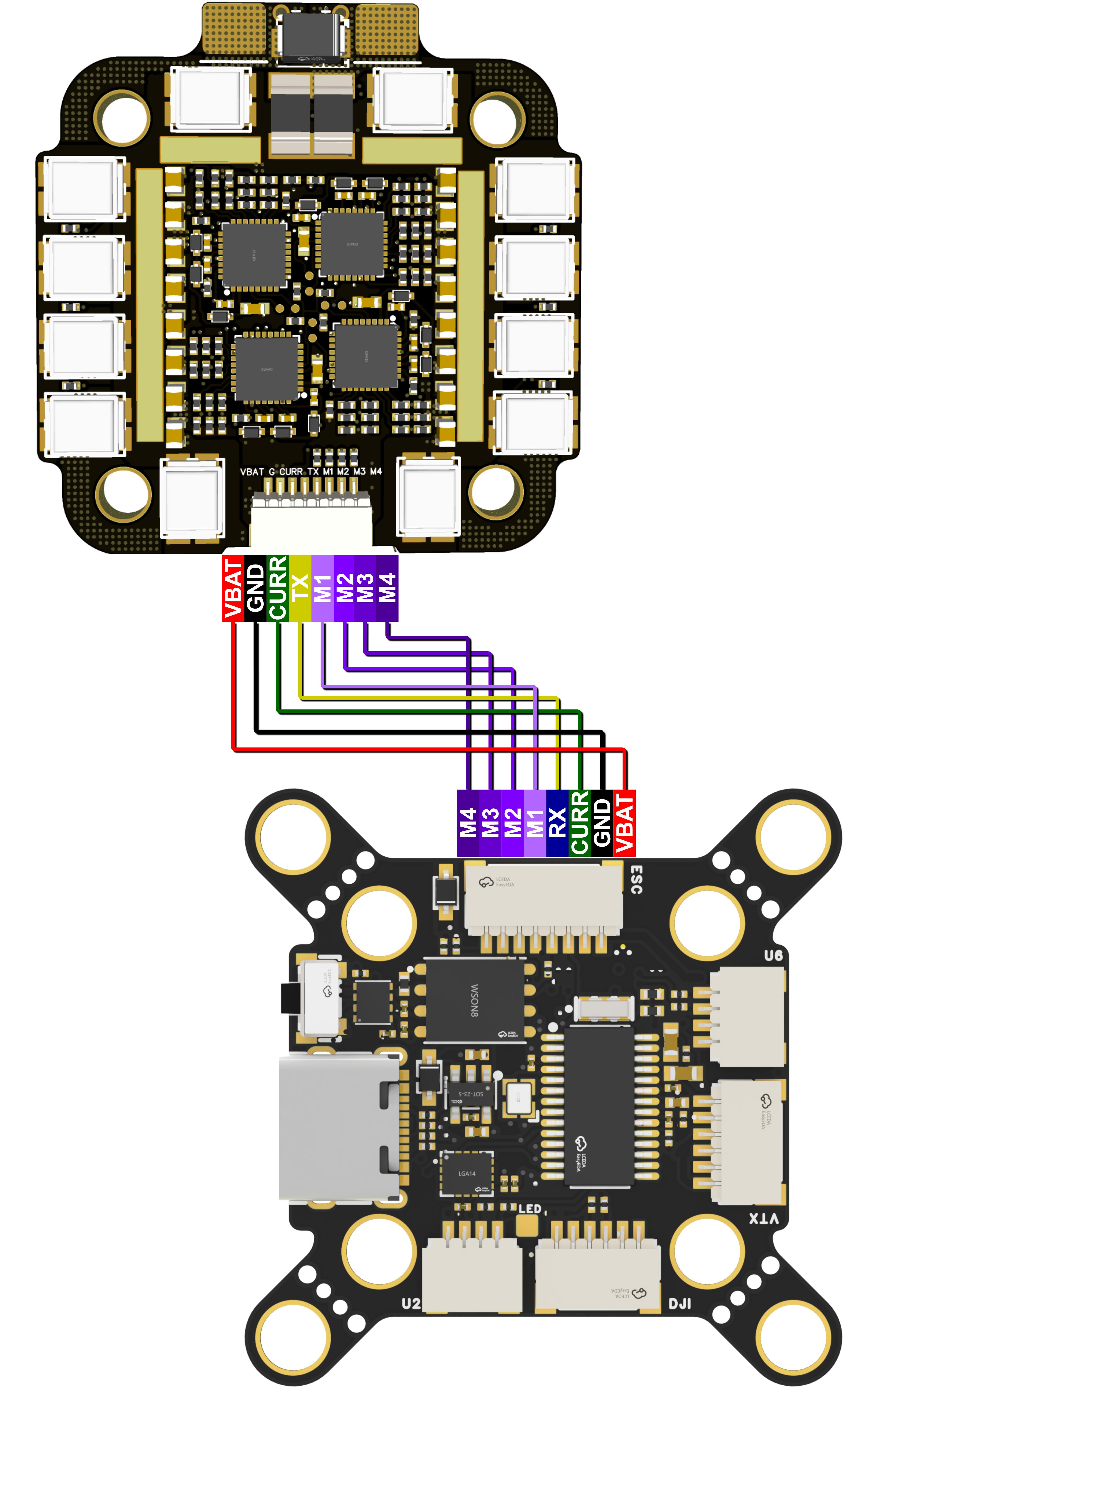
Connection with FlyingRC® 4IN1 75A Gold-Sealed ESC
(Note: The ESC is V4.0 Version)

- ELRS Receiver
Note the TX/RX cross-connection: Flight controller TX → Receiver RX; Flight controller RX → Receiver TX

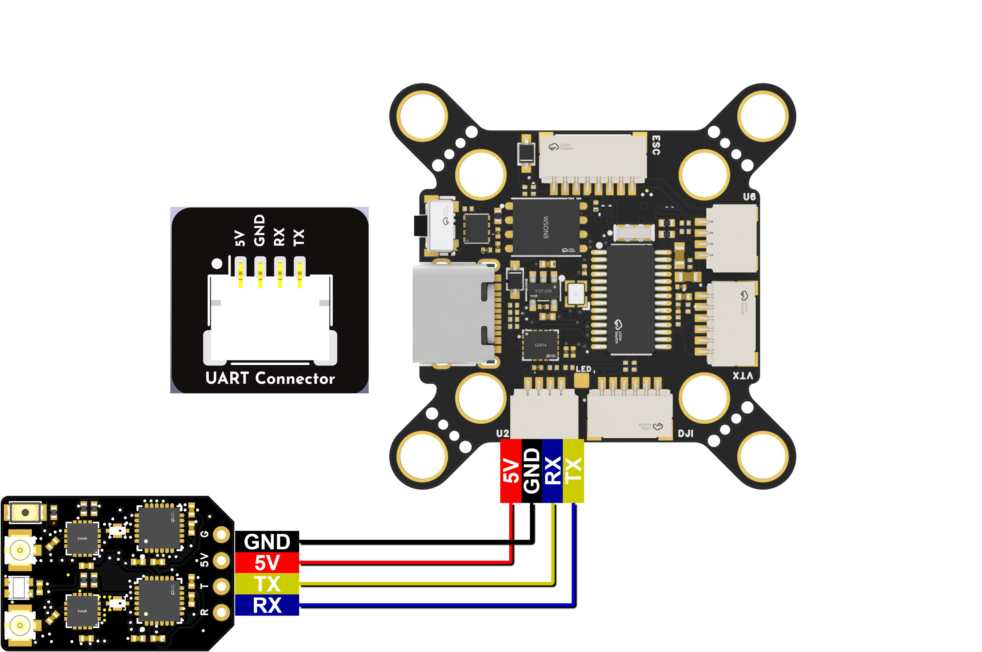

Connection with FlyingRC® ELRS Receiver

- GPS
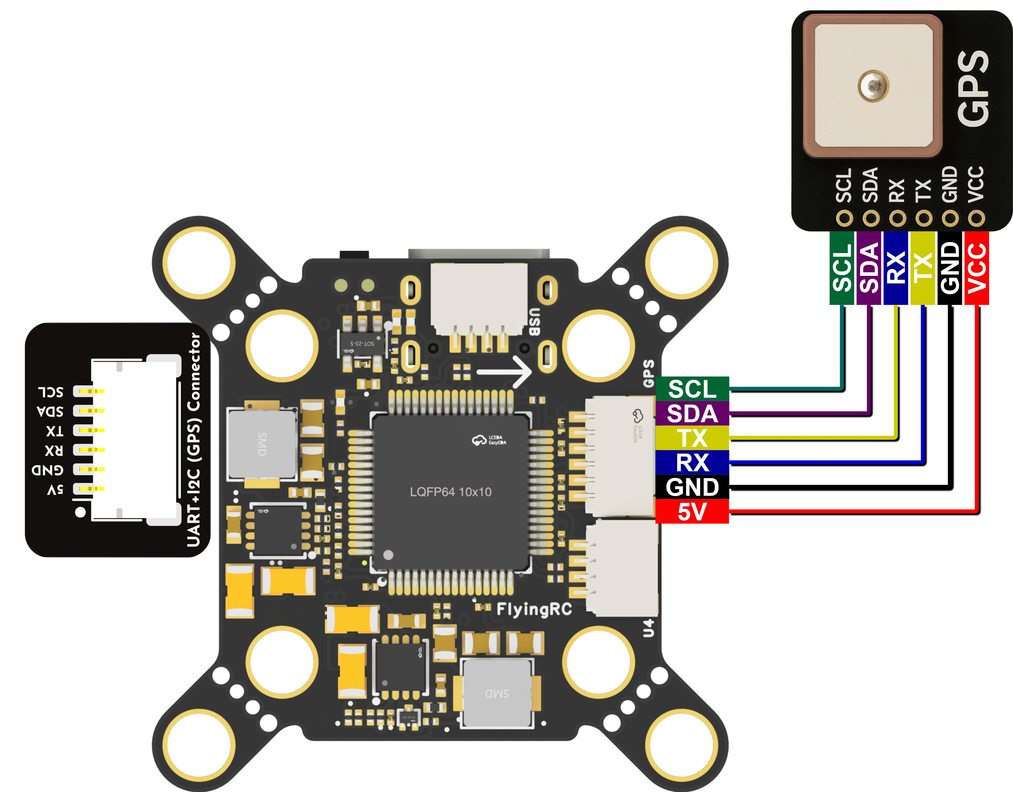

Connection with FlyingRC® GPS

- Digtital VTX
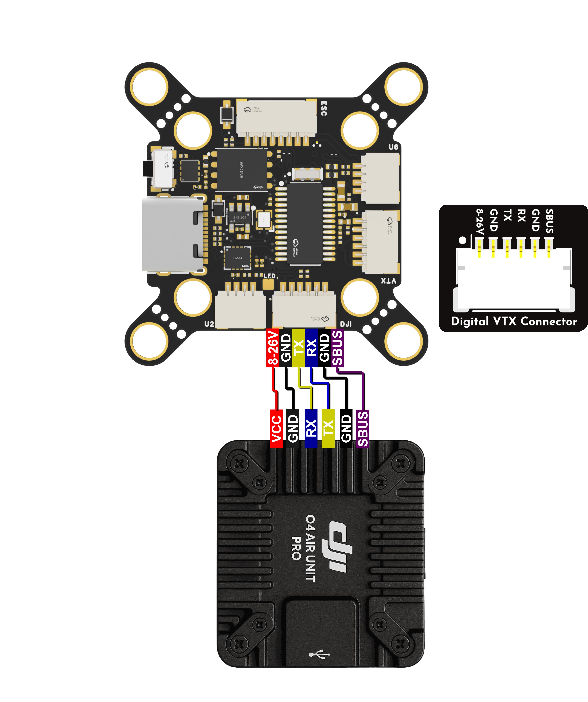
Connection to Digital Video Transmission (SBUS supported on F4D Flight Controller)

- Analog Camera and VTX
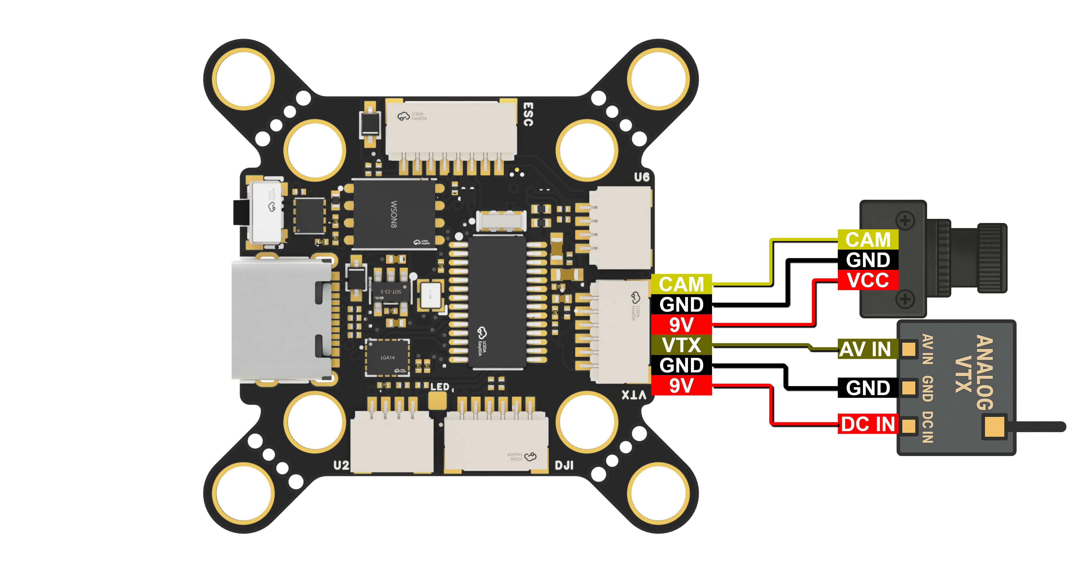
Connection with Analog Camera and VTX

Firmware Flashing of the Flight Controller
BF, AP, and INAV firmwares are recommended. The factory default firmware is BF.
The following wiring instructions use BF firmware as an example.
Download links for the latest stable version (as of 2025/06/15)：
ArduPlane4.6.1 Matek F405-TE ArduPlane4.6.1
Matek F405-TE(Download）
ArduCopter4.6.1 Matek F405-TE ArduCopter4.6.1
Matek_F405-TE(Download）
INAV: Matek F405TE
BF:
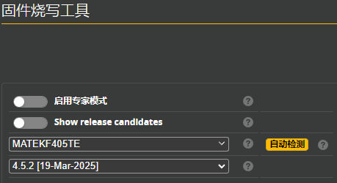

BF Firmware Flashing Tutorial: Bilibili Column ---- Ardupilot Fixed-Wing - Flight Controller Firmware Flashing and Version Update

Please note: Limited technical support is provided for BF and Ardupilot; no technical support is available for INAV.

Detailed Explanation of the Flight Controller Interfaces ：
- UARTs（UARTx 、Serialx）
!!! Note: In Ardupilot firmware, Serial numbers do not correspond one-to-one with UART/USART numbers. Refer to the correspondence table below. !!!
Ardupilot UART Mapping
PCB Silkscreen | UART Number | Config | Protocol | SERIAL_X
USB | USB | USB |  | SERIAL0
DJI | UART1 | telem1 | with DMA | SERIAL1
U2 | UART2 | RC input/Receiver | CRSF | SERIAL6
ESC (R3) | UART3 | ESC Telemetry | NO DMA | SERIAL2
U4 | UART4 | User Define | NO DMA | SERIAL4
GPS | UART5 | GPS | NO DMA | SERIAL3
U6 | UART6 | User Define | TX6 with DMA | SERIAL5
Ardupilot UART Correspondence Table

!!! Note: After wiring, the flight controller parameters must be adjusted accordingly. For example, in the above sample diagram, if the GPS is connected to R2 and T2, you can find in the UART correspondence table that R2 and T2 correspond to Serial3. In this case, set Serial3_Protocol to GPS, and ensure that the function of other ports is not set to GPS. !!!

If using receivers with non-SBUS/PPM protocols such as ELRS on Serial7, set brd_alt_config to 1.
- PWM Output Functions
PWM Channels
PWM Group | PWM Channels | GPIO | Timer | DMA/DShot
Group1 | S1 | PWM1 GPIO50 | TIM8_CH4 | DMA/DShot
Group1 | S2 | PWM2 GPIO51 | TIM8_CH3 | DMA/DShot
Group2 | S3 | PWM3 GPIO52 | TIM1_CH3N | DMA/DShot
Group2 | S4 | PWM4GPIO53 | TIM1_CH1 | DMA/DShot
PWM Output Function Table

PWM ports in the same group cannot be used simultaneously for Dshot ESCs and 50Hz PWM servos

- I2C Bus
I2C
I2C number | Config | Parameterl | Value
I2C1 | Compass | COMPASS_AUTODEC | 1
I2C1 | onboard Baro DPS310 / DSP368 | Address | 0x76
I2C1 | Digital Airspeed I2C | ARSPD_BUS | 1
I2C1 | MS4525 | ARSPD_TYPE | 1
I2C1 | DLVR-L10D | ARSPD_TYPE | 9
I2C Bus Table

- ADC Analog Signal Inputs
ADC
Pin | Voltage Tolerance | Definition | Config | Value
Vbat | 1K:20K divider builtin | on board battery voltage | BATT_VOLT_PIN | 14
Vbat | 0~28V | on board battery voltage | BATT_VOLT_MULT | 21
Curr | 0~3.3V | on board current sensor | BATT_CURR_PIN | 15
Curr | 0~3.3V | on board current sensor | BATT_AMP_PERVLT | 66.7

ADC Analog Signal Input Table

Betaflight General Parameter Settings:
Gyro installation orientation: CW90Flip

Ardupilot General Parameter Settings:
LOG_BACKEND_TYPE = 4 (enables TF card black box function to record flight logs)
BATT_VOLT_PIN 10
BATT_VOLT_MULT 11.0，(Default voltmeter scaling factor, with a 5% error margin; additional calibration is unnecessary.)
BATT_CURR_PIN 11

INAV General Parameter Settings:
Default voltmeter scaling factor 1100

Other FlyingRC® Products
 |  |  |  | - FlyingRC® F4WSE Pro - F405 Fixed-Wing Flight Controller  Upgraded Version | Enhanced Performance  Manual：https://www.kdocs.cn/l/cavm9EoVEq5A |  |  | 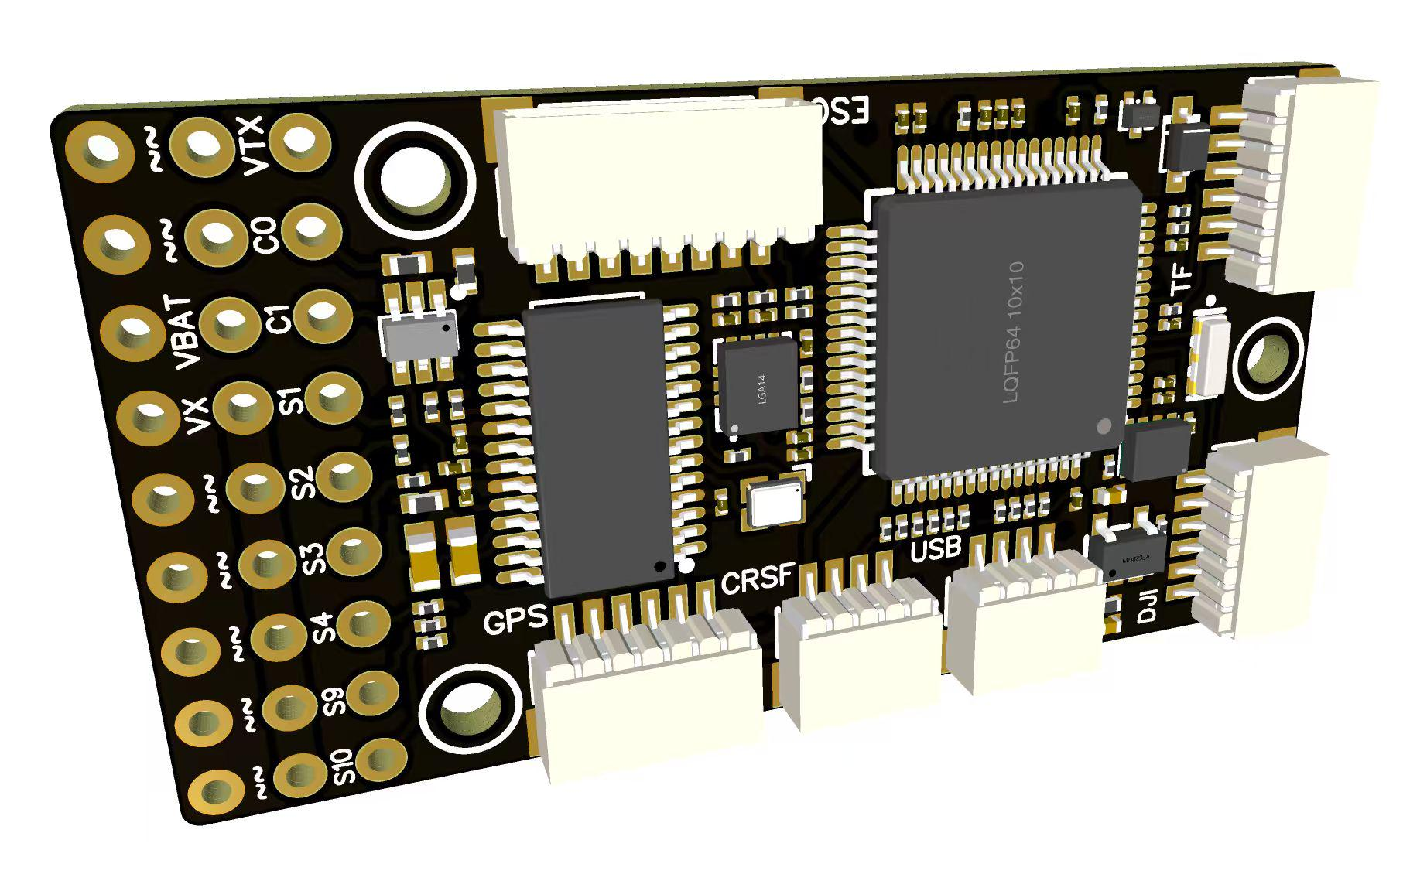
 |  |  | - FlyingRC® F4WSE MK1.5 - F405 Fixed-Wing Flight Controller  Classic model, unique design, highly acclaimed.  Manual：https://kdocs.cn/l/cpyd8MTS56DD |  |  | 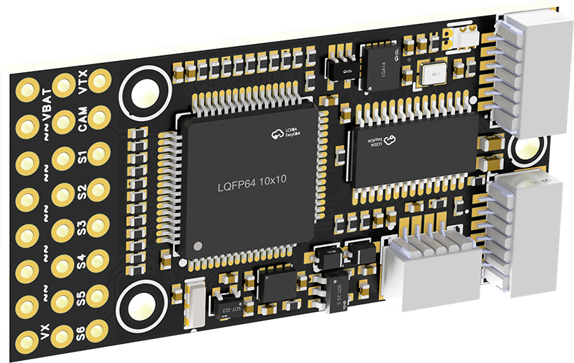
 |  |  |  | - FlyingRC® H7Wlite MK1 H743 Fixed-Wing Flight Controller  Flagship performance, full expansion, high-power BEC.  Manual：https://kdocs.cn/l/cpYaBiFKh8U1 |  |  | 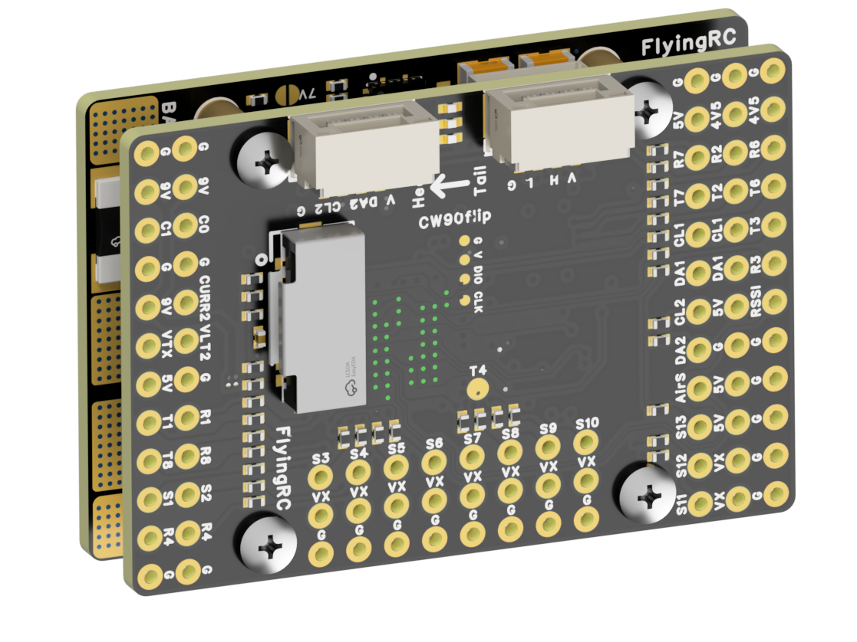
 |  |  |  | - FlyingRC® F4Wing Mini MK1 F405 Fixed-Wing Flight Controller  2025 bestseller, ultra-compact, smallest on the market, great value.  Manual：https://kdocs.cn/l/cdUIdmpSpW7J |  |  | 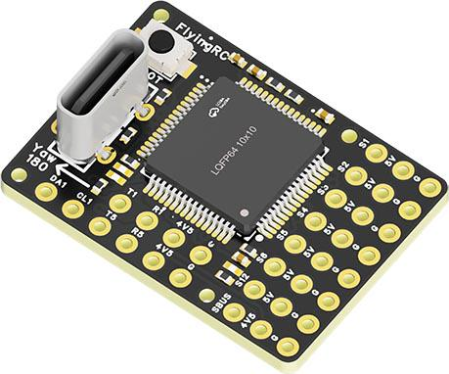
 | - FlyingRC® AM32 Dual ESC 40A 2-in-1 ESC  Unique design for dual-power aerial, land and water vehicles including drones.  Manual：https://www.kdocs.cn/l/cjwNtsKK6HeR |  |  |  | 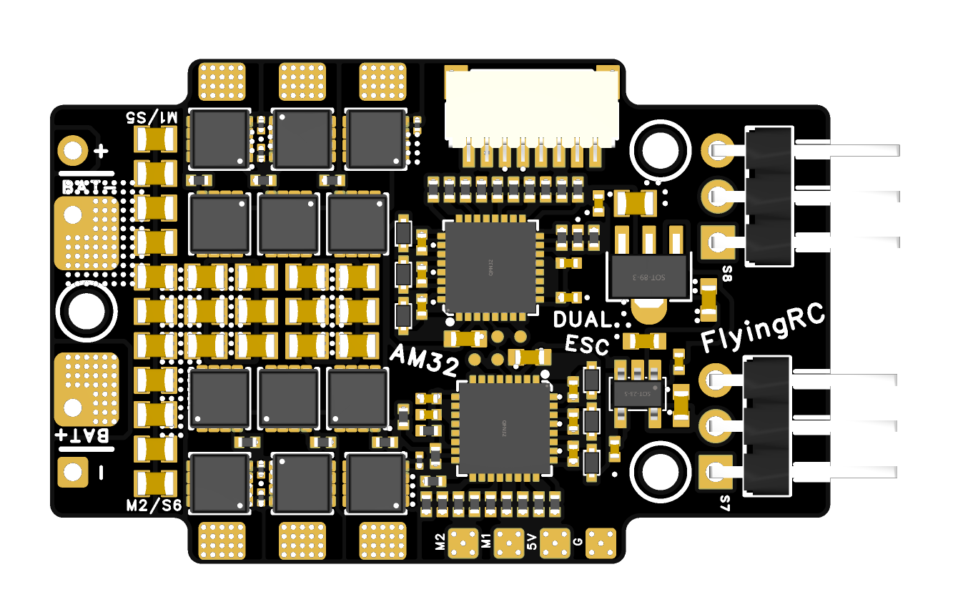
 |  |  | - FlyingRC® AM32 ESC V2.5 75A - Single ESC  Infineon gold-package MOSFETs, premium materials, superior heat dissipation.  Manual：https://kdocs.cn/l/cv6hUy67IdTJ |  |  |  | 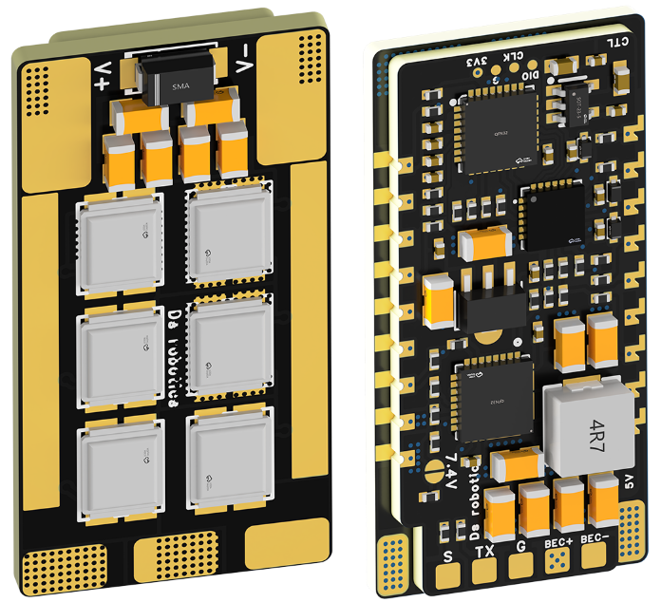
 |  |  | - FlyingRC® AM32 Mini ESC 40A V1.0 - Single ESC  Ultra-miniature, ideal for micro drones, high over-current capability, stable operation.  Manual：https://kdocs.cn/l/cqdLSysEyWFh |  |  |  |  | 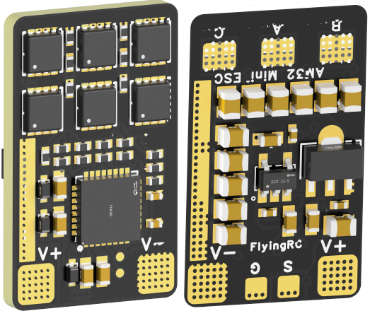
 |  |  | - FlyingRC® 10A 12S 440A Power Distribution Board for FPV Drones  Industry top choice, excellent quality and affordable price.  Manual：https://kdocs.cn/l/coel7OgrlCBP |  |  |  |  | 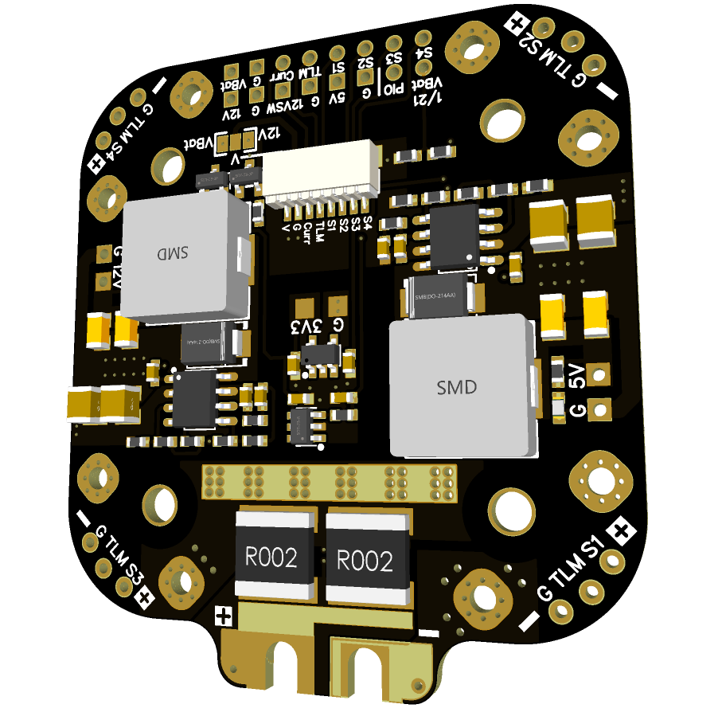
 |  |  | - FlyingRC® H7D Pro MK1 H743 FPV Flight Controller with Dual Gyro  Fully Upgraded & More Powerful  Manual：https://www.kdocs.cn/l/ctcekCy676Ez |  |  |  | 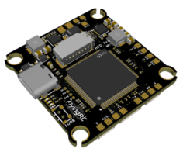
 |  |  | - FlyingRC® H7D MK1 H743 FPV Flight Controller with Dual Gyro  Powerful computing, stable and precise flight, rich interfaces, smooth control.  Manual：https://kdocs.cn/l/cqMh1I0RwAoD |  |  |  | 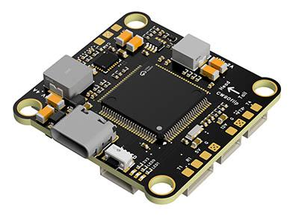
 |  |  | - FlyingRC® F420 MK1 F405 FPV Flight Controller (20/30.5mm Mounting)  Dual mounting holes, all connectors, no soldering required, compliant with Betaflight interface standards.  Manual：https://kdocs.cn/l/ctGeLiN9ZYKj |  |  |  | 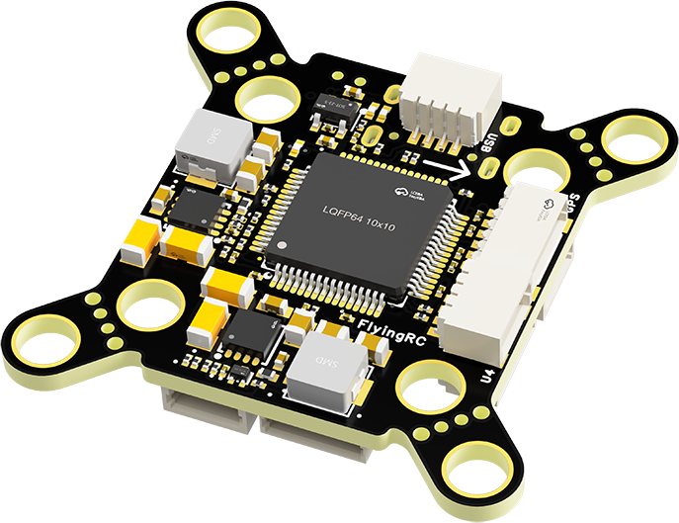
 |  | - FlyingRC® 4-in-1 75A V3.2 Gold-Sealed FPV ESC  Infineon gold-package MOSFETs, superior heat dissipation & over-current capability, premium choice.  Manual：https://kdocs.cn/l/ceLilc8Gaa21 |  |  |  |  | 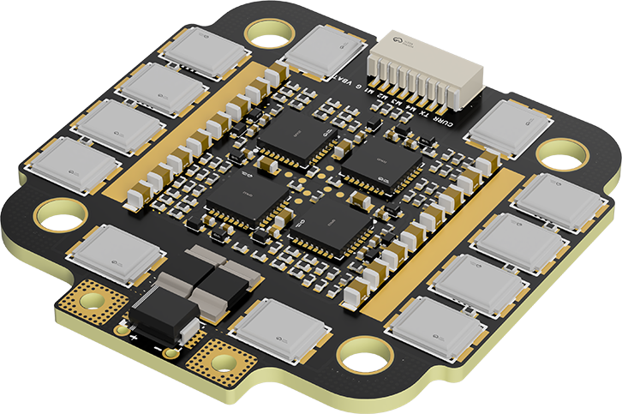
- FlyingRC® Stack Combo: H743 Flight Controller + 4-in-1 75A Gold-Sealed ESC  Professional flight choice, flagship materials & craftsmanship, reasonable price.  Manual：https://www.kdocs.cn/l/ctcekCy676Ez  https://kdocs.cn/l/ceLilc8Gaa21 |  |  |  |  |  |  | 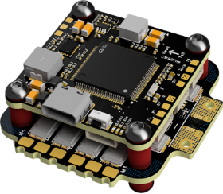
 |  | - FlyingRC® Stack Combo: F405 Flight Controller + 4-in-1 75A Gold-Sealed ESC  Best-selling combo, excellent performance, affordable price.  Manual：https://kdocs.cn/l/ctGeLiN9ZYKj  https://kdocs.cn/l/ceLilc8Gaa21 |  |  |  |  | 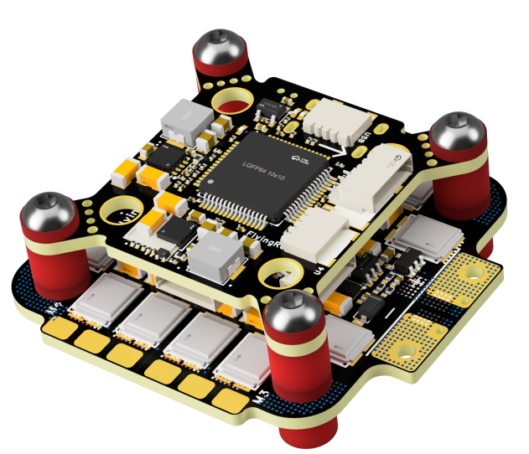
 |  | - FlyingRC® Stack Combo: H743 Flight Controller + 4-in-1 45A ESC  Winning combo: great performance, budget-friendly price  Manual：https://www.kdocs.cn/l/ctcekCy676Ez  https://kdocs.cn/l/ceLilc8Gaa21 |  |  |  |  | 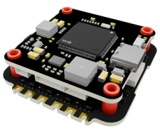
 |  | - FlyingRC® Stack Combo: F405 Flight Controller + 4-in-1 45A ESC  Hit combo, great value, budget-friendly  Manual：https://kdocs.cn/l/ctGeLiN9ZYKj  https://kdocs.cn/l/ceLilc8Gaa21 |  |  |  |  | 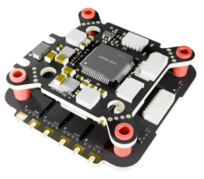
 |  | - FlyingRC® Stack Combo: F4WSE Pro - F405 Fixed-Wing Flight Controller + AM32 Dual ESC 40A 2-in-1 ESC  Unique Design • Exclusive Offer • Bestselling Bundle  Manual：https://www.kdocs.cn/l/cavm9EoVEq5A  https://www.kdocs.cn/l/cjwNtsKK6HeR |  |  |  |  | 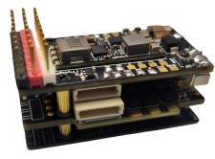
 | - FlyingRC® ELRS 2.4G Diversity Receiver  True diversity reception, temperature compensation, high-sensitivity reception.  Manual：https://kdocs.cn/l/cbvlOlShmsPS |  |  |  |  |  | 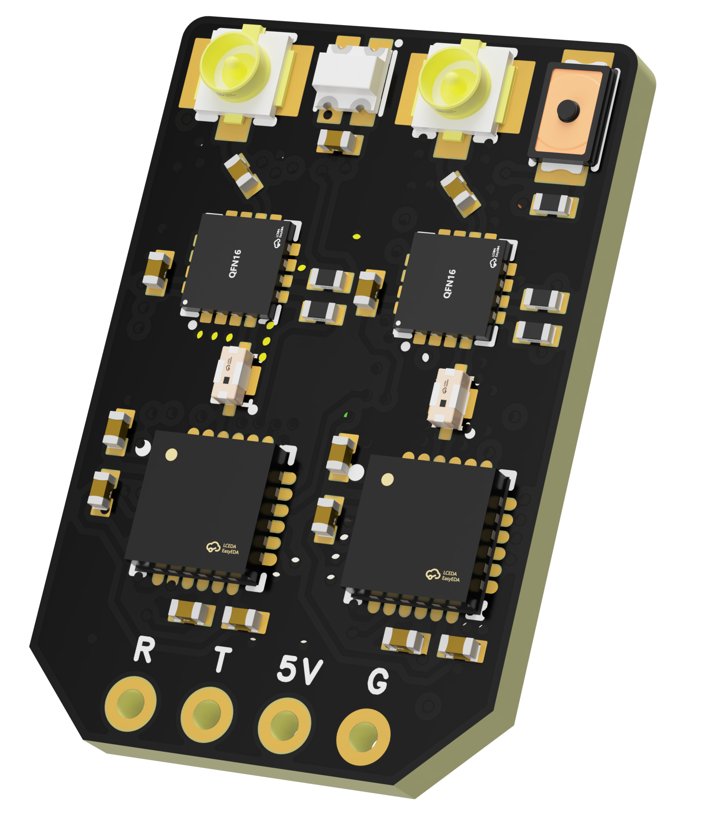
 | - FlyingRC® RM3100 SPI Module 罗盘模块  Ultra-high Resolution • Low Power • Industry Top Choice  Manual：https://www.kdocs.cn/l/cdGuHvBVyndC |  |  |  |  |  | 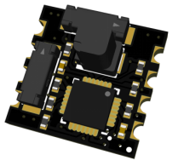
 | - FlyingRC® 10A 12S BEC Step-Down Module  Wide voltage input, high power, compact size, multiple voltages available, 10A continuous output.  Manual：https://kdocs.cn/l/clssNCKgNhLV |  |  |  |  |  | 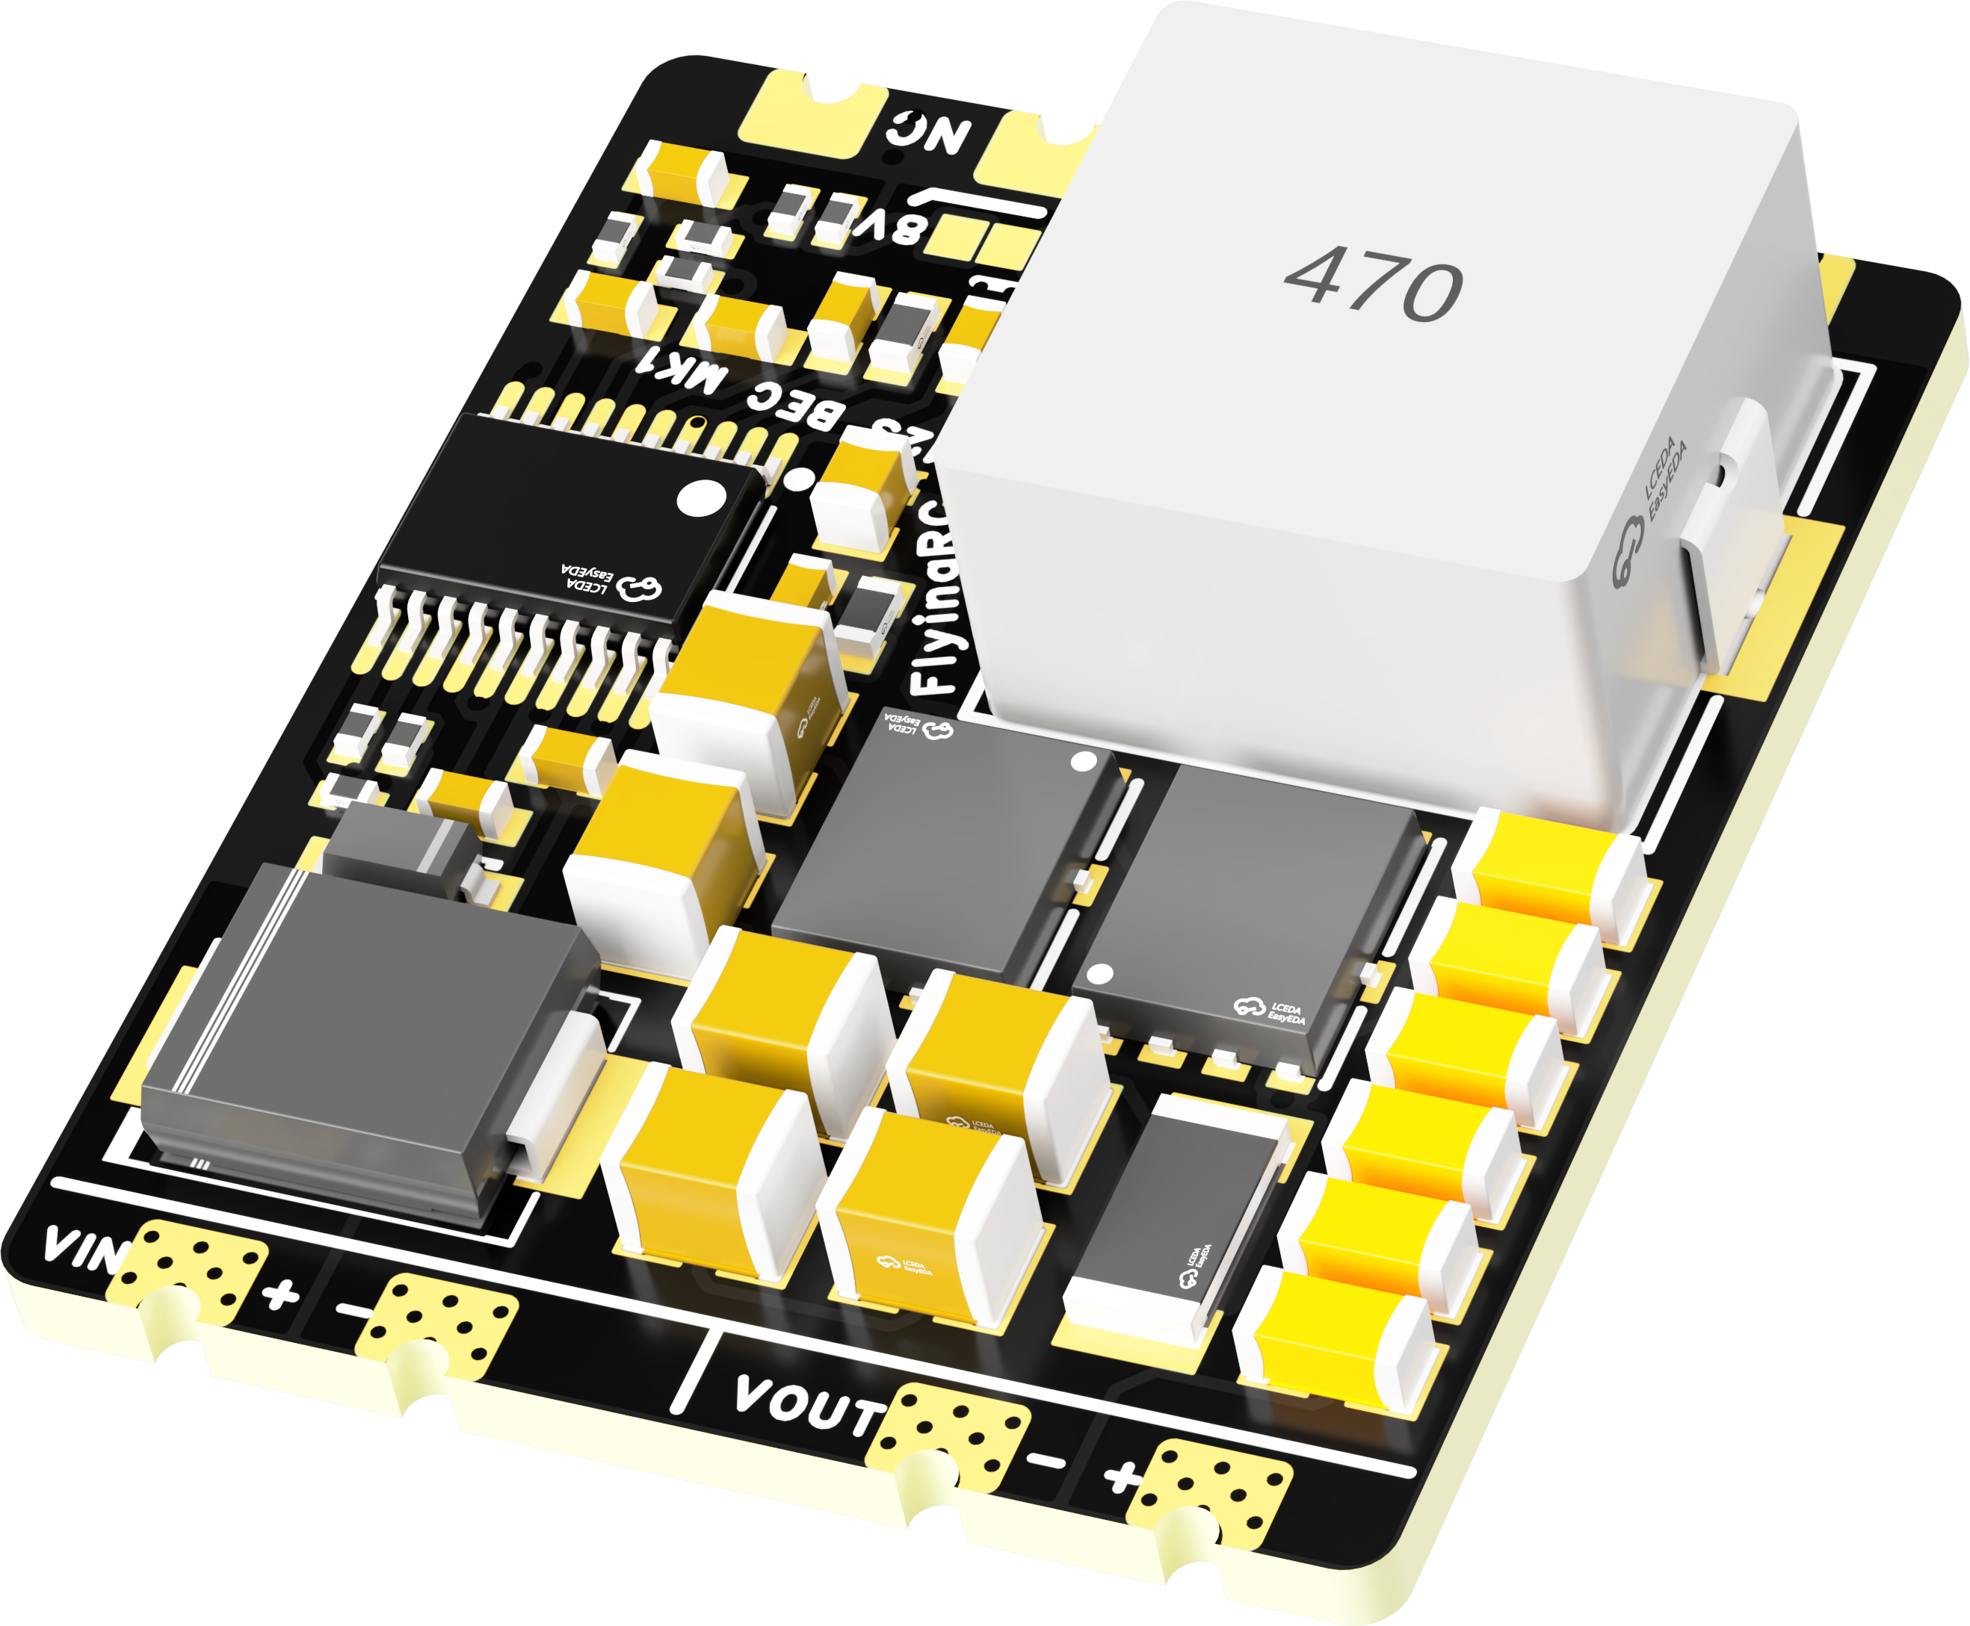
 | FlyingRC® 5A BEC Step-Down Module  Ultra-small size, multiple voltages available, 5A continuous output.  Manual：https://kdocs.cn/l/cb9VdNywqCKA |  |  |  |  |  | 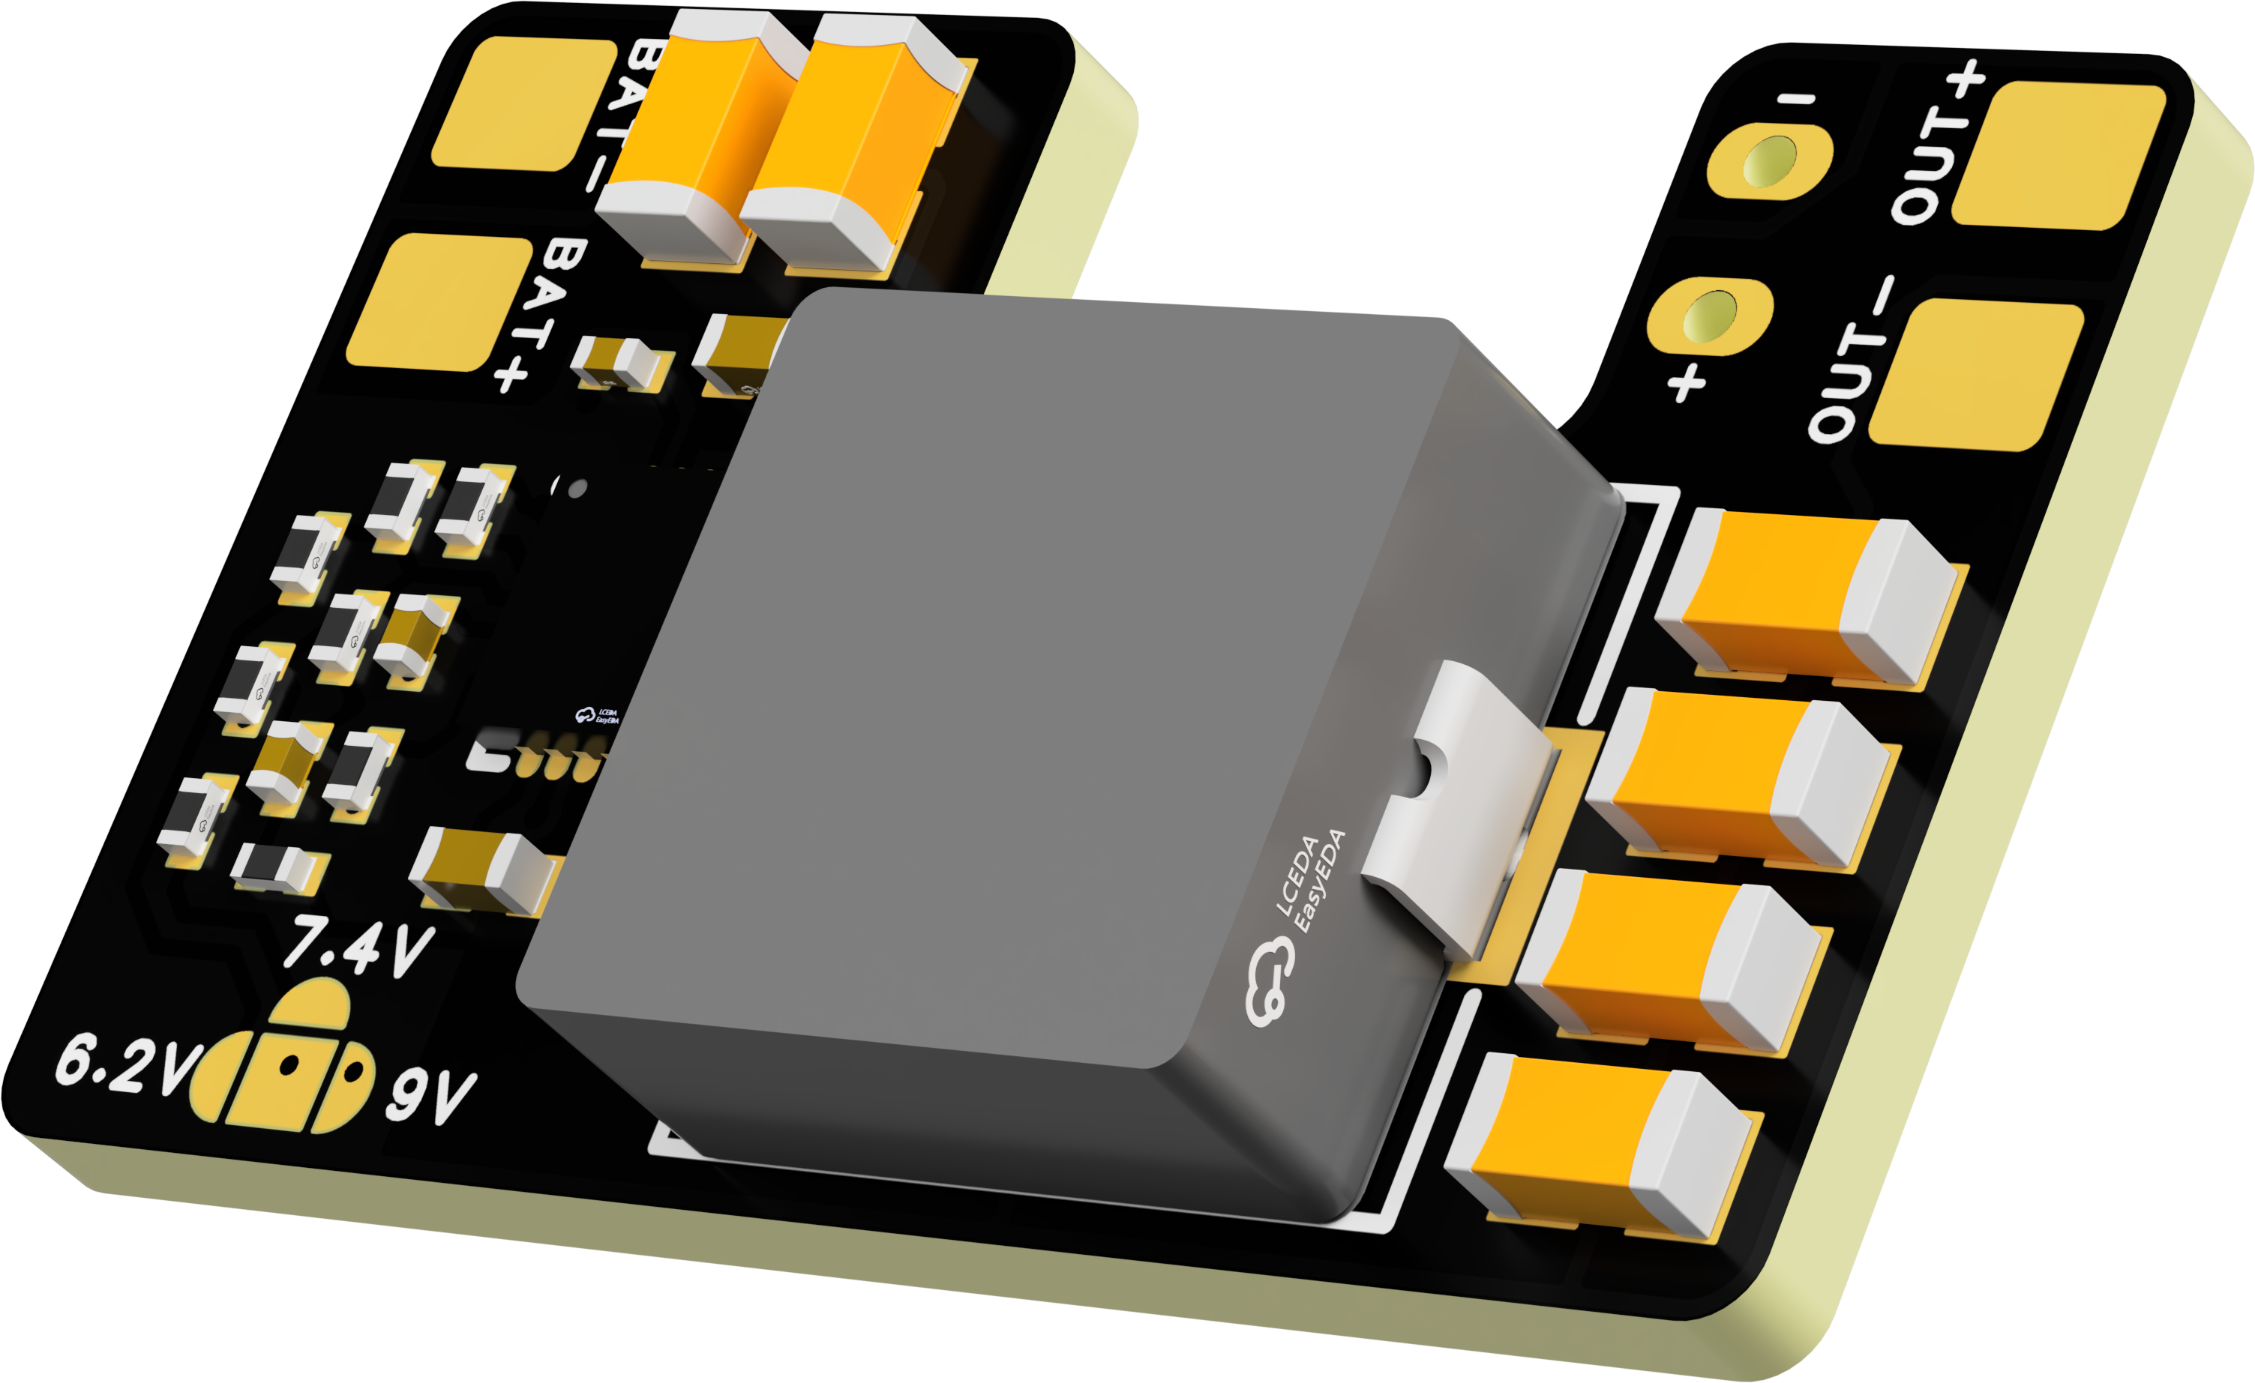
 | FlyingRC® Mini BEC For DJI O4  Easy wiring, ultra-small size, stable power supply.  Manual：https://www.kdocs.cn/l/ckkebieur37K |  |  |  |  |  | 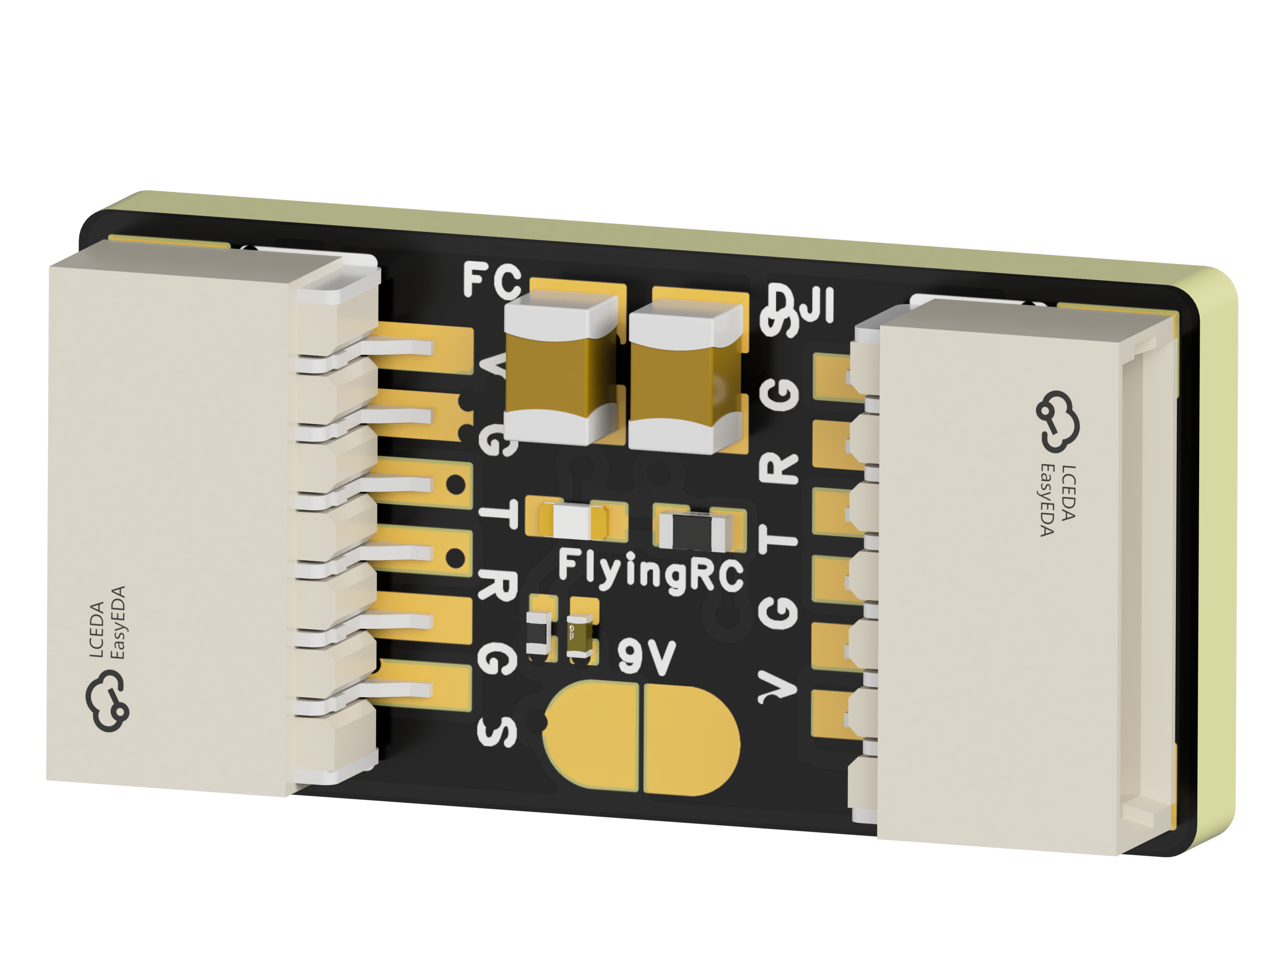
 | FlyingRC® CAN Bus Serial & PWM Expansion Board  Long-distance transmission, high speed, excellent stability.  Manual：https://www.kdocs.cn/l/cmxRyBnU4BXj |  |  |  |  |  | 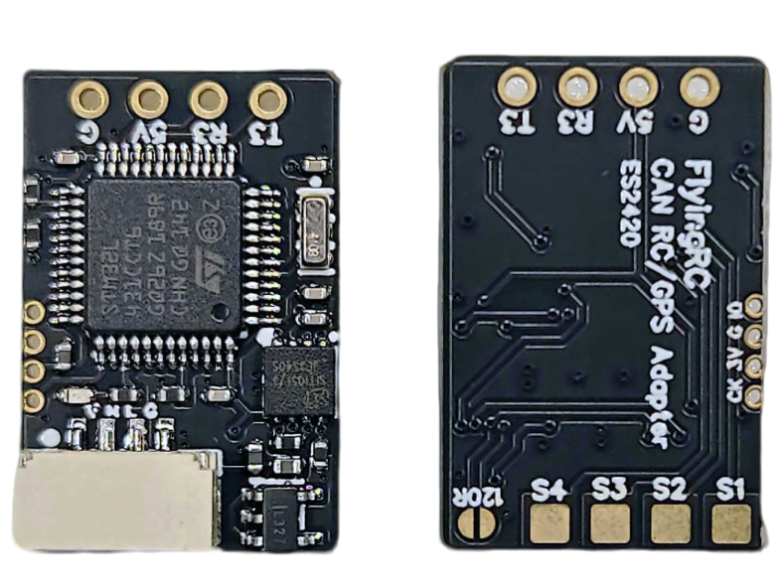
 | FlyingRC® AM3 2ESC Programmer  Supports BL, BL32, AM32. Simple and easy to use.  Manual：https://kdocs.cn/l/cogBSEBe67mE |  |  |  |  |  | 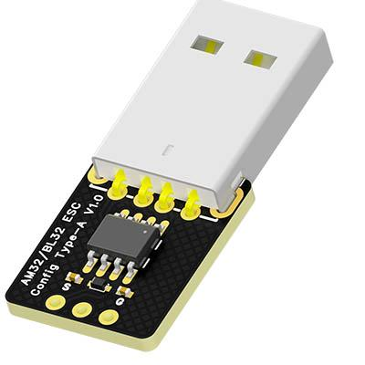
 | FlyingRC® Digital Airspeed Sensor without Pitot Tube  Integrated design, smallest on the market. MS4525D protocol, I2C interface.  Manual：https://www.kdocs.cn/l/clPvEEEcJgCC |  |  |  |  |  | 
 | FlyingRC® U-Blox M10 GPS  Compatible with all open-source flight controllers.  Manual：https://www.kdocs.cn/l/cdSYQrzx74O8 |  |  |  |  |  | 