FlyingRC® F4Wing Mini MK1 Fixed-Wing Flight Controller Product Manual

FlyingRC® is a globally-oriented professional brand of electronic devices. We specialize in the R&D and sales of drone electronics, core robot circuits and sensors. Our design team is based in Singapore, and our products are sold worldwide.

Since launched in 2023, FlyingRC® products have gained widespread recognition from customers as well as strong market response. As of April 2026, our cumulative sales volume has exceeded 46,000 units. Our products are widely applied in industries, robotics, emergency rescue, environmental protection & inspection, aerial photography, public security, retail and many other fields. Above all, we are committed to distinctive design and superior reliable quality.

Our Chief Technology Officer Liu Yuhan possesses outstanding expertise in circuit design. Over the past four years, he has designed more than 80 circuit projects and contributed 39 to open-source platforms. Moreover, he won the Design Award on the open-source platform X.JLC.com twice in 2023 and 2024, and has become the youngest certified designer on this platform.

He holds the NUS (National University of Singapore, rank 8th worldwide) Science and Technology Scholarship, and is currently majoring in Electronic Engineering with a focus on Aerospace Technology. In addition, all members of our technical team are graduates from prestigious universities with extensive professional product experience.

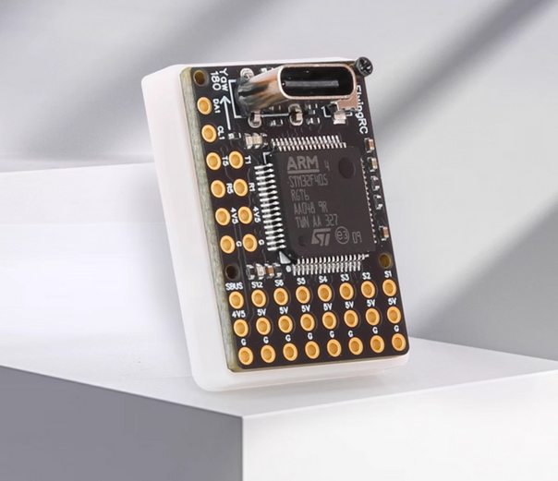
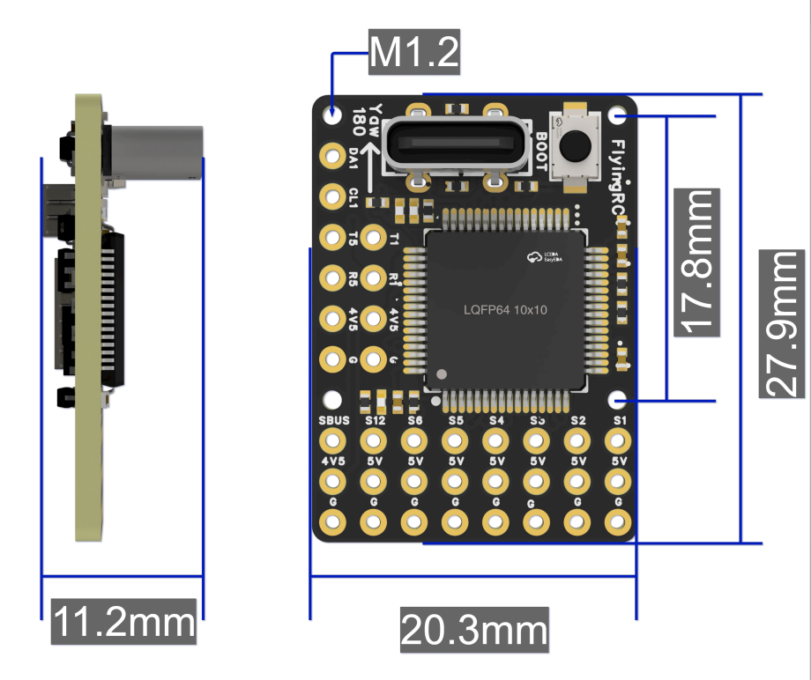
Flight Controller Overview:
- MCU: STM32F405RGT6
- Gyroscope: ICM42688P / ICM42605
- Barometer: SPL06-001 / SPA06-003
- Dual on-board LDOs with independent power supply for sensors, ensuring more stable flight.
- HD OSD (On-Screen Display), 3×UARTs, 1×SBUS, 6×PWM, 1×I2C
- Current Meter: External I2C current meter
- Voltage Range: 2.5–30V, 1–6S LiPo
- Power Input: 5V
- Dimensions: 27.9mm×20.3mm×11.2mm
- Weight: 2.8g (without soldered headers), 5.3g (with soldered headers)
FlyingRC F4Wing Ultra-Mini Fixed-Wing Flight Controller Packing List
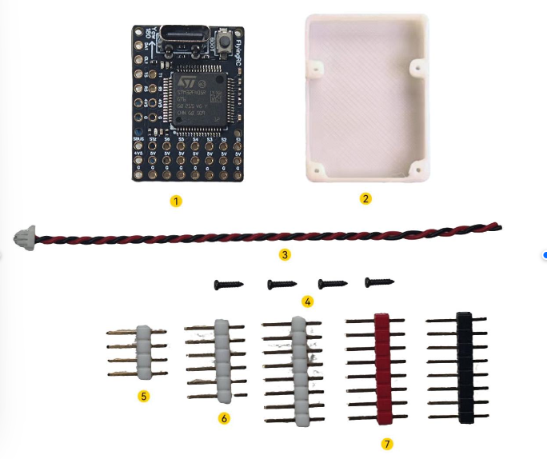
① Flight Controller
② 3D-Printed Mount Base
③ Voltage Detection & VTX Power Cable (Direct Battery Connection)
④ Mounting Screws for FC & Base (Size M1.2*5) *4
⑤ 4-Pin Gold-Plated Pin Header *1
⑥ 6-Pin Gold-Plated Pin Header *1
⑦ 8-Pin Gold-Plated Pin Header *3 (1 each in White, Red, Black)

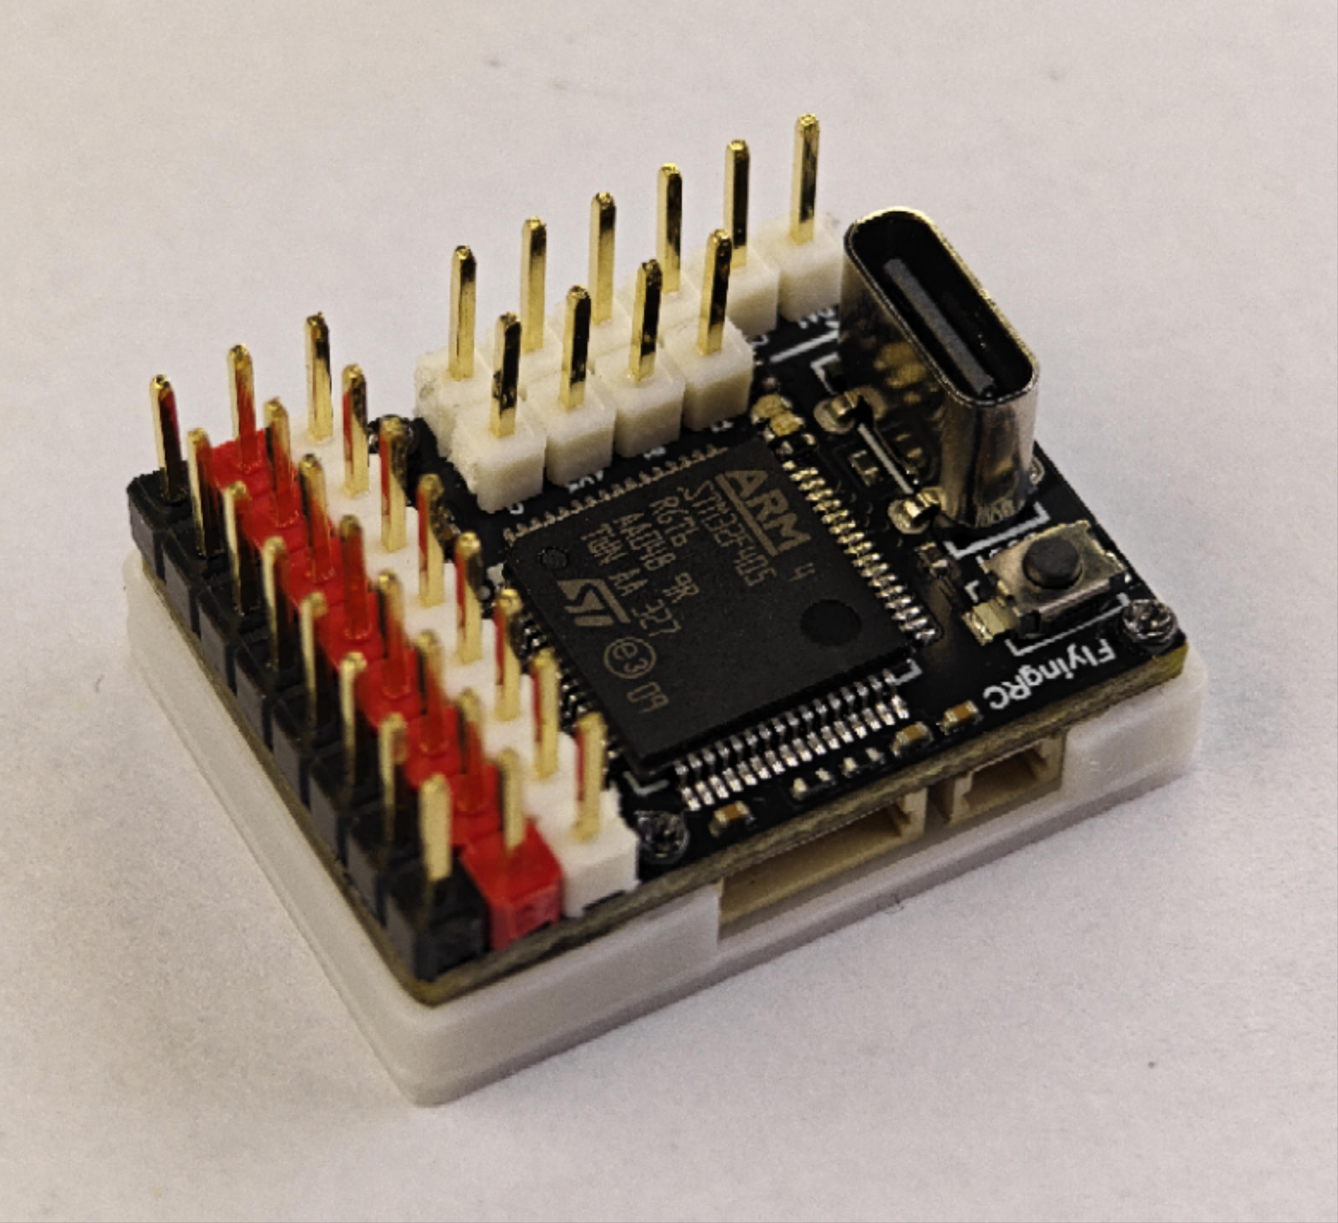
Photo of the flight controller with soldered pin headers and mounted base
Product Features:
- Ultra-Mini Size: 27.9×20.3×11.2mm, only 2.8 g (without pin headers) / approx. 5.3 g （with pin headers soldered）.
- Suitable for small and micro fixed-wing aircraft, such as the F80, Micro Claw, and modified hand-thrown models like the Arwing Mini., etc.
- MCU STM32F405RGT6 (M4 core, 168MHz clock frequency, 1MB Flash): Over 5× higher performance than closed-source mini flight controllers equipped with STM32F0 series MCUs from competitors.
- Gyroscope ICM42688P / ICM42605 (3rd-gen TDK sensor), optimized for Fixed-Wing UAV applications.
- Barometer SPL06 / SPA06: high-precision barometer.
- Dual on-board LDOs with independent power supply for sensors, ensuring more stable flight.
- 7×PWM outputs, 3.5×UARTs (SBUS uses half a UART).
- Features a Type‑C connector for stable connection and extended service life; the FC can connect to a smartphone via a USB‑C to USB‑C cable for parameter tuning using a mobile ground station (QGroundControl App recommended for ArduPilot firmware).
- No on-board analog current sensor (external I2C current sensor supported). The SH1.0 2P connector accepts battery voltage input exclusively for the HD VTX direct plug-in port, supporting up to 6S. The flight controller requires external 5V power supply.
- Supports direct plug-in for HD VTX (SH1.0 6P connector) and HD OSD (e.g., DJI HD, Walksnail HD, OpenIPC, etc.). Analog OSD is not supported.
- Supports direct plug-in for ELRS receivers for ultra-compact size.
- Compatible with open-source firmware including AP, BF, INAV, etc. AP firmware is recommended for fixed-wing aircraft, with detailed tutorials and professional support available in our user group.
- JLCPCB SMT Mass production. PCB specs: 4-layer, black solder mask, immersion gold, resin plug holes.

Basic Parameters |  | Sensors
Model | FlyingRC® F4Wing Mini | IIMU (Gyroscope & Accelerometer) | ICM42688P / ICM42605
Dimensions | 27.9mm*20.3mm*11.2mm | Barometer | SPA06 / SPL06
Mounting Holes | 17.8mm*17.8mm M1.2 | Magnetometer | None
Weight (Unpopulated Pins) | 2.8g | Analog OSD | None
Weight (Soldered Pins | 5.3g
Weight (Soldered Pins + Base) | 6.4g
MCU |  | Power Output
MCU | STM32F405RGT6 | Onboard Step-Down Module (BEC) | None
Core Clock Frequency | 168MHz
Flash | 1MB
RAM | 192k
Interfaces |  | Firmware Support
UART | 3 UARTs (UART1, UART4-DJI HD VTX Port, UART5) | Ardupilot | Supported
PWM | 7 Channels (1 dedicated to LED) | INAV | Supported
I2C | 1 | Betaflight | Supported
Current ADC Sampling | None | PX4 | Not Supported
SWD Debug | None
Buzzer Port | None | Operating Environment
LED Strip Port | WS2812 Supported | VBAT Input Range | 2.5-30V，1-6S LiPo
USB - TYPE - C | Onboard Direct Plug-in | Power Input | 5V
Black Box Storage | None | Operating Temperature Range | -10-100℃
SBUS | 1 | Storage Temperature Range | 0-40℃

Usage Instructions

- Note: Install with the Type-C port facing toward the nose of the aircraft.
LAYOUT：
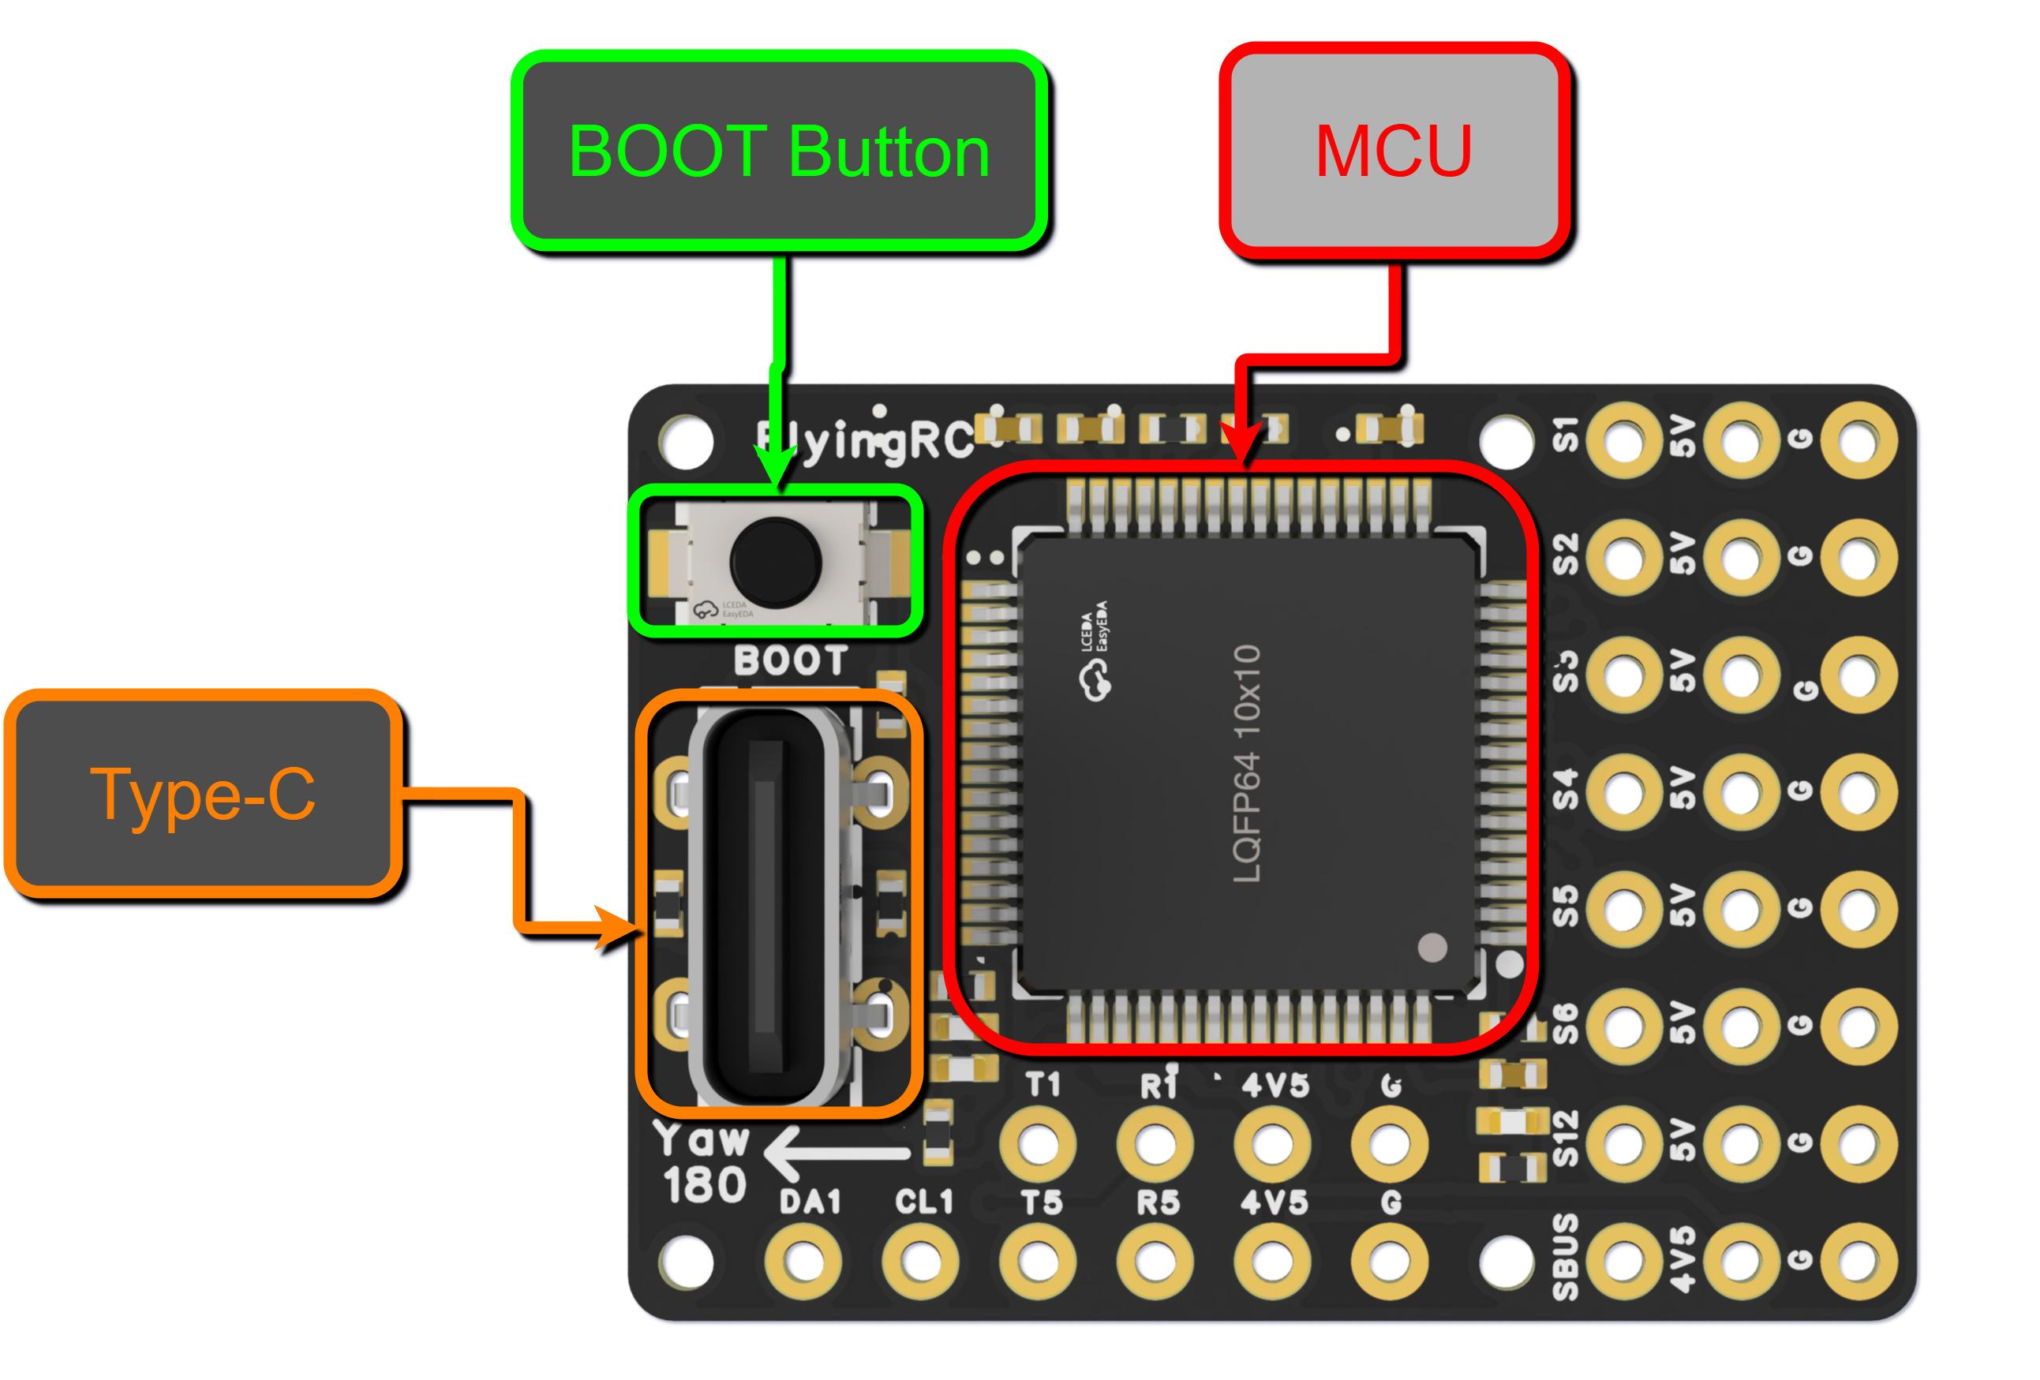
3D Schematic Diagram of the Flight Controller - Front View
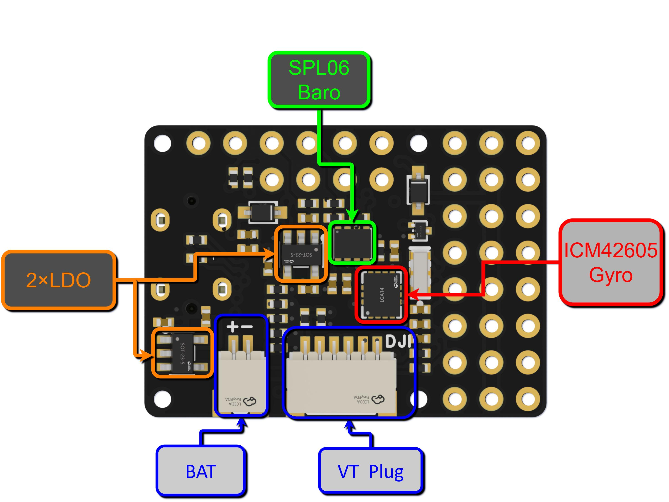
3D Schematic Diagram of the Flight Controller - Rear View
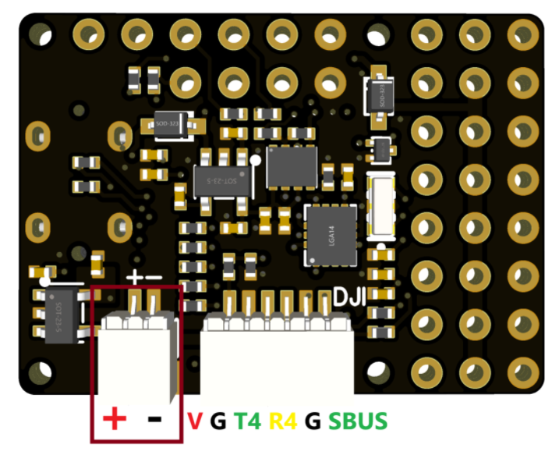
Note: The HD air unit must support battery voltage power input.
Connector Functional Schematic

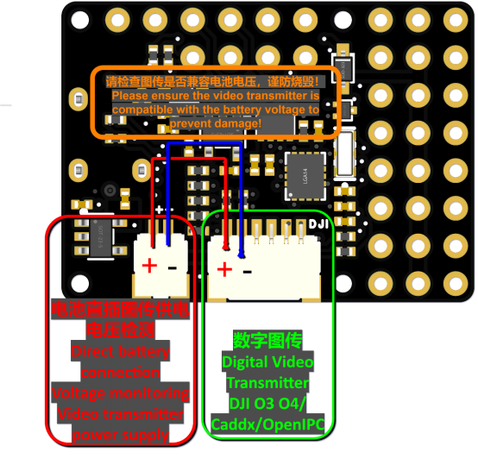

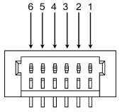
1. Battery Voltage Input Pin Definition。
Pin Number | Pin Name | Pin Definition
1 | - | Connect to the battery negative terminal
2 | + | Connect to the battery positive terminal

2. HD Video Transmission Direct Plug-in Pin Definition
Pin Number | Pin Name | Pin Definition
1 | SBUS | DJI SBUS Remote Control Signal Input (UART8)
2 | G | GND
3 | R4 | OSD MSP RX (UART4)
4 | T4 | OSD MSP
5 | G | GND
6 | V | Battery Direct Connection Power Supply

Flight Controller Wiring and Firmware：
INAV firmware can be downloaded from the group files (with instructions on joining the group at the end of the manual).
ArduPlane firmware (AP) is recommended for fixed-wing aircraft. AP is pre-flashed as default upon factory shipment.
Download link for the latest stable firmware (as of 2025/01/06): AP4.5.7
The following wiring examples will use AP firmware.
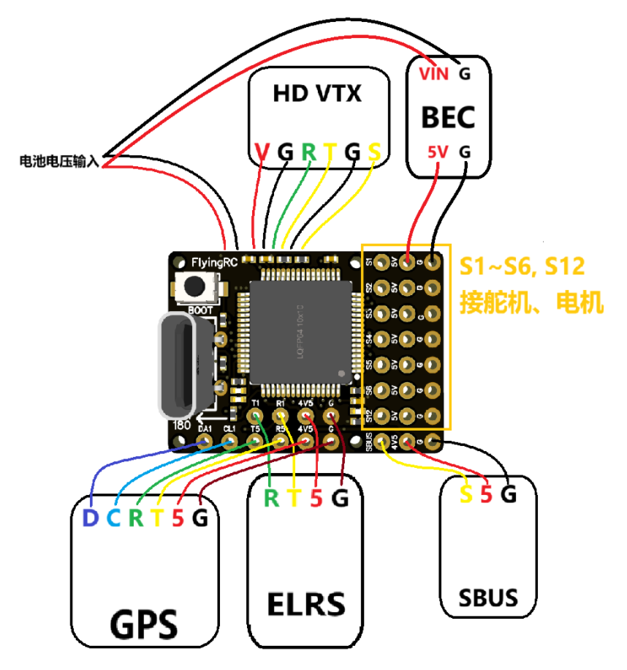
Wiring Diagram for External Independent BEC
（SBUS or ELRS receiver, GPS with compass, HD VTX）
Independent BEC option includes the FlyingRC® 5A BEC V1 available in our online store.
Complete Wiring Diagram for External Independent BEC

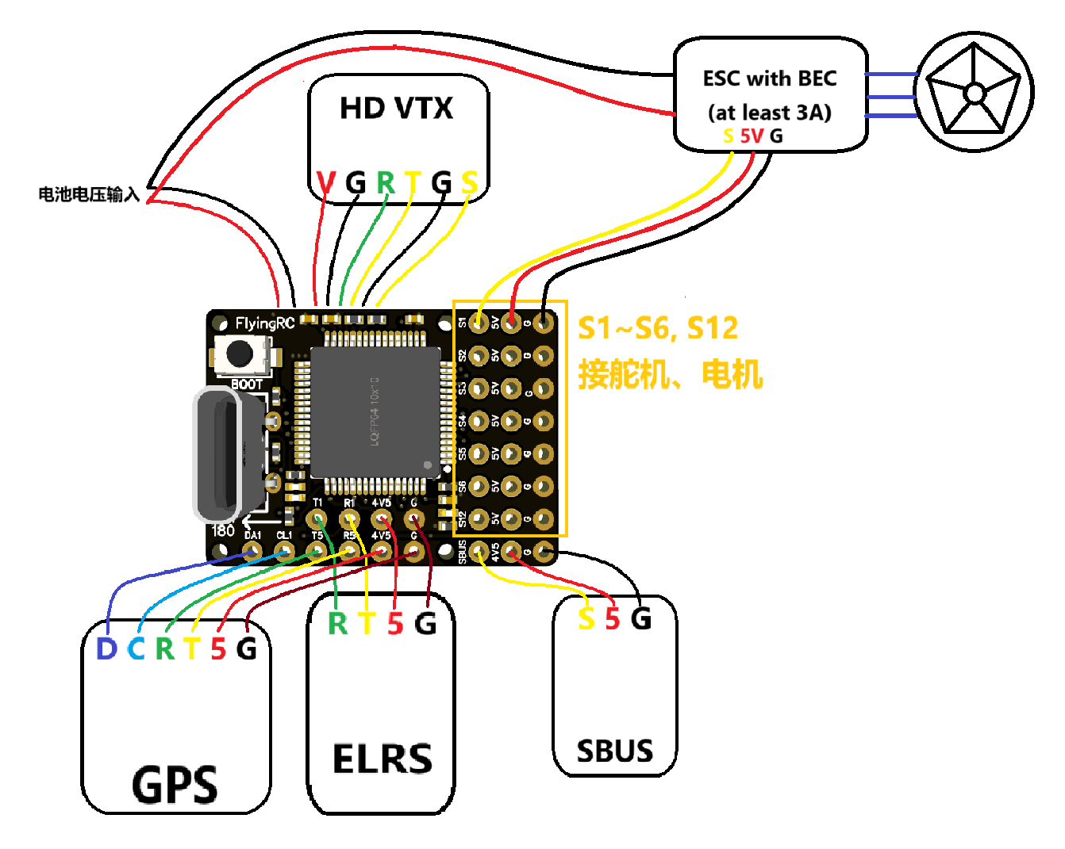
Wiring Schematic for ESC with Built-in BEC
（SBUS or ELRS receiver, GPS with compass, HD VTX）
Key notes:
- ESC BEC output must exceed 3A.
- 3A BEC: Supports 2–3 × 9g servos; 5A BEC: Supports 4–5 × 9g servos.
Recommended option: FlyingRC® 75A ESC V2.5 (BEC version) available in our online store, featuring an onboard 4.5A BEC.

Complete Wiring Diagram for ESC with Built-in BEC

- Connection of ESC with Built-in BEC
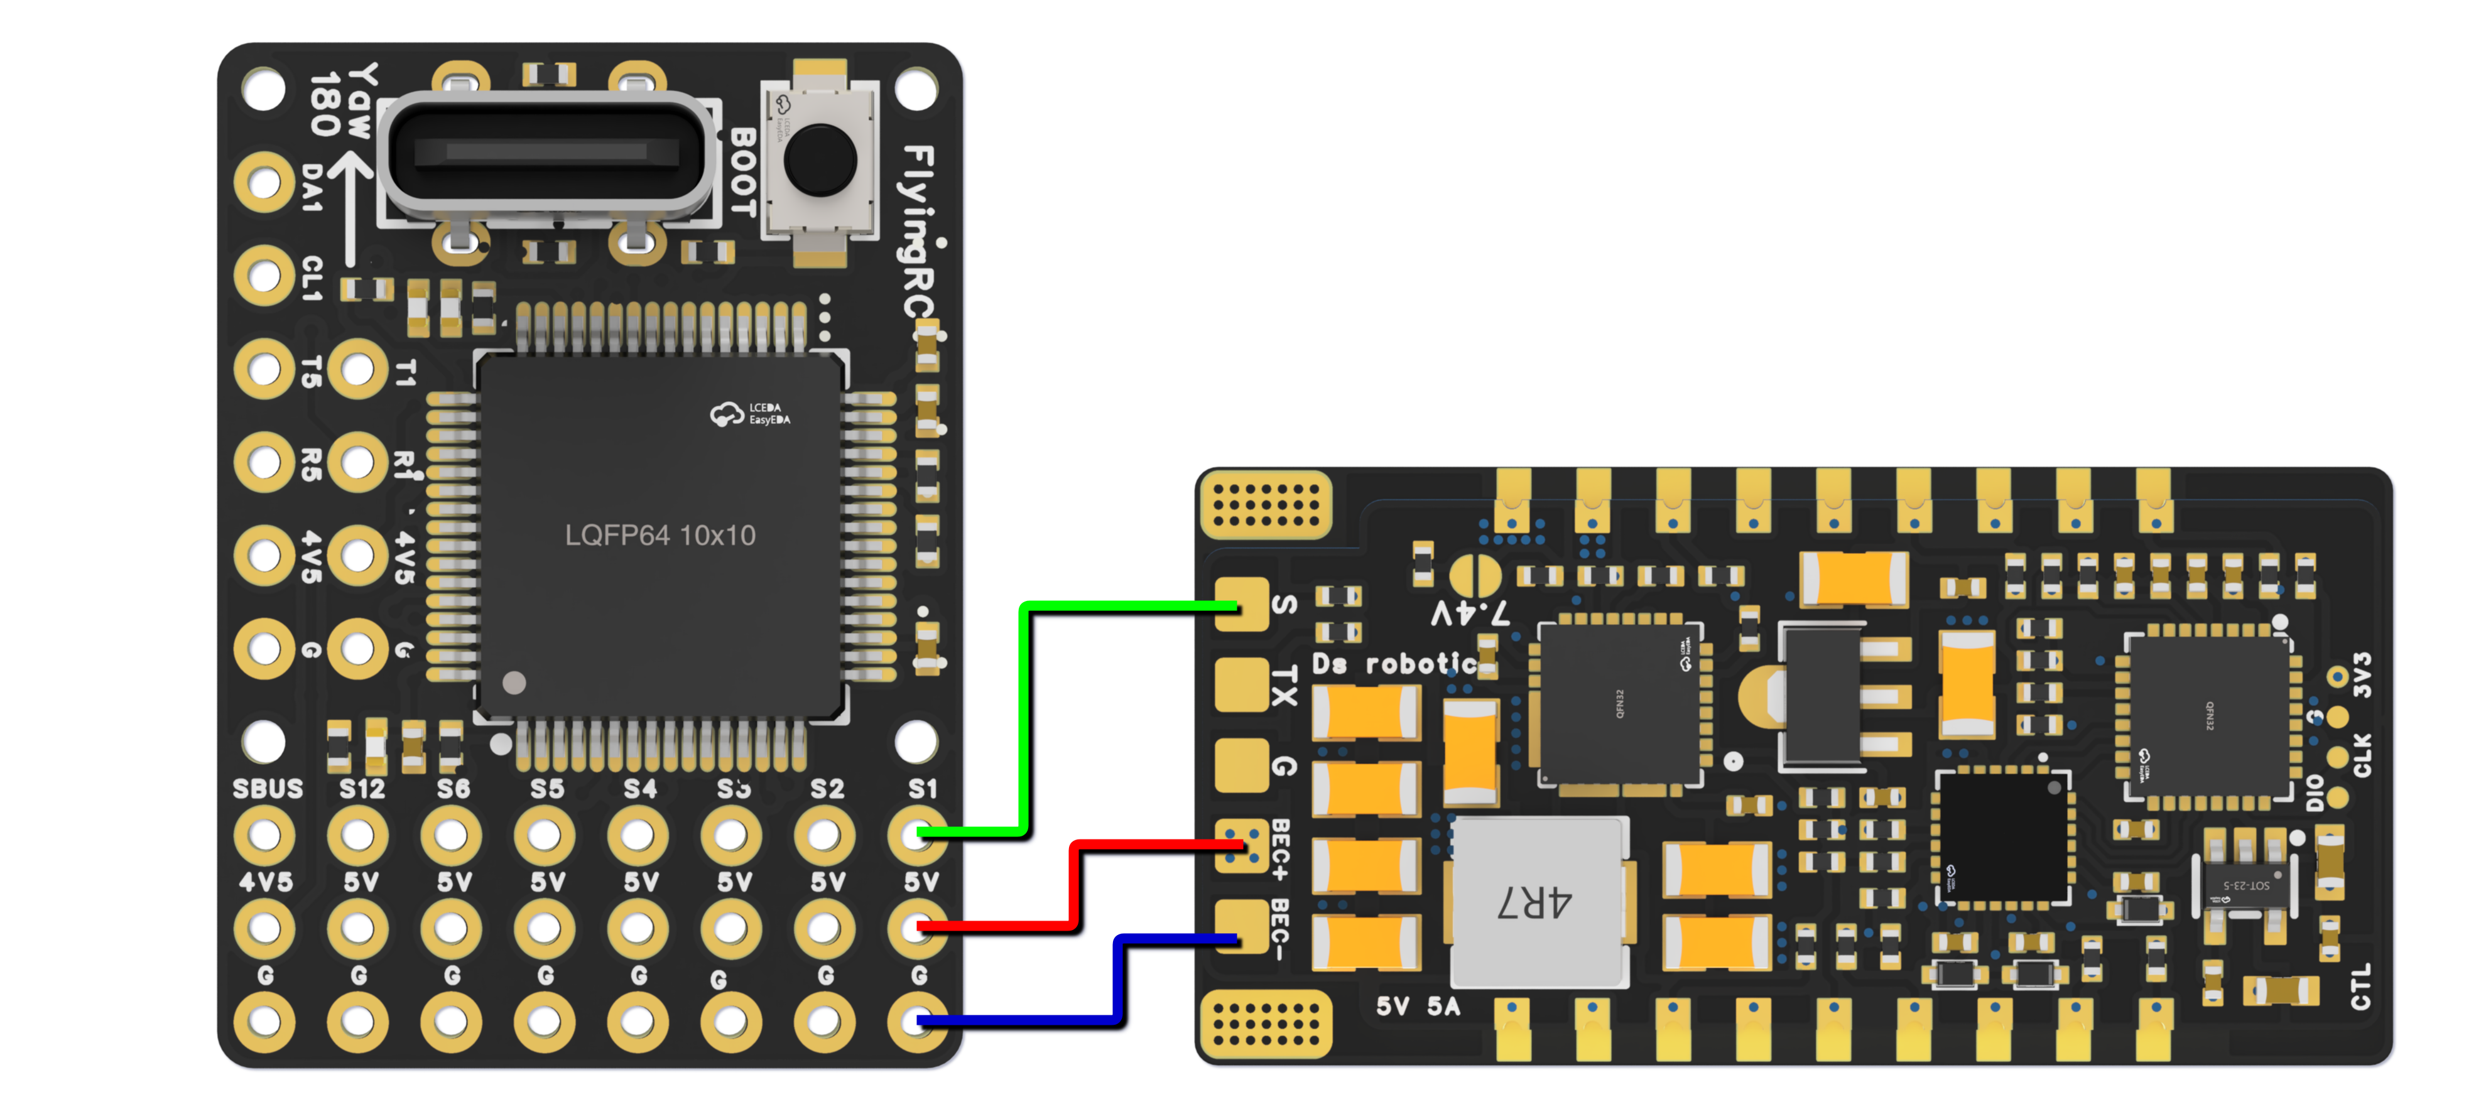
Wiring Diagram for Connection with FlyingRC® AM32 75A Single ESC

- ELRS Receiver
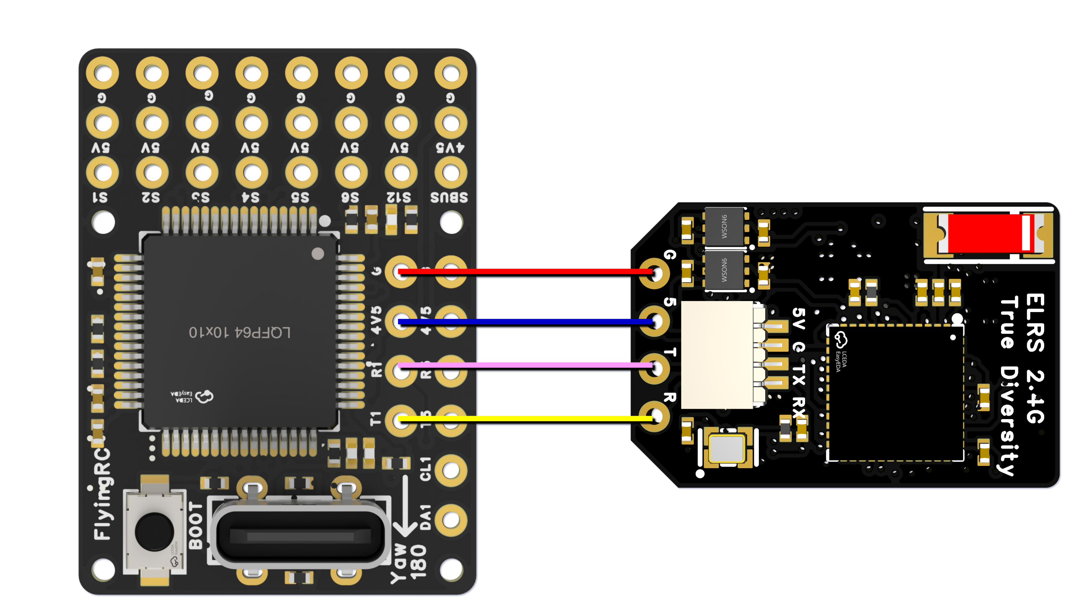
Wiring Diagram for Connection with FlyingRC® ELRS Receiver

- GPS

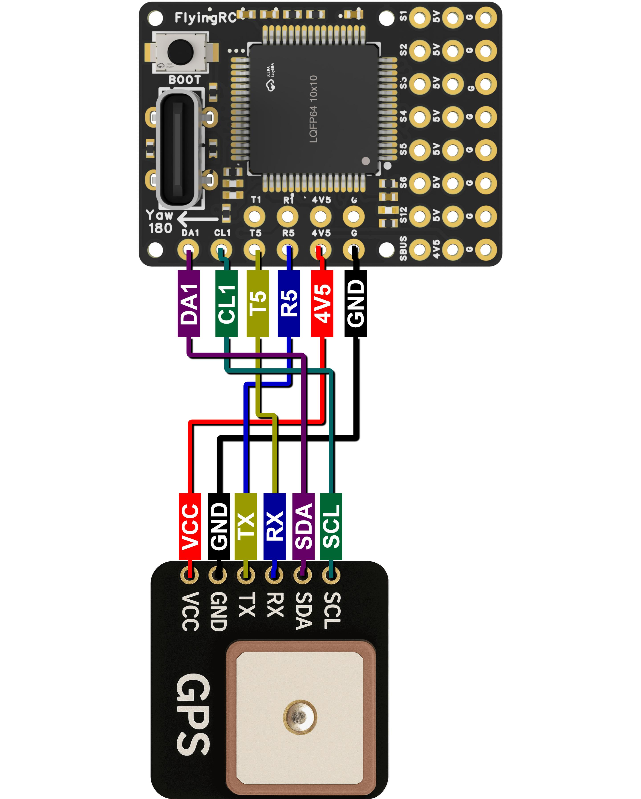
Wiring Diagram for Connection with FlyingRC® GPS

- HD Digital VTX
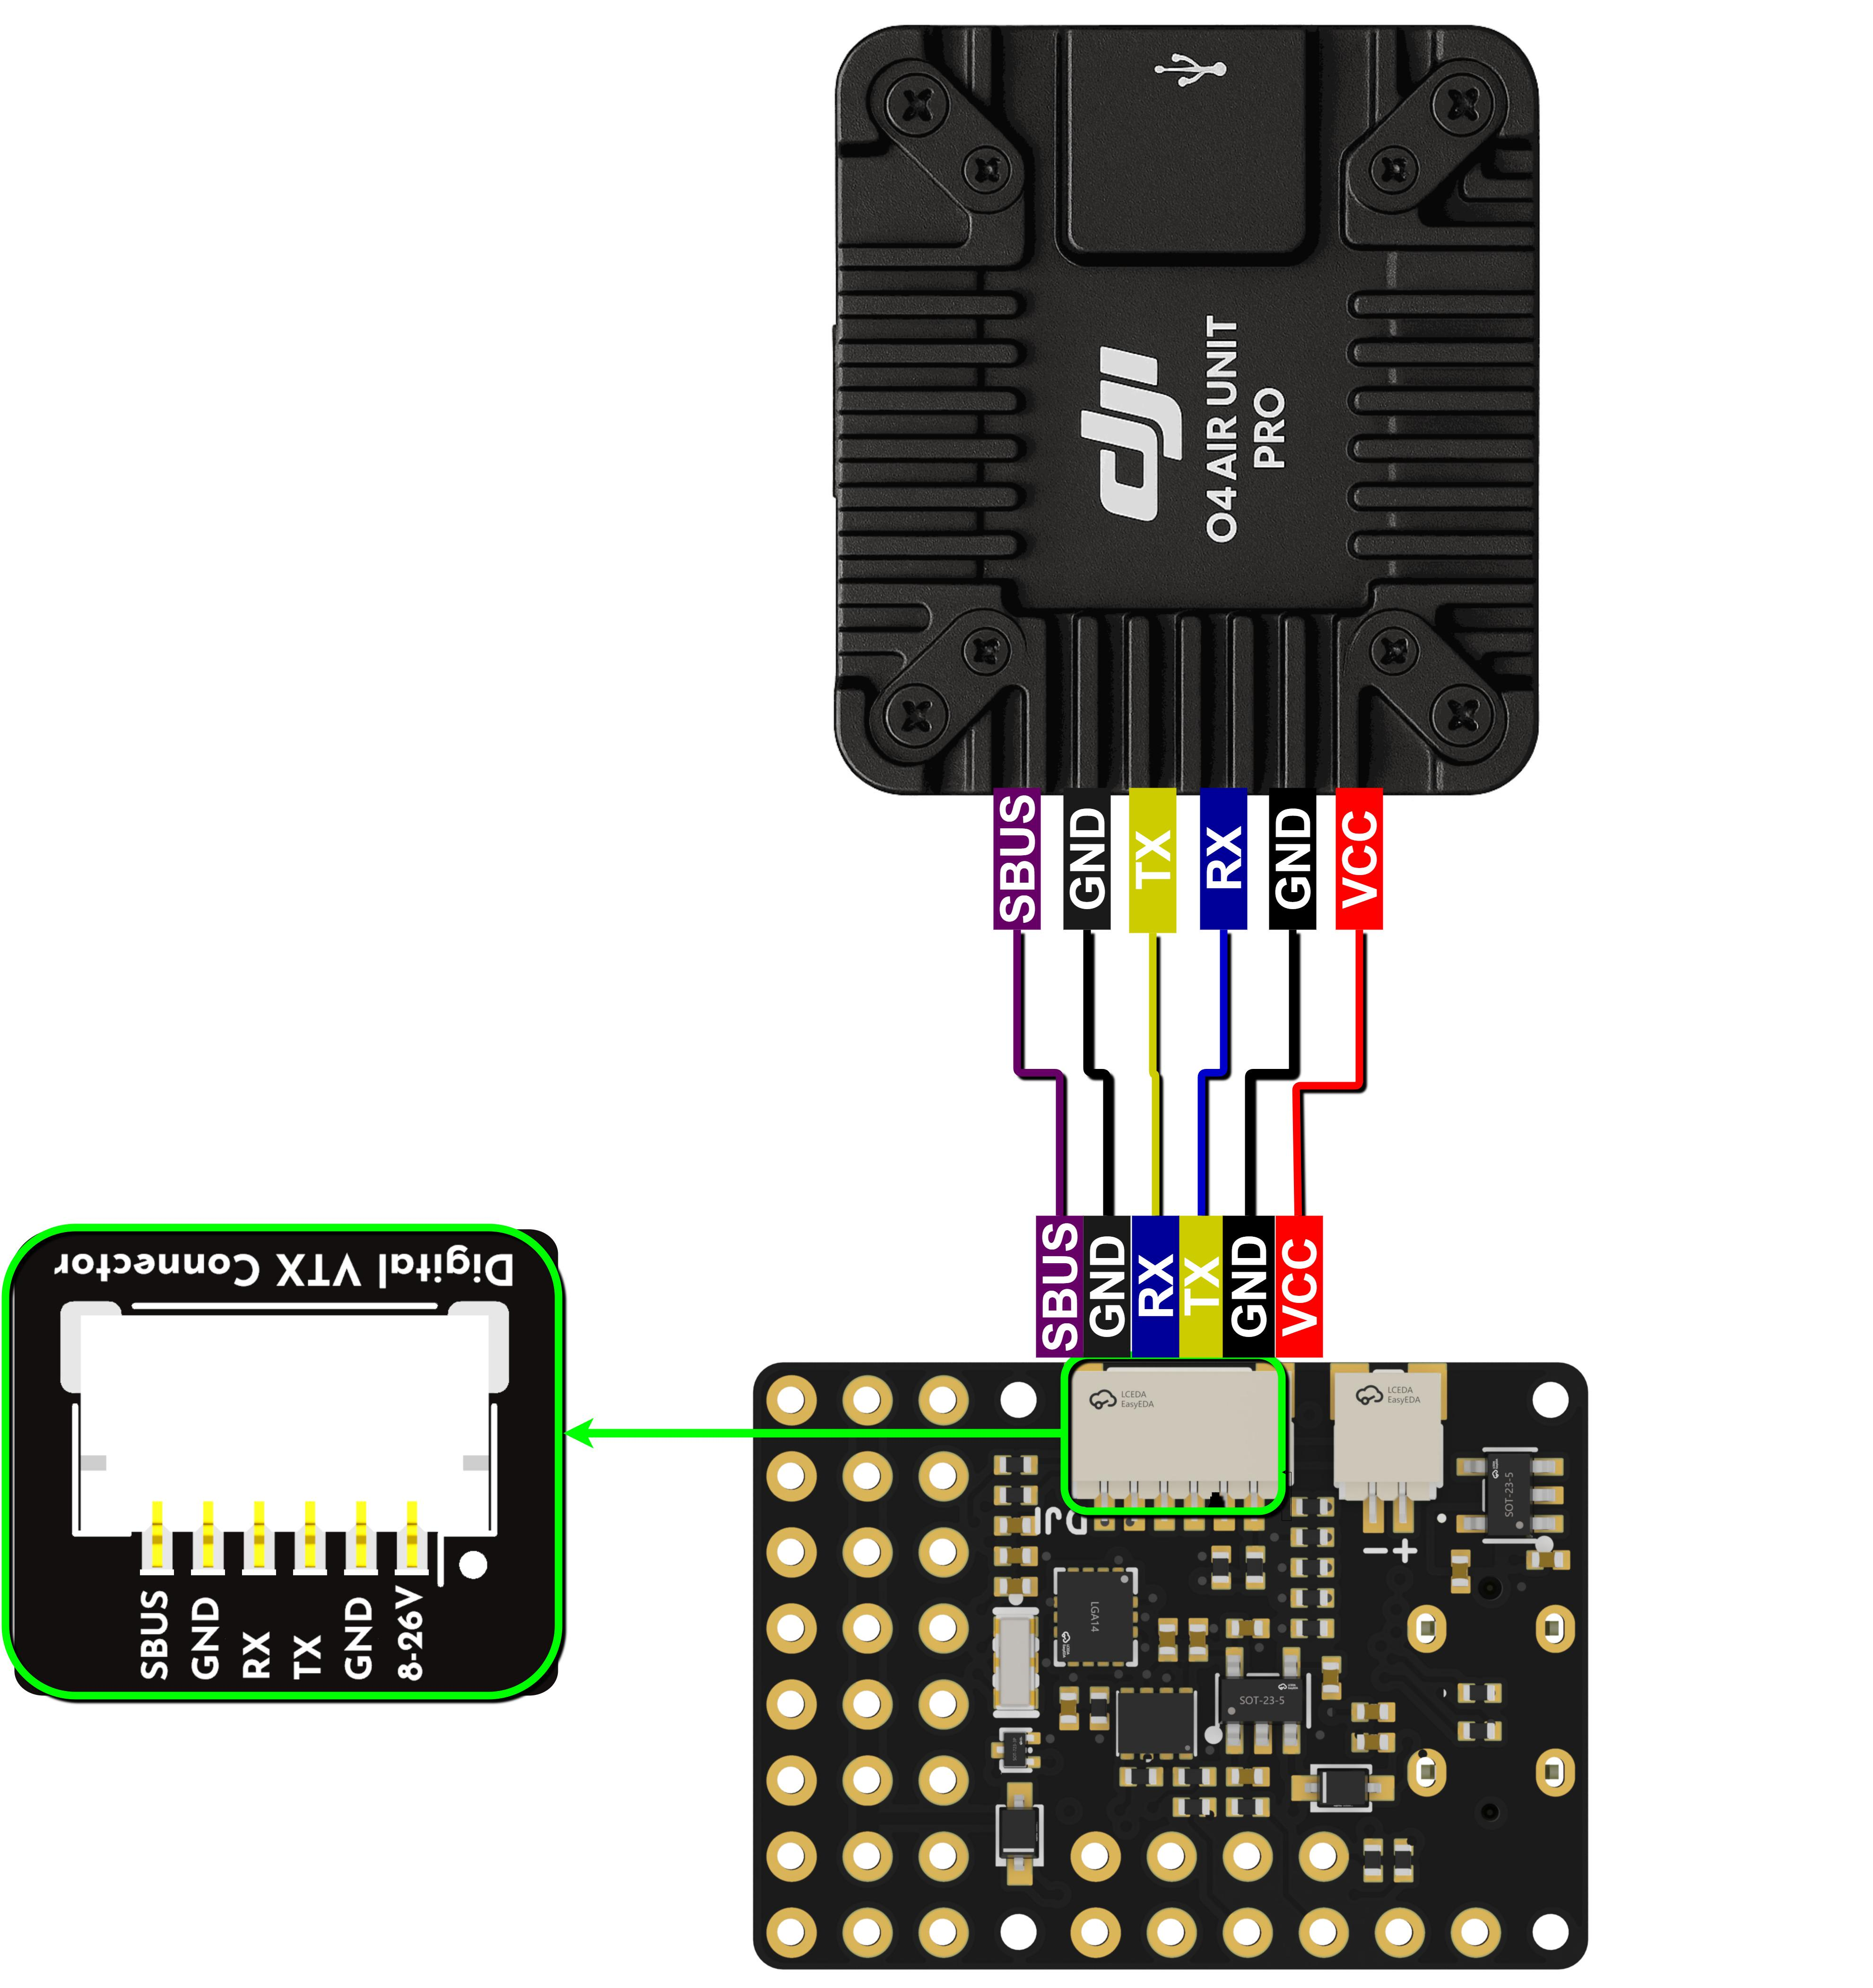
Connect to Digital Video Transmission

- BEC
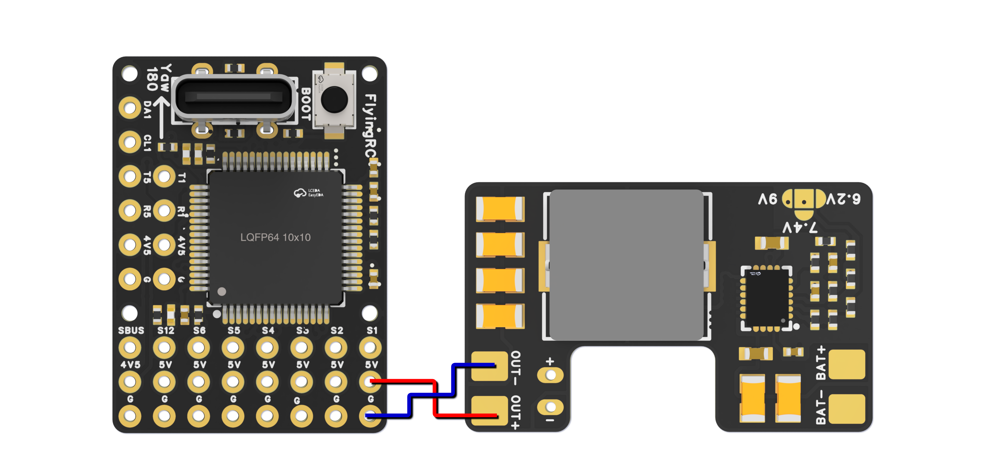
Wiring Diagram for Connection with FlyingRC® 5A BEC

- SBUS
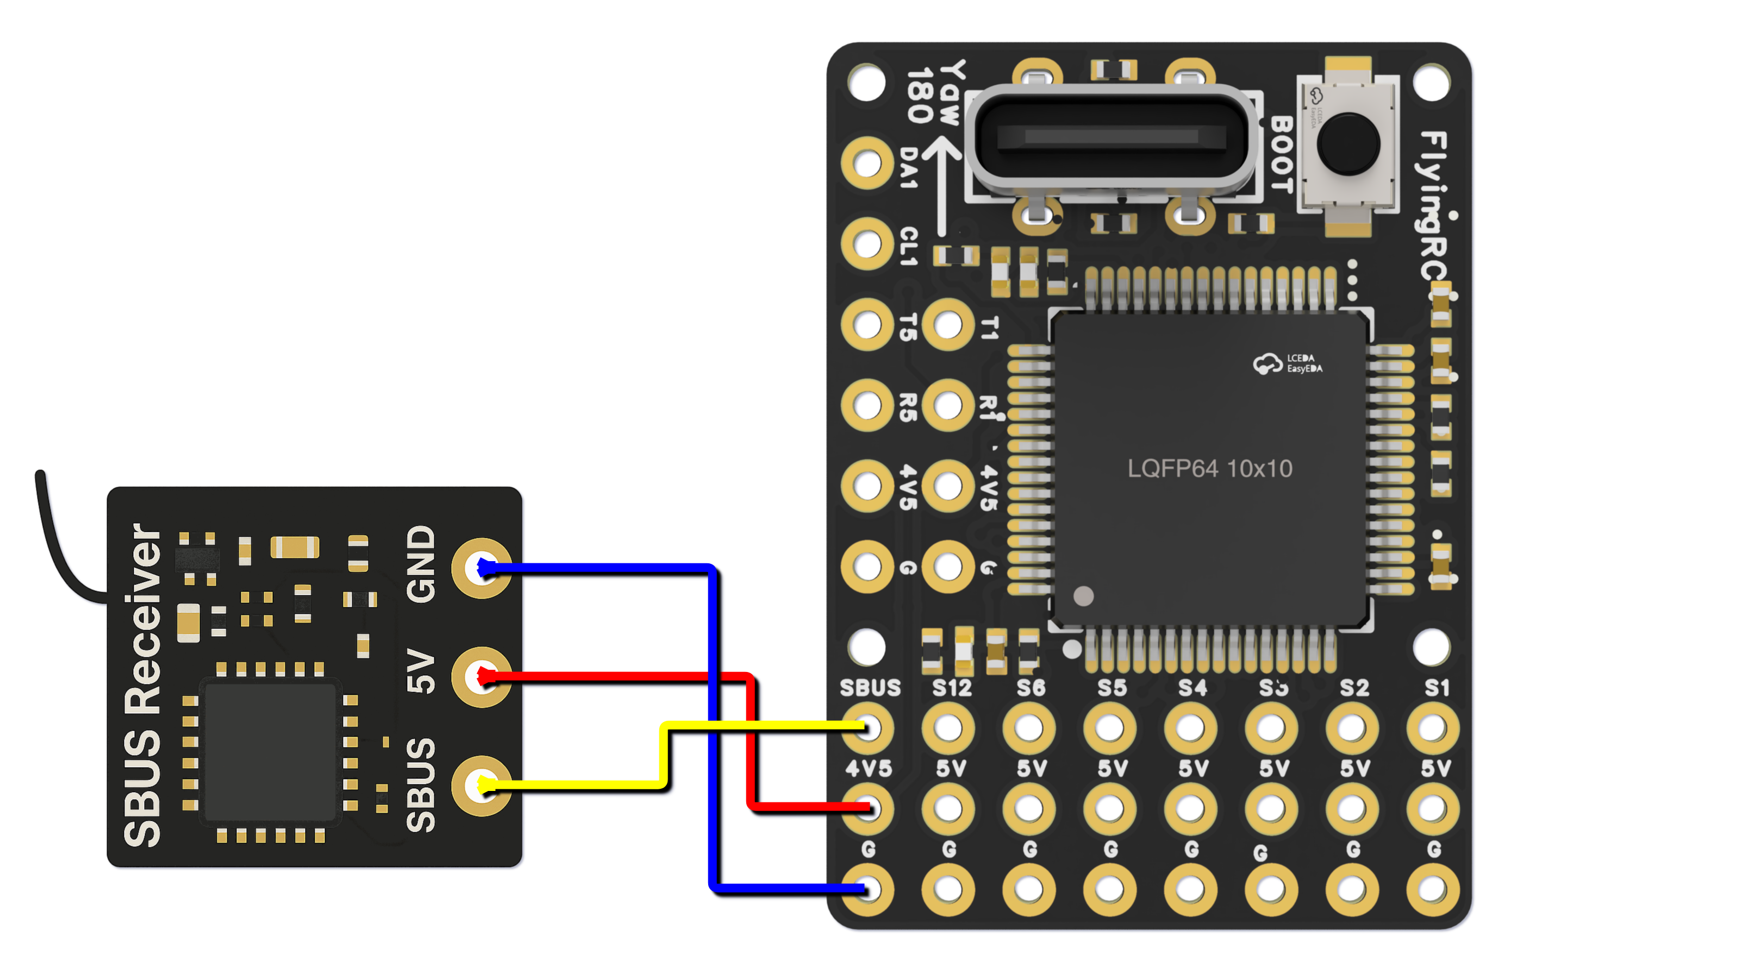
Wiring Diagram for Connection with SBUS

- PWM Output Function
Group1 | PWM 5V  tolerant I/O | S1 | PWM1 GPIO50 | TIM8_CH4 | DMA/DShot
Group1 | PWM 5V  tolerant I/O | S2 | PWM2 GPIO51 | TIM8_CH3 | DMA/DShot
Group2 | PWM 5V  tolerant I/O | S3 | PWM3 GPIO52 | TIM1_CH3N | DMA/DShot
Group2 | PWM 5V  tolerant I/O | S4 | PWM4 GPIO53 | TIM1_CH1 | DMA/DShot
Goup3 | PWM 5V  tolerant I/O | S5 | PWM5 GPIO54 | TIM2_CH4 | DMA/DShot
Goup3 | PWM 5V  tolerant I/O | S6 | PWM6 GPIO55 | TIM2_CH3 | DMA/DShot
Goup3 | PWM 5V  tolerant I/O | S7 | PWM7 GPIO56 | TIM2_CH2 | DMA/DShot
Goup7 | PWM 5V  tolerant I/O | LED pad | PWM12 GPIO61 | TIM3_CH4 | DMA/DShot
Goup7 | PWM 5V  tolerant I/O | LED pad | SERVO12_FUNCTION 120, NTF_LED_TYPES neopixel |  | DMA/DShot
Mixing Dshot and normal PWM operation for outputs is restricted into groups, ie, enabling Dshot for an output in a group requires that ALL outputs in that group be configured and used as Dshot, rather than PWM outputs.
If servo and motor are mixed in same group, make sure this group run lowest PWM frequency according to the servo specification. ie. Servo supports Max. 50Hz, ESC must run at 50Hz in this group.

S12 port can connect to LED, displaying the status of the Flight Controller (AP firmware) through WS2812 light strips.
PWM ports in the same Group cannot be used for Dshot ESCs and 50Hz PWM servos simultaneously.
DSHOT All interfaces are compatible with DSHOT.

- Serial Port Mapping
UART 5V tolerant I/O | USB | USB |  | console | SERIAL0
UART 5V tolerant I/O | TX1 RX1 | USART1 | with DMA | telem1 | SERIAL1
UART 5V tolerant I/O | TX5 RX5 | UART5 | NO DMA | GPS1 | SERIAL3
UART 5V tolerant I/O | TX4 RX4 | UART4 | NO DMA | USER | SERIAL4
UART 5V tolerant I/O | SBUS | USART2 | with DMA | RC input/Receiver | SERIAL6
UART 5V tolerant I/O | SBUS |  |  | BRD_ALT_CONFIG 0 Default | SERIAL6
UART 5V tolerant I/O | SBUS | Sbs pad | SBUS | BRD_ALT_CONFIG 0 Default | SERIAL6
Correspondence between Ardupilot Firmware UART/USART and SERIAL, and Their Default Functions
RX4，TX4（Serial4） The serial port of the HD video transmission direct plug-in interface on the rear side of the Flight Controller is RX4/TX4 (Serial4).
Recommended Device Connections:
- ELRS: Connect to RX1, TX1 (Serial1).
- GPS: Connect to RX5, TX5 (Serial3).

- I2C Devices
I2C | I2C1 | 5V tolerant I/O | Compass | COMPASS_AUTODEC | 1
I2C | I2C1 | 5V tolerant I/O | onboard Baro SPL06 - 001 | Address | 0x76
I2C | I2C1 | 5V tolerant I/O | Digital Airspeed I2C | ARSPD_BUS | 1
I2C | I2C1 | 5V tolerant I/O | MS4525 | ARSPD_TYPE | 1
I2C | I2C1 | 5V tolerant I/O | DLVLR - L10D | ARSPD_TYPE | 9
The built-in barometer occupies the 0x76 address. Do not externally connect any device with the address 0x76.
Pin Header Soldering Guide：
Tools and Consumables Preparation：
Digital soldering iron/soldering station (recommended: T12 series or 936 series), solder wire (recommended: 63% tin content)，several pin headers (included with the Flight Controller)

Soldering Tips：
- A "k" soldering tip is more efficient for soldering than a pointed tip.
- Prioritize high-quality solder – it is more critical than the soldering iron itself.
- A premium soldering iron (e.g., T12 series) is still recommended for optimal performance.
- If solder fluidity decreases, use soldering flux (search "BGA soldering flux" on Taobao, recommended brand: Anlixin).
- Ensure no solder bridges form between adjacent components during soldering.
- Pre-soldered pin headers are recommended for convenience.
Note: Use silicone wires for signal lines. The flight controller connector is SH1.0, which is compact. When plugging or unplugging, support the rear of the connector by hand to prevent it from being pulled off.

Other FlyingRC® Products
 |  |  |  | - FlyingRC® F4WSE Pro - F405 Fixed-Wing Flight Controller  Upgraded Version | Enhanced Performance  Manual：https://www.kdocs.cn/l/cavm9EoVEq5A |  |  | 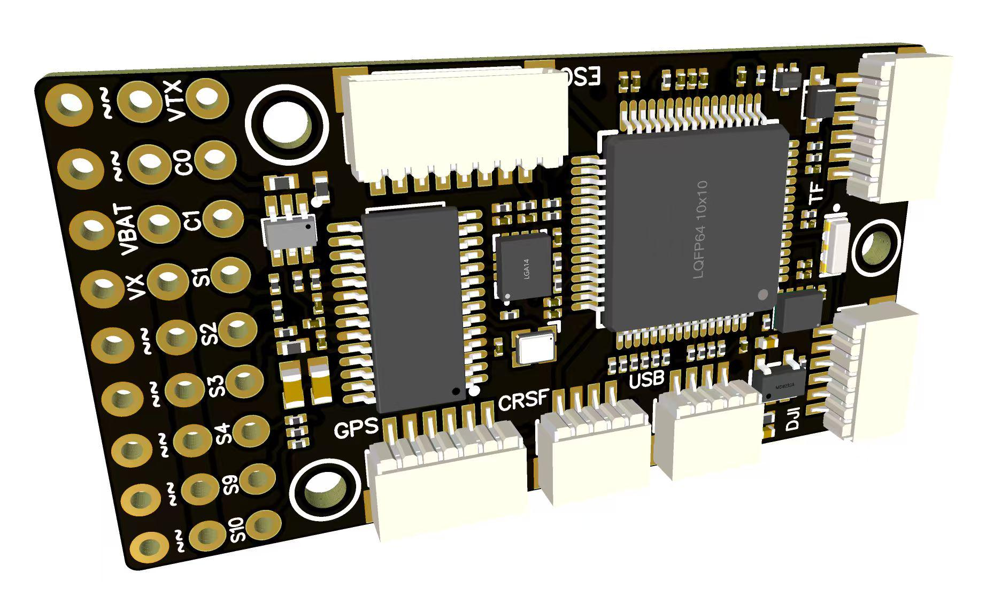
 |  |  | - FlyingRC® F4WSE MK1.5 - F405 Fixed-Wing Flight Controller  Classic model, unique design, highly acclaimed.  Manual：https://kdocs.cn/l/cpyd8MTS56DD |  |  | 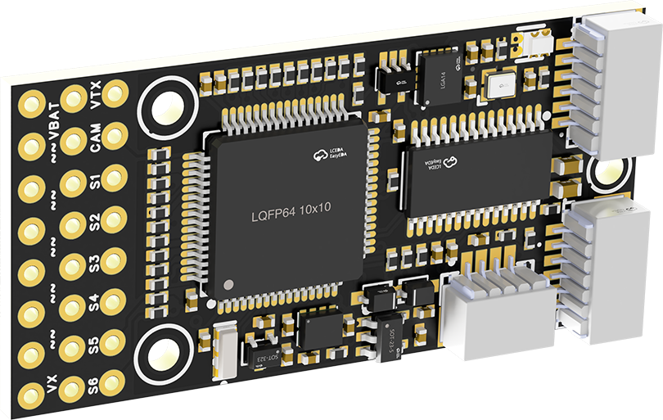
 |  |  |  | - FlyingRC® H7Wlite MK1 H743 Fixed-Wing Flight Controller  Flagship performance, full expansion, high-power BEC.  Manual：https://kdocs.cn/l/cpYaBiFKh8U1 |  |  | 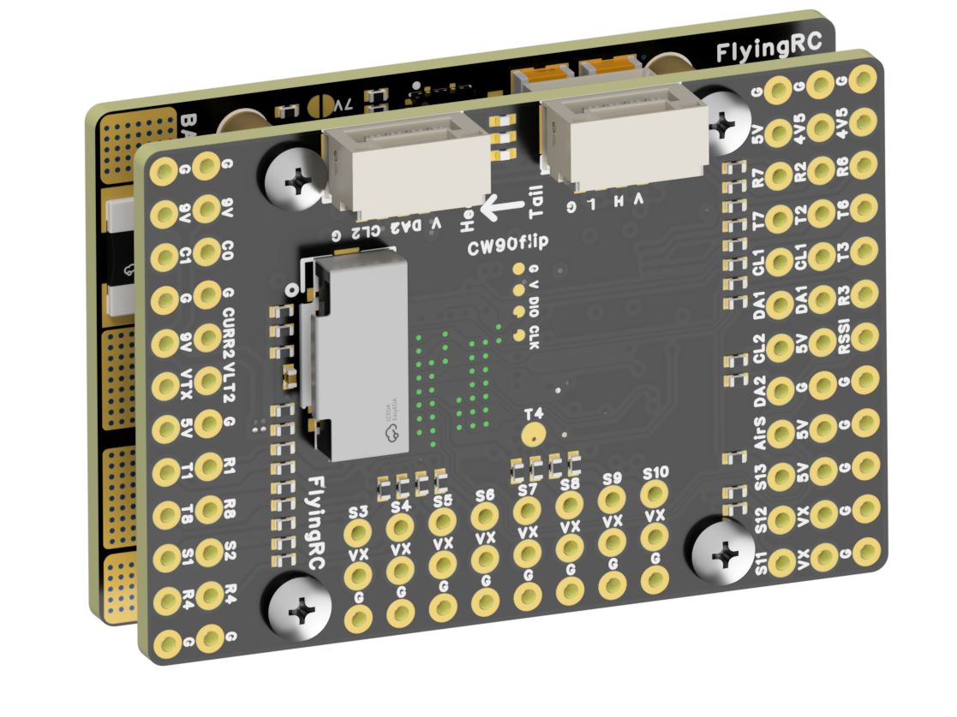
 |  |  |  | - FlyingRC® F4Wing Mini MK1 F405 Fixed-Wing Flight Controller  2025 bestseller, ultra-compact, smallest on the market, great value.  Manual：https://kdocs.cn/l/cdUIdmpSpW7J |  |  | 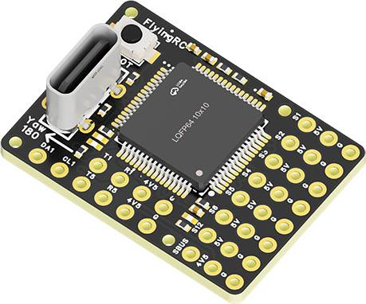
 | - FlyingRC® AM32 Dual ESC 40A 2-in-1 ESC  Unique design for dual-power aerial, land and water vehicles including drones.  Manual：https://www.kdocs.cn/l/cjwNtsKK6HeR |  |  |  | 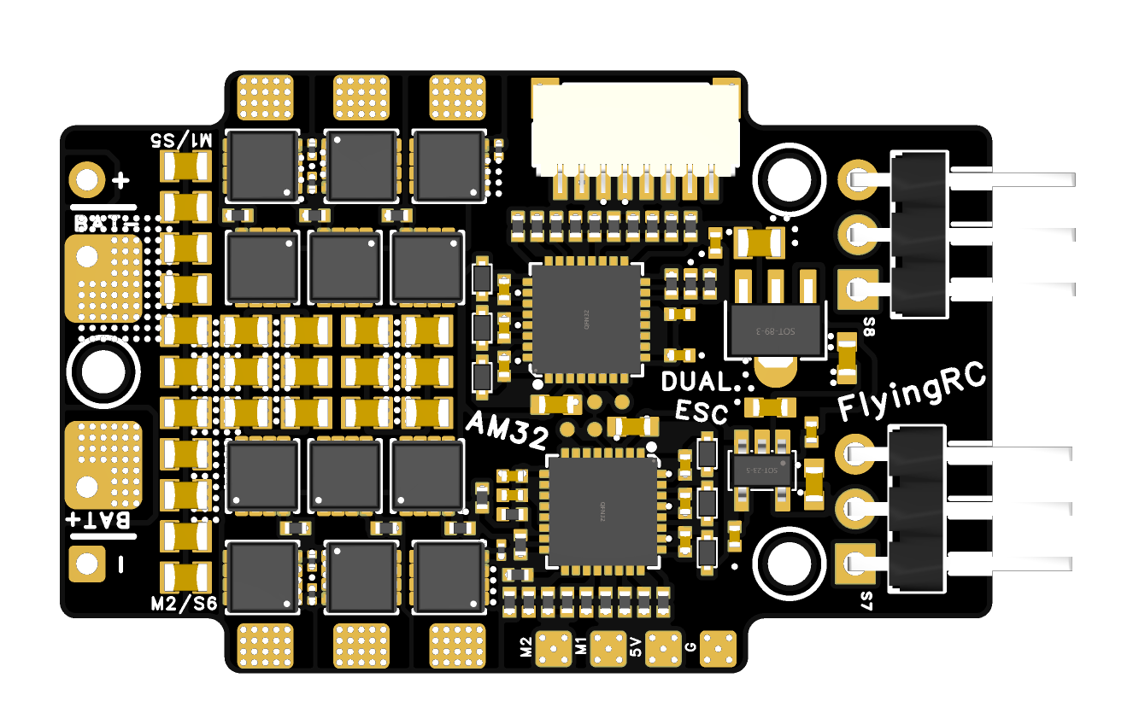
 |  |  | - FlyingRC® AM32 ESC V2.5 75A - Single ESC  Infineon gold-package MOSFETs, premium materials, superior heat dissipation.  Manual：https://kdocs.cn/l/cv6hUy67IdTJ |  |  |  | 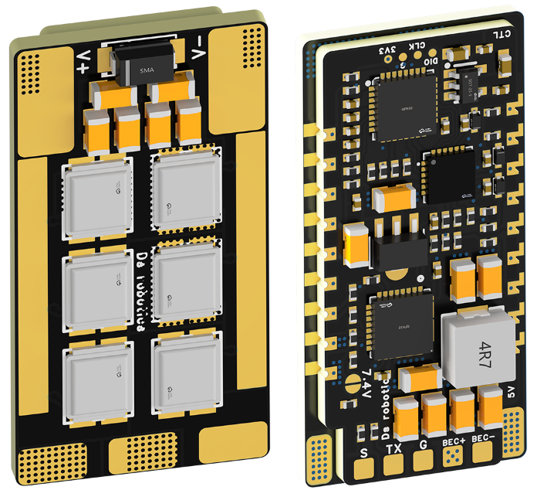
 |  |  | - FlyingRC® AM32 Mini ESC 40A V1.0 - Single ESC  Ultra-miniature, ideal for micro drones, high over-current capability, stable operation.  Manual：https://kdocs.cn/l/cqdLSysEyWFh |  |  |  |  | 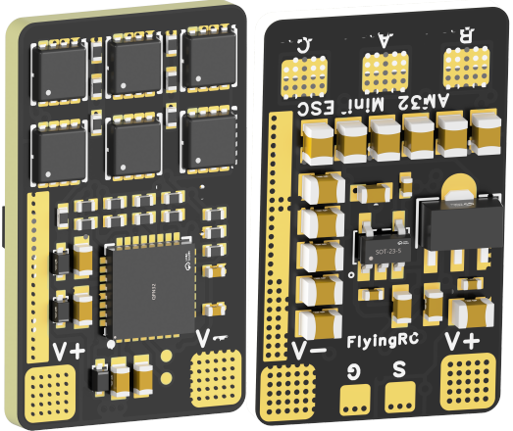
 |  |  | - FlyingRC® 10A 12S 440A Power Distribution Board for FPV Drones  Industry top choice, excellent quality and affordable price.  Manual：https://kdocs.cn/l/coel7OgrlCBP |  |  |  |  | 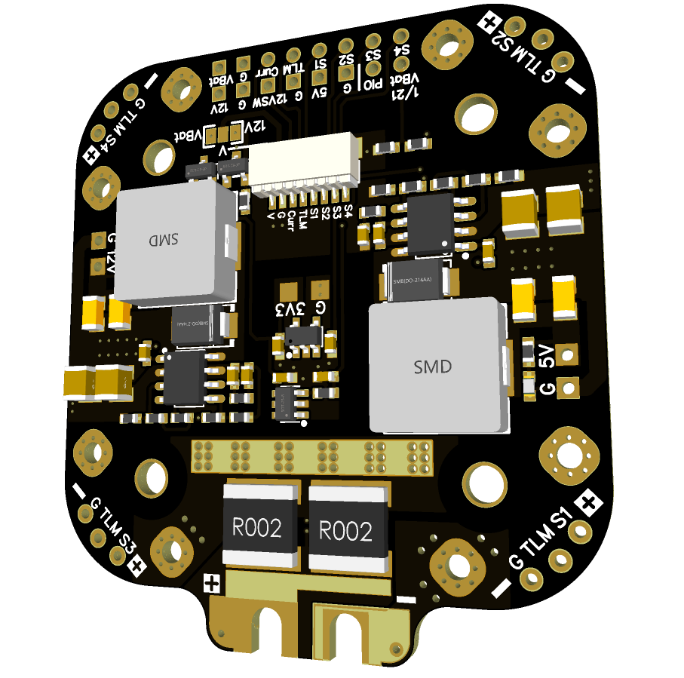
 |  |  | - FlyingRC® H7D Pro MK1 H743 FPV Flight Controller with Dual Gyro  Fully Upgraded & More Powerful  Manual：https://www.kdocs.cn/l/ctcekCy676Ez |  |  |  | 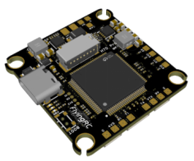
 |  |  | - FlyingRC® H7D MK1 H743 FPV Flight Controller with Dual Gyro  Powerful computing, stable and precise flight, rich interfaces, smooth control.  Manual：https://kdocs.cn/l/cqMh1I0RwAoD |  |  |  | 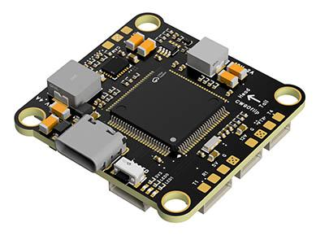
 |  |  | - FlyingRC® F420 MK1 F405 FPV Flight Controller (20/30.5mm Mounting)  Dual mounting holes, all connectors, no soldering required, compliant with Betaflight interface standards.  Manual：https://kdocs.cn/l/ctGeLiN9ZYKj |  |  |  | 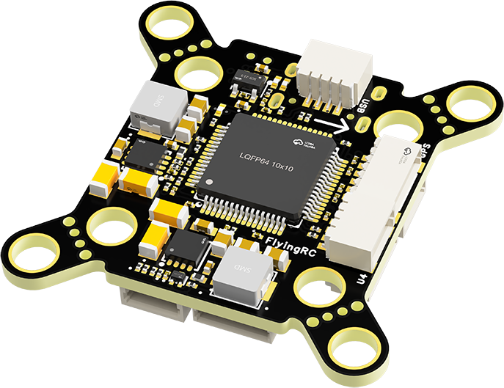
 |  | - FlyingRC® 4-in-1 75A V3.2 Gold-Sealed FPV ESC  Infineon gold-package MOSFETs, superior heat dissipation & over-current capability, premium choice.  Manual：https://kdocs.cn/l/ceLilc8Gaa21 |  |  |  |  | 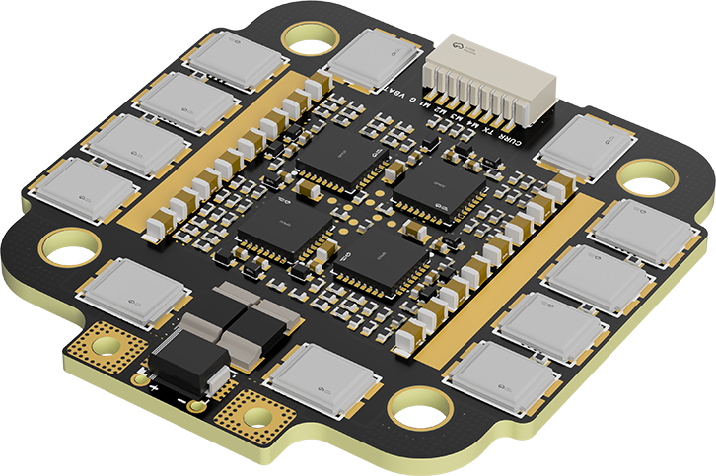
- FlyingRC® Stack Combo: H743 Flight Controller + 4-in-1 75A Gold-Sealed ESC  Professional flight choice, flagship materials & craftsmanship, reasonable price.  Manual：https://www.kdocs.cn/l/ctcekCy676Ez  https://kdocs.cn/l/ceLilc8Gaa21 |  |  |  |  |  |  | 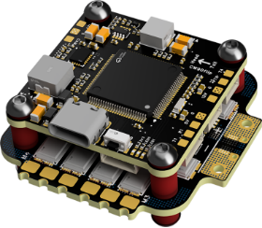
 |  | - FlyingRC® Stack Combo: F405 Flight Controller + 4-in-1 75A Gold-Sealed ESC  Best-selling combo, excellent performance, affordable price.  Manual：https://kdocs.cn/l/ctGeLiN9ZYKj  https://kdocs.cn/l/ceLilc8Gaa21 |  |  |  |  | 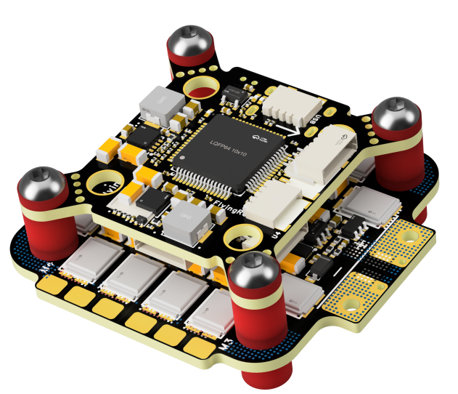
 |  | - FlyingRC® Stack Combo: H743 Flight Controller + 4-in-1 45A ESC  Winning combo: great performance, budget-friendly price  Manual：https://www.kdocs.cn/l/ctcekCy676Ez  https://kdocs.cn/l/ceLilc8Gaa21 |  |  |  |  | 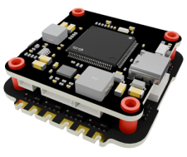
 |  | - FlyingRC® Stack Combo: F405 Flight Controller + 4-in-1 45A ESC  Hit combo, great value, budget-friendly  Manual：https://kdocs.cn/l/ctGeLiN9ZYKj  https://kdocs.cn/l/ceLilc8Gaa21 |  |  |  |  | 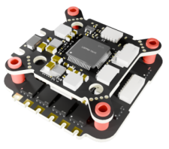
 |  | - FlyingRC® Stack Combo: F4WSE Pro - F405 Fixed-Wing Flight Controller + AM32 Dual ESC 40A 2-in-1 ESC  Unique Design • Exclusive Offer • Bestselling Bundle  Manual：https://www.kdocs.cn/l/cavm9EoVEq5A  https://www.kdocs.cn/l/cjwNtsKK6HeR |  |  |  |  | 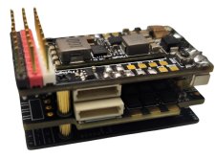
 | - FlyingRC® ELRS 2.4G Diversity Receiver  True diversity reception, temperature compensation, high-sensitivity reception.  Manual：https://kdocs.cn/l/cbvlOlShmsPS |  |  |  |  |  | 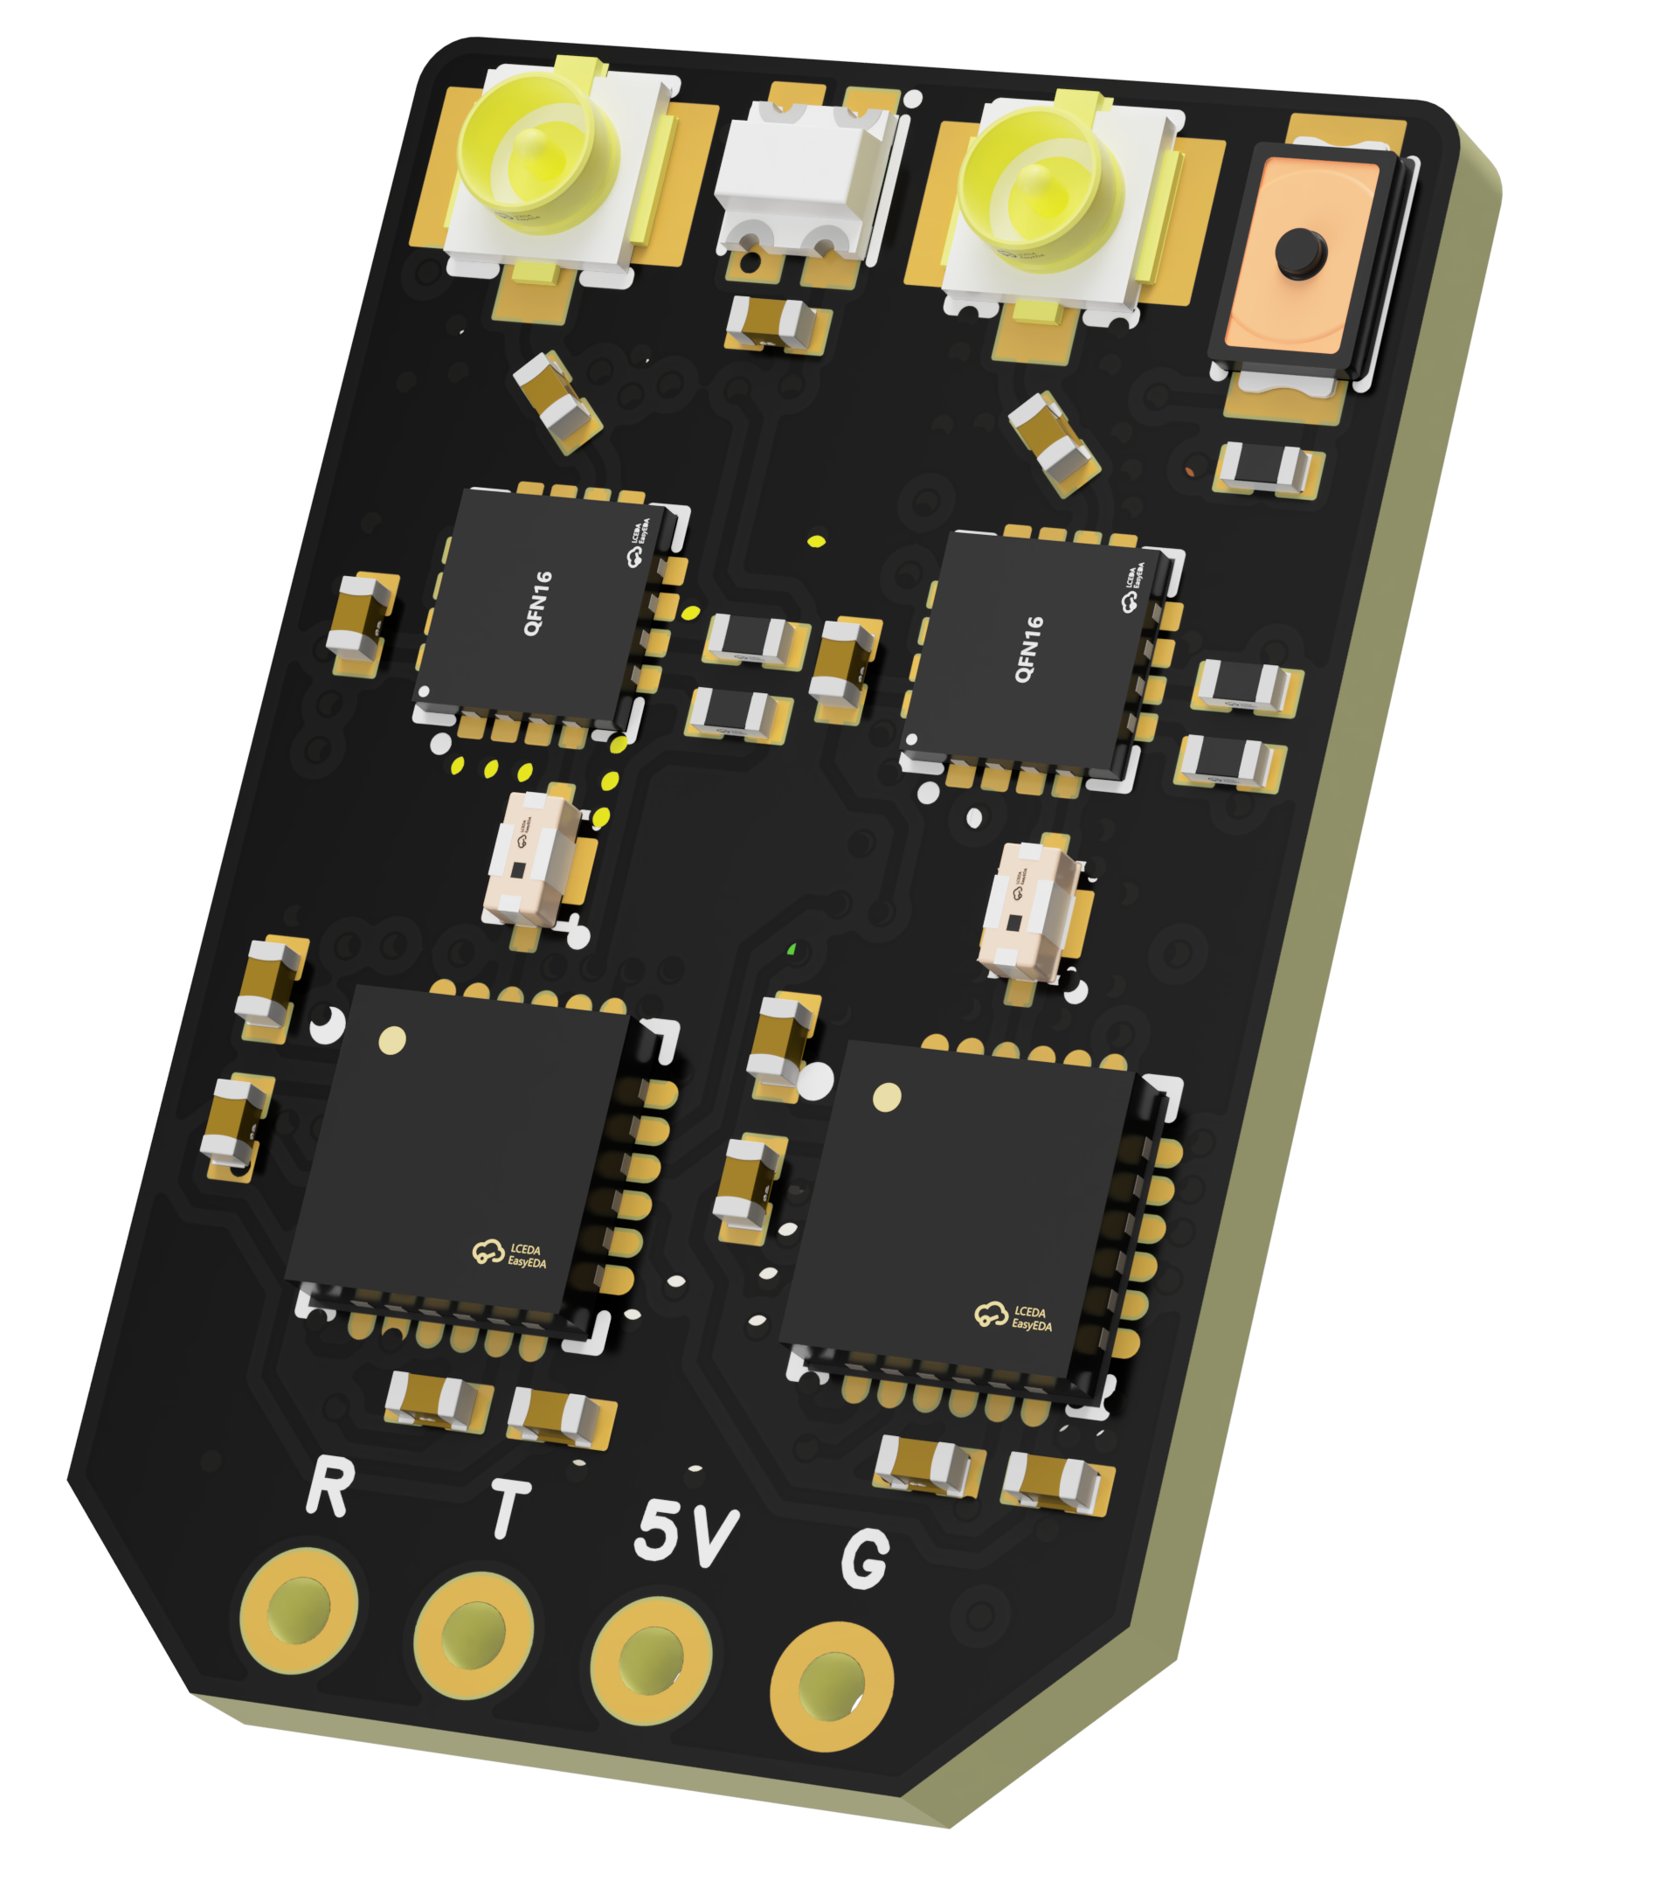
 | - FlyingRC® RM3100 SPI Module 罗盘模块  Ultra-high Resolution • Low Power • Industry Top Choice  Manual：https://www.kdocs.cn/l/cdGuHvBVyndC |  |  |  |  |  | 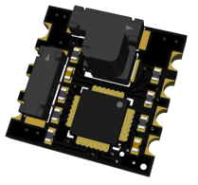
 | - FlyingRC® 10A 12S BEC Step-Down Module  Wide voltage input, high power, compact size, multiple voltages available, 10A continuous output.  Manual：https://kdocs.cn/l/clssNCKgNhLV |  |  |  |  |  | 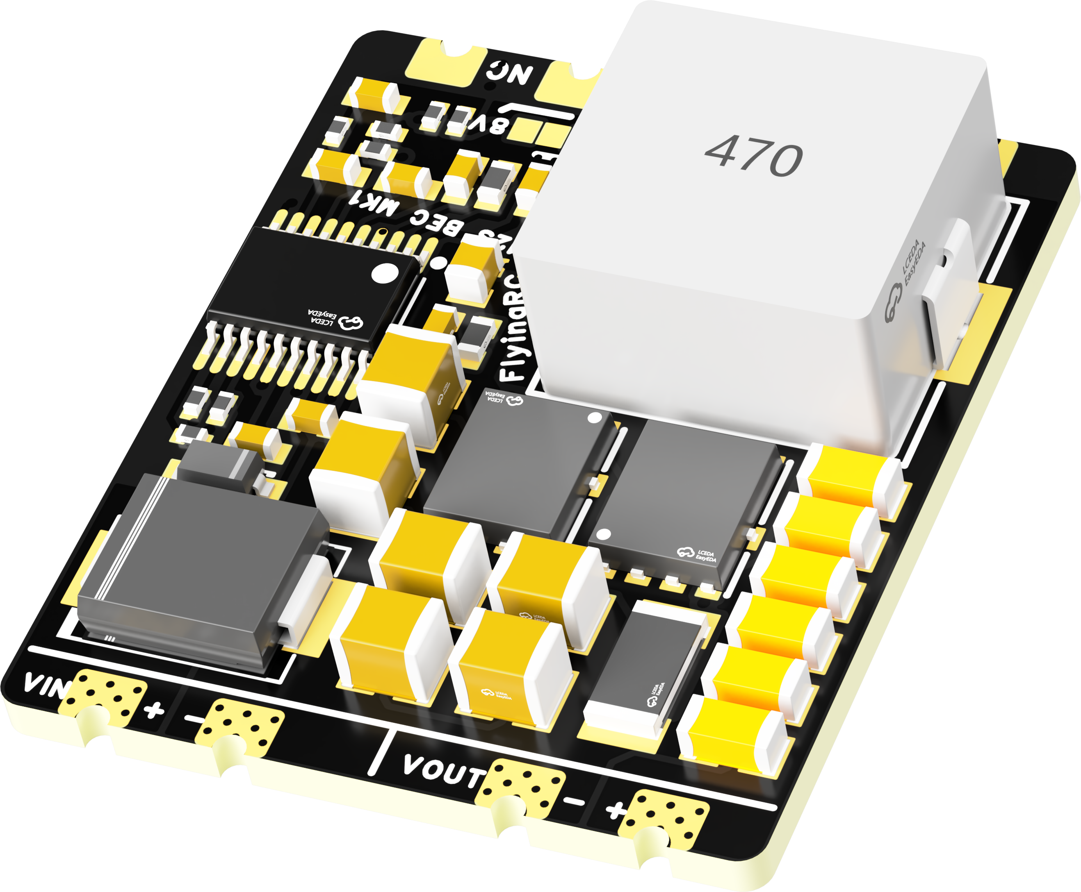
 | FlyingRC® 5A BEC Step-Down Module  Ultra-small size, multiple voltages available, 5A continuous output.  Manual：https://kdocs.cn/l/cb9VdNywqCKA |  |  |  |  |  | 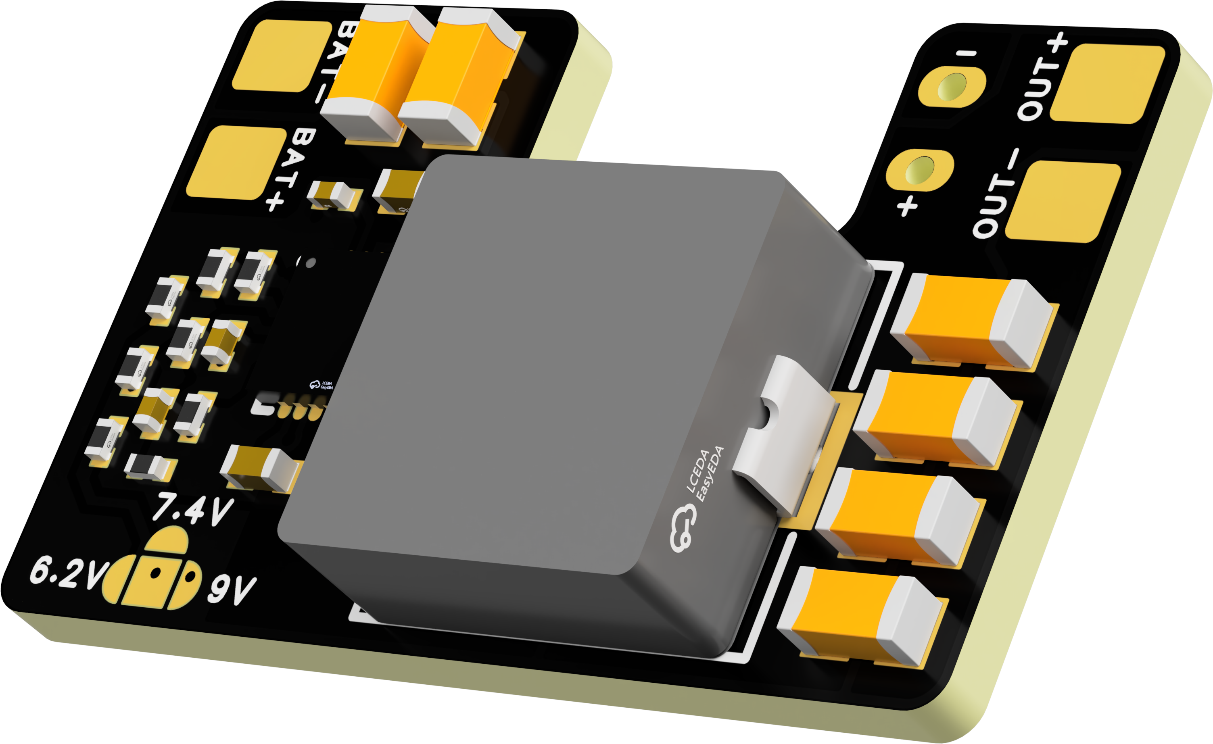
 | FlyingRC® Mini BEC For DJI O4  Easy wiring, ultra-small size, stable power supply.  Manual：https://www.kdocs.cn/l/ckkebieur37K |  |  |  |  |  | 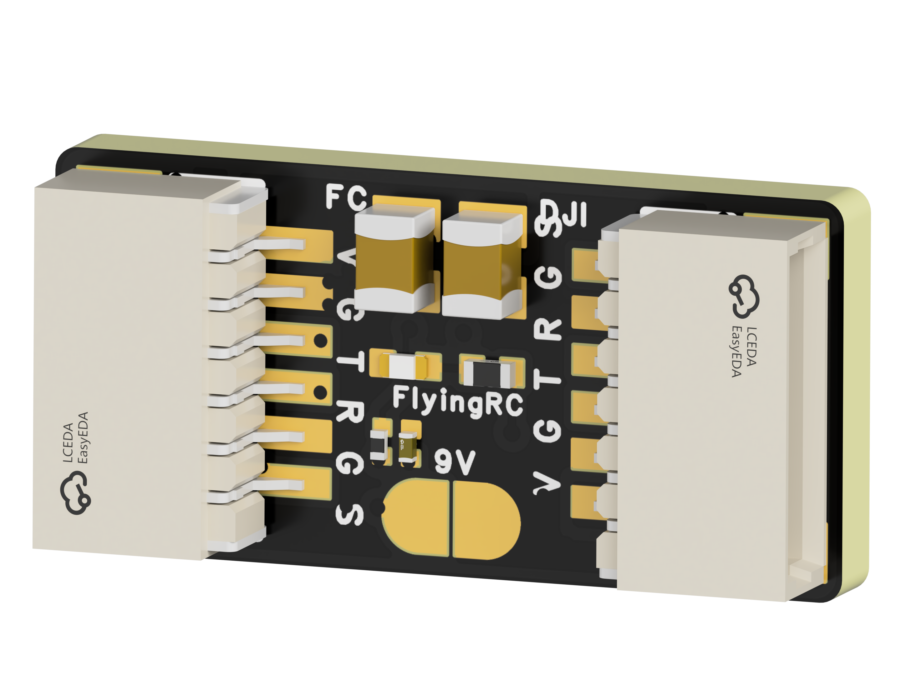
 | FlyingRC® CAN Bus Serial & PWM Expansion Board  Long-distance transmission, high speed, excellent stability.  Manual：https://www.kdocs.cn/l/cmxRyBnU4BXj |  |  |  |  |  | 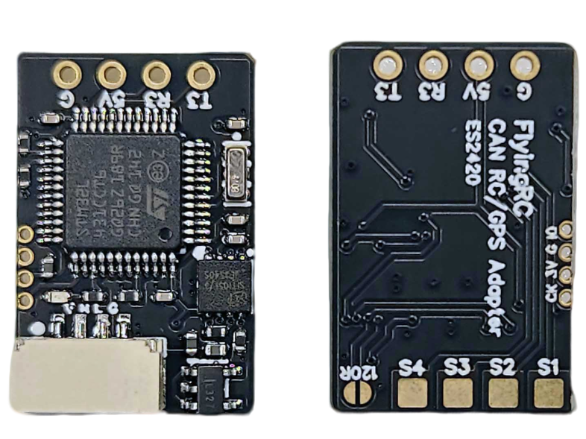
 | FlyingRC® AM3 2ESC Programmer  Supports BL, BL32, AM32. Simple and easy to use.  Manual：https://kdocs.cn/l/cogBSEBe67mE |  |  |  |  |  | 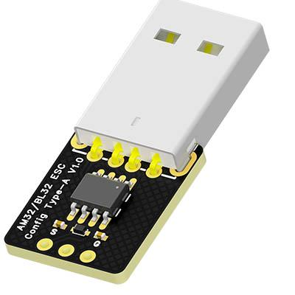
 | FlyingRC® Digital Airspeed Sensor without Pitot Tube  Integrated design, smallest on the market. MS4525D protocol, I2C interface.  Manual：https://www.kdocs.cn/l/clPvEEEcJgCC |  |  |  |  |  | 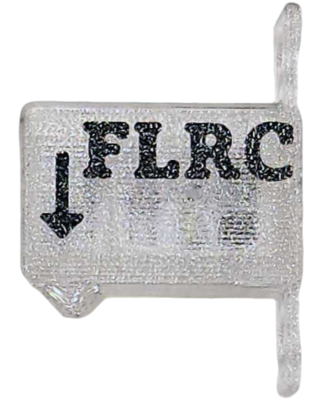
 | FlyingRC® U-Blox M10 GPS  Compatible with all open-source flight controllers.  Manual：https://www.kdocs.cn/l/cdSYQrzx74O8 |  |  |  |  |  | 