FlyingRC® F4WSE Pro Flight Controller Product Manual
FlyingRC® is a globally-oriented professional brand of electronic devices. We specialize in the R&D and sales of drone electronics, core robot circuits and sensors. Our design team is based in Singapore, and our products are sold worldwide.

Since launched in 2023, FlyingRC® products have gained widespread recognition from customers as well as strong market response. As of April 2026, our cumulative sales volume has exceeded 46,000 units. Our products are widely applied in industries, robotics, emergency rescue, environmental protection & inspection, aerial photography, public security, retail and many other fields. Above all, we are committed to distinctive design and superior reliable quality.

Our Chief Technology Officer Liu Yuhan possesses outstanding expertise in circuit design. Over the past four years, he has designed more than 80 circuit projects and contributed 39 to open-source platforms. Moreover, he won the Design Award on the open-source platform X.JLC.com twice in 2023 and 2024, and has become the youngest certified designer on this platform.

He holds the NUS (National University of Singapore, rank 8th worldwide) Science and Technology Scholarship, and is currently majoring in Electronic Engineering with a focus on Aerospace Technology. In addition, all members of our technical team are graduates from prestigious universities with extensive professional product experience.

Description:
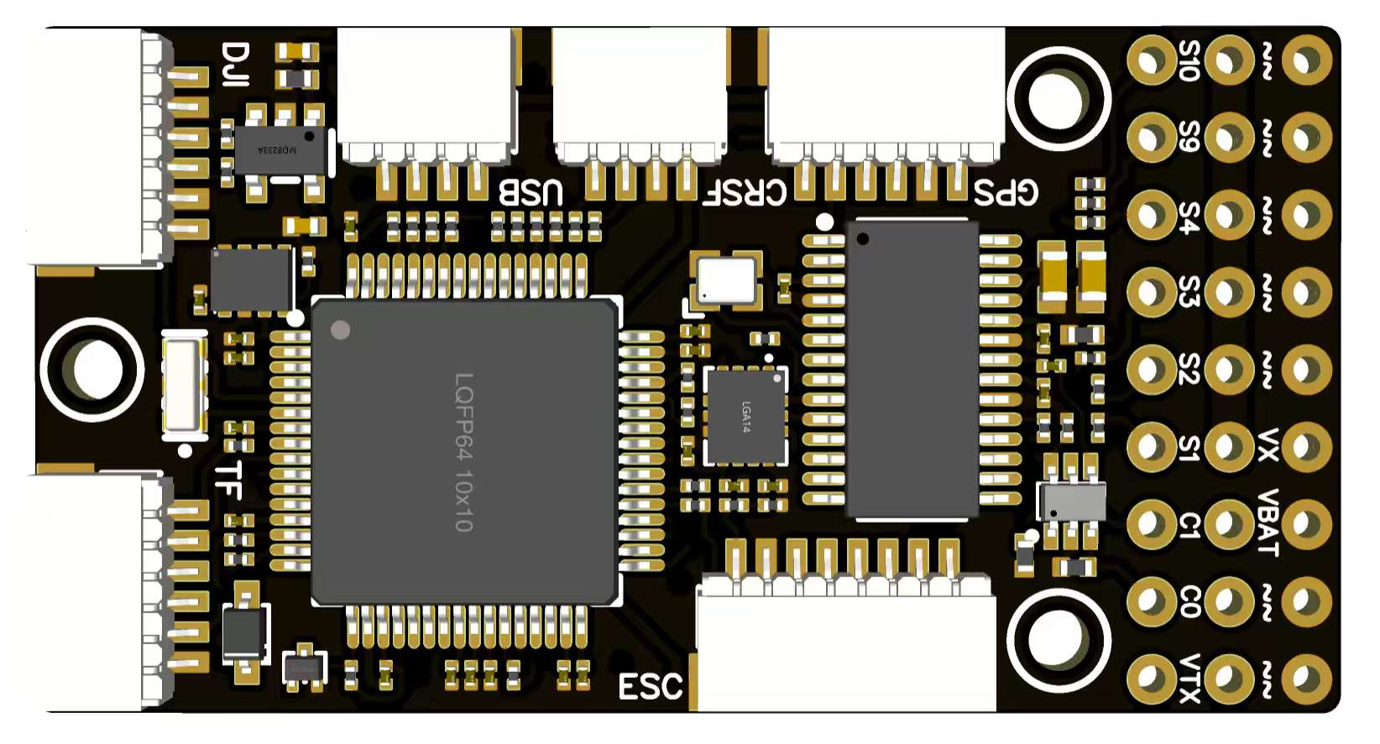
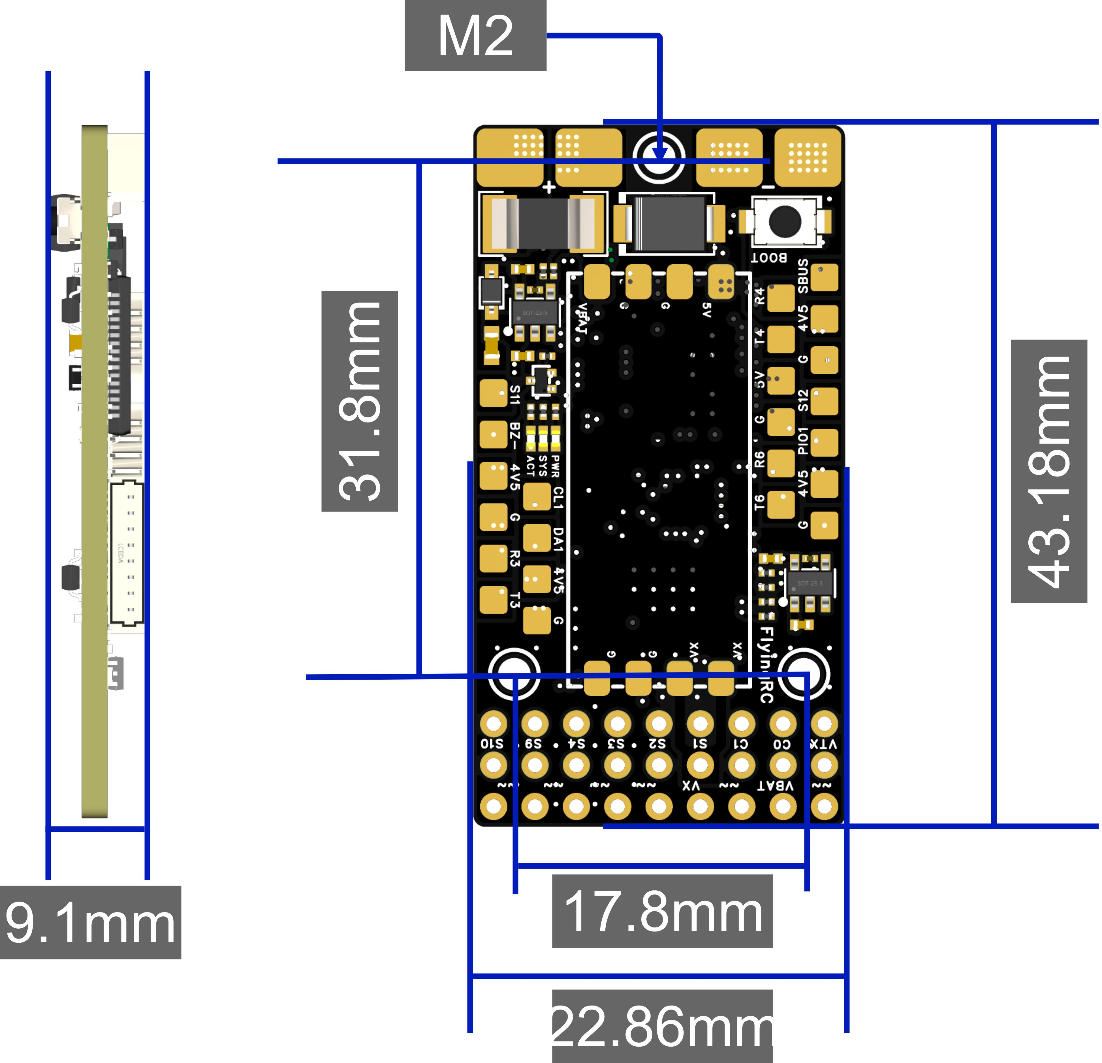

Technical Specifications

Basic specifications |  | Sensor
Model | FlyingRC® F4WSE Pro | IMU(Gyroscope and Accelerometer) | ICM-42688-P
Dimensions | 22.6mm*42.8mm*9mm | Barometer | SPA06-001
Weight | 9.1g | Magnetometer | No on-board magnetometer
 |  | Simulated OSD | AT7465E
MCU |  | Power output
MCU | STM32F405RGT6 | BEC | MP9943+MP9447
Frequency | 168 MHz | BEC-Device | 5V3A
Flash | 1 MB | BEC-Servo | 5V5A
RAM | 192 k
Connector |  | Firmware Support
UART | 6xUART | Betaflight | Supported
UART | UART1, UART2, UART3 | INAV | Supported
UART | UART4, UART5, UART6 | Ardupilot | Supported (Factory Default)
PWM | A total of 12 channels:  6 channels via 2.54mm pin headers,  2 channels via solder pads,  and 4 channels via the 4-in-1 ESC port. | PX4 | Not Supported
I2C | 1
Current-ADC | 80A(cont) /120A(inst)
SWD | N/A | Working Environment
Buzzer | Supports passive buzzer | VBAT Support range | 7-28V DC IN 2-6S LiPo
LED Strip | Supports WS2812 LED strips.  When using INAV firmware, connect the LED strip signal port to the S12 solder pad. | Input | Same as VBAT range
USB-TYPE-C | External USB Brd | Working Temp | -10-100℃
Blackbox | External TF(Recommended usable capacity：4GB, Maximum supported capacity: 32GB) | Storing Temp | 0-40℃
SBUS | Built-in inverter
SBUS | SBUS is internally connected to the RX pin of UART2.

Complete upgrade
Compared to the F4WSE, the F4WSE Pro edition features the following enhancements:
1. Upgraded Boot button for improved usability
2. USB sub-board requires no soldering
3. Supports direct plug-in of 4-in-1 ESCs for easy quadcopter VTOL construction
4. Supports direct plug-in connection for receivers, GPS modules and high-definition air units.
5. Added dual analogue camera switching function
6. PCB upgraded to 2oz copper thickness for improved continuous current handling capability

Product Features
- Compact design, ideal for small FPV aircraft or modified hand-launch planes.
- Innovative design with strong expandability, supports Y3 or quadcopter aircraft. Equipped with 12 PWM channels, also compatible with large carrier drones and VTOL fixed-wing aircraft.
- Adopts high-precision gyroscopes and barometers, delivering significantly enhanced stability compared to comparable flight controllers.
- Onboard current sensor and built-in dual 5V BEC, providing the strongest BEC current output capability among flight controllers in the same form factor.
- External USB and TF card modules allow more flexible installation layout.
- Supports Ardupilot and INAV firmware.
- Supports LED strip connection for spectacular visual effects during flight.

LAYOUT:
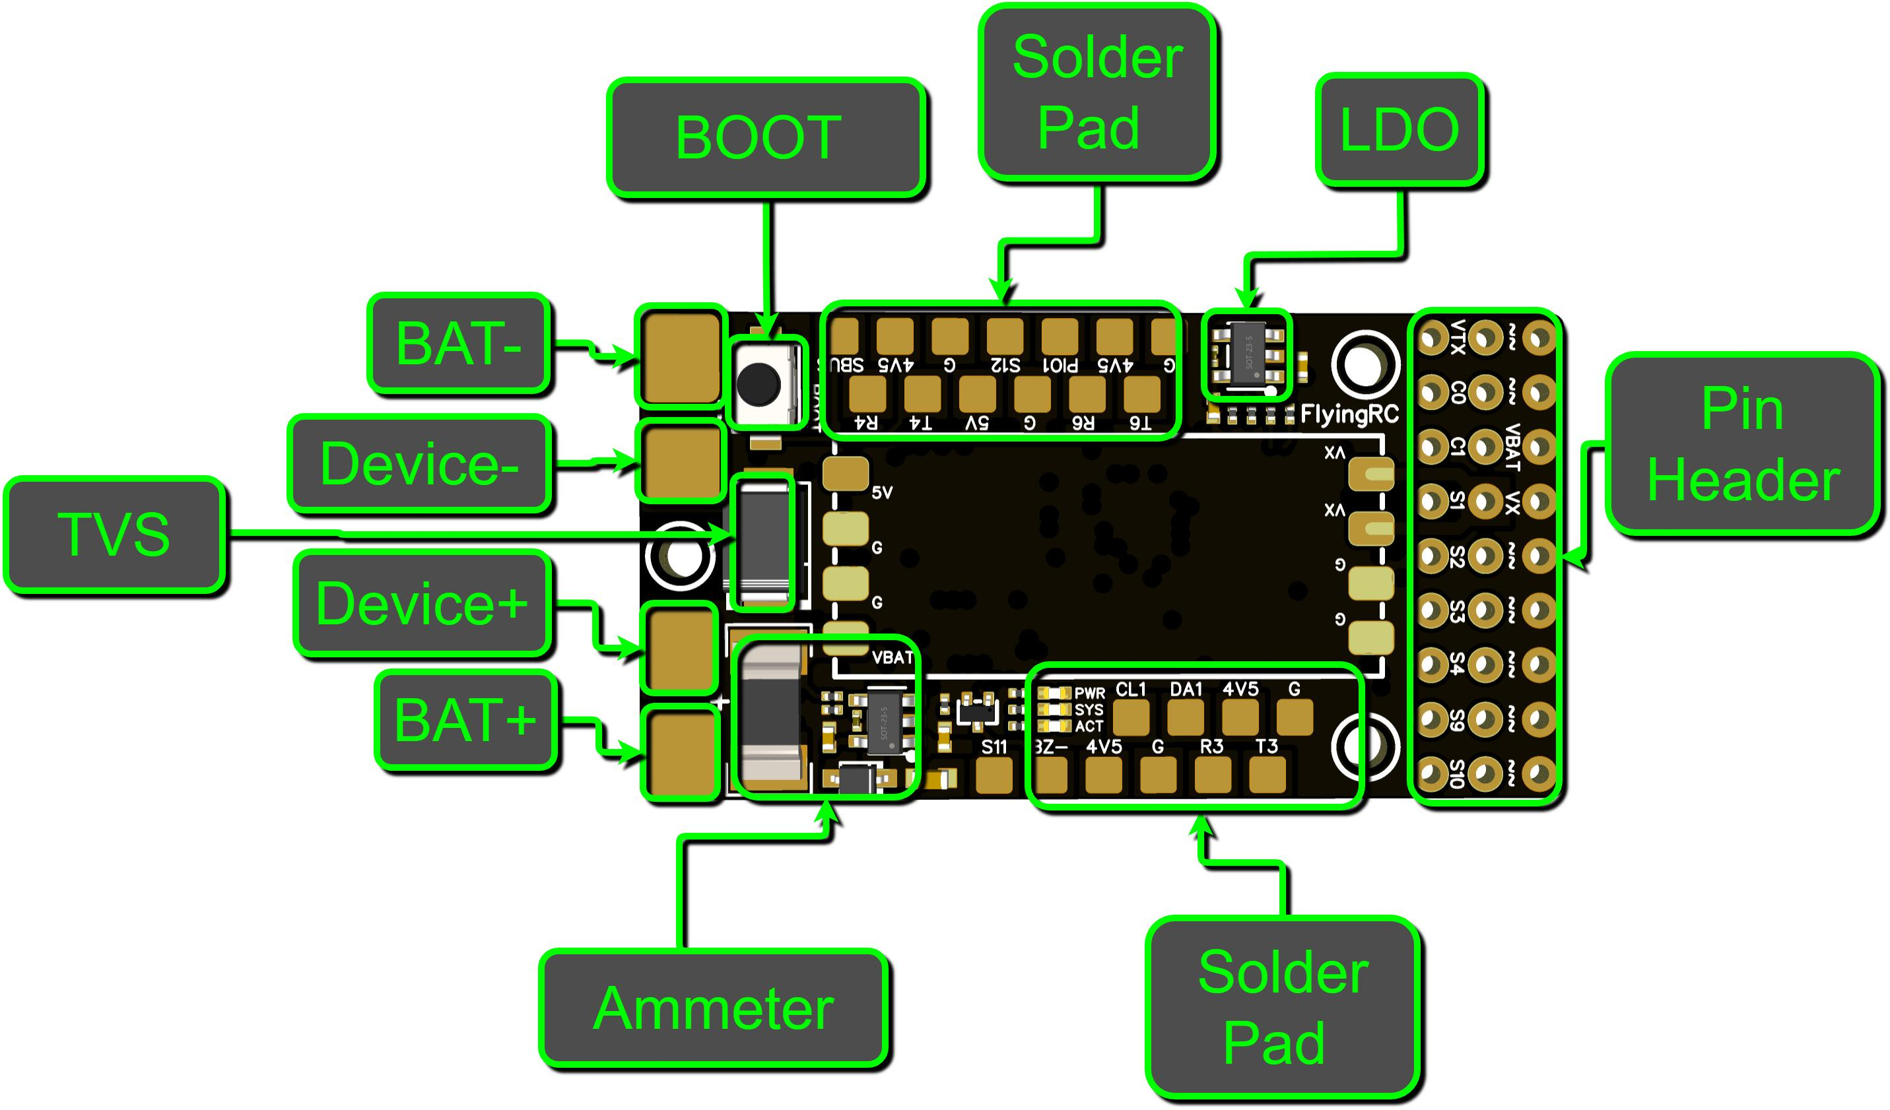
3D Diagram - Top

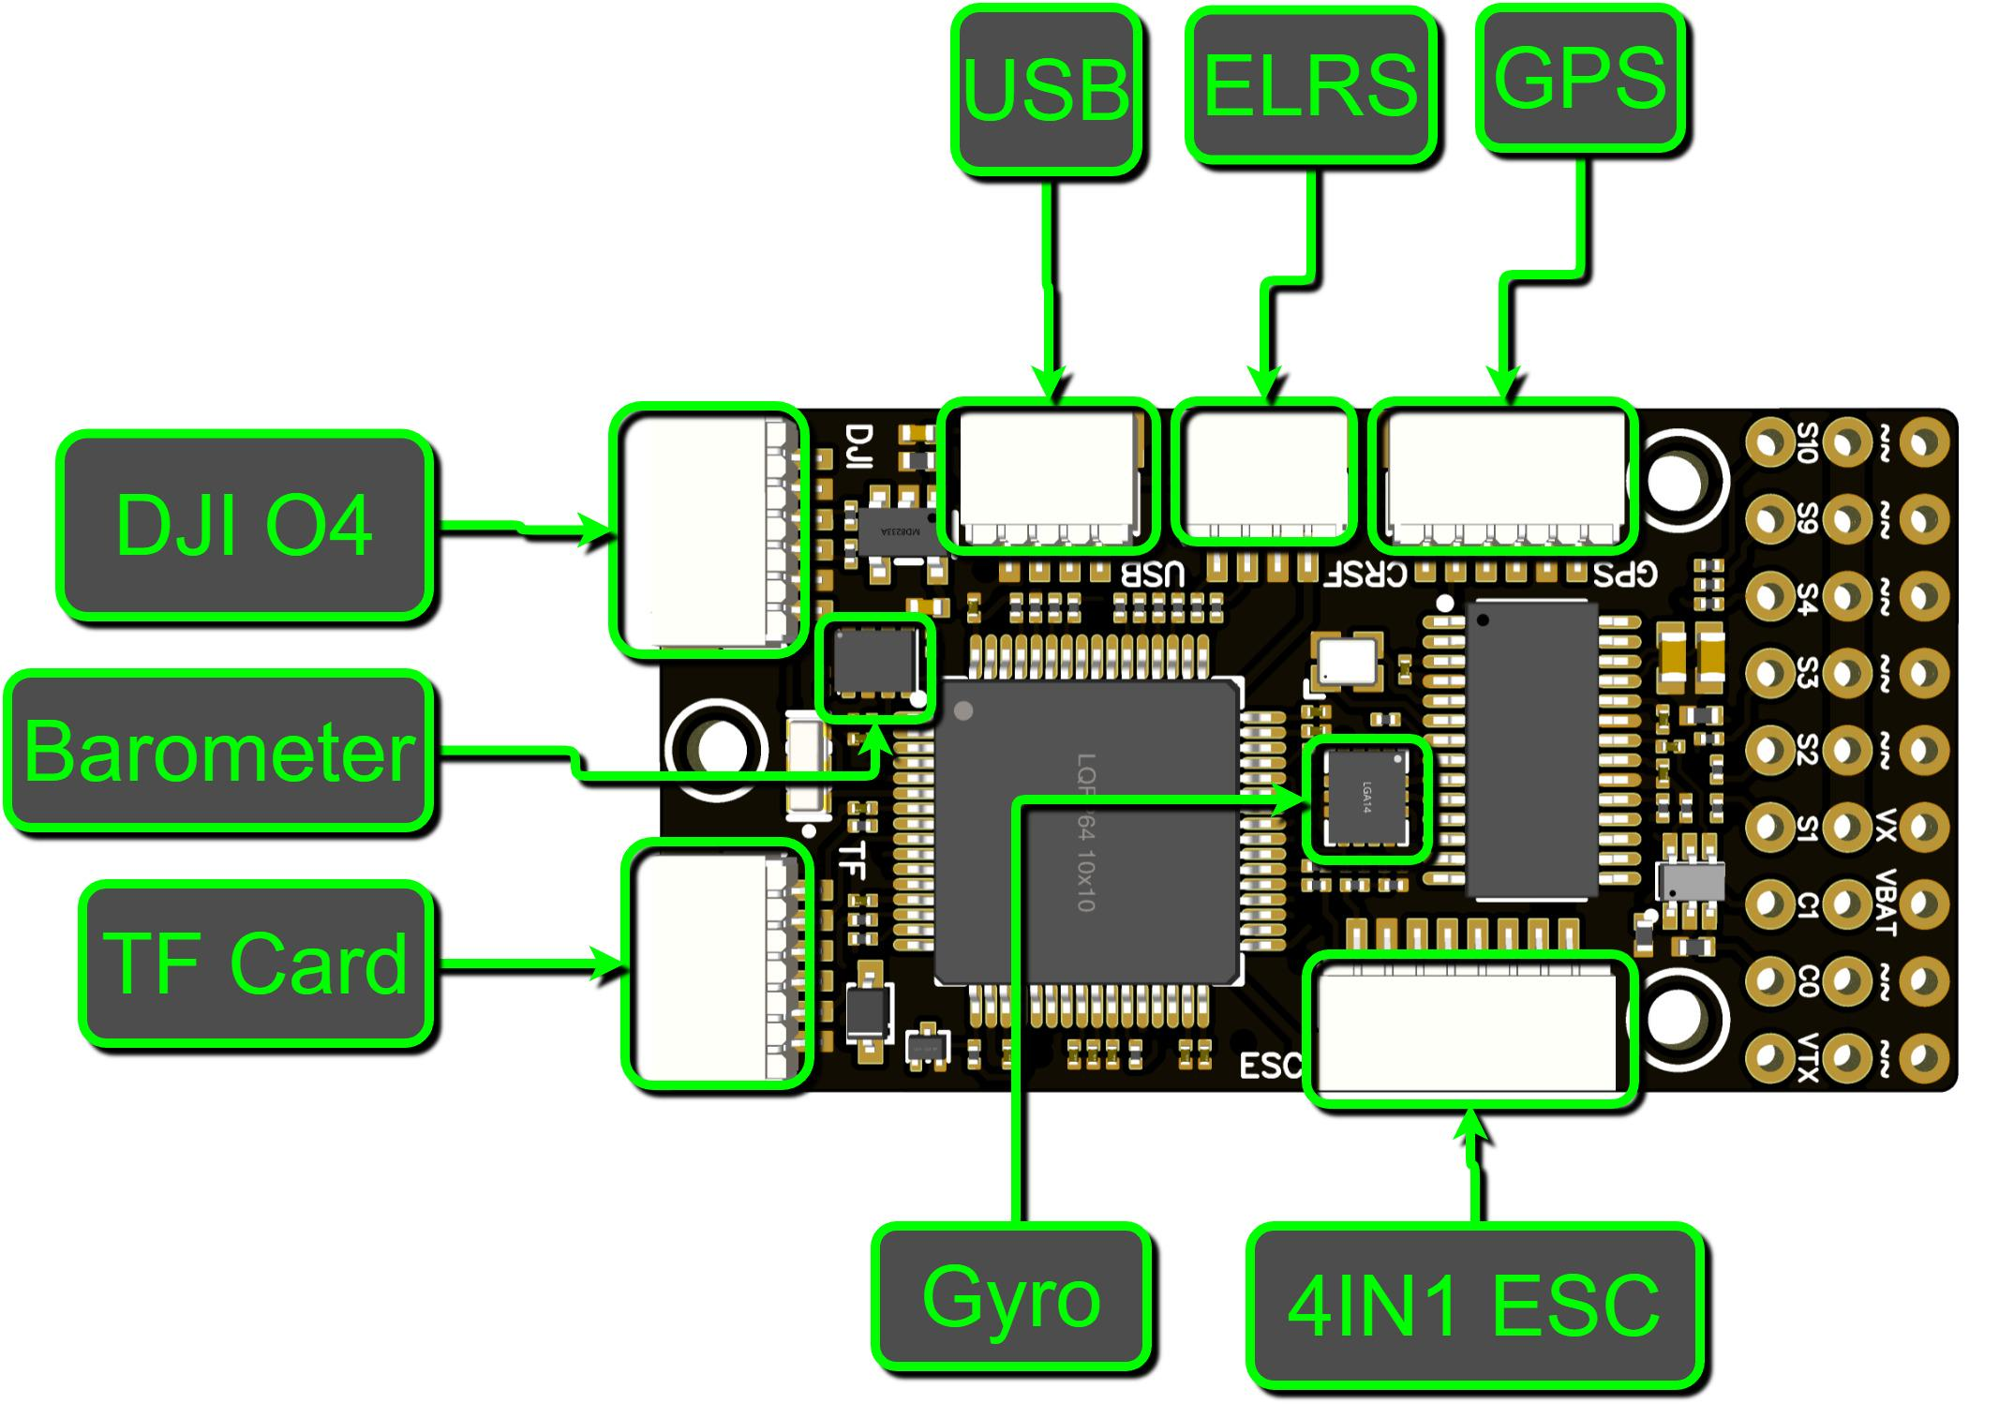
3D Diagram - Bottom
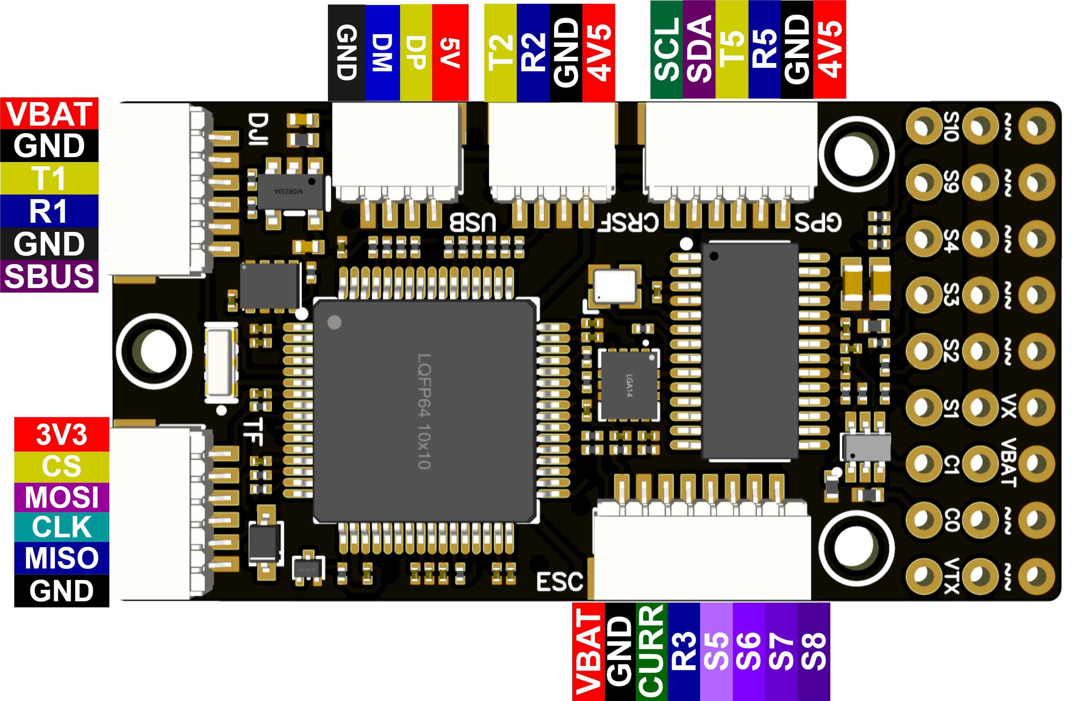

Definition Diagram for the Flight Controller 's Direct Plug-in Ports

4.Usage Instructions:
(1) Preparation before using：
Preparation of Tools and Materials:
soldering iron or soldering station (T12 series or 936 series recommended), solder wire (recommended 63Sn37Pb), wire (28-30AWG wire recommended for signal wires, 14-18AWG recommended for power wires),35V 470uF capacitor (can be parallel soldered on the power input pad, optional), 10V 2A buck module (optional, required for DJI HD video transmission system, Caddx HD video transmission system, and some analog cameras and video transmission systems with poor filtering).

- Connecting the USB sub-board to the Flight Controller
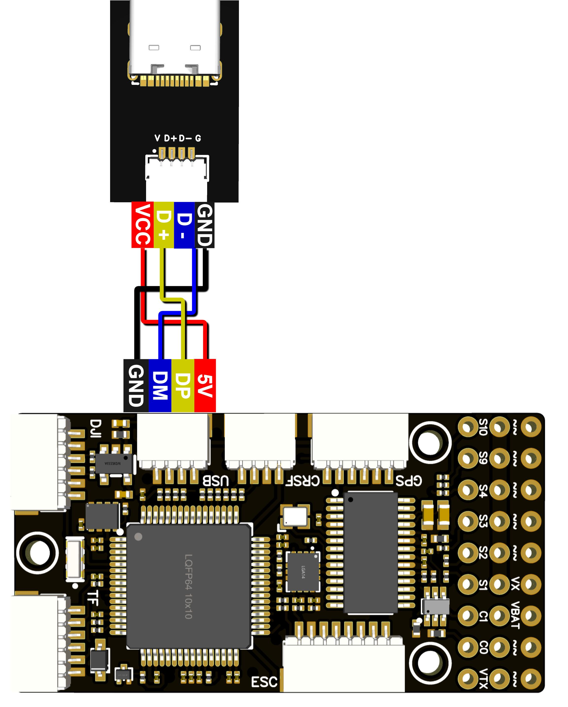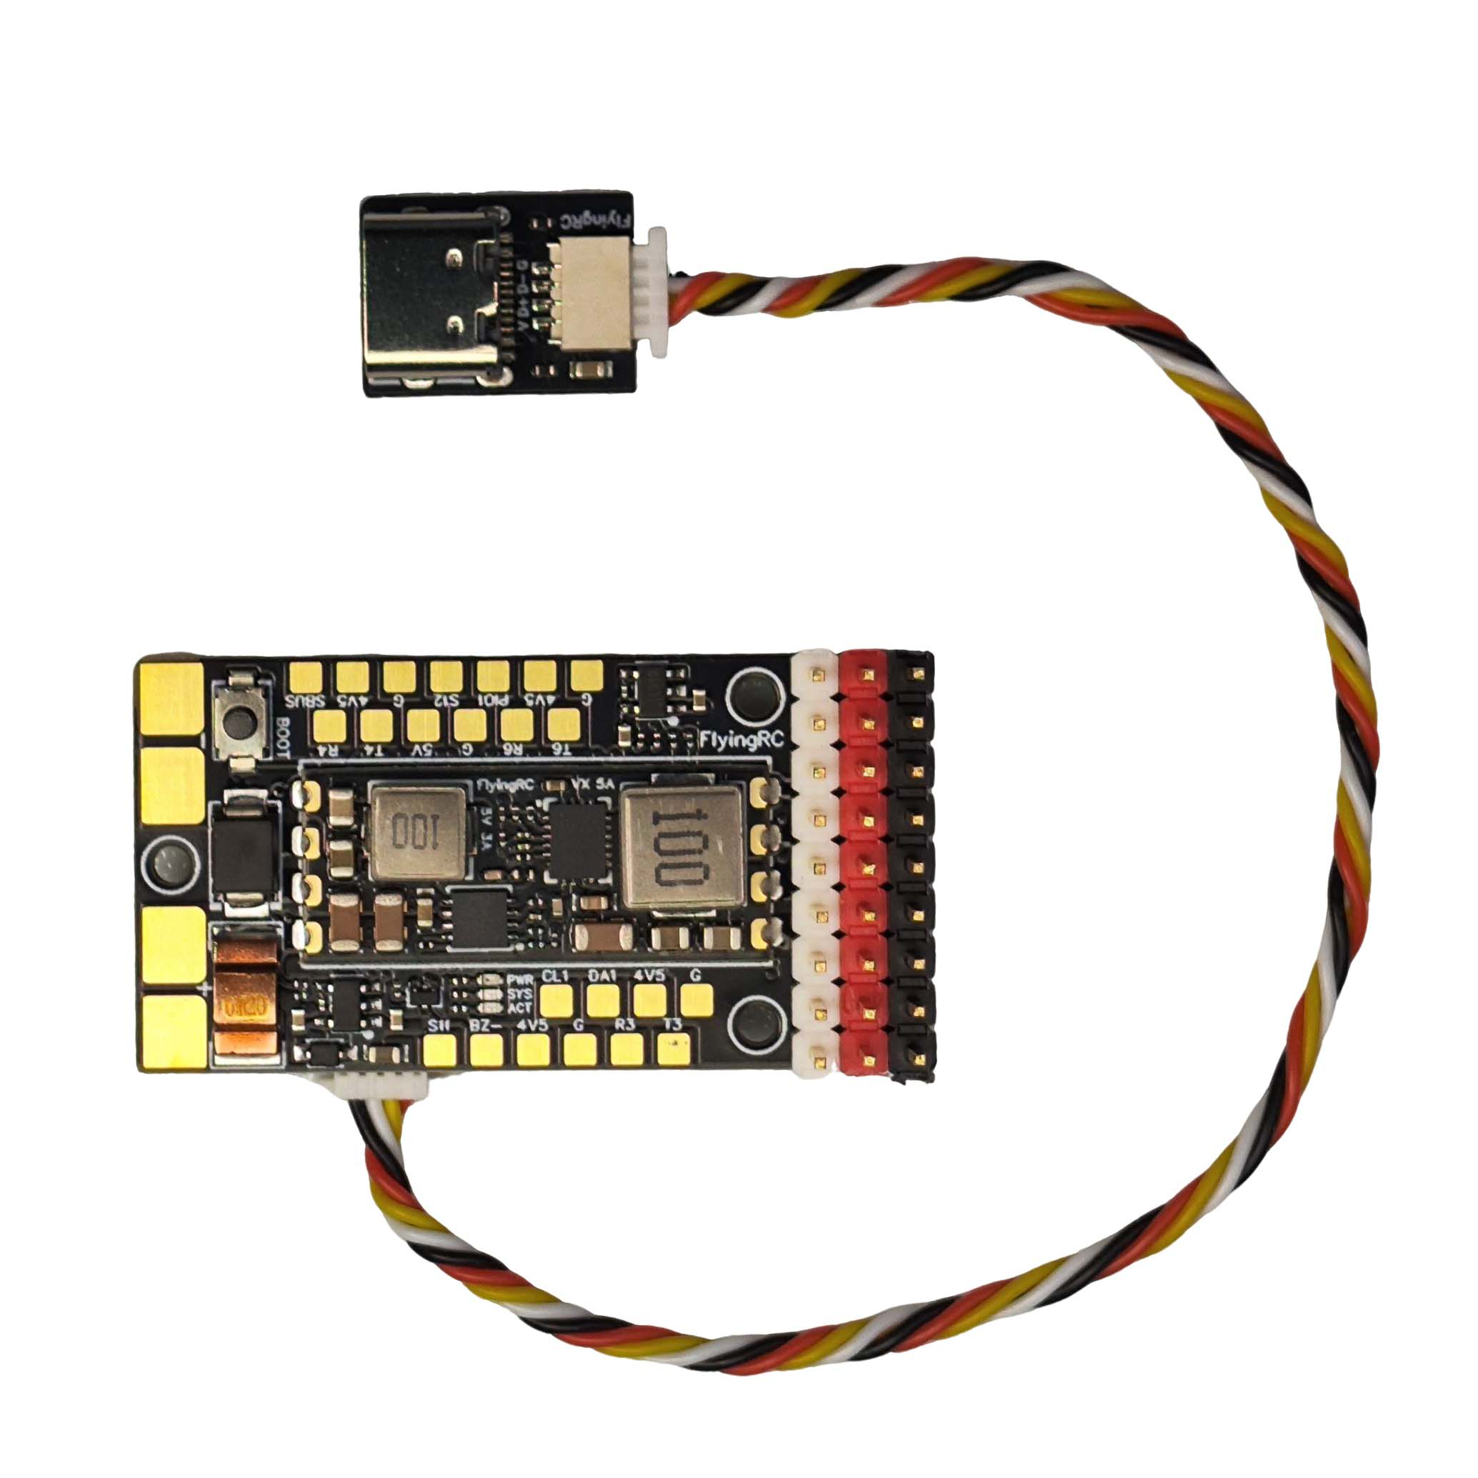
Wiring diagram for connection to USB sub-board
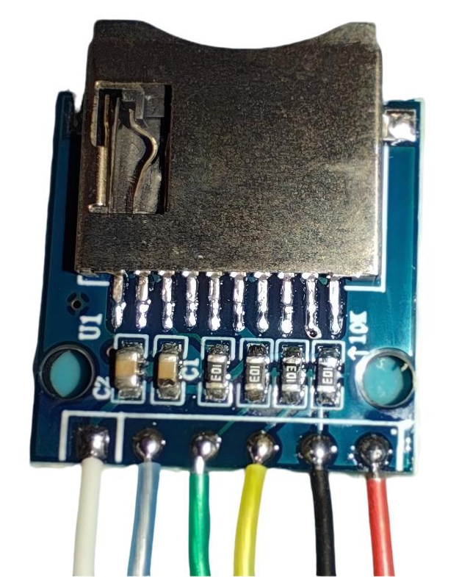
Soldering order of wire to External TF Card module
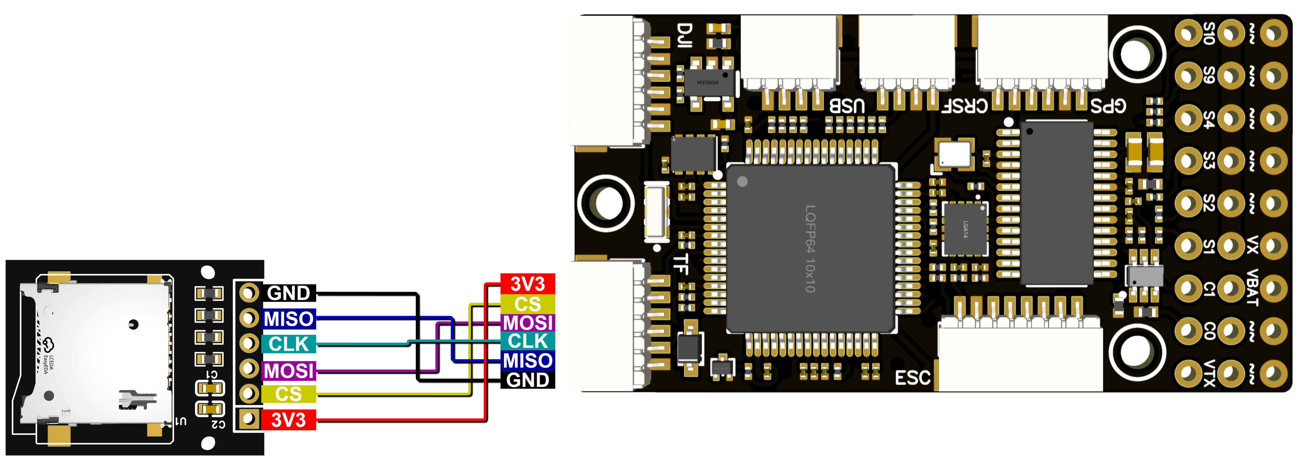
Wiring diagram for connection to TF sub-board

Precautions:
Use silicone wires for signal lines. The flight controller terminal is of model SH1.0 and is small in size. When plugging or unplugging, support the rear of the socket with your hand to prevent it from falling off due to force.

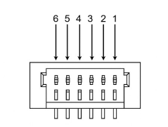
Interface sequence diagram

Pin Definition of PWM Expansion Interface
Pin Number | Pin Name | Pin Definition
1 | S12 | PWM_CH12 ESC/Servo
2 | S11 | PWM_CH11 ESC/Servo
3 | S10 | PWM_CH10 ESC/Servo
4 | S9 | PWM_CH9 ESC/Servo
5 | S8 | PWM_CH8 ESC/Servo
6 | S7 | PWM_CH7 ESC/Servo
Soldering wire sequence of flight controller and servo expansion board

- Firmware
For fixed-wing aircraft, ArduPlane and INAV firmware are recommended. ArduPlane firmware is pre-installed by default
This flight controller is directly compatible with MatekF405-TE firmware.
Latest stable firmware download links (updated 2025/11/09):
ArduPlane V4.6.3 MatekF405-TE
ArduCopter V4.6.3 MatekF405-TE
INAV 8.0.1 MatekF405TE_SD
BF MatekF405-TE
The flight controller supports direct flashing via ground stations such as Mission Planner.
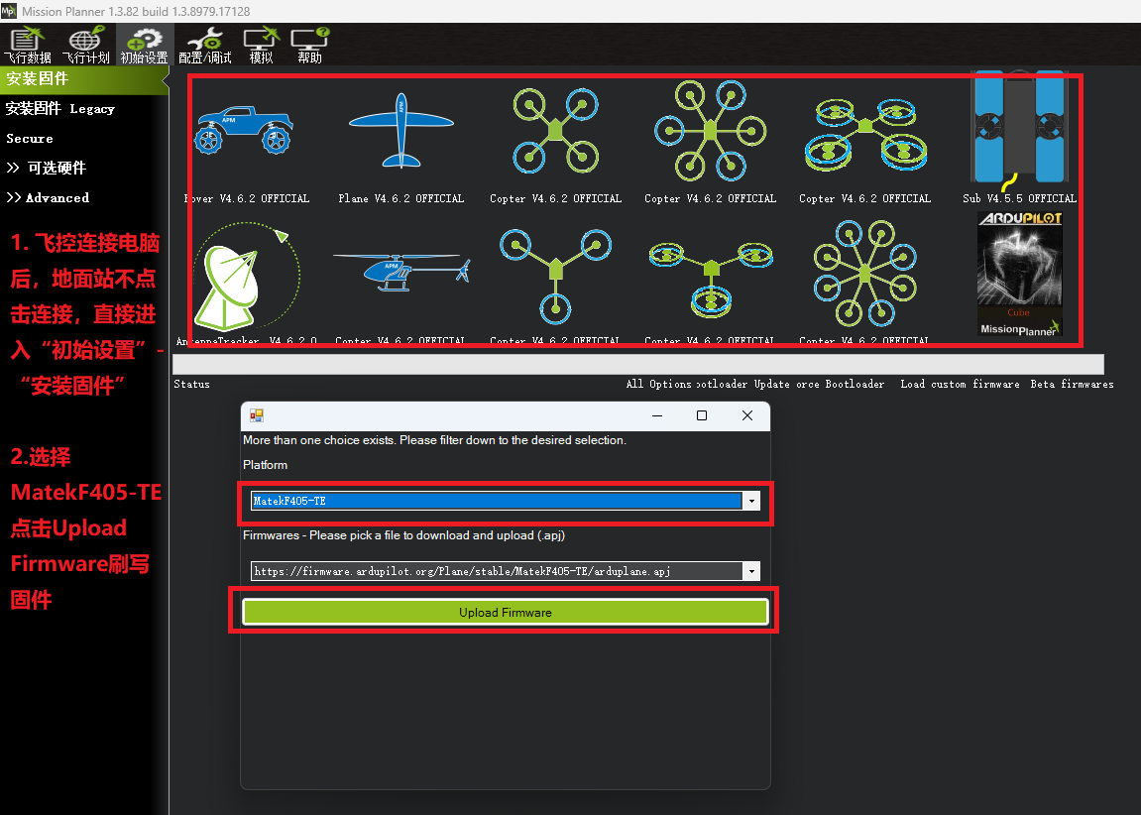
To access the flight controller configuration file, please click: MTKS F405TE_SD
For the firmware flashing tutorial, please click：Bilibili Column — Ardupilot Fixed-Wing Flight Controller Firmware Flashing & Version Update
For the Ardupilot firmware operation tutorial, please click：FlyingRC® F4Wing MK5User Manual
(4)Wiring：
Complete wiring diagram for the Flight Controller
(Note: The 4IN1 75A ESC is the V3.2 version)
The 4-in-1 electronic control interface is exclusively designed for voltage detection and cannot provide power to the flight control system.

The 4IN1 75A ESC is currently available in two versions: V3.2 and V4.0, with differing wiring sequences. The V4.0 version complies with the BF wiring sequence standard. Customers should note the visual distinctions between the V3.2 and V4.0 models.
1.The 8P socket of the V4.0 version bears the printed warning: ‘Note the wire sequence.’
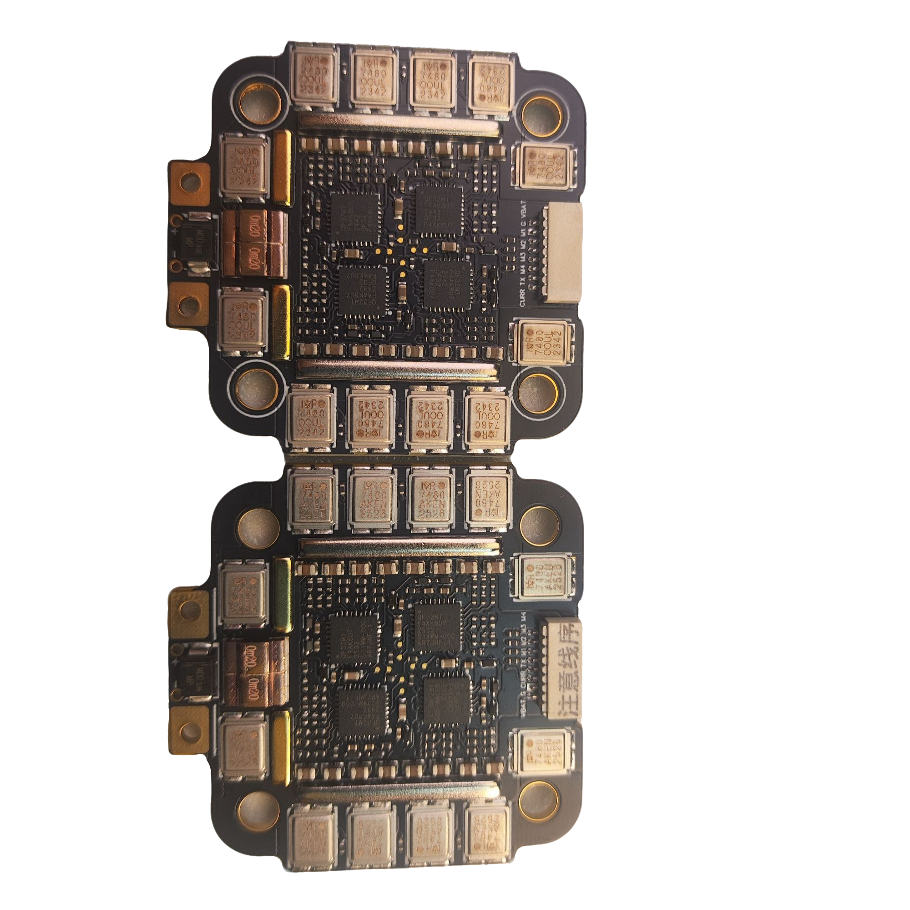
V3.2 V4.0
2.Both versions bear the version number.
3.The V4.0 version bears an S/N code.
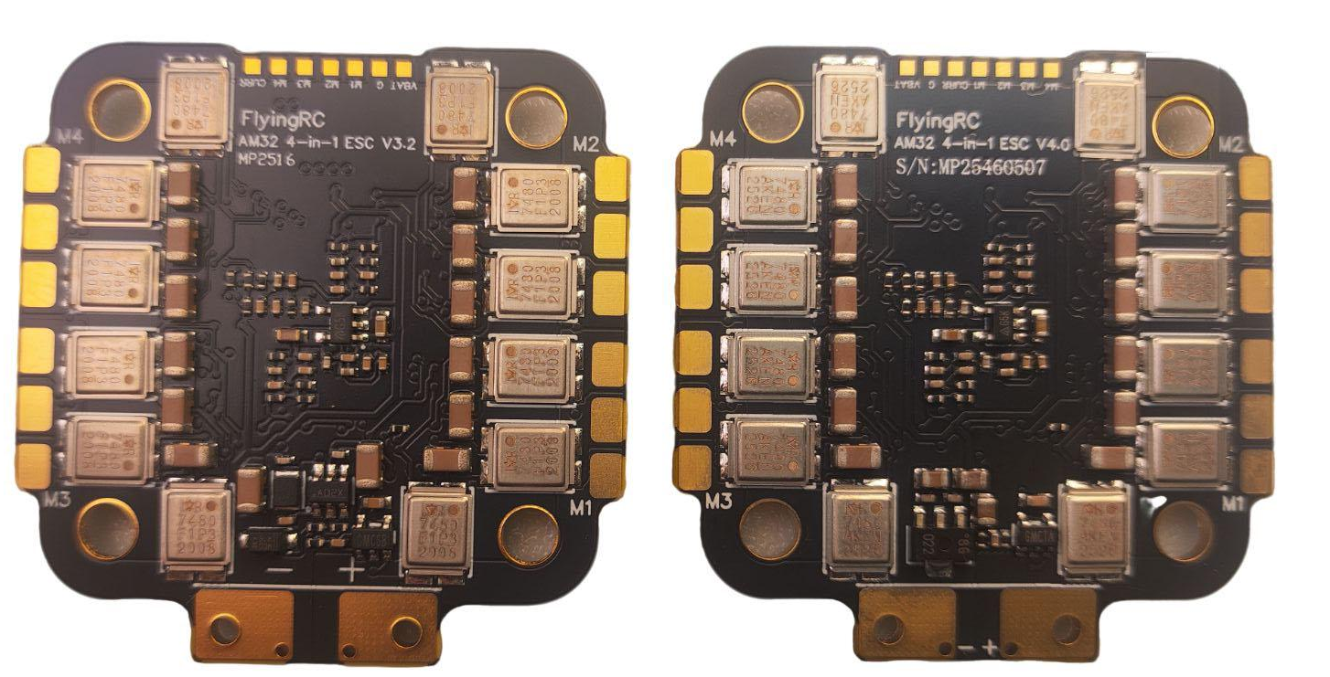
V3.2 V4.0
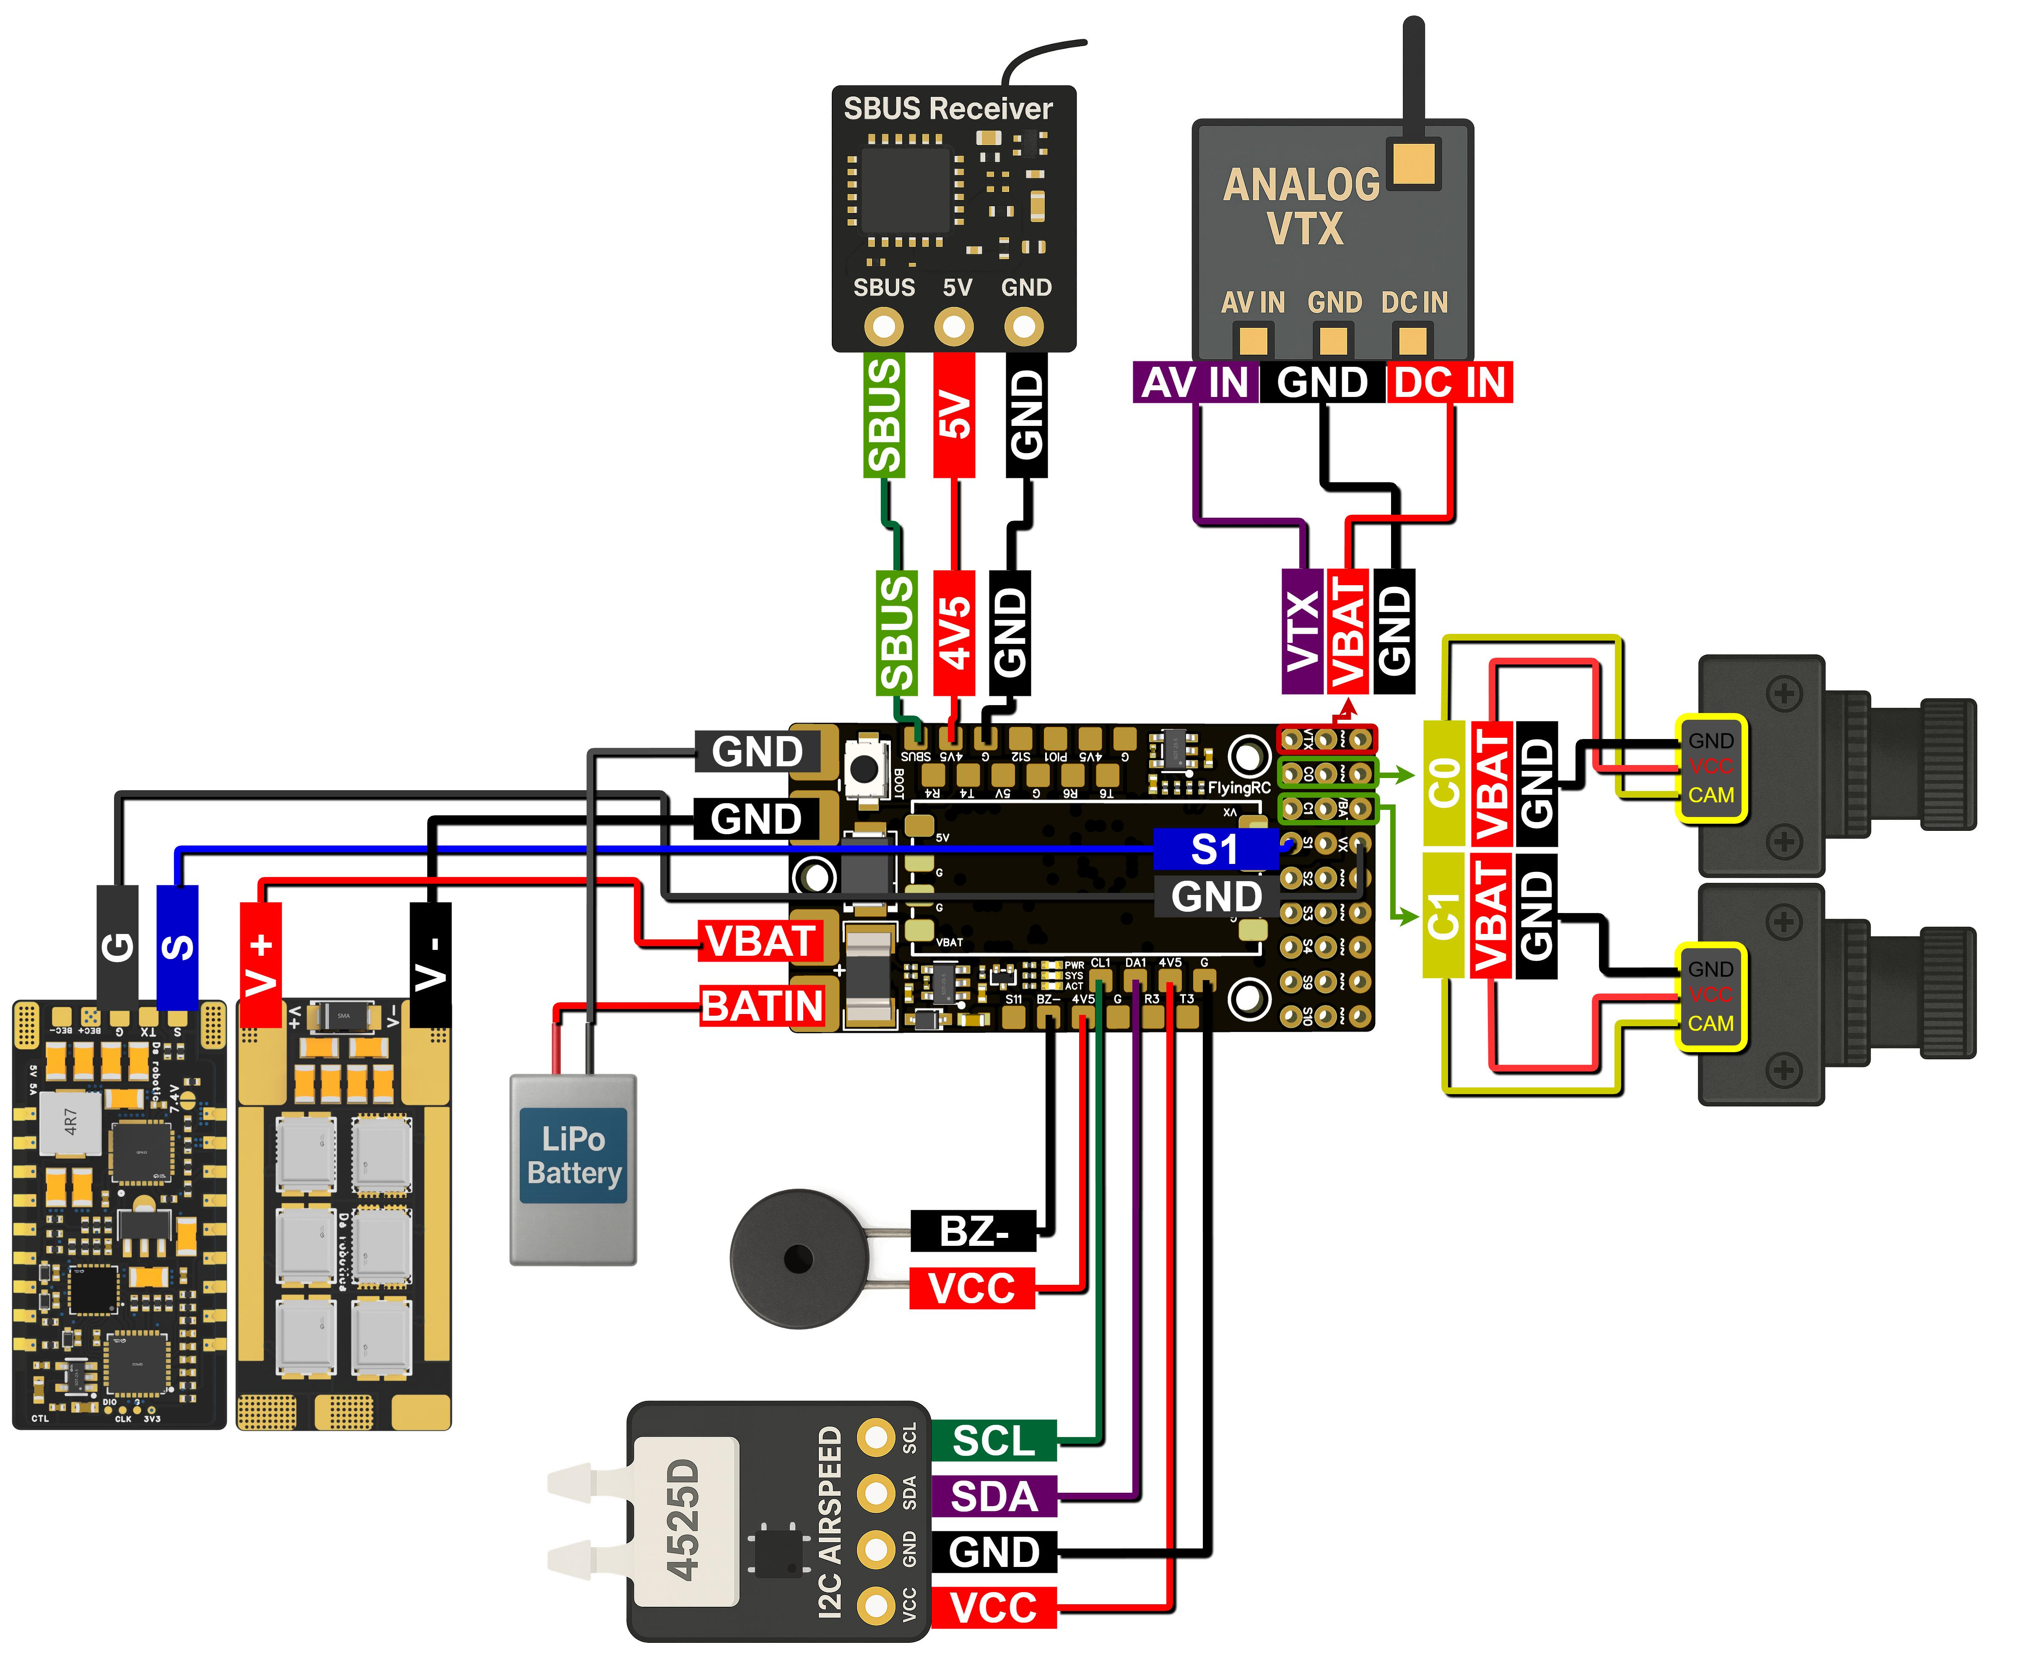

The Complete wiring diagram for the Flight Controller

Wiring for Individual Equipment-Detailed Instructions

ELRS Receiver
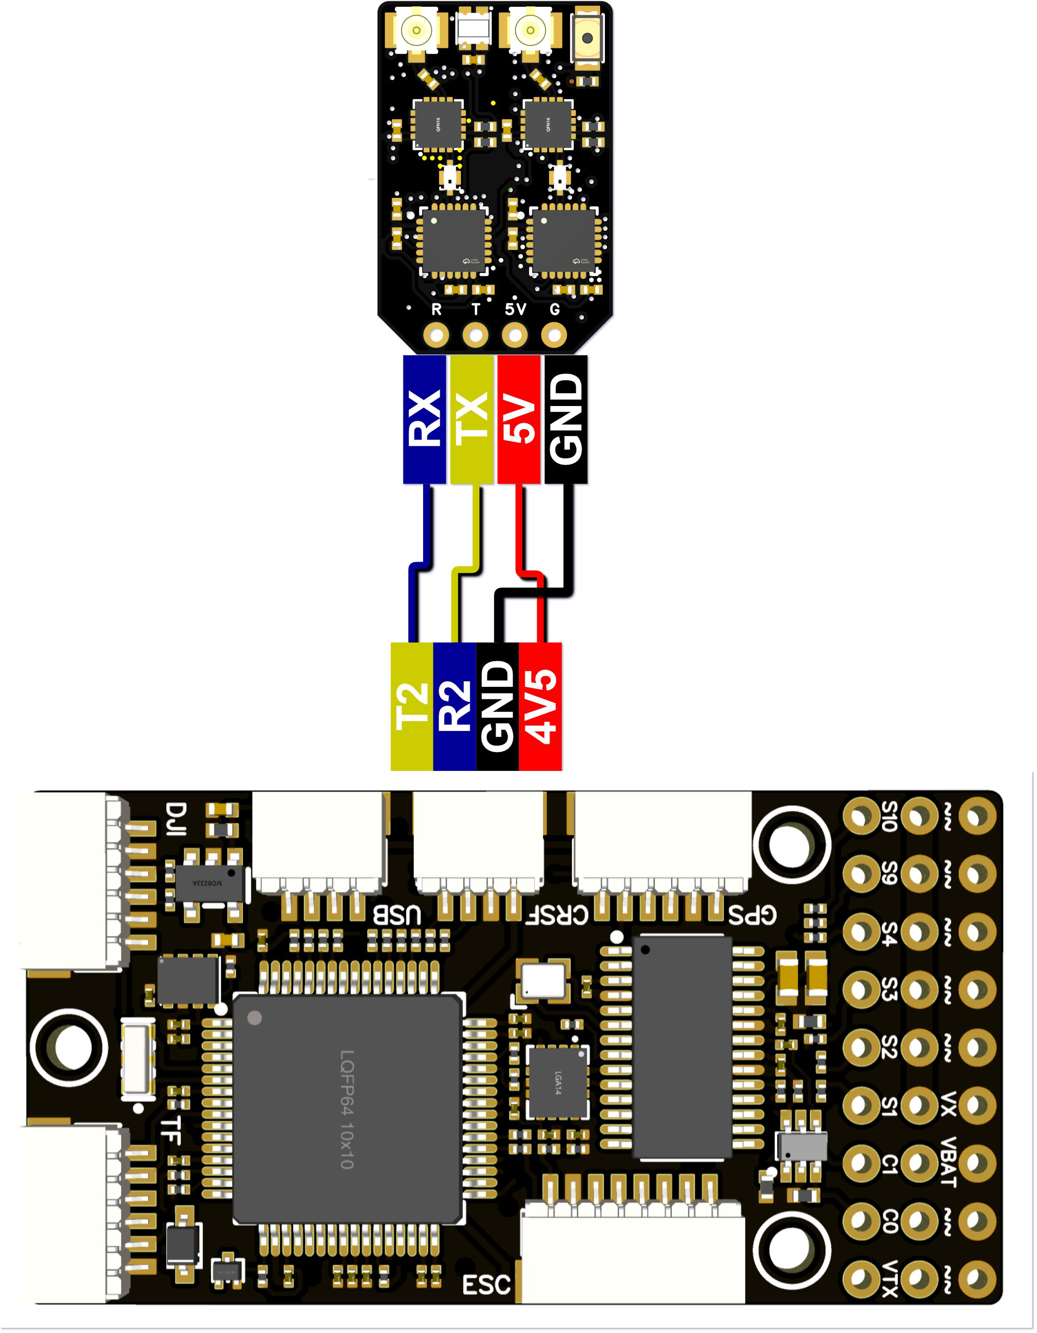
The wiring diagram for connecting to the FlyingRC® ELRS receiver
- SBUS Receiver
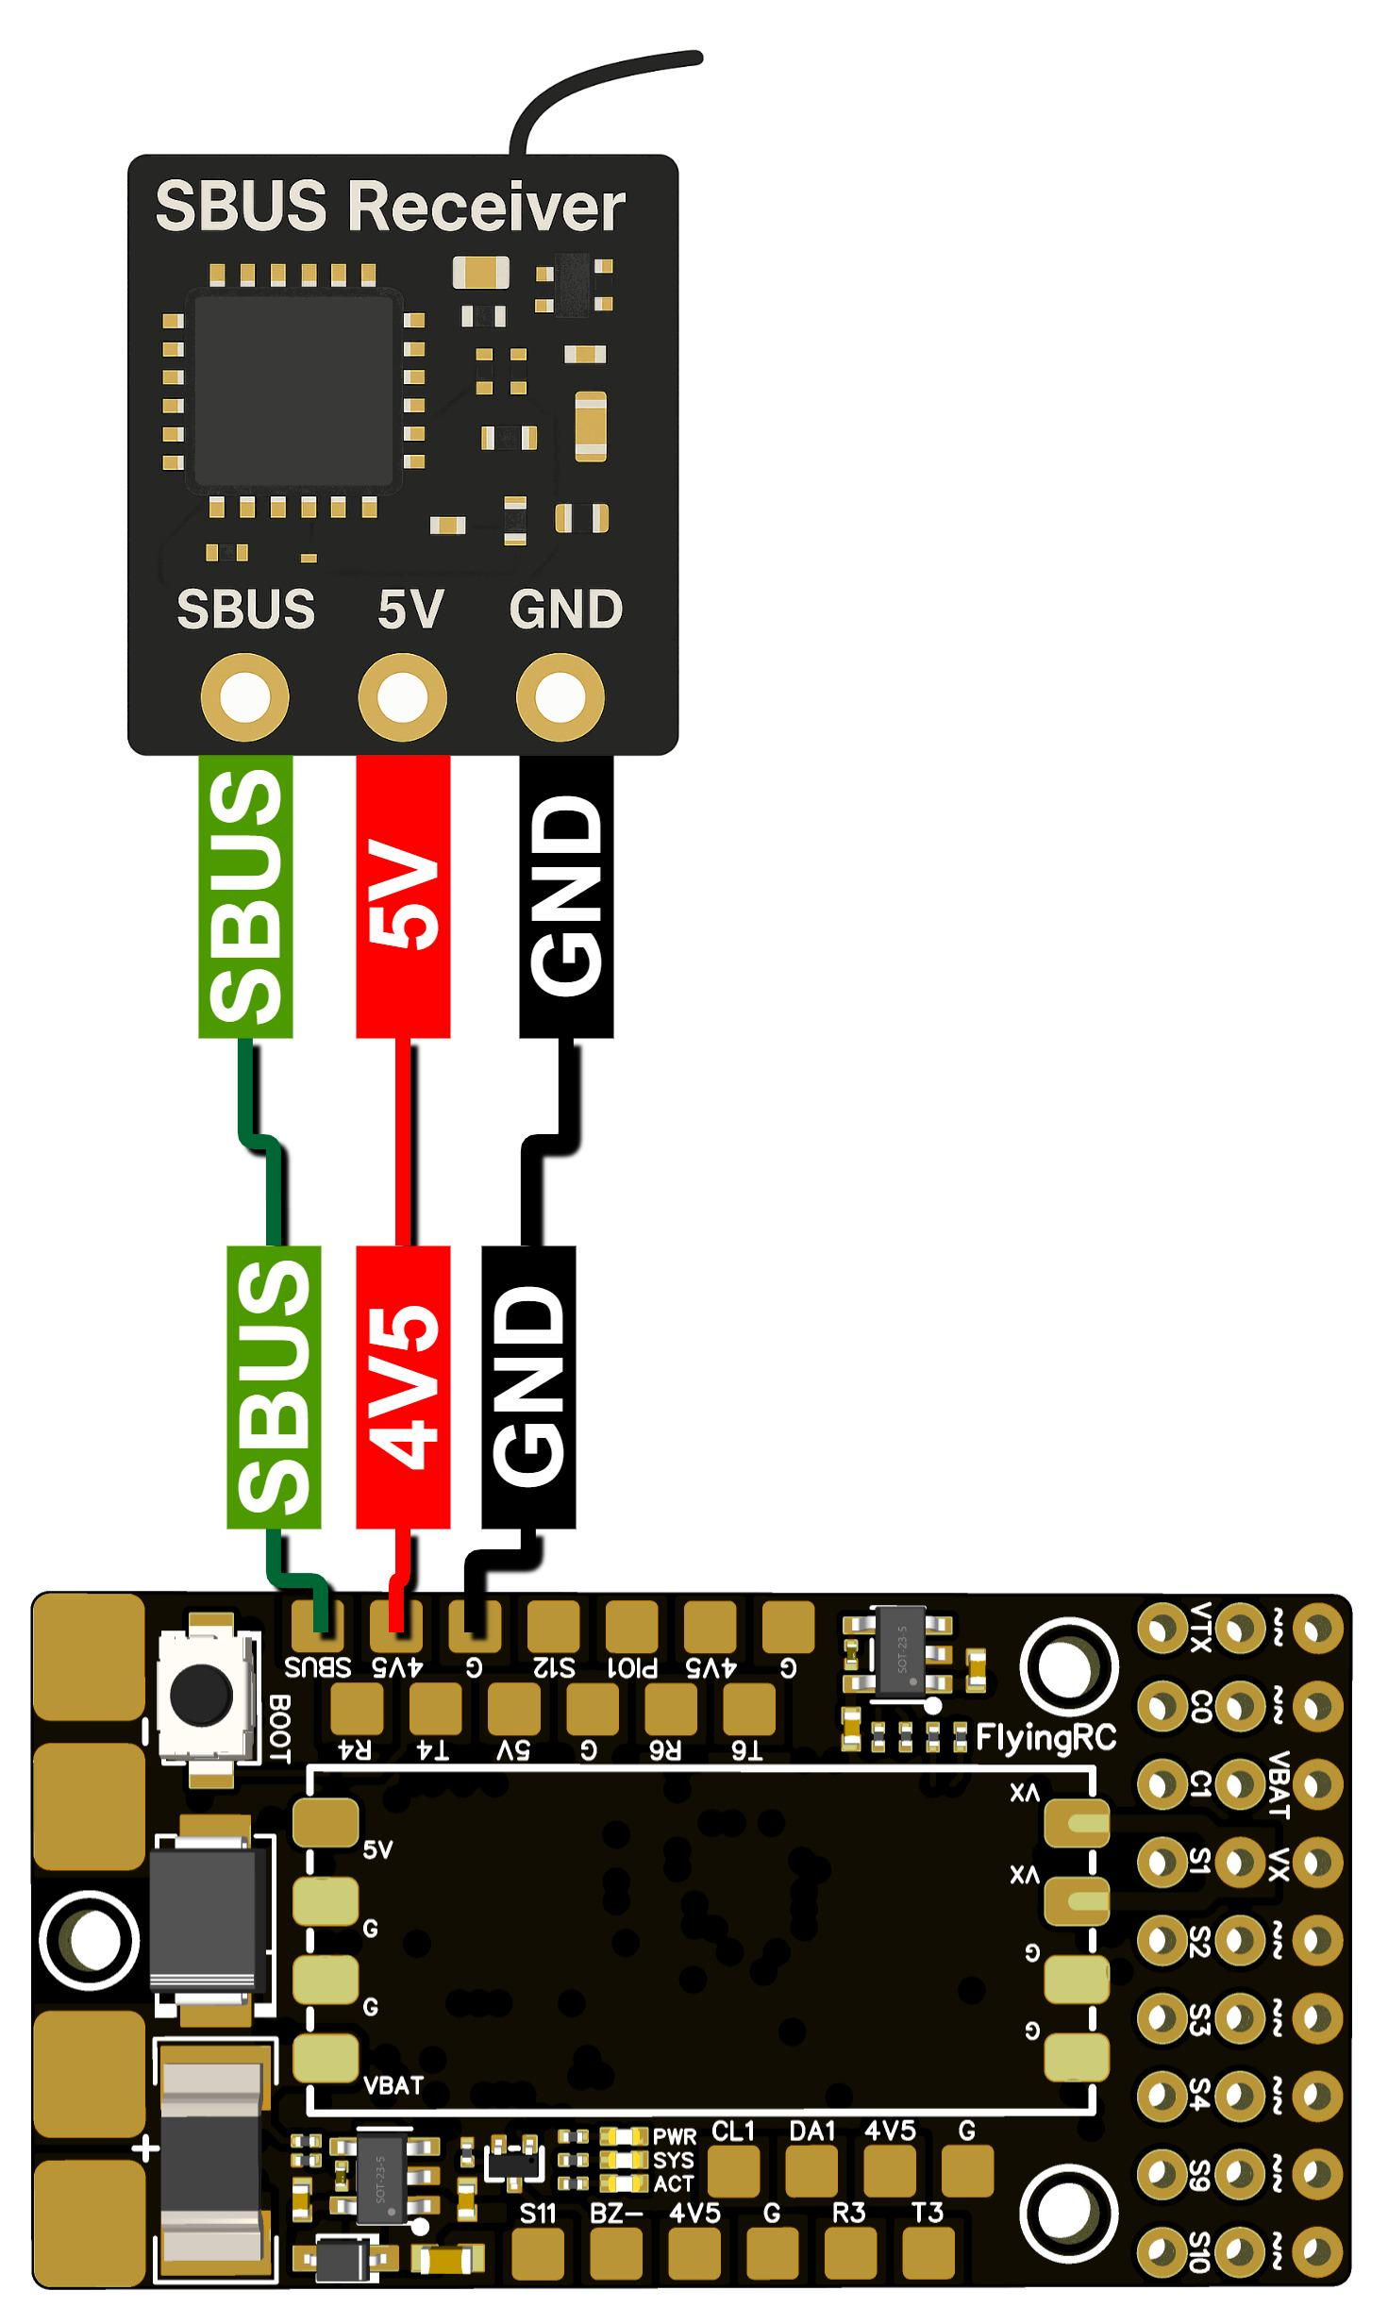
The wiring diagram for connecting to the SBUS receiver

GPS
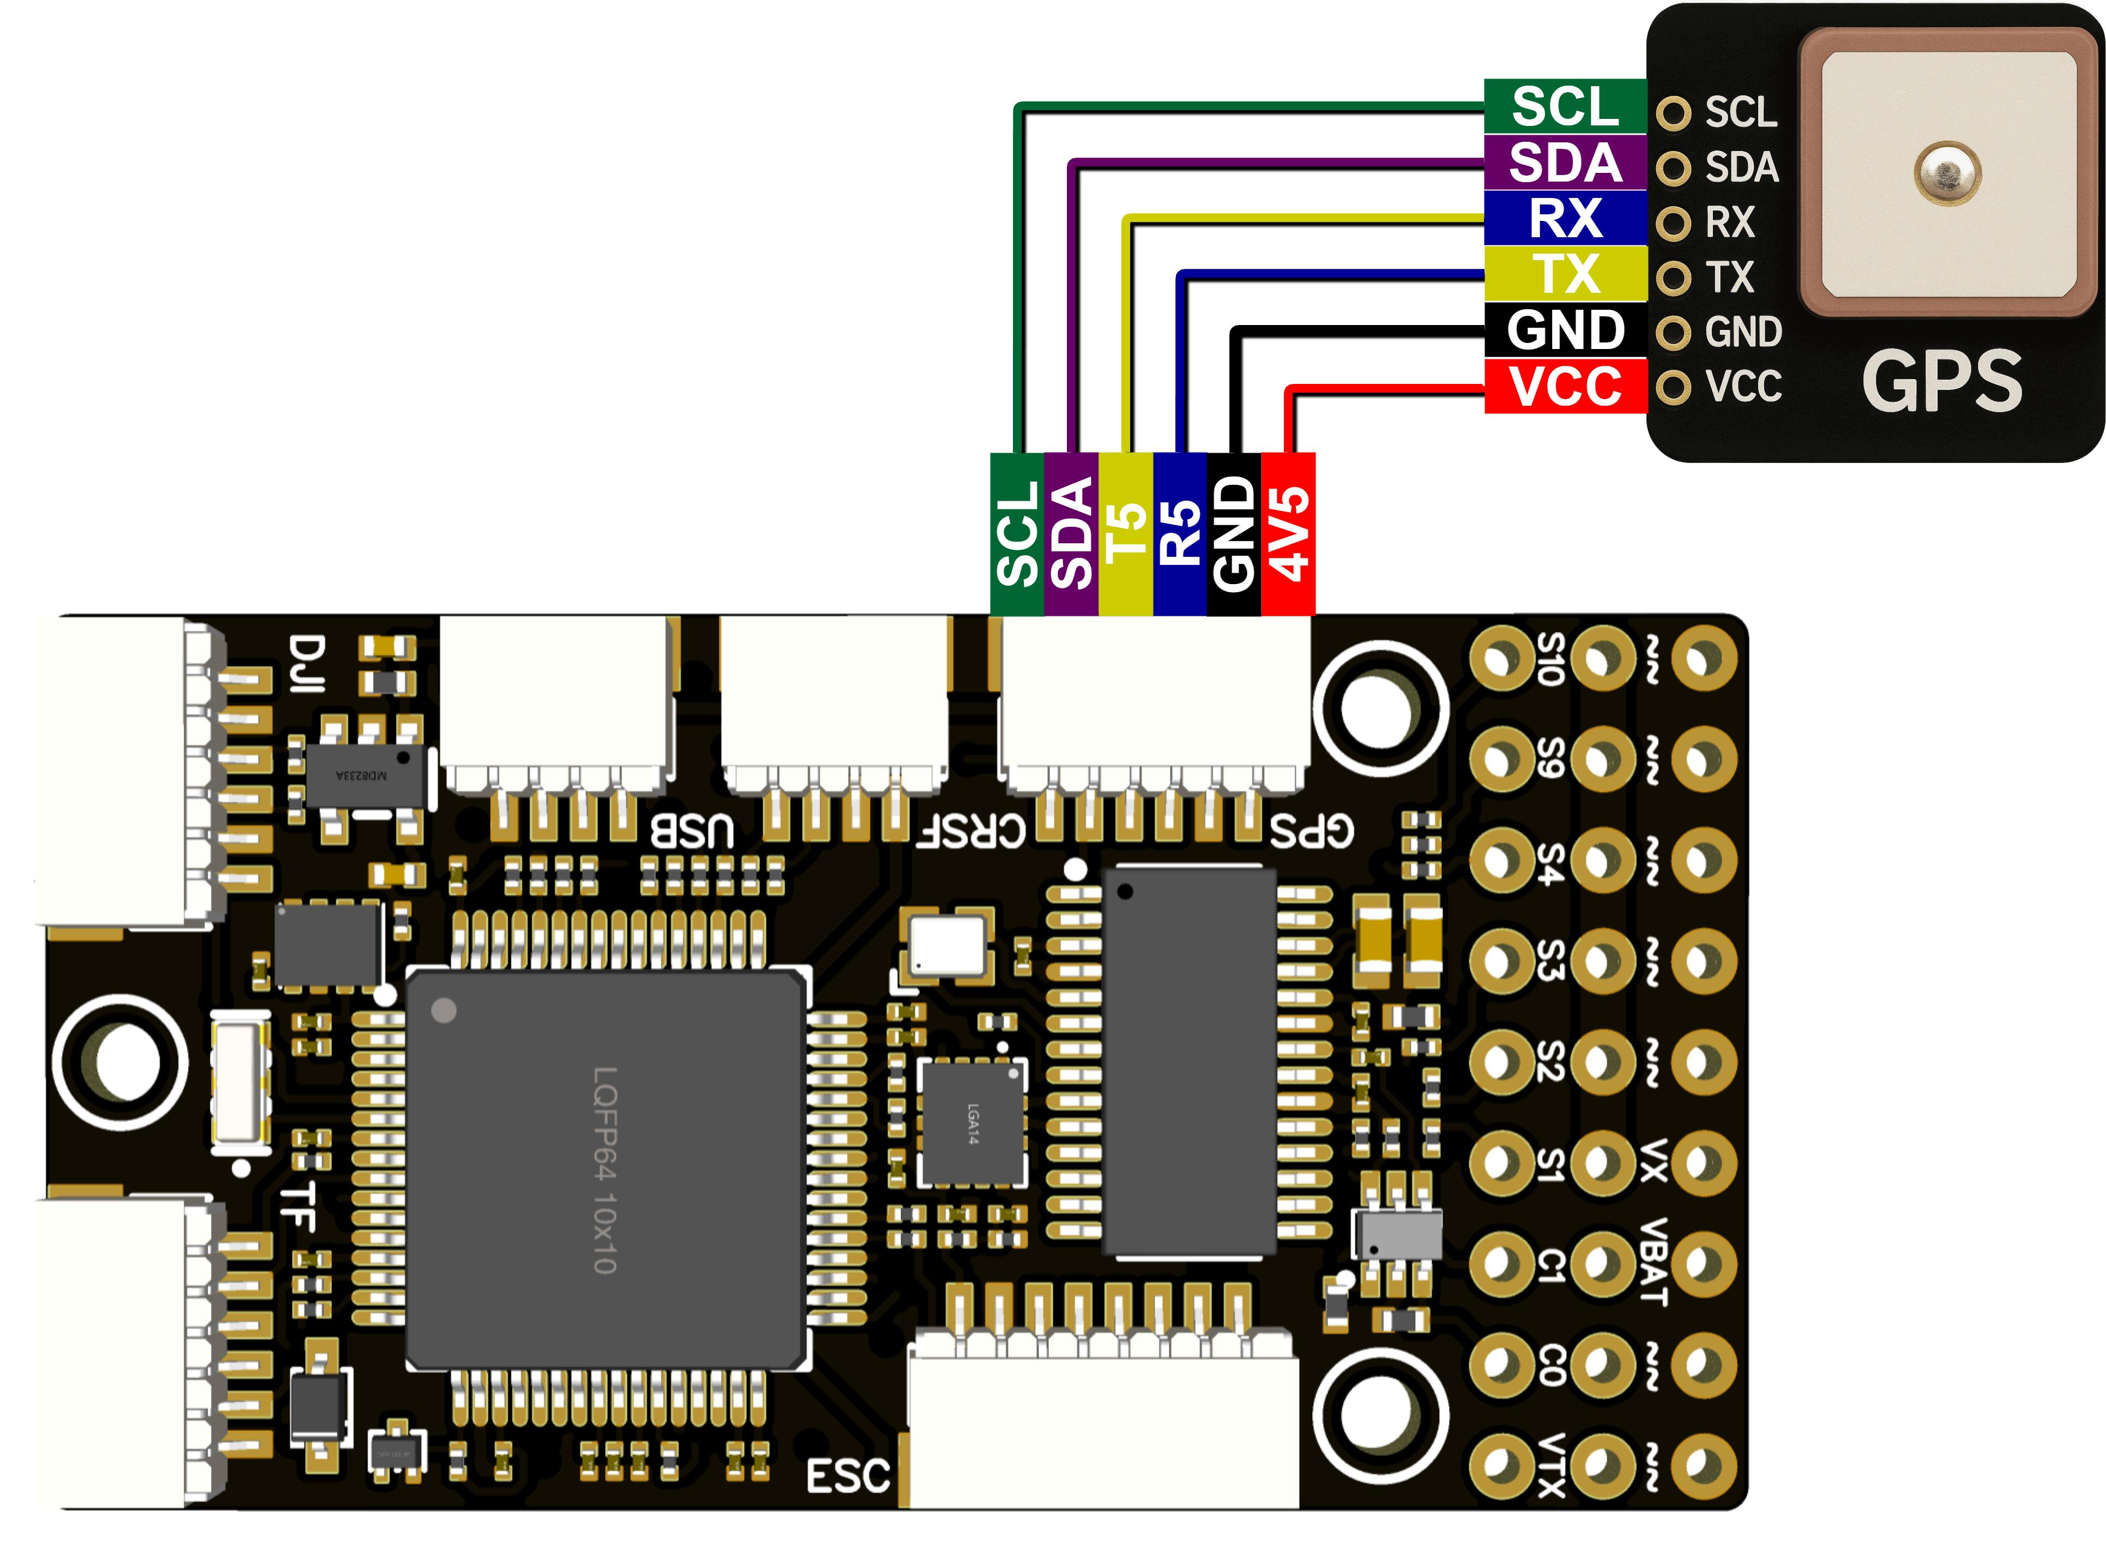
The wiring diagram for connecting to the FlyingRC® GPS
！Note the GPS terminal pinout; please carefully examine the silk-screen markings on the GPS unit!

Analogue Camera and Video Transmission Unit
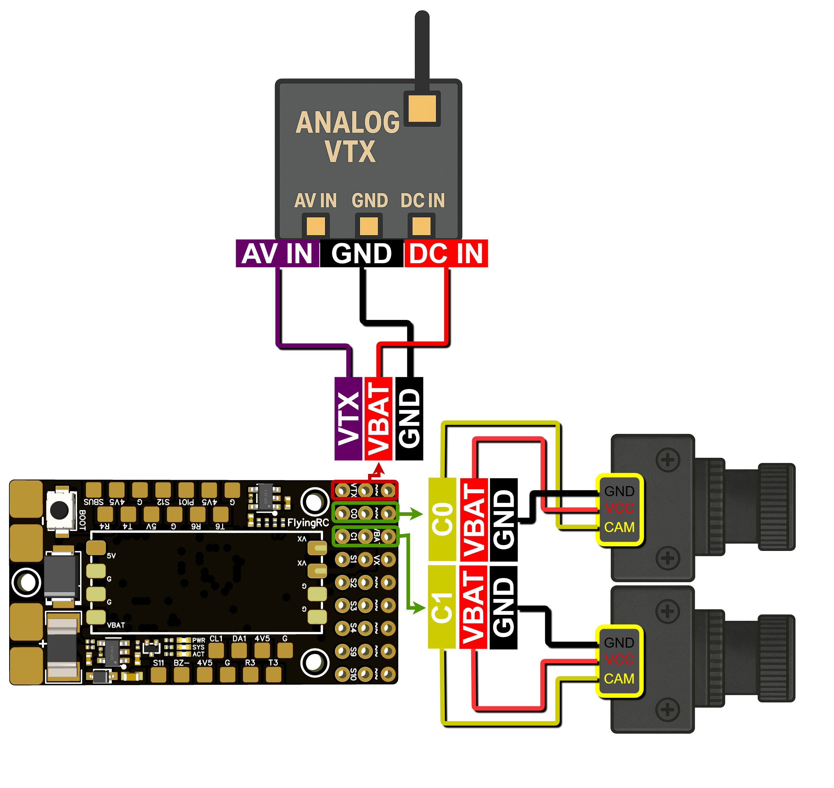

The wiring diagram for connecting the Analogue Camera and the Video Transmission Unit

4IN1 ESC
The wiring diagram for connecting to the FlyingRC® 4IN1 ESC
(Note: The ESC is version V3.2)

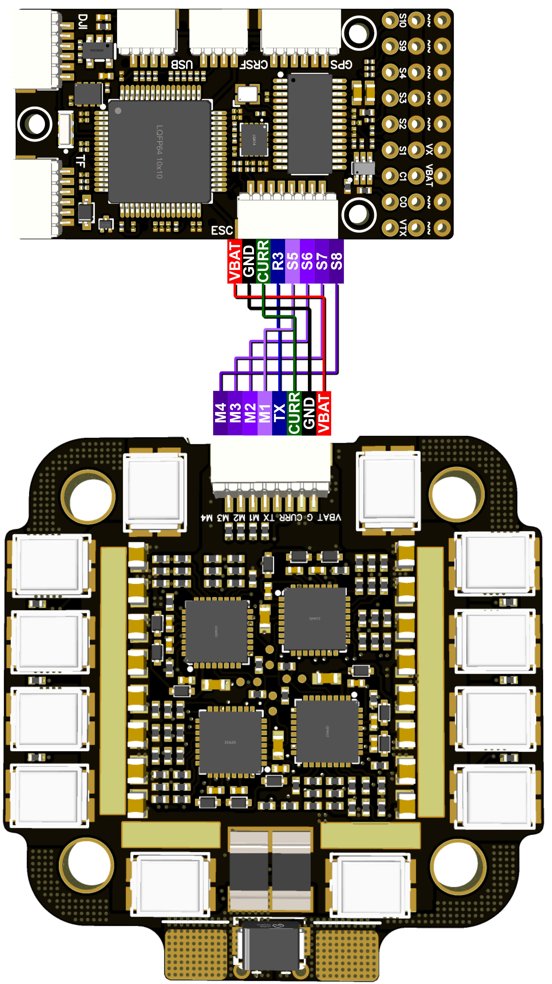
The wiring diagram for connecting to the FlyingRC® 4IN1 ESC
(Note: The ESC is version V4.0)

Digital Video Transmission Unit with SBUS (DJI,Walksnail)
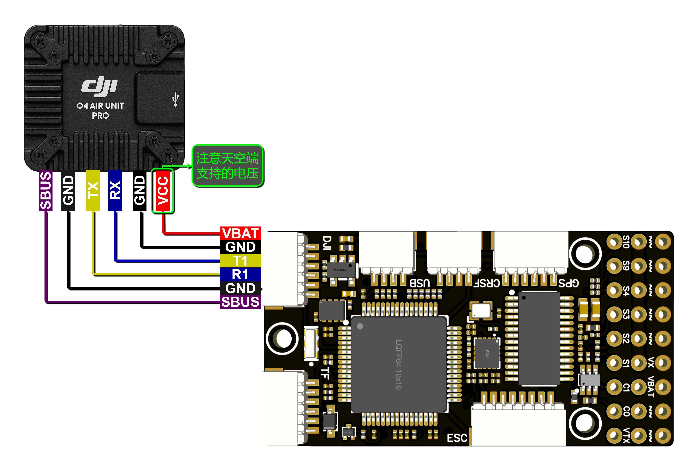
Pay attention to the air unit voltage
The wiring diagram for connecting to the Digital Video Transmission Unit with SBUS

O4 BEC
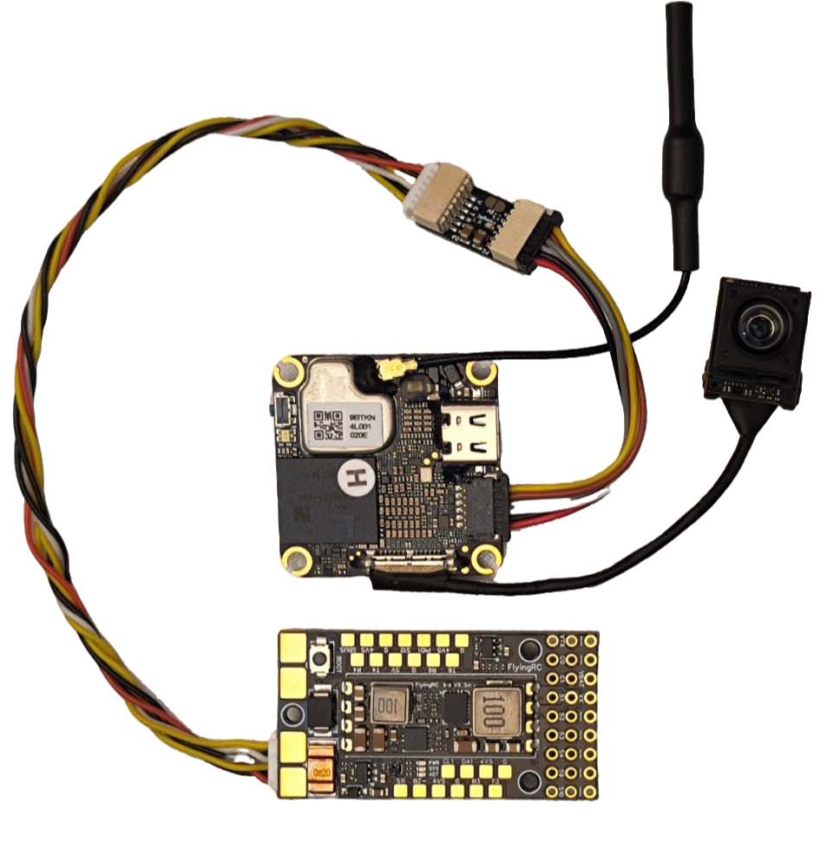
The wiring diagram for connection to the O4 BEC

40A Single ESC
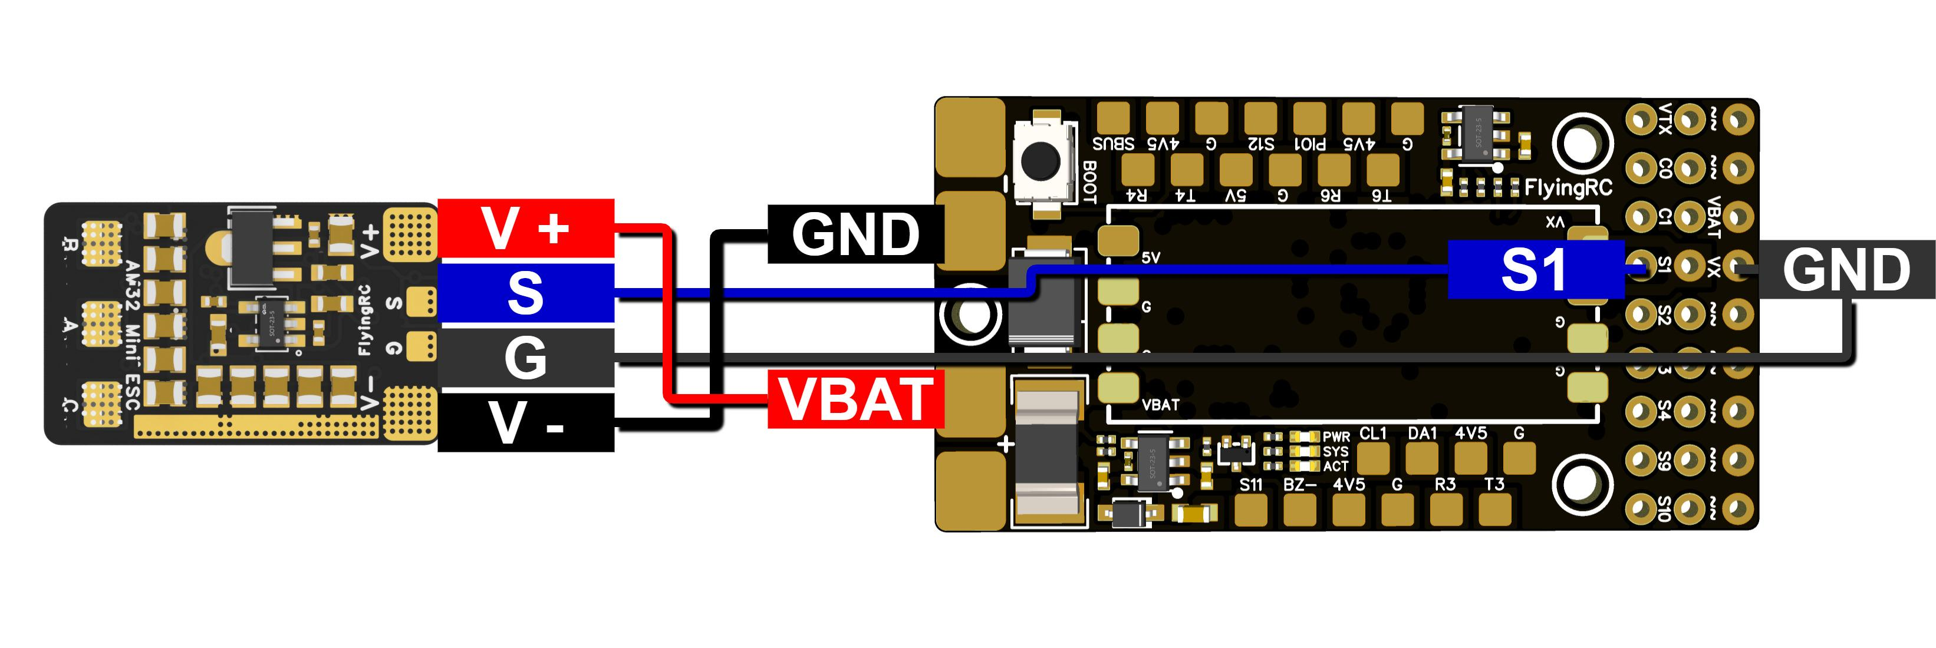
The wiring diagram for connecting the FlyingRC® AM32 Mini 40A ESC

（9） 75A Single ESC
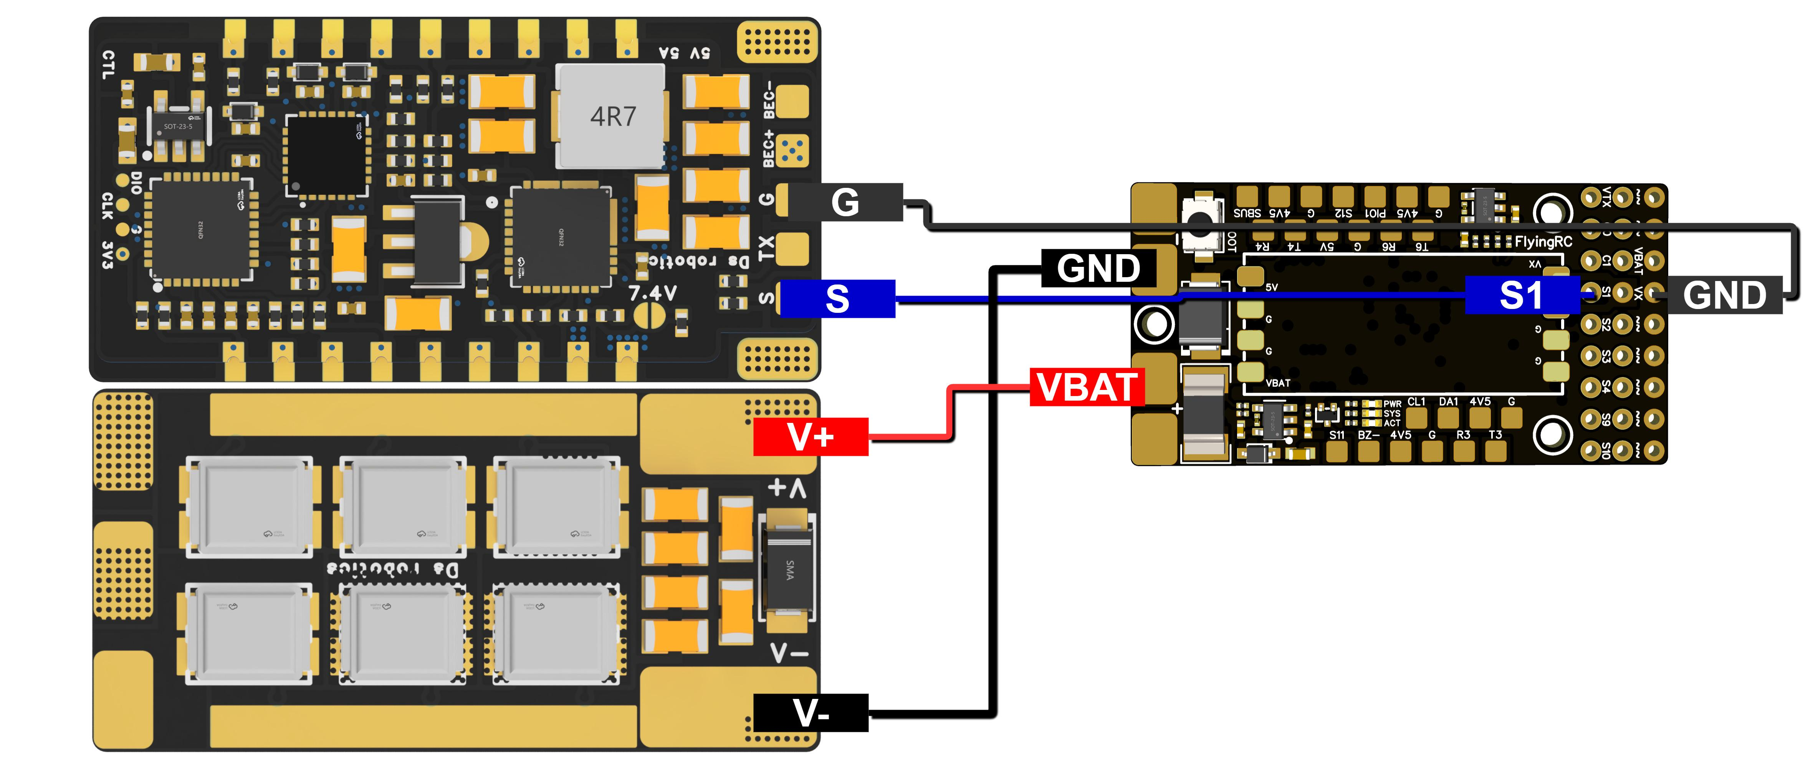
The wiring diagram for connecting to the FlyingRC® AM32 75A ESC
!!! Please note that in the Ardupilot firmware, Serial numbers do not correspond one-to-one with UART/USART numbers. The mapping table is shown below !!!
!!! Please note that after soldering, corresponding adjustments must be made to the Flight Controller Parameters. For instance, in the example diagram above, the GPS is connected to R5 and T5. In the corresponding serial port table below, R5 and T5 correspond to Serial3. Therefore, Serial3_Protocol must be set to GPS, and it must be confirmed that no other port functions are set to GPS!!!

(5)I0 Interface & Serial Port Mapping & I2C Bus
1）PWM Output Functions
PWM Group | IO耐压 | PWMs(建议功能) | GPIO对应编号 | Timer | DMA/DShot
Group1 | 5V | S1(Pin Header, Single ESC) | GPIO50 | TIM8_CH4 | DMA/DShot
Group1 | 5V | S2(Pin Header, Single ESC) | GPIO51 | TIM8_CH3 | DMA/DShot
Group2 | 5V | S3(Pin Header, Servo) | GPIO52 | TIM1_CH3N | DMA/DShot
Group2 | 5V | S4(Pin Header, Servo) | GPIO53 | TIM1_CH1 | DMA/DShot
Group3 | 5V | S5(Port, 4-in-1 ESC) | GPIO54 | TIM2_CH4 | DMA/DShot
Group3 | 5V | S6(Port, 4-in-1 ESC) | GPIO55 | TIM2_CH3 | DMA/DShot
Group3 | 5V | S7((Port, 4-in-1 ESC) | GPIO56 | TIM2_CH2 | DMA/DShot
Group3 | 5V | S8(Port, 4-in-1 ESC) | GPIO57 | TIM2_CH1 | DMA/DShot
Group4 | 5V | S9(Pin Header, Servo) | GPIO58 | TIM12_CH1 | NO DMA
Group5 | 5V | S10(Pin Header, Servo) | GPIO59 | TIM13_CH1 | NO DMA
Group6 | 5V | S11(Solder Pad, Servo) | GPIO60 | TIM4_CH1 | NO DMA
Group7 | 5V | S12(Solder Pad, WS2812 LED Strip) | GPIO61 | TIM3_CH4 | DMA/DShot
Group7 | 5V | S12(Solder Pad, WS2812 LED Strip) | SERVO12_FUNCTION 120, NTF_LED_TYPES neopixel |  | DMA/DShot
LED pad is the S12 port on external PWM expansion board, can connect to WS2812 LEDs to show the state of the flight controller.
PWM channels under the same Timer Group can NOT be used simultaneously for ESCs using Dshot and Servos using 50Hz PWM.
S9-S11 does not have DMA, therefore could not be used for Dshot Protocol

2）Serial Port Mapping List
 | PCB Silkscreen | UART No. | Protocol | Recommended Configuration | SERIAL No.
UART 5V tolerant I/O | USB | USB |  | console | SERIAL0
UART 5V tolerant I/O | TX1 RX1 | USART1 | with DMA | MSP Displayport | SERIAL1
UART 5V tolerant I/O | TX3 RX3 | USART3 | NO DMA | USER | SERIAL2
UART 5V tolerant I/O | TX5 RX5 | UART5 | NO DMA | GPS | SERIAL3
UART 5V tolerant I/O | TX4 RX4 | UART4 | NO DMA | USER | SERIAL4
UART 5V tolerant I/O | TX6 RX6 | USART6 | TX6 with DMA | USER | SERIAL5
UART 5V tolerant I/O | TX2 RX2  SBUS | USART2 | with DMA | BRD_ALT_CONFIG 1 | SERIAL6
UART 5V tolerant I/O | TX2 RX2  SBUS | SBUS pad | SBUS | BRD_ALT_CONFIG 0 Default | SERIAL6
Correspondence between UART/USART and SERIAL in ArduPilot Firmware, and Their Default Functions
For high-data-rate devices such as CRSF receivers and high-definition air units, it is recommended to connect them to DMA-enabled ports, such as UART1 (SERIAL1) or UART2 (SERIAL6).

3）I2C
I2C |  | Config | Parameterl | Value
I2C1 | 5V tolerant I/O | Compass | COMPASS_AUTODEC | 1
I2C1 | 5V tolerant I/O | onboard Baro SPL06 - 001 | Address | 0x76
I2C1 | 5V tolerant I/O | Digital Airspeed I2C | ARSPD_BUS | 1
I2C1 | 5V tolerant I/O | MS4525 | ARSPD_TYPE | 1
I2C1 | 5V tolerant I/O | DLVLR - L10D | ARSPD_TYPE | 9
The Internal Baro is at 0x76, therefore, can NOT connect to external devices that are also on 0x76

4）ADC Analog Input

-This product does not have an analog signal input interface.

General Parameter Settings

ArduPilot General Parameters：
LOG_BACKEND_TYPE = 1，Enable TF card black box function to record flight logs
BATT_VOLT_PIN 14
BATT_VOLT_MULT 21.0
BATT_CURR_PIN 15
BATT_AMP_PERVLT 100

INAV General Parameters：
Default voltage meter ratio: 2100
Default current meter ratio: 100

Other FlyingRC® Products
 |  |  |  | - FlyingRC® F4WSE Pro - F405 Fixed-Wing Flight Controller  Upgraded Version | Enhanced Performance  Manual：https://www.kdocs.cn/l/cavm9EoVEq5A |  |  | 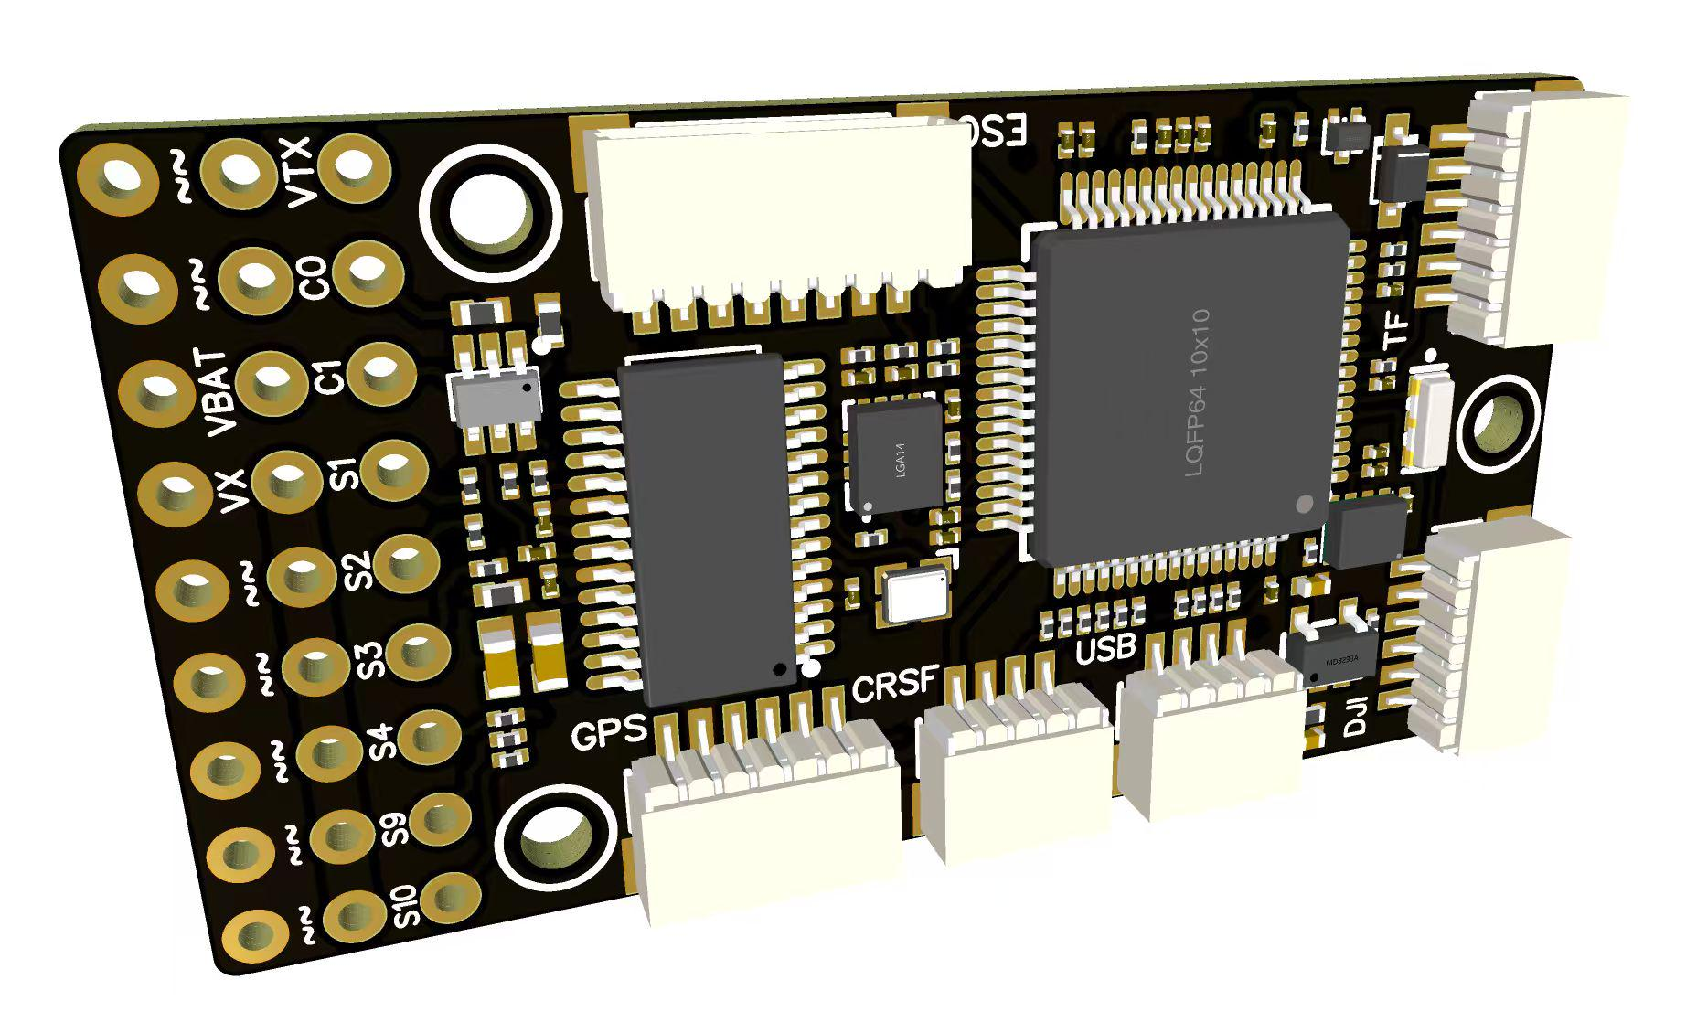
 |  |  | - FlyingRC® F4WSE MK1.5 - F405 Fixed-Wing Flight Controller  Classic model, unique design, highly acclaimed.  Manual：https://kdocs.cn/l/cpyd8MTS56DD |  |  | 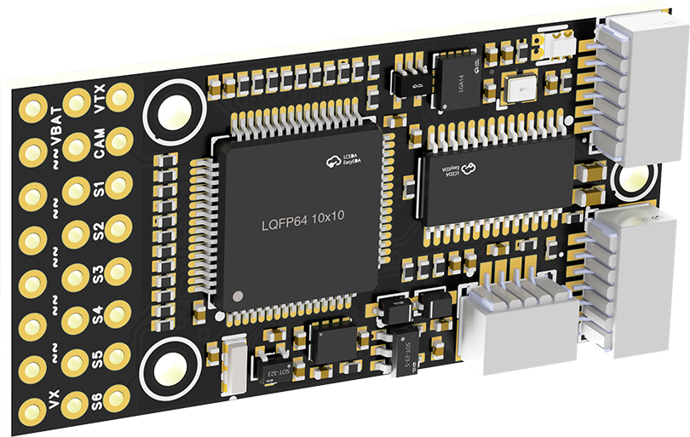
 |  |  |  | - FlyingRC® H7Wlite MK1 H743 Fixed-Wing Flight Controller  Flagship performance, full expansion, high-power BEC.  Manual：https://kdocs.cn/l/cpYaBiFKh8U1 |  |  | 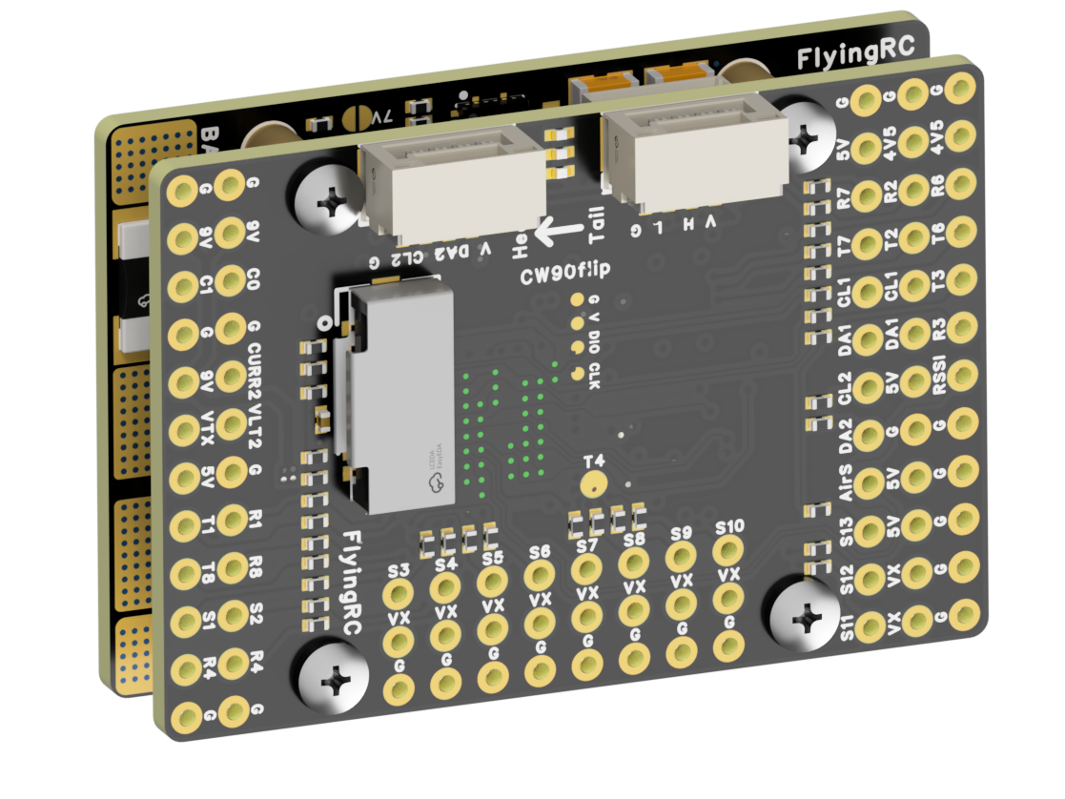
 |  |  |  | - FlyingRC® F4Wing Mini MK1 F405 Fixed-Wing Flight Controller  2025 bestseller, ultra-compact, smallest on the market, great value.  Manual：https://kdocs.cn/l/cdUIdmpSpW7J |  |  | 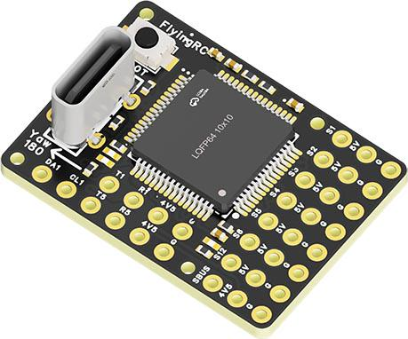
 | - FlyingRC® AM32 Dual ESC 40A 2-in-1 ESC  Unique design for dual-power aerial, land and water vehicles including drones.  Manual：https://www.kdocs.cn/l/cjwNtsKK6HeR |  |  |  | 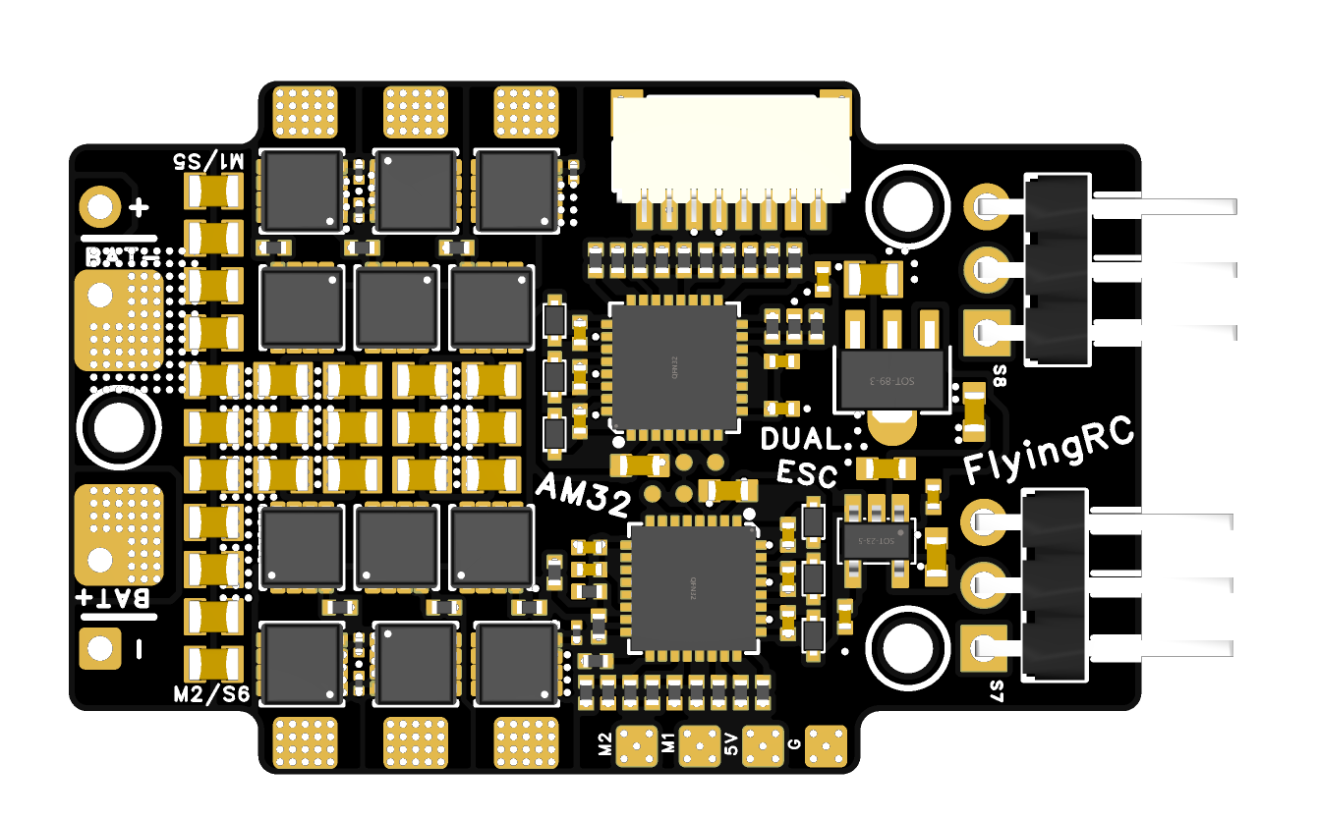
 |  |  | - FlyingRC® AM32 ESC V2.5 75A - Single ESC  Infineon gold-package MOSFETs, premium materials, superior heat dissipation.  Manual：https://kdocs.cn/l/cv6hUy67IdTJ |  |  |  | 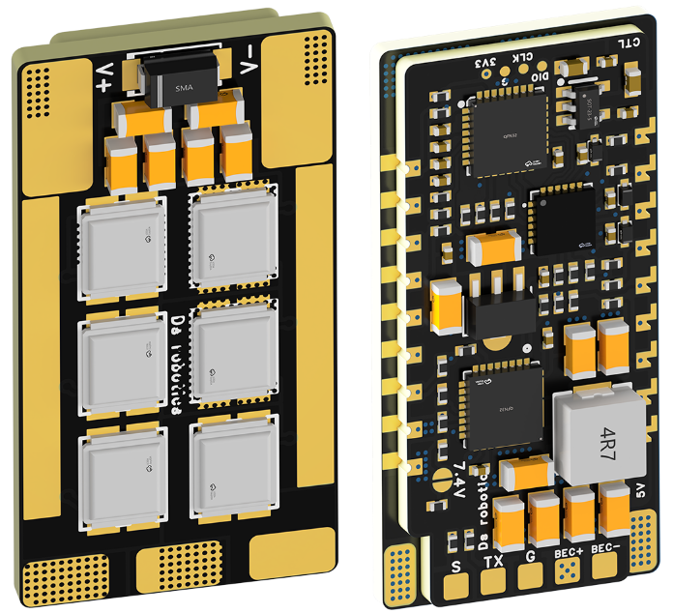
 |  |  | - FlyingRC® AM32 Mini ESC 40A V1.0 - Single ESC  Ultra-miniature, ideal for micro drones, high over-current capability, stable operation.  Manual：https://kdocs.cn/l/cqdLSysEyWFh |  |  |  |  | 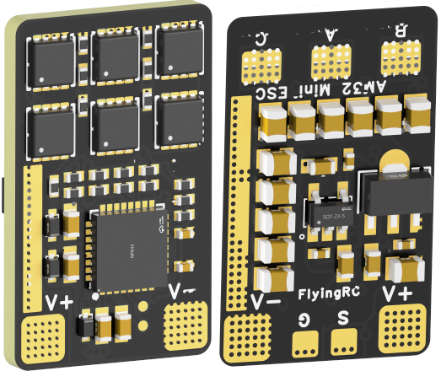
 |  |  | - FlyingRC® 10A 12S 440A Power Distribution Board for FPV Drones  Industry top choice, excellent quality and affordable price.  Manual：https://kdocs.cn/l/coel7OgrlCBP |  |  |  |  | 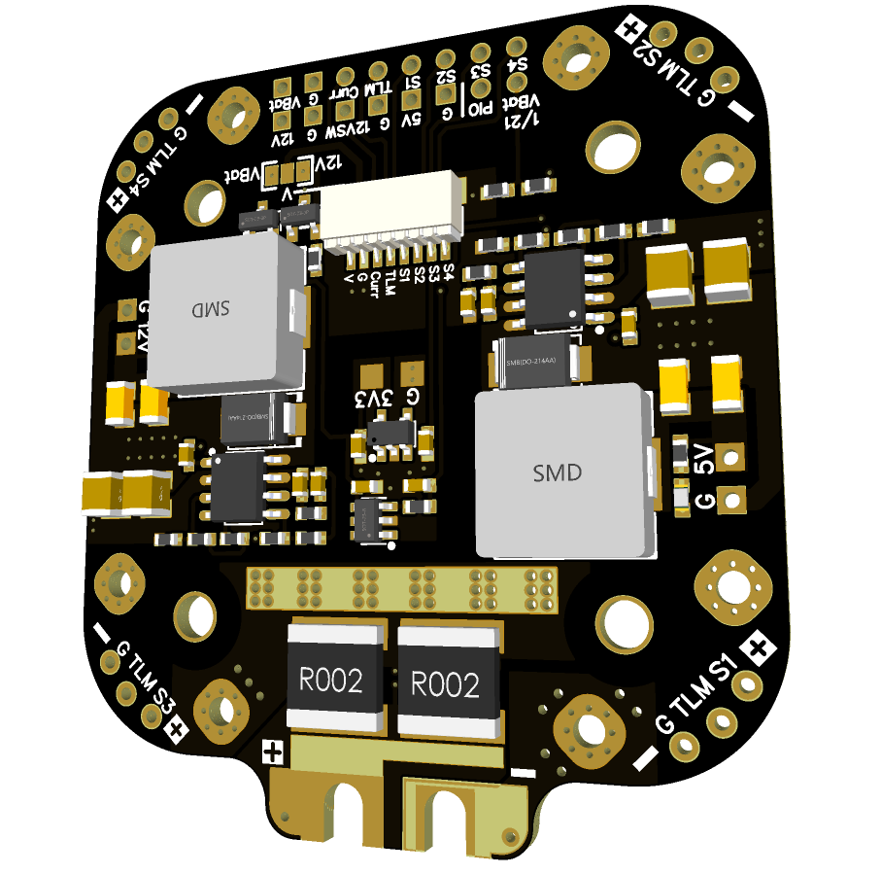
 |  |  | - FlyingRC® H7D Pro MK1 H743 FPV Flight Controller with Dual Gyro  Fully Upgraded & More Powerful  Manual：https://www.kdocs.cn/l/ctcekCy676Ez |  |  |  | 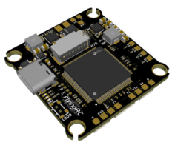
 |  |  | - FlyingRC® H7D MK1 H743 FPV Flight Controller with Dual Gyro  Powerful computing, stable and precise flight, rich interfaces, smooth control.  Manual：https://kdocs.cn/l/cqMh1I0RwAoD |  |  |  | 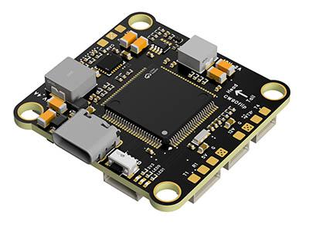
 |  |  | - FlyingRC® F420 MK1 F405 FPV Flight Controller (20/30.5mm Mounting)  Dual mounting holes, all connectors, no soldering required, compliant with Betaflight interface standards.  Manual：https://kdocs.cn/l/ctGeLiN9ZYKj |  |  |  | 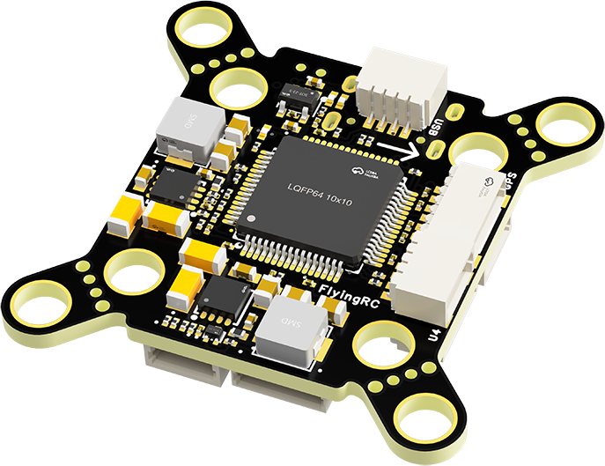
 |  | - FlyingRC® 4-in-1 75A V3.2 Gold-Sealed FPV ESC  Infineon gold-package MOSFETs, superior heat dissipation & over-current capability, premium choice.  Manual：https://kdocs.cn/l/ceLilc8Gaa21 |  |  |  |  | 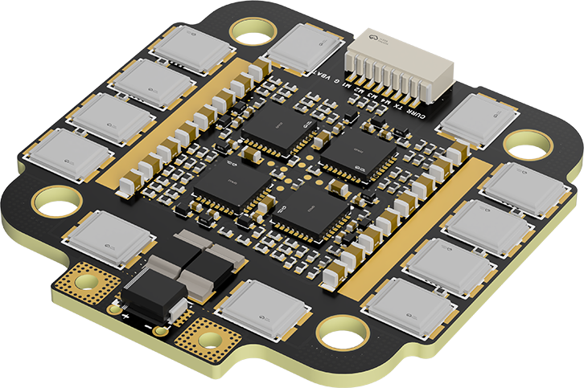
- FlyingRC® Stack Combo: H743 Flight Controller + 4-in-1 75A Gold-Sealed ESC  Professional flight choice, flagship materials & craftsmanship, reasonable price.  Manual：https://www.kdocs.cn/l/ctcekCy676Ez  https://kdocs.cn/l/ceLilc8Gaa21 |  |  |  |  |  |  | 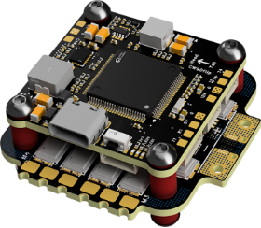
 |  | - FlyingRC® Stack Combo: F405 Flight Controller + 4-in-1 75A Gold-Sealed ESC  Best-selling combo, excellent performance, affordable price.  Manual：https://kdocs.cn/l/ctGeLiN9ZYKj  https://kdocs.cn/l/ceLilc8Gaa21 |  |  |  |  | 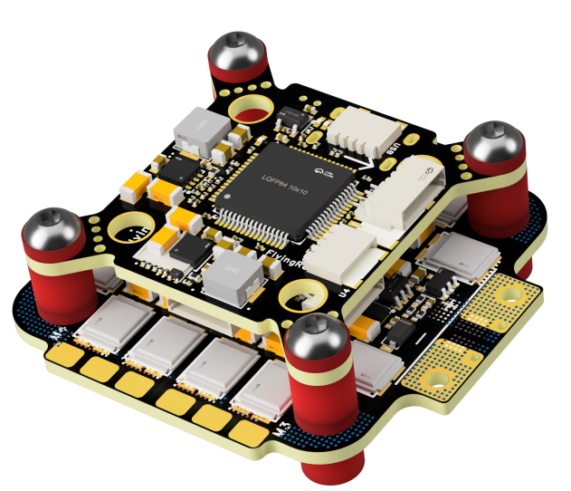
 |  | - FlyingRC® Stack Combo: H743 Flight Controller + 4-in-1 45A ESC  Winning combo: great performance, budget-friendly price  Manual：https://www.kdocs.cn/l/ctcekCy676Ez  https://kdocs.cn/l/ceLilc8Gaa21 |  |  |  |  | 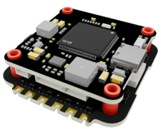
 |  | - FlyingRC® Stack Combo: F405 Flight Controller + 4-in-1 45A ESC  Hit combo, great value, budget-friendly  Manual：https://kdocs.cn/l/ctGeLiN9ZYKj  https://kdocs.cn/l/ceLilc8Gaa21 |  |  |  |  | 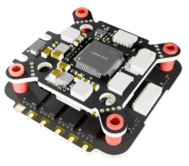
 |  | - FlyingRC® Stack Combo: F4WSE Pro - F405 Fixed-Wing Flight Controller + AM32 Dual ESC 40A 2-in-1 ESC  Unique Design • Exclusive Offer • Bestselling Bundle  Manual：https://www.kdocs.cn/l/cavm9EoVEq5A  https://www.kdocs.cn/l/cjwNtsKK6HeR |  |  |  |  | 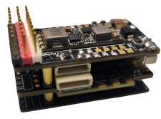
 | - FlyingRC® ELRS 2.4G Diversity Receiver  True diversity reception, temperature compensation, high-sensitivity reception.  Manual：https://kdocs.cn/l/cbvlOlShmsPS |  |  |  |  |  | 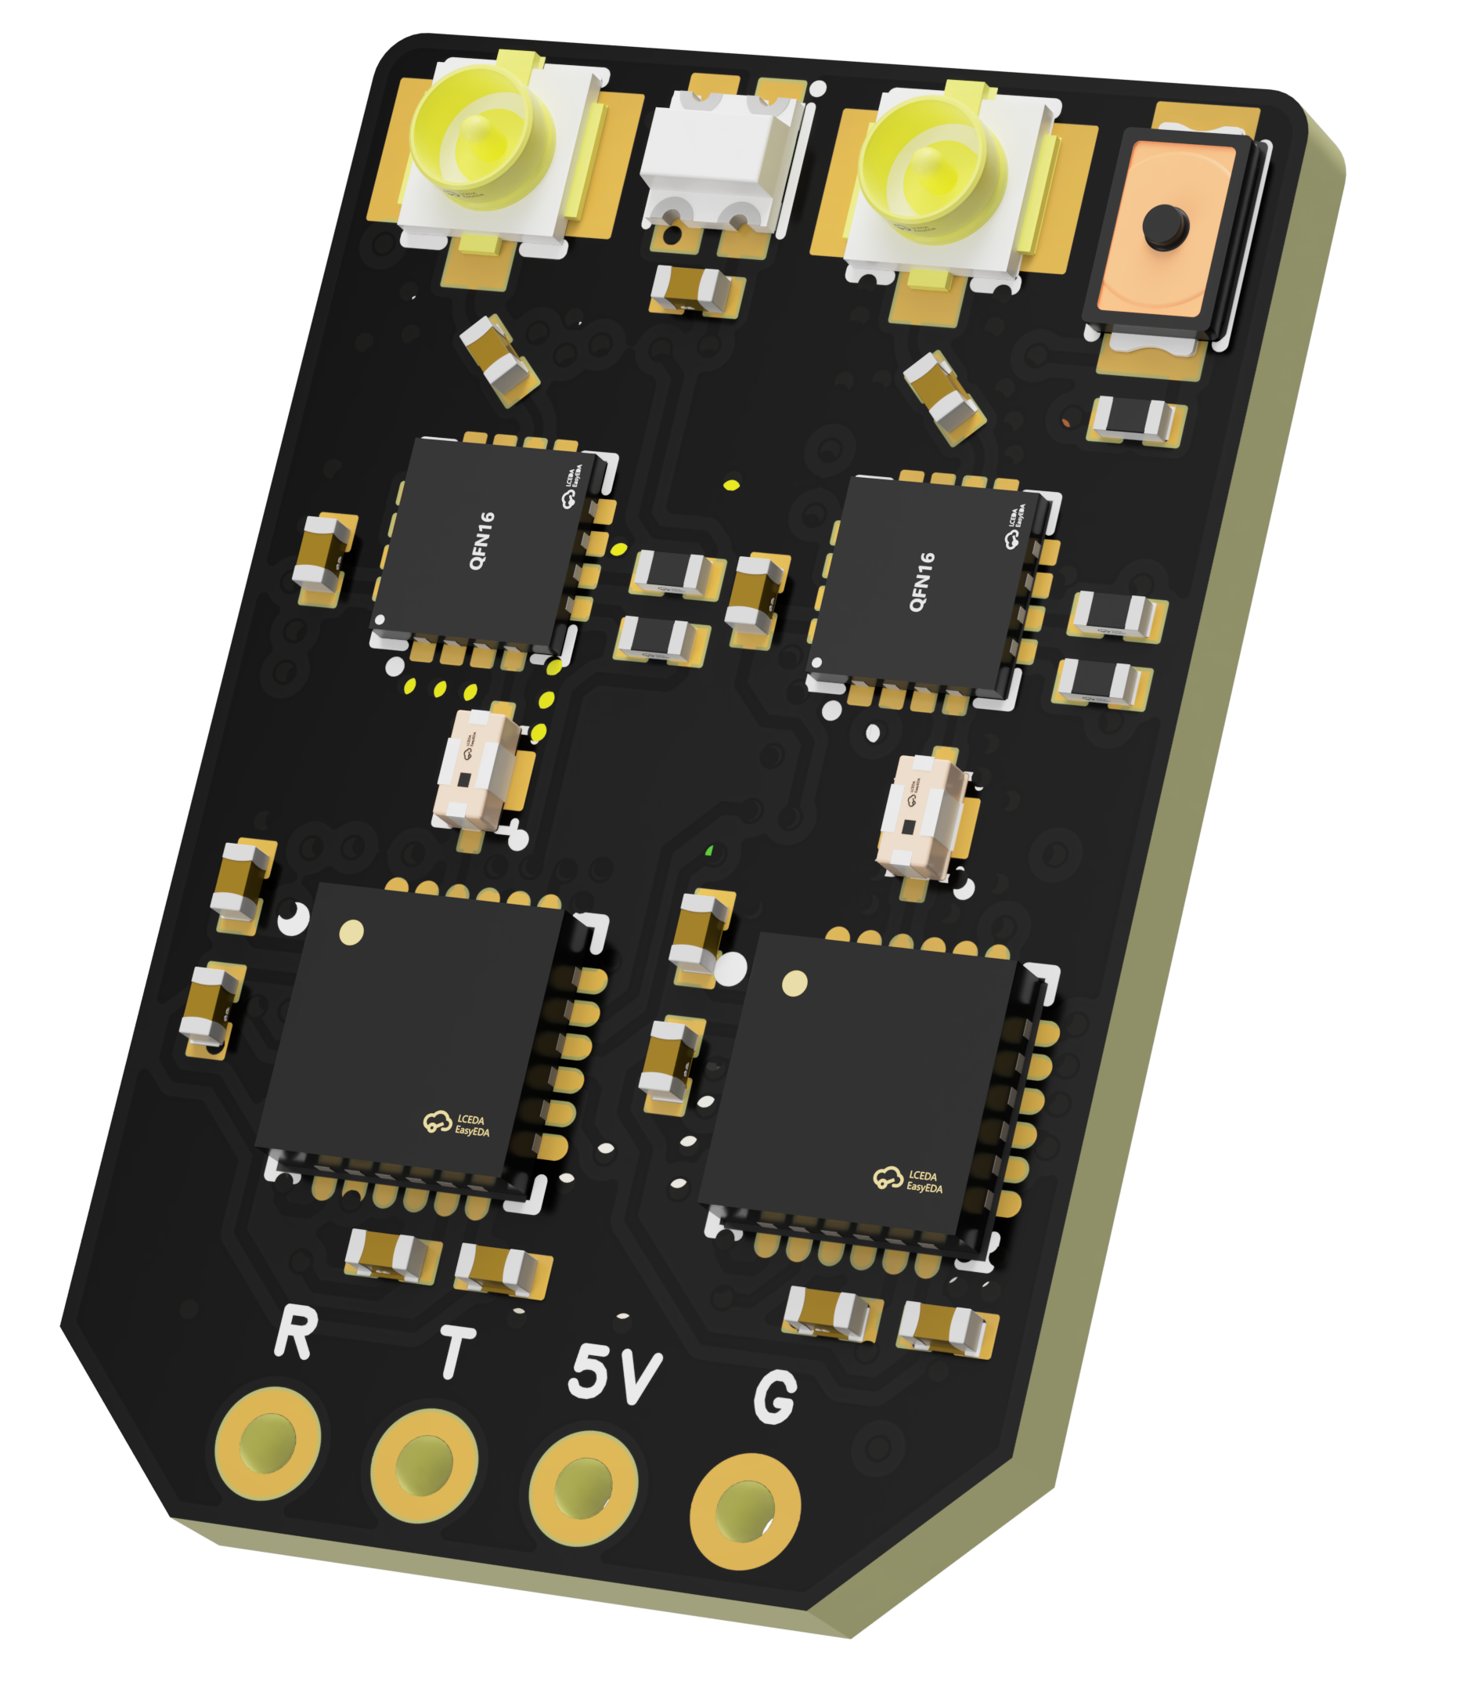
 | - FlyingRC® RM3100 SPI Module 罗盘模块  Ultra-high Resolution • Low Power • Industry Top Choice  Manual：https://www.kdocs.cn/l/cdGuHvBVyndC |  |  |  |  |  | 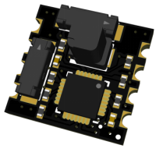
 | - FlyingRC® 10A 12S BEC Step-Down Module  Wide voltage input, high power, compact size, multiple voltages available, 10A continuous output.  Manual：https://kdocs.cn/l/clssNCKgNhLV |  |  |  |  |  | 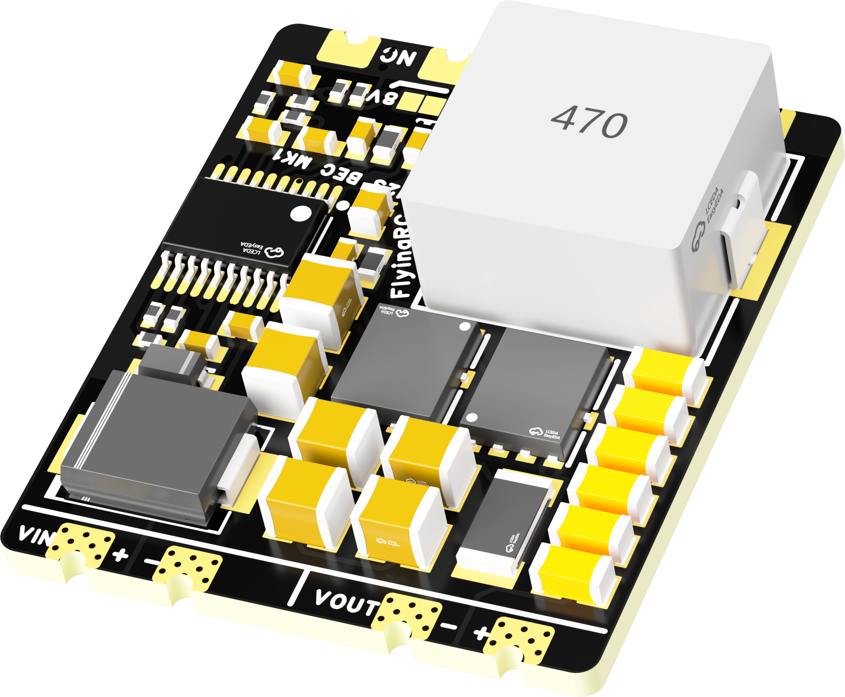
 | FlyingRC® 5A BEC Step-Down Module  Ultra-small size, multiple voltages available, 5A continuous output.  Manual：https://kdocs.cn/l/cb9VdNywqCKA |  |  |  |  |  | 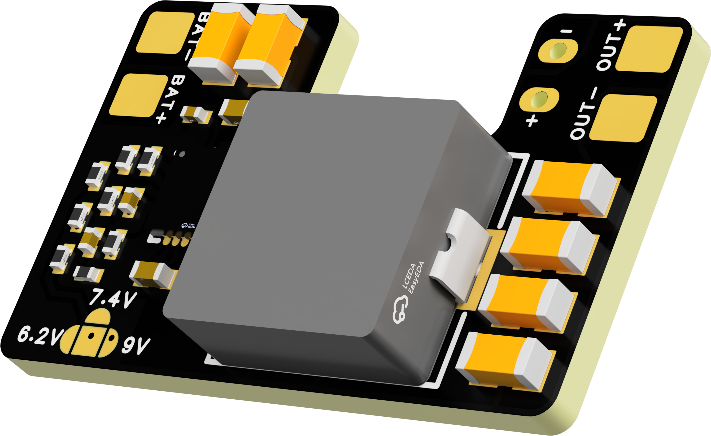
 | FlyingRC® Mini BEC For DJI O4  Easy wiring, ultra-small size, stable power supply.  Manual：https://www.kdocs.cn/l/ckkebieur37K |  |  |  |  |  | 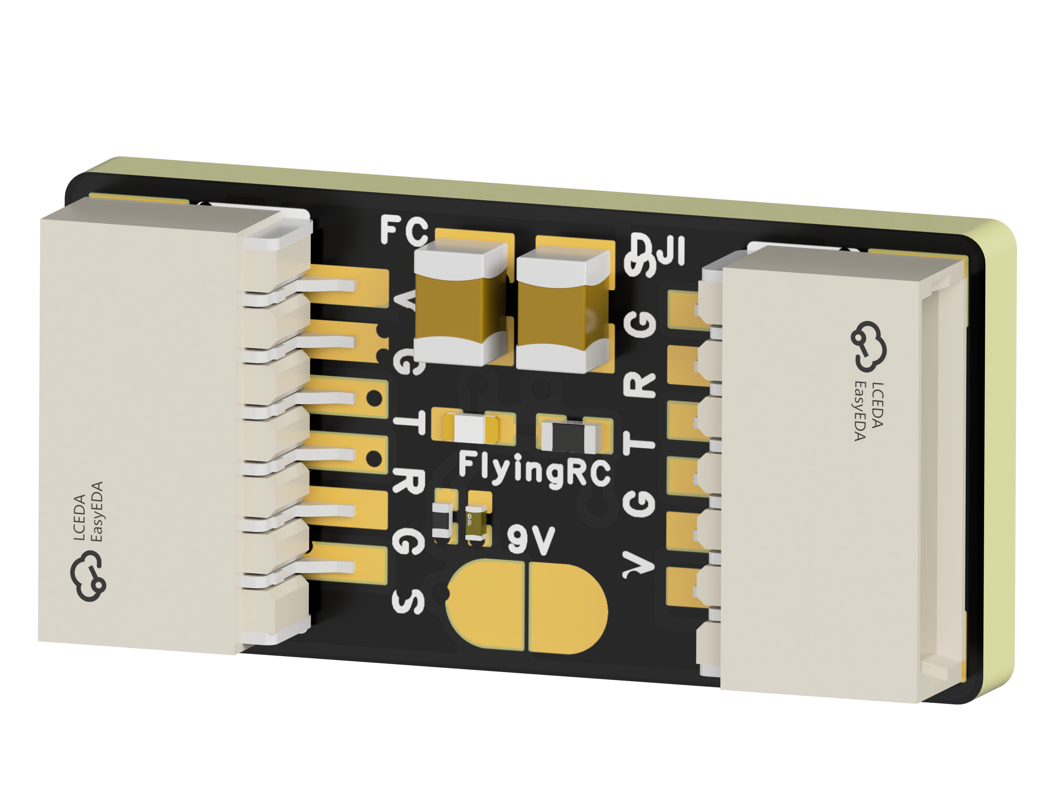
 | FlyingRC® CAN Bus Serial & PWM Expansion Board  Long-distance transmission, high speed, excellent stability.  Manual：https://www.kdocs.cn/l/cmxRyBnU4BXj |  |  |  |  |  | 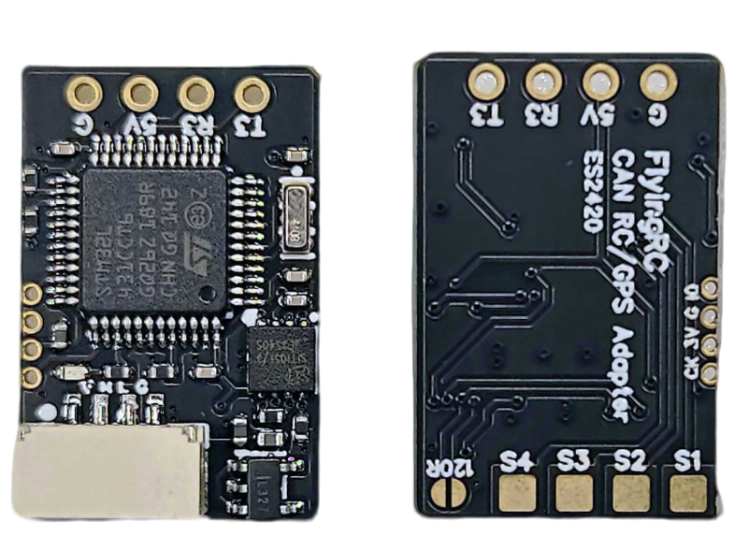
 | FlyingRC® AM3 2ESC Programmer  Supports BL, BL32, AM32. Simple and easy to use.  Manual：https://kdocs.cn/l/cogBSEBe67mE |  |  |  |  |  | 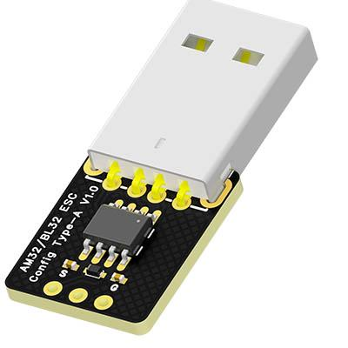
 | FlyingRC® Digital Airspeed Sensor without Pitot Tube  Integrated design, smallest on the market. MS4525D protocol, I2C interface.  Manual：https://www.kdocs.cn/l/clPvEEEcJgCC |  |  |  |  |  | 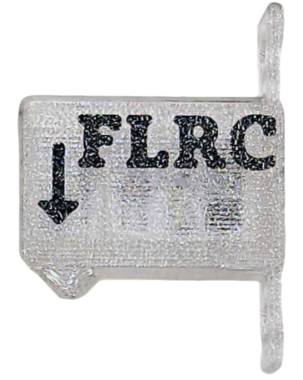
 | FlyingRC® U-Blox M10 GPS  Compatible with all open-source flight controllers.  Manual：https://www.kdocs.cn/l/cdSYQrzx74O8 |  |  |  |  |  | 