FlyingRC® H7D MK1 H743 FPV Drone Flight Controller Product Manual
FlyingRC® is a globally-oriented professional brand of electronic devices. We specialize in the R&D and sales of drone electronics, core robot circuits and sensors. Our design team is based in Singapore, and our products are sold worldwide.

Since launched in 2023, FlyingRC® products have gained widespread recognition from customers as well as strong market response. As of April 2026, our cumulative sales volume has exceeded 46,000 units. Our products are widely applied in industries, robotics, emergency rescue, environmental protection & inspection, aerial photography, public security, retail and many other fields. Above all, we are committed to distinctive design and superior reliable quality.

Our Chief Technology Officer Liu Yuhan possesses outstanding expertise in circuit design. Over the past four years, he has designed more than 80 circuit projects and contributed 39 to open-source platforms. Moreover, he won the Design Award on the open-source platform X.JLC.com twice in 2023 and 2024, and has become the youngest certified designer on this platform.

He holds the NUS (National University of Singapore, rank 8th worldwide) Science and Technology Scholarship, and is currently majoring in Electronic Engineering with a focus on Aerospace Technology. In addition, all members of our technical team are graduates from prestigious universities with extensive professional product experience.

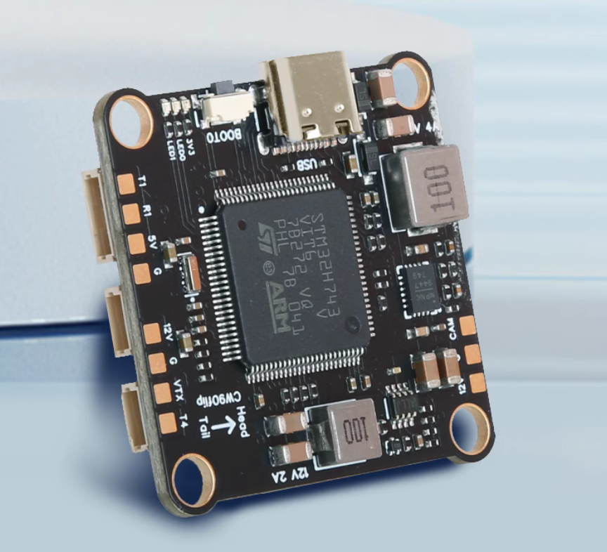
Flight Controller Overview：
- MCU STM32H743VIT6, Dual ICM-42688-P Gyroscopes, Barometer DPS310 or DPS368
- Analog/HD OSD, 7x UARTs (UART4 TX only, UART3 RX only), 9 PWMs (4 + 4 + 1), 1x I2C, 1x ADC (RSSI), onboard 12V BEC PinIO
- Black Box: onboard NOR Flash, 128MB
- 12–28V DC input (3–6S LiPo). Note: When using 3S/4S LiPo batteries, ensure the VTX BEC input voltage is above 12.8V for stable output. 5S/6S LiPo or 4S LiHV is recommended.
- Dual BECs (MP9447 + MP9942): 5V/4A (for Devices) & 12V/2A (for VTX and Camera)
- Dimensions & Weight: 36.6mm×36.6mm×7.45mm, 9.3g

Basic Parameters |  | Sensors
Model | FlyingRC® H7D | IMU (Gyro & Accelerometer) | Dual Invensense 3rd Gen ICM-42688-P
Dimensions | 36.6mm*36.6mm*7.45mm | Barometer | DPS310/ DPS368
Mounting Hole Spacing | 30.5mm | Magnetometer | No Onboard Magnetometer
Weight | 9g | Analog OSD | AT7465E
MCU |  | Power Output
MCU | STM32H743VIT6 | BEC Chip Model | MP9447 + MP9942
Clock Speed | 480 MHz | Onboard Step-Down BEC (for Devices) | 5V4A
Flash | 2 MB | Onboard Step-Down BEC (for VTX) | 12V2A
RAM | 1 MB
Interfaces |  | Firmware Support
UART | 7×UART | Betaflight | Supported (Factory Default)
UART | UART1,UART2, UART3: RX only | INAV | Supported
UART | UART4-7, UART8: TX only | Ardupilot | Supported
PWM | 9 channels (including 1 LED channel) | PX4 | Not Supported
I2C | 1
Current ADC Sampling | Supported
SWD Debug | Not Supported | Operating Environment
Buzzer Port | Yes, supports passive buzzer | VBAT Input Range | 12-28V DC IN 3-6S LiPo
LED Strip Port | Supports WS2812 | Power Input | Same as VBAT Input Range
USB-TYPE-C | Onboard, direct plug-in | Operating Temperature | -10-100℃
Black Box Storage | Onboard NOR Flash，128MB | Storage Temperature | 0-40℃
SBUS | Built-in inverter on H7 MCU
SBUS | SBUS can be connected to any RX port
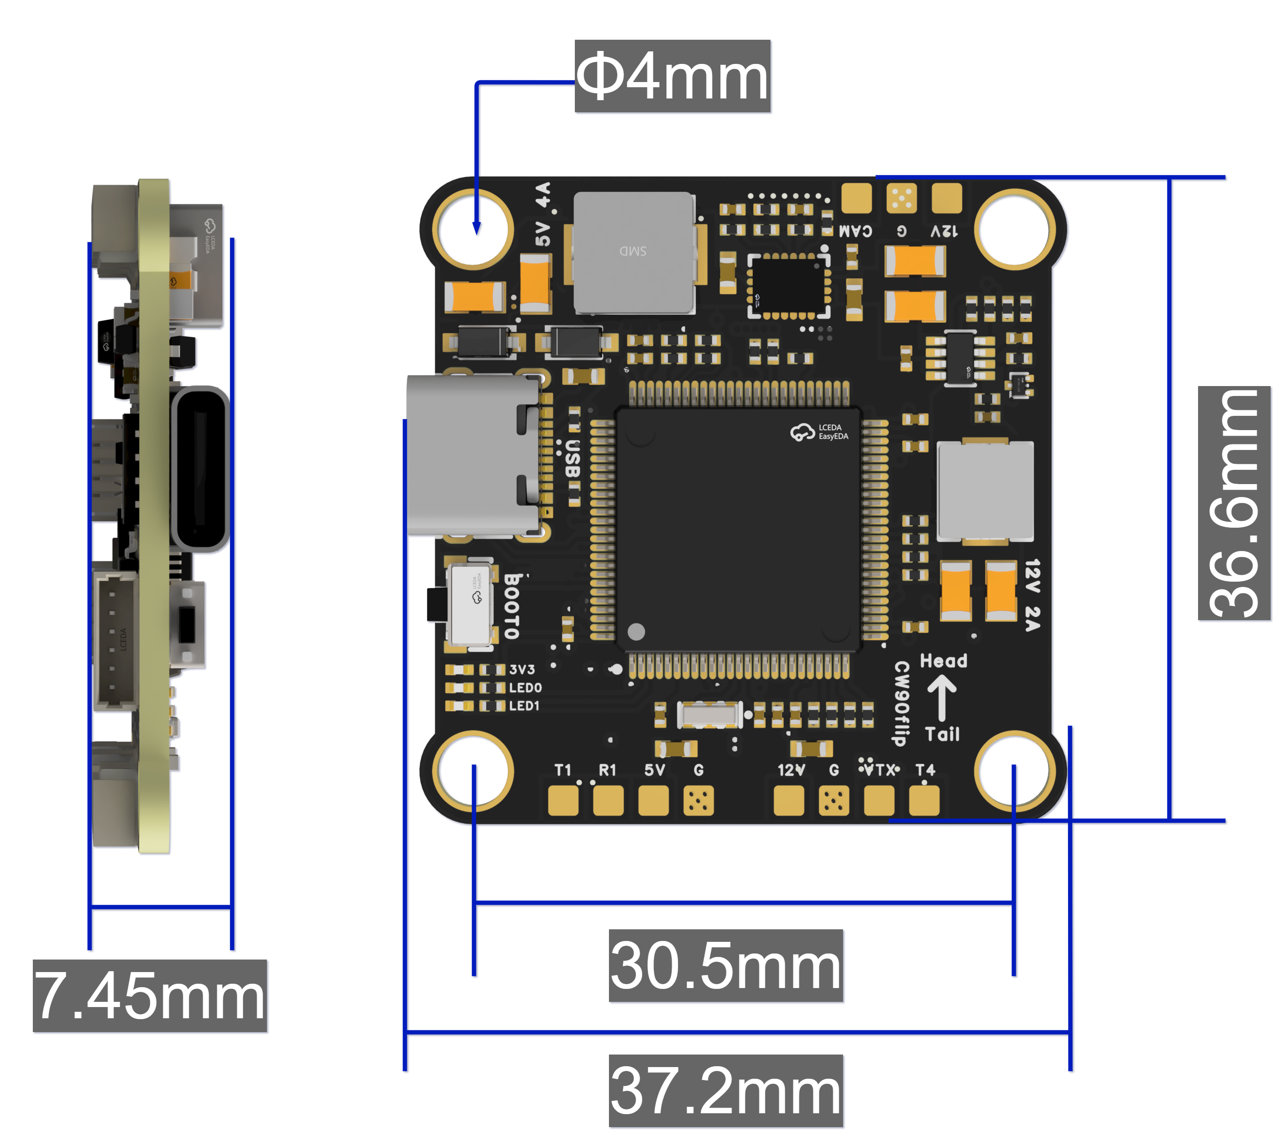
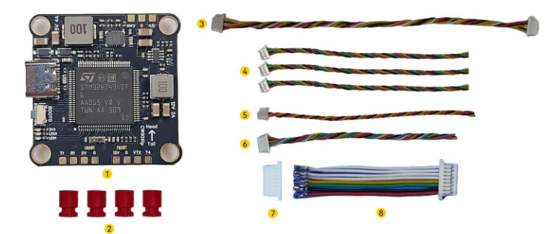
Package Contents:

① 1× FlyingRC H7D H743 Flight Controller
② 4× Silicone Anti-Vibration Standoffs
③ 1× DJI VTX 6-Pin Cable (15cm)
④ 3× SH1.0 4-Pin 30AWG Ultra-Flexible Silicone Cable (10cm)
⑤ 1× SH1.0 3-Pin 30AWG Ultra-Flexible Silicone Cable (10cm)
⑥ 1× SH1.0 6-Pin 30AWG Ultra-Flexible Silicone Cable (10cm)
⑦ 1× SH1.0 8-Pin Crimp Terminal
⑧ 1× SH1.0 8-Pin 30AWG Ultra-Flexible Silicone Wire (3.5cm)

Features:
- MCU: STM32H743VIT6, 2MB Flash, 1MB RAM, 480MHz, delivering powerful performance.
- Dual ICM-42688-P (Gyroscopes & Accelerometers): optimized for drones to ensure high stability.
- 30.5mm mounting hole spacing with standard M4 threaded holes (compatible with M3 screws when Anti-Vibration Standoffs are installed), suitable for 4–12 inch FPV drones.
- 8 PWM Outputs: Supports simultaneous connection of dual 4-in-1 ESCs, suitable for X8 or 8-axis configurations.
- Full Socket Design: ESCs, Receivers, GPS, Analog VTX, Digital VTX, Cameras, LED strips and Buzzers can all be connected via sockets. Solder pads for Cameras, VTX and Receivers are also reserved for extra flexibility.
- Equipped with dual high-precision gyroscopes and a high-precision barometer, delivering significantly improved stability compared to comparable flight controllers (especially noticeable when using AP firmware).
- Industry-leading BEC output in its form factor: 5V/4A for Devices.
- Switchable Onboard 12V BEC: Controlled via PINIO1 (User1 in BF firmware), preventing VTX from overheating and damage during bench testing.
- Onboard 128MB Flash: Plenty of storage for multiple flight data recordings.

LAYOUT：
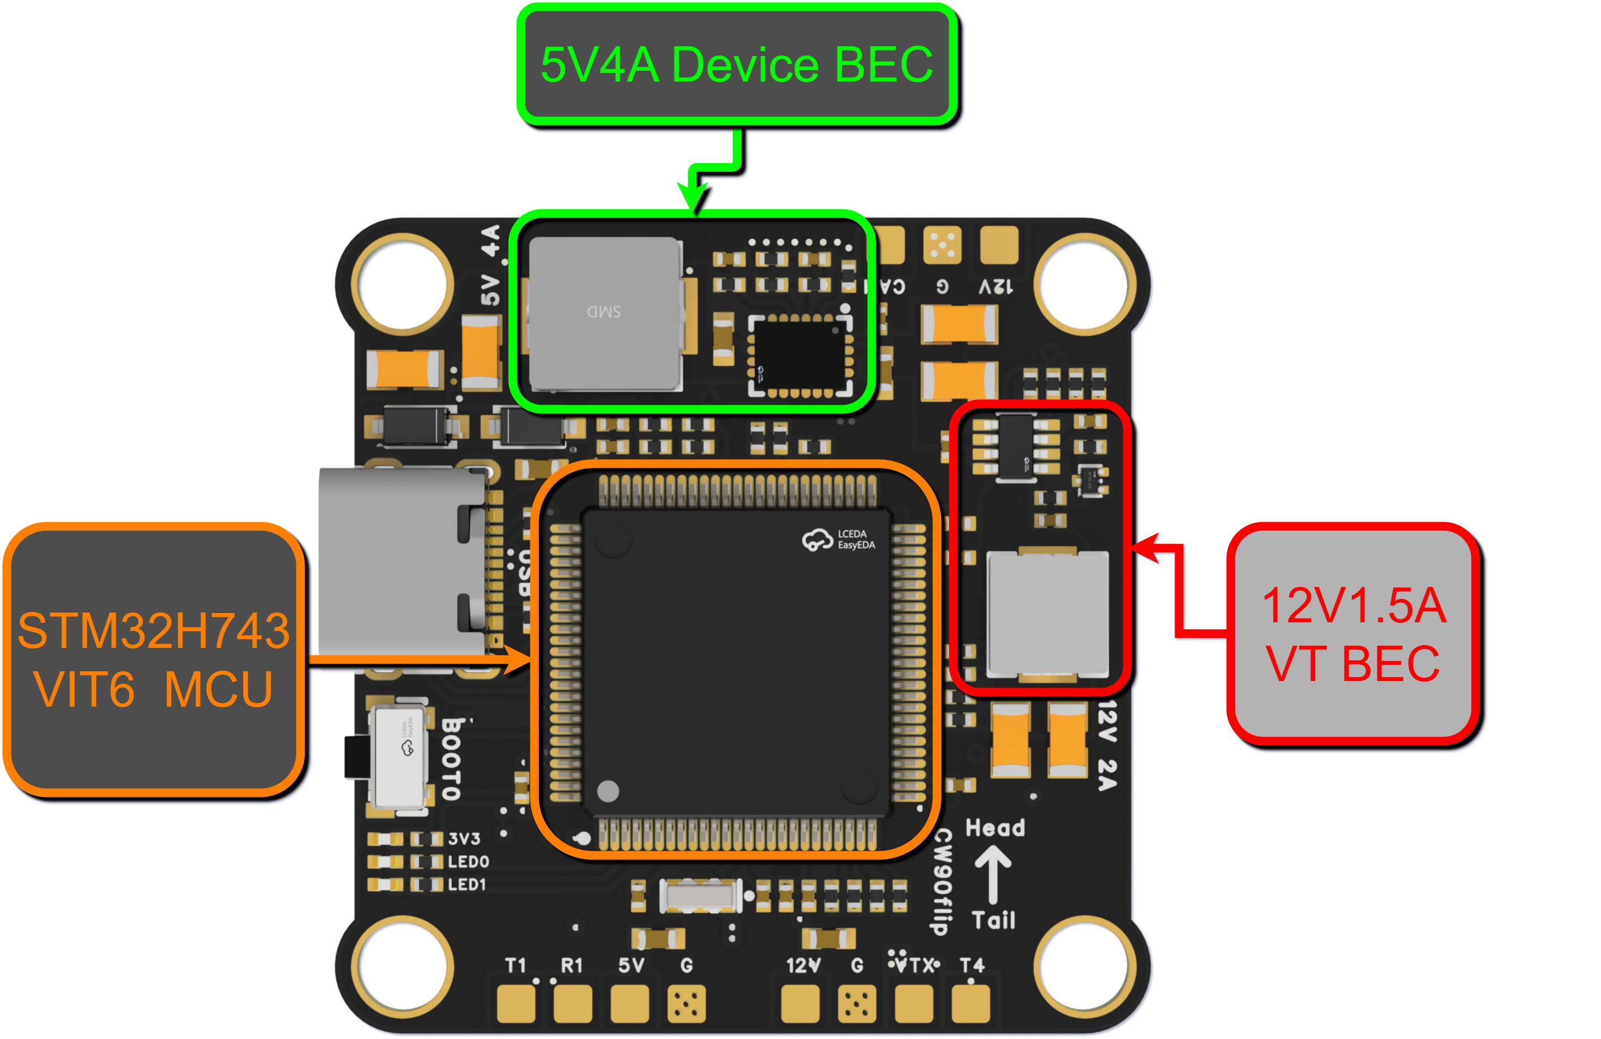
3D schematic diagram of the Flight Controller - front view

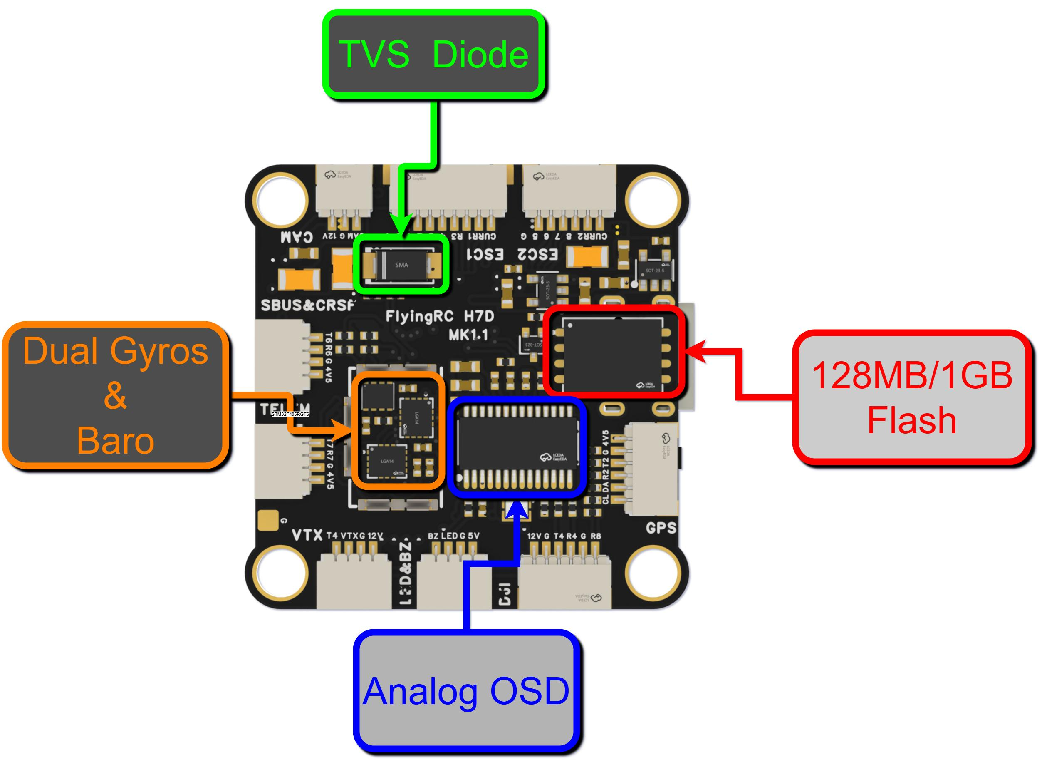
3D schematic diagram of the Flight Controller - back view
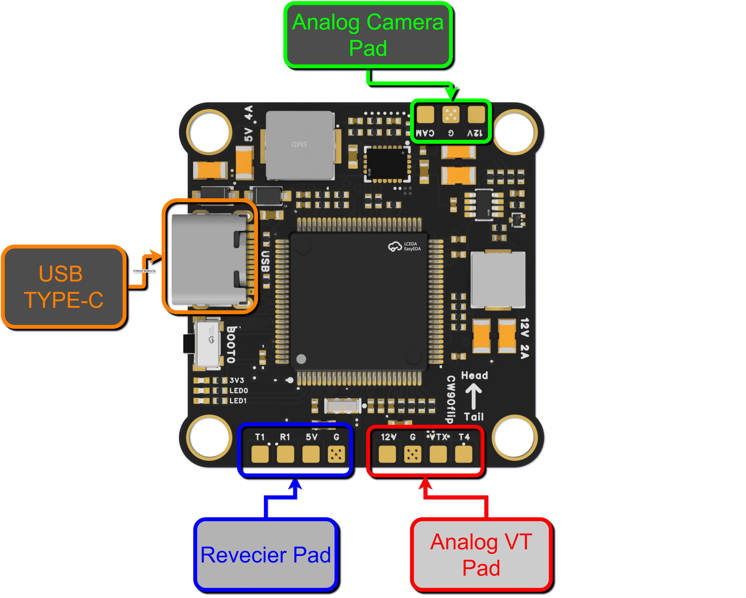
Schematic diagram of connector and pad functions - front view
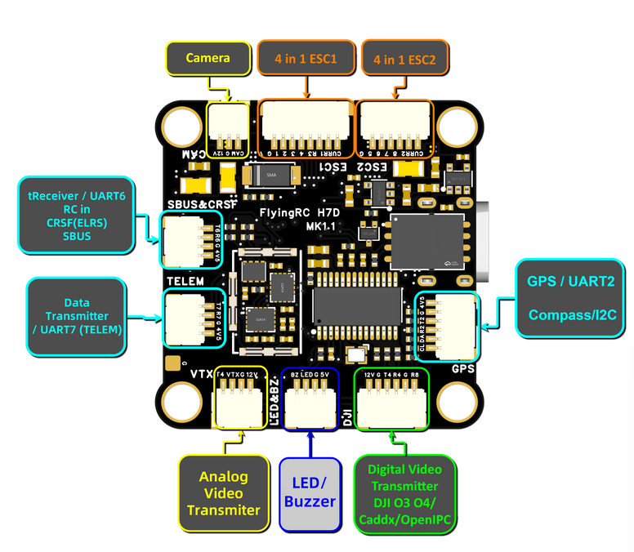
Schematic diagram of connector and pad functions - back view
Preparations Before Use：
‼️CRITICAL‼️
Make an 8P ESC connection cable with the correct wiring sequence according to the ESC model. If you have any questions about the wiring sequence, please consult in the official FlyingRC® group. Incorrect wiring may cause the Flight Controller to burn out!
‼️CRITICAL‼️

Wiring diagram (applicable to BF, AP, and INAV firmwares)：
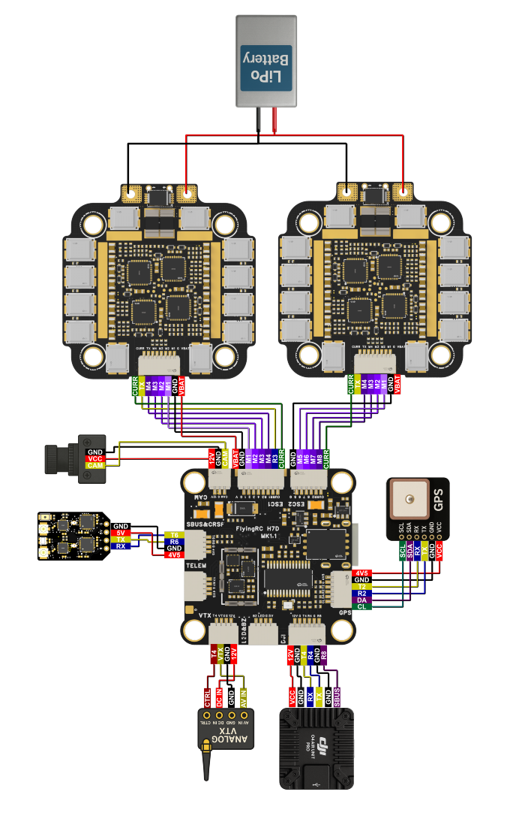
Wiring Schematic Diagram of the Flight Controller （Note: The ESC is V3.2 version.）
The functions of the Flight Controller Pads are clearly labeled with text directly on the board. For example, T4 represents the UART4 TX port, and R1 represents the USART1 RX port.
The ESC is available in two versions, V3.2 and V4.0, with different wiring sequences. V4.0 complies with BF wiring standards.
As both versions share the same manual, users are kindly reminded to distinguish V3.2 from V4.0 by their appearance:
1.The 8P socket of V4.0 is printed with the words "Caution: Wiring Order".

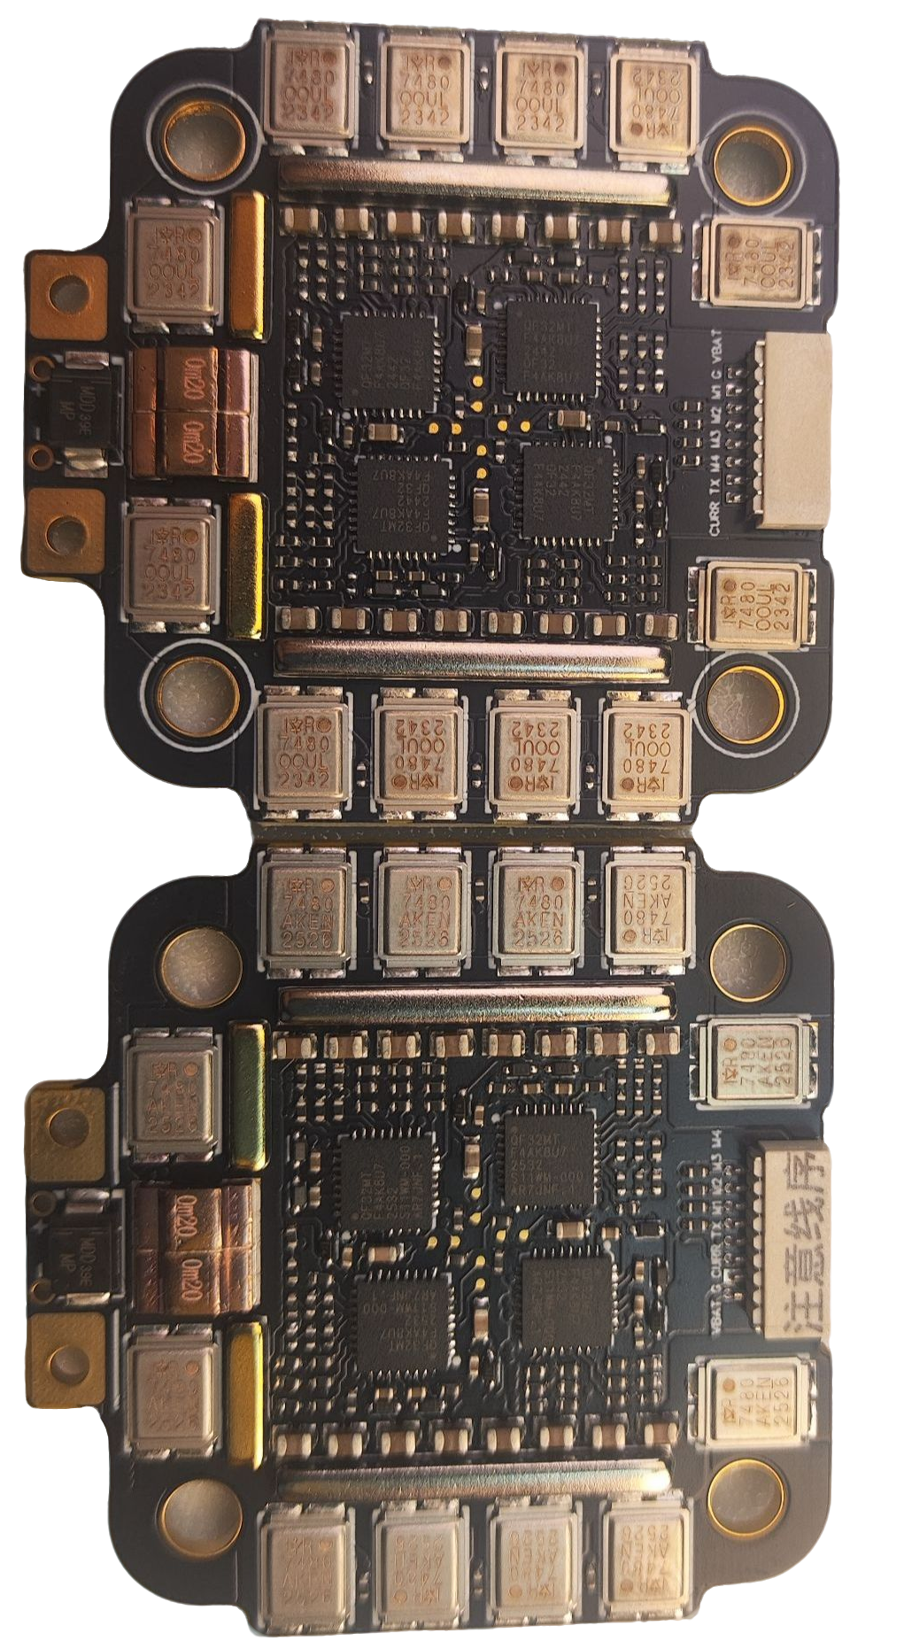
V3.2 V4.0

2.Both versions are printed with their respective version numbers.
3.The S/N code is printed on V4.0.
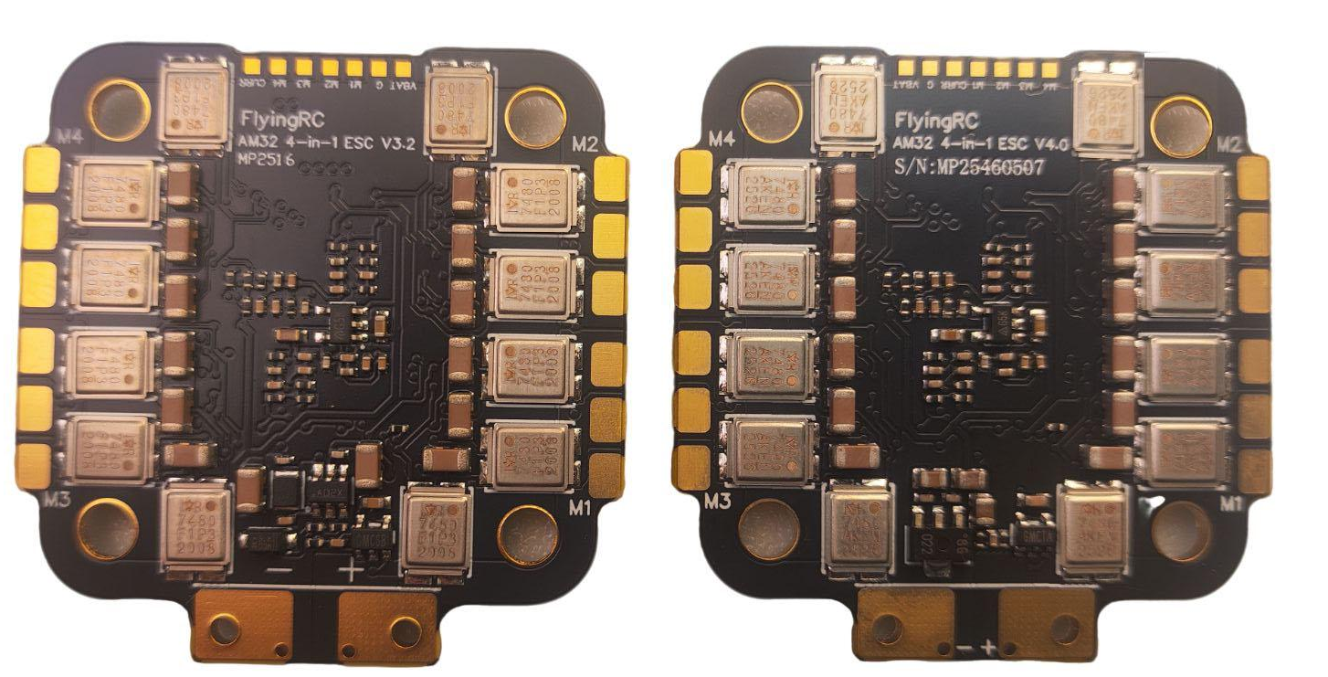
V3.2 V4.0

4IN1 75A Gold-Sealed ESC
Wiring Diagram for Connection with FlyingRC® 4IN1 75A Gold-Sealed ESC
(Note: The ESC is V3.2 version)

Wiring Diagram for Connection with FlyingRC® 4IN1 75A Gold-Sealed ESC
(Note: The ESC is V4.0 version)

- ELRS
Note：the TX/RX cross connection! (FC TX → Receiver RX, FC RX → Receiver TX)
If using non-SBUS/PPM protocol receivers (e.g. ELRS) on UART6 (Serial7, silkscreen: SBUS&CRSF), set brd_alt_config = 1.
Power off and restart the device after configuration!
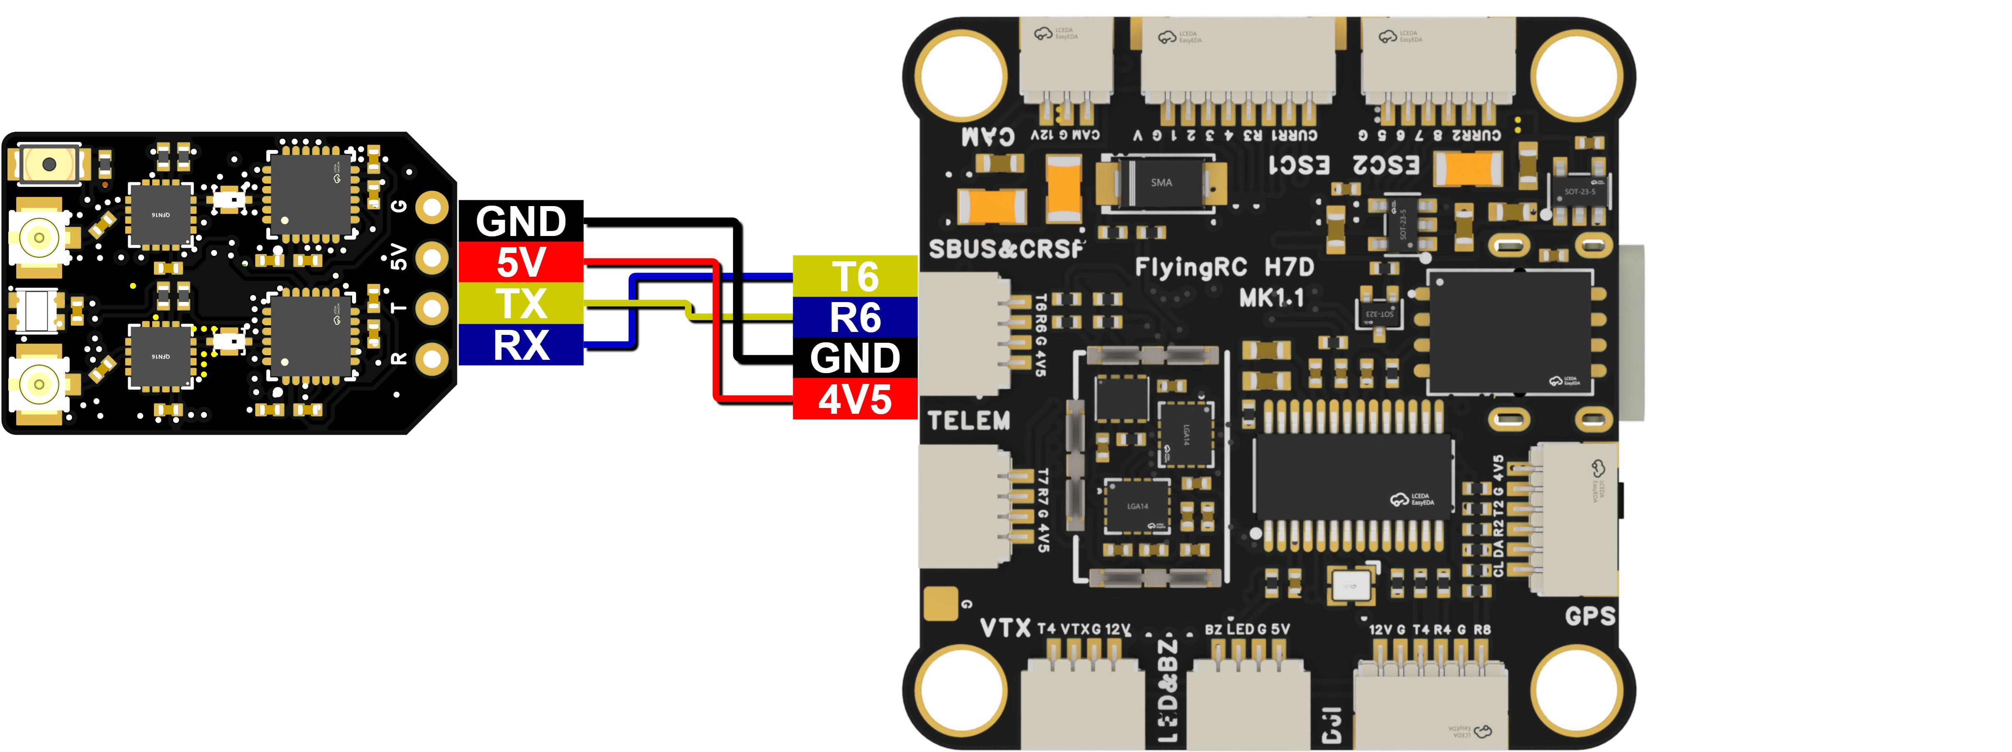
Wiring Diagram for Connection with FlyingRC® ELRS

- GPS
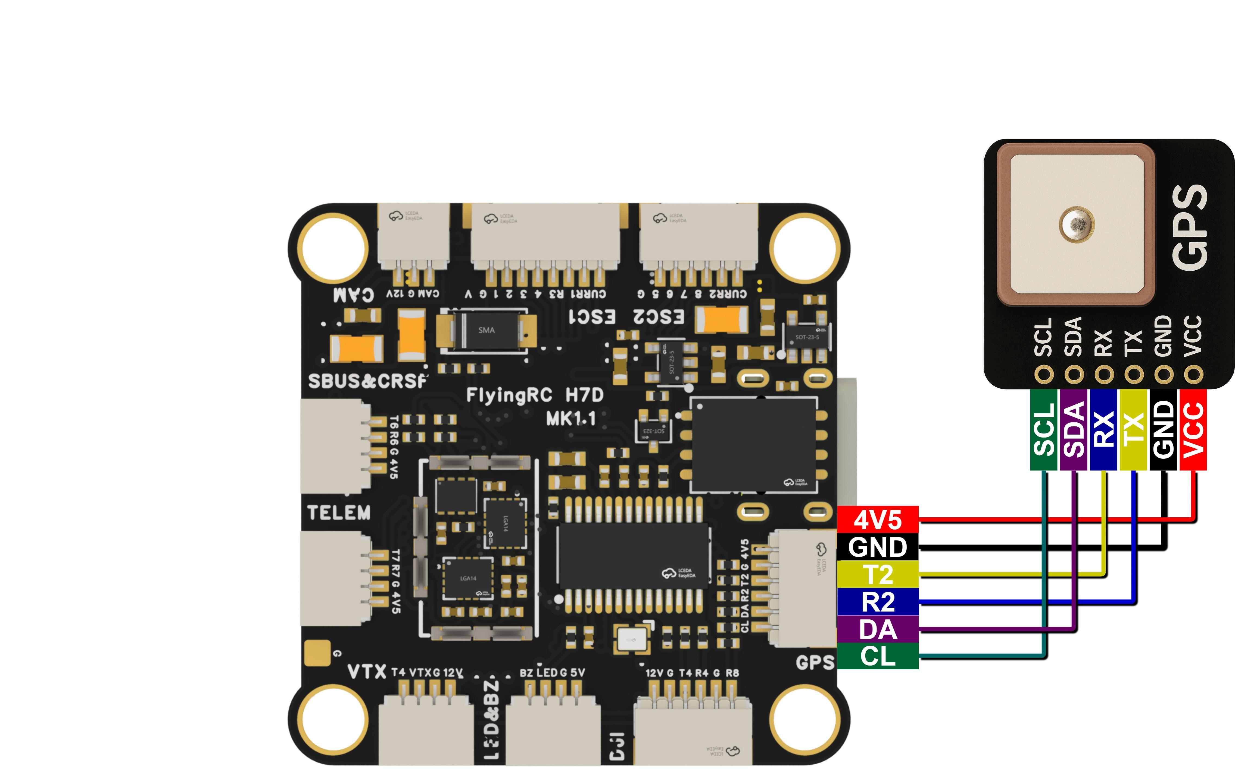
Wiring Diagram for Connection with FlyingRC® GPS

- Digital Video Transmitter
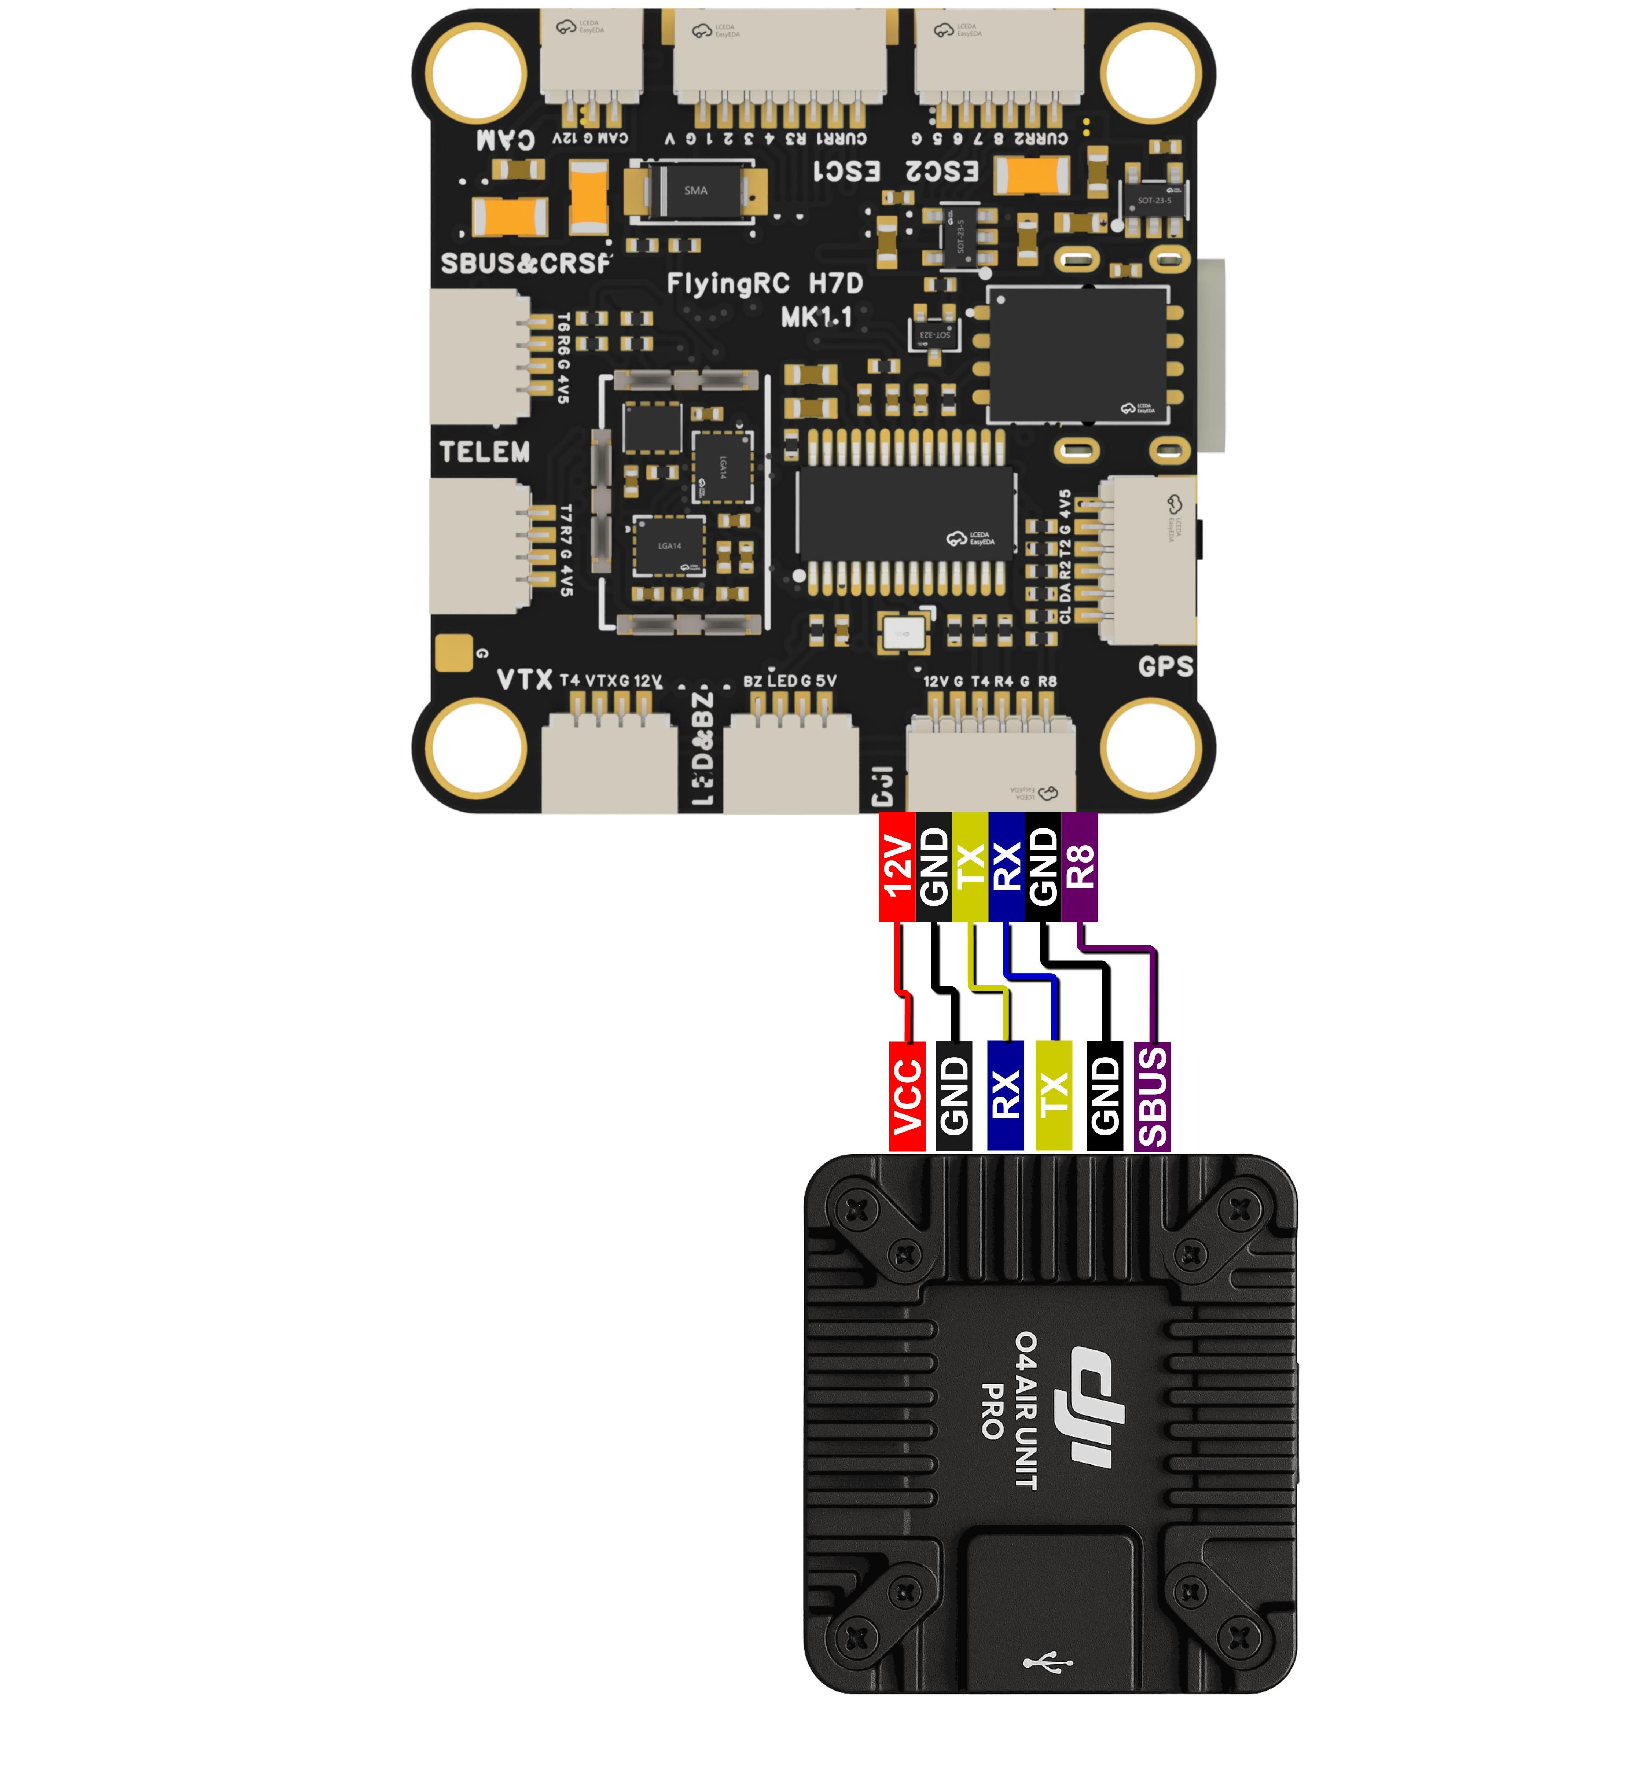
Wiring Diagram for Connection with DJI Digital Video Transmitter

- Analog VTX and Camera
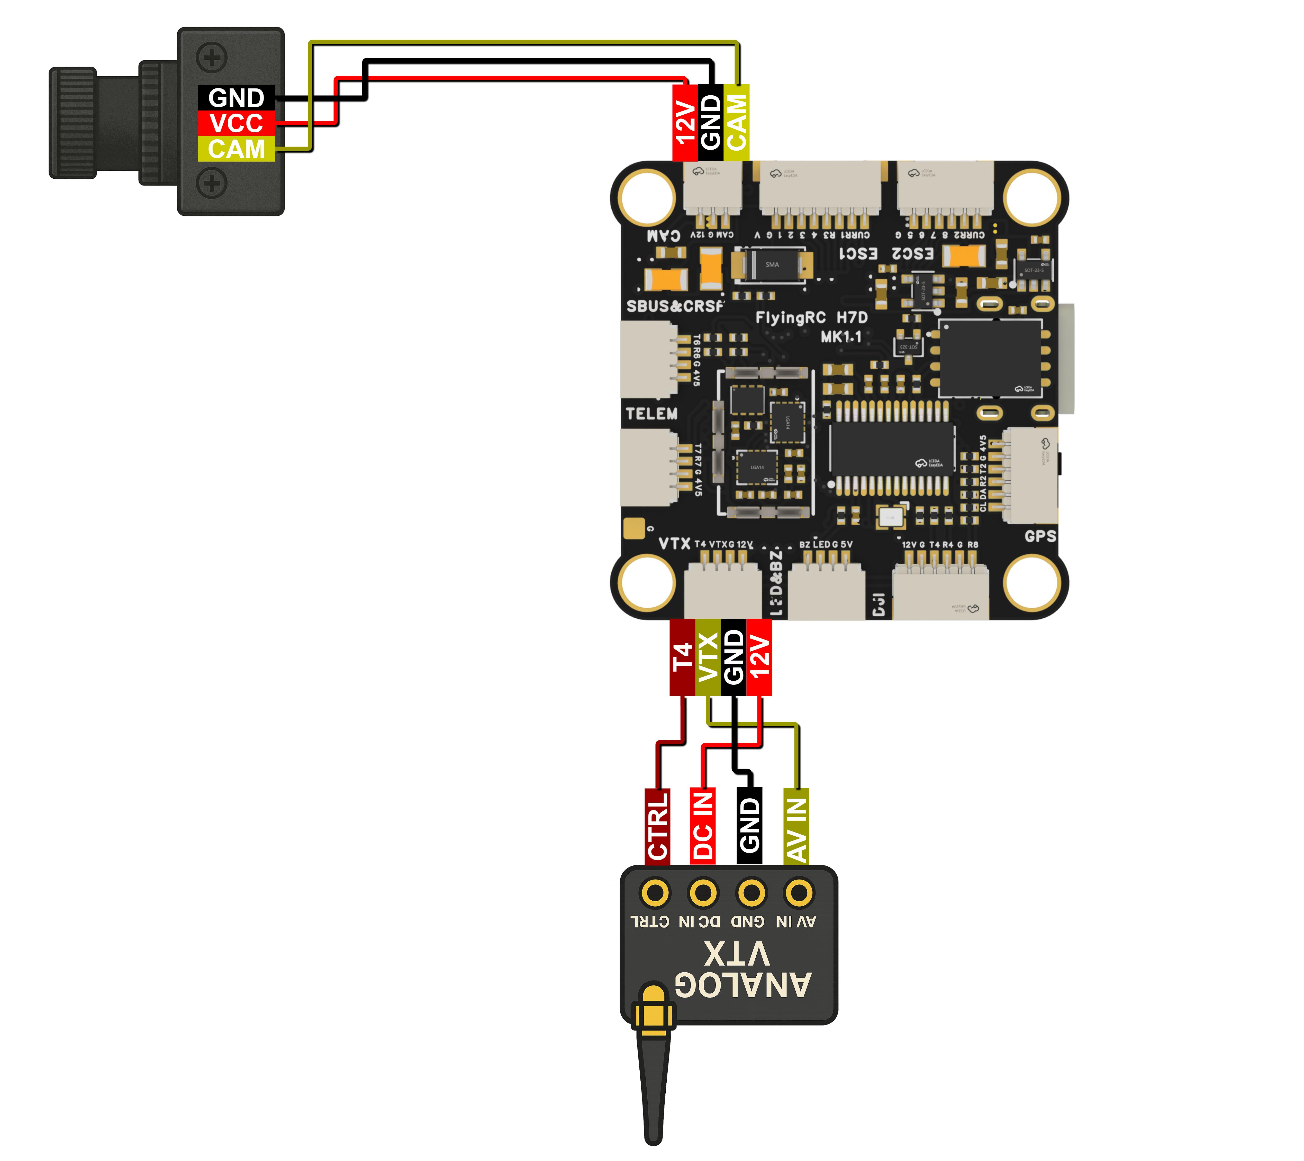
Wiring Diagram for Connection with Analog VTX and Camera

（6）Buzzer and LED
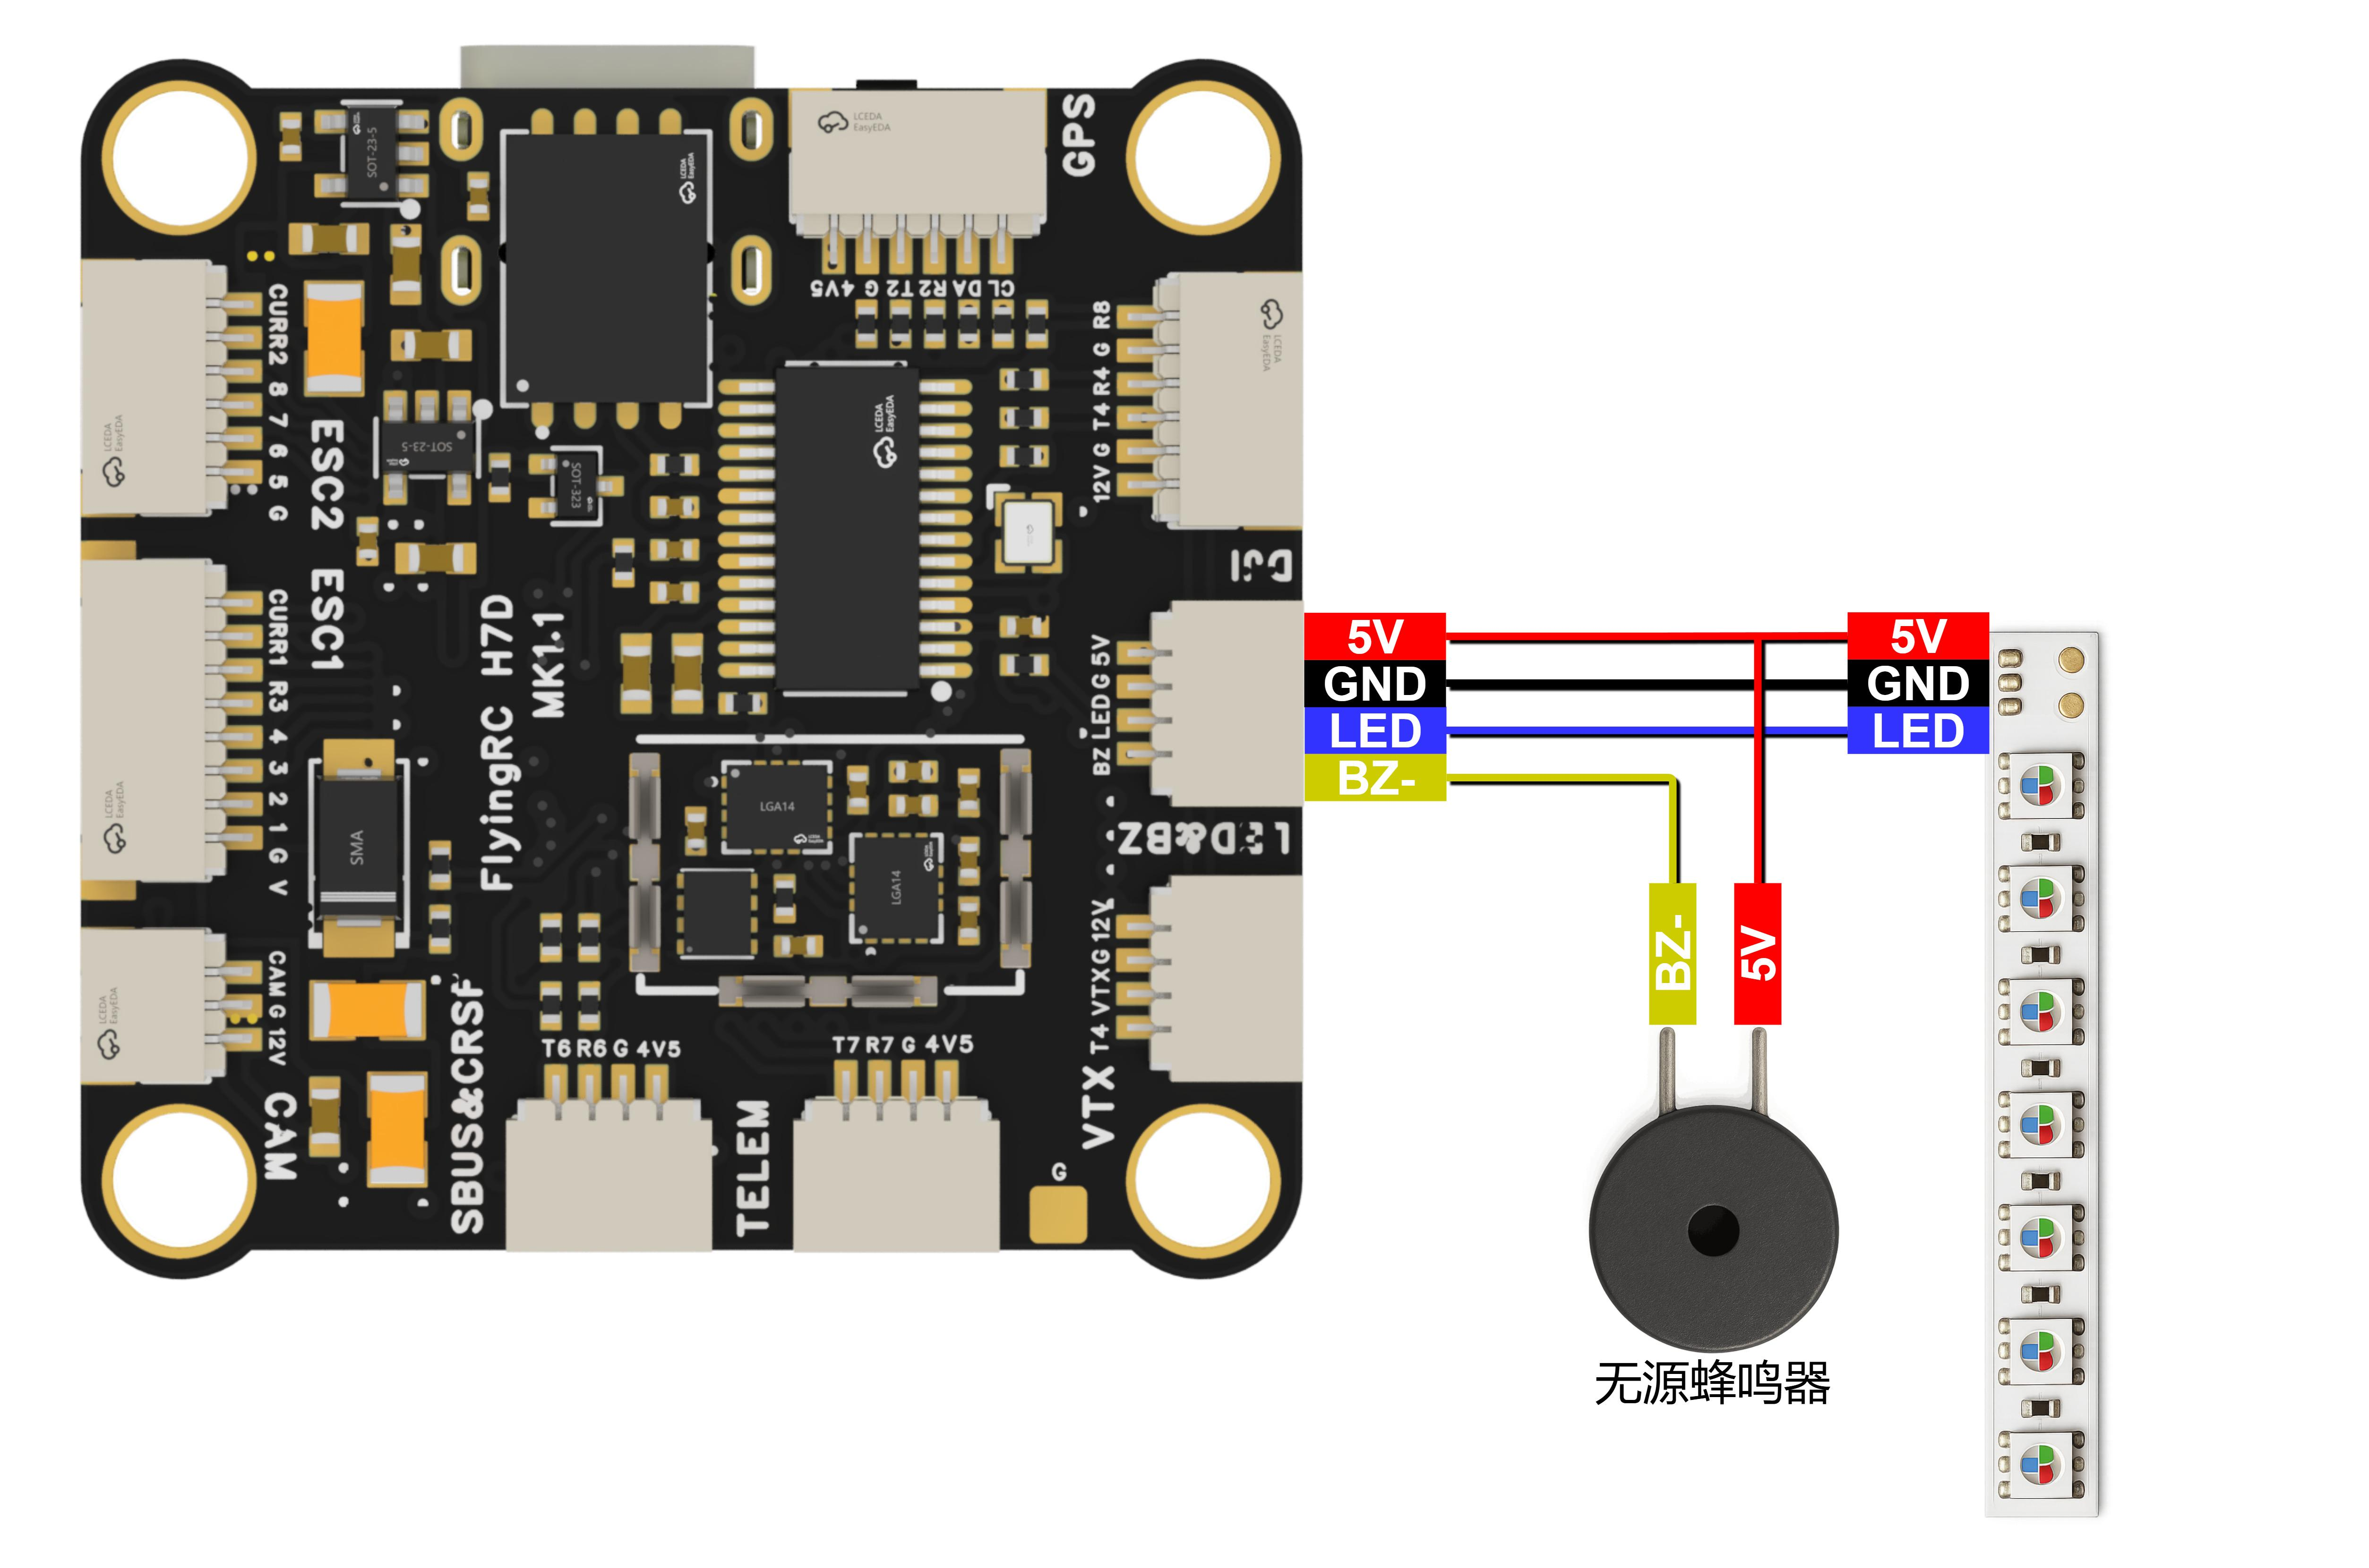

Wiring Diagram for Connection with Buzzer and LED

Flight Controller Firmware Flashing
BF, AP, and INAV firmwares are recommended. The Flight Controller comes pre-flashed with BF4.4.2 firmware as factory default. The following wiring instructions will use BF firmware as an example.

Firmware is officially compiled by FlyingRC® and not available in the public Betaflight firmware list. Please download the firmware from our official website.

Firmware Target：FLRC H7D

Betaflight Firmware Flashing Tutorial：Bilibili Article — Ardupilot Fixed-Wing: Flight Controller Firmware Flashing & Version Updates

Technical Support Notes:

- Limited technical support is provided for BF and Ardupilot firmwares.

- No technical support is available for INAV firmware.

Detailed Explanation of Flight Controller Interfaces：

- Serial Ports (UARTx, Serialx)
️NOTE: In Ardupilot firmware, the Serial port numbers do not correspond with UART/USART numbers. The mapping table is shown below. ‼️
 |  |  | UART | Config | SERIAL_X
USB | PA11/PA12 | 5 V tolerant I/O | USB | console | SERIAL0
RX7 TX7 RTS7 CTS7 | PE7/8/9/10 | 3.3 V tolerant I/O | UART7 | telem1 | SERIAL1
TX1 RX1 | PA9/PA10 | 5 V tolerant I/O | USART1 | telem2 | SERIAL2
TX2 RX2 | PD5/PD6 | 5 V tolerant I/O | USART2 | GPS1 | SERIAL3
TX3 RX3 | PD8/PD9 | 5 V tolerant I/O | USART3 | GPS2 | SERIAL4
TX8 RX8 | PE1/PE0 | 5 V tolerant I/O | UART8 | USER | SERIAL5
TX4 RX4 | PB9/PB8 | 5 V tolerant I/O | UART4 | USER | SERIAL6
TX6 RX6 | PC6/PC7 | 5 V tolerant I/O | USART6 | RC input/Receiver | SERIAL7
TX6 RX6 | PC6/PC7 | 5 V tolerant I/O | RX6 | SBUS/IBUS/DSM/PPM | SERIAL7
TX6 RX6 | PC6/PC7 | 5 V tolerant I/O | TX6 | FPORT/SRXL2 | SERIAL7
Ardupilot Serial Port Mapping Table
Note: After wiring, the Flight Controller Parameters must be adjusted accordingly. For example, in the sample Wiring Diagram above, the GPS is connected to R2 and T2. In the Serial Port Mapping Table below, R2 and T2 correspond to Serial3. Therefore, set Serial3_Protocol to GPS and ensure no other ports are configured for GPS functionality.

If you use a receiver that uses non-SBUS/PPM protocols (such as ELRS) on Serial7, you need to set brd_alt_config to 1.

（2）PWM output function

PWM Group | PWM channels |  |  | GPIO | Timer
Group1 | S1 | PB0 | 5V tolerant I/O | PWM1 GPIO50 | TIM8_CH2N
Group1 | S2 | PB1 | 3.3V tolerant I/O | PWM2 GPIO51 | TIM8_CH3N
Group2 | S3 | PA0 | 5V tolerant I/O | PWM3 GPIO52 | TIM5_CH1
Group2 | S4 | PA1 | 5V tolerant I/O | PWM4 GPIO53 | TIM5_CH2
Group2 | S5 | PA2 | 5V tolerant I/O | PWM5 GPIO54 | TIM5_CH3
Group2 | S6 | PA3 | 5V tolerant I/O | PWM6 GPIO55 | TIM5_CH4
Group3 | S7 | PD12 | 5V tolerant I/O | PWM7 GPIO56 | TIM4_CH1
Group3 | S8 | PD13 | 5V tolerant I/O | PWM8 GPIO57 | TIM4_CH2
Group5 | LED | PA8 | 5V tolerant I/O | PWM13 GPIO62 | TIM1_CH1
 |  |  |  | SERVO13_FUNCTION 120, NTF_LED_TYPES neopixel
PWM Output Function Table

The LED pad is the S13 port, which can connect to a WS2812 light strip and be freely configured in the BF ground station (AP firmware displays the Flight Controller status).
PWM ports in the same Group cannot be used for Dshot ESCs and 50Hz PWM servos simultaneously.

（3）I2C Bus
I2C num |  |  | Config | Parameterl | Value
I2C1 CL1/DA1 | PB6/PB7 | 5V tolerant I/O | Compass | COMPASS_AUTODEC | 1
I2C bus Table

- ADC Analog Signal Input
Pin |  |  | Definition | Config | Value
Vbat pad  1K:10K divider builtin | PC0 | 0 - 36V | Vbat ADC  onboard battery voltage sense | BATT_VOLT_PIN  BATT_VOLT_MULT | 10  11.0
Curr pad | PC1 | 0 - 3.3V | Current ADC  onboard current sense | BATT_CURR_PIN  BATT_AMP_PERVLT | 11 66.7
CU2 Pad | PA7 | 0 - 3.3V | Current2 ADC | BATT2_CURR_PIN  BATT2_AMP_PERVLT | 7 /

ADC Analog Signal Input Table

Betaflight General Parameter Settings：
Gyroscope Installation Orientation: CW90Flip

Ardupilot General Parameter Settings：
LOG_BACKEND_TYPE = 4，Enable TF card black box function to record flight logs
BATT_VOLT_PIN 10
BATT_VOLT_MULT 11.0，Default voltmeter ratio (5% error), additional calibration not required
BATT_CURR_PIN 11
INAV General Parameter Settings：
Default voltmeter ratio: 1100

Other FlyingRC® Products
 |  |  |  | - FlyingRC® F4WSE Pro - F405 Fixed-Wing Flight Controller  Upgraded Version | Enhanced Performance  Manual：https://www.kdocs.cn/l/cavm9EoVEq5A |  |  | 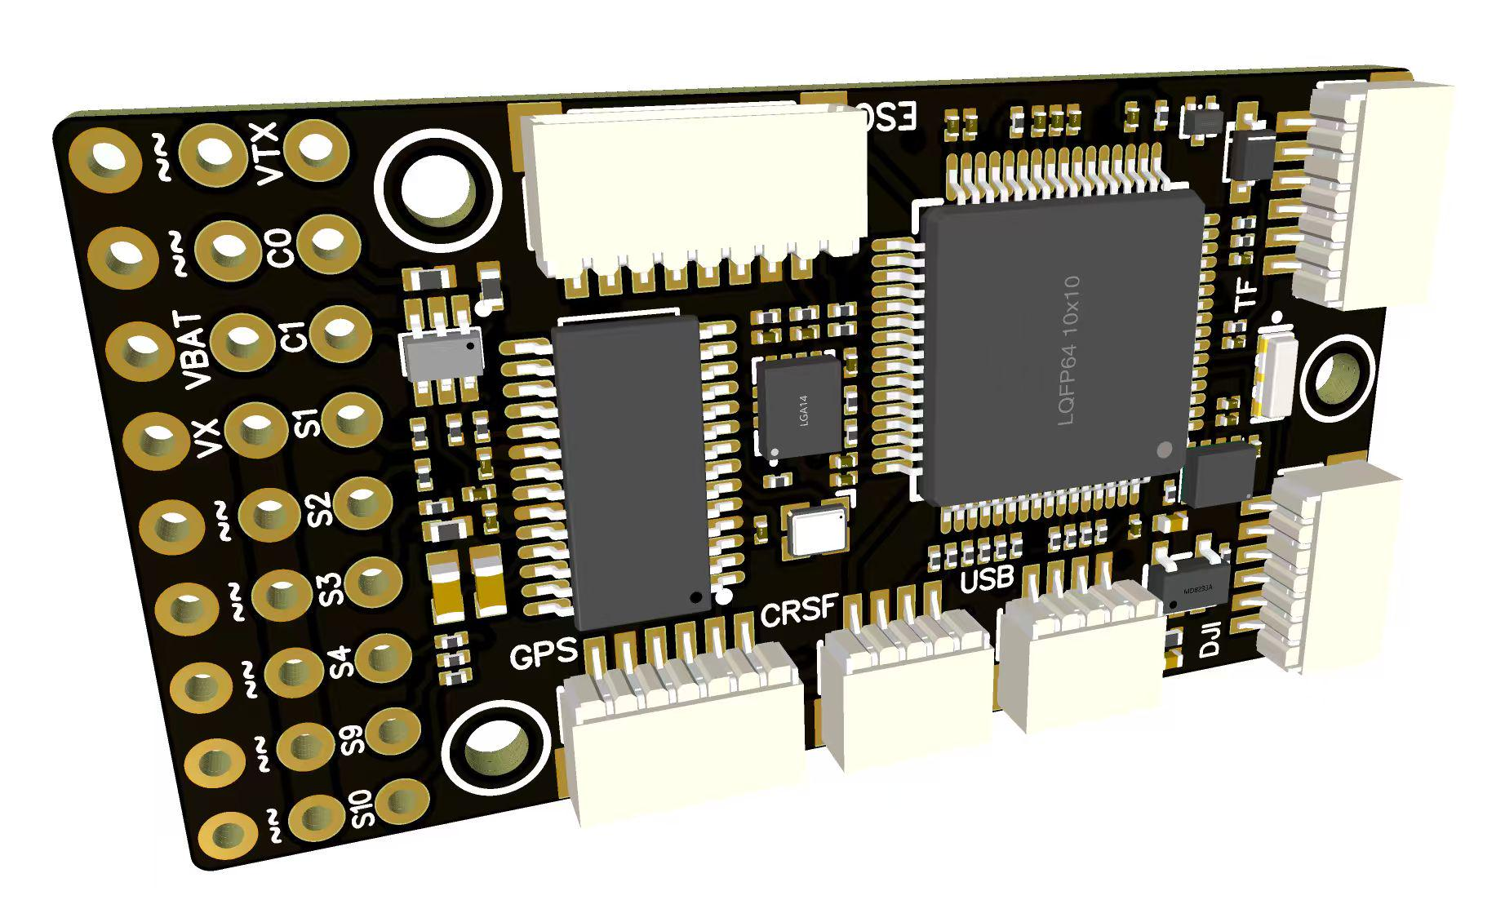
 |  |  | - FlyingRC® F4WSE MK1.5 - F405 Fixed-Wing Flight Controller  Classic model, unique design, highly acclaimed.  Manual：https://kdocs.cn/l/cpyd8MTS56DD |  |  | 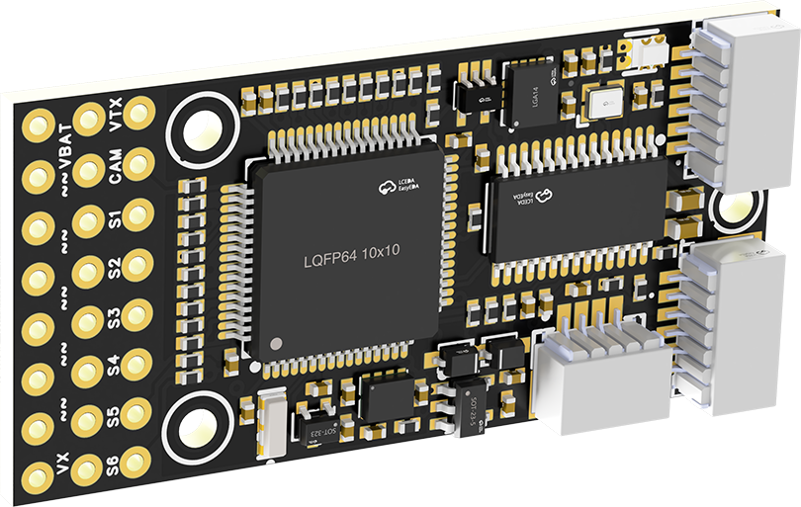
 |  |  |  | - FlyingRC® H7Wlite MK1 H743 Fixed-Wing Flight Controller  Flagship performance, full expansion, high-power BEC.  Manual：https://kdocs.cn/l/cpYaBiFKh8U1 |  |  | 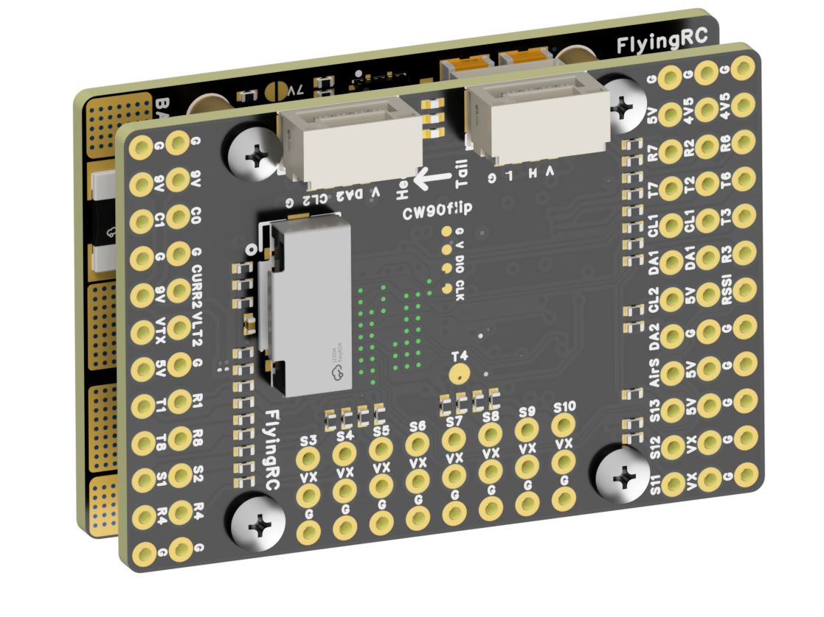
 |  |  |  | - FlyingRC® F4Wing Mini MK1 F405 Fixed-Wing Flight Controller  2025 bestseller, ultra-compact, smallest on the market, great value.  Manual：https://kdocs.cn/l/cdUIdmpSpW7J |  |  | 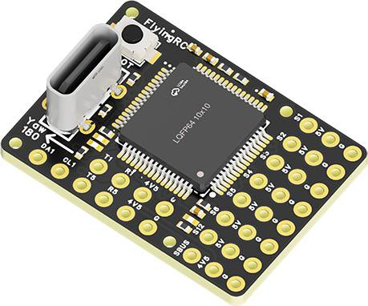
 | - FlyingRC® AM32 Dual ESC 40A 2-in-1 ESC  Unique design for dual-power aerial, land and water vehicles including drones.  Manual：https://www.kdocs.cn/l/cjwNtsKK6HeR |  |  |  | 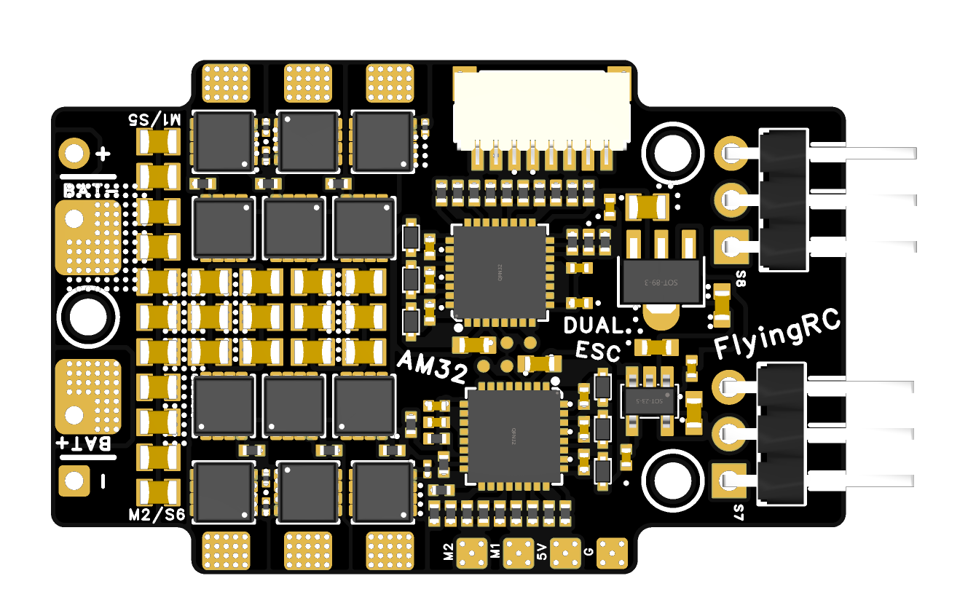
 |  |  | - FlyingRC® AM32 ESC V2.5 75A - Single ESC  Infineon gold-package MOSFETs, premium materials, superior heat dissipation.  Manual：https://kdocs.cn/l/cv6hUy67IdTJ |  |  |  | 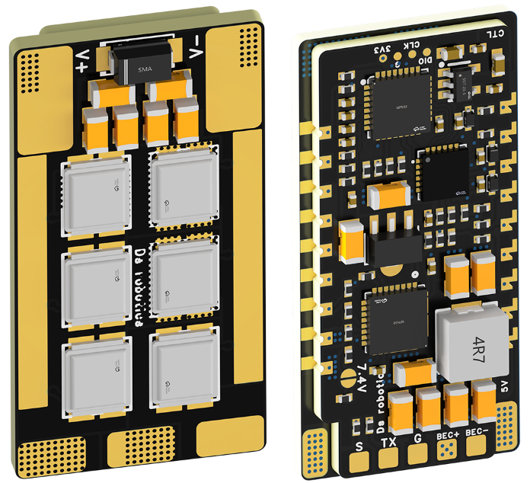
 |  |  | - FlyingRC® AM32 Mini ESC 40A V1.0 - Single ESC  Ultra-miniature, ideal for micro drones, high over-current capability, stable operation.  Manual：https://kdocs.cn/l/cqdLSysEyWFh |  |  |  |  | 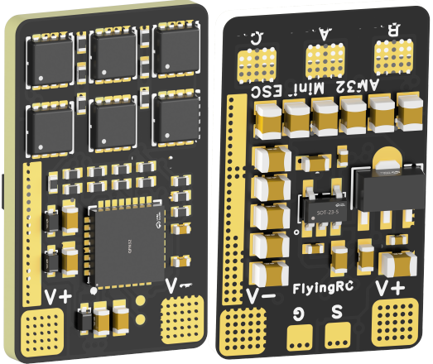
 |  |  | - FlyingRC® 10A 12S 440A Power Distribution Board for FPV Drones  Industry top choice, excellent quality and affordable price.  Manual：https://kdocs.cn/l/coel7OgrlCBP |  |  |  |  | 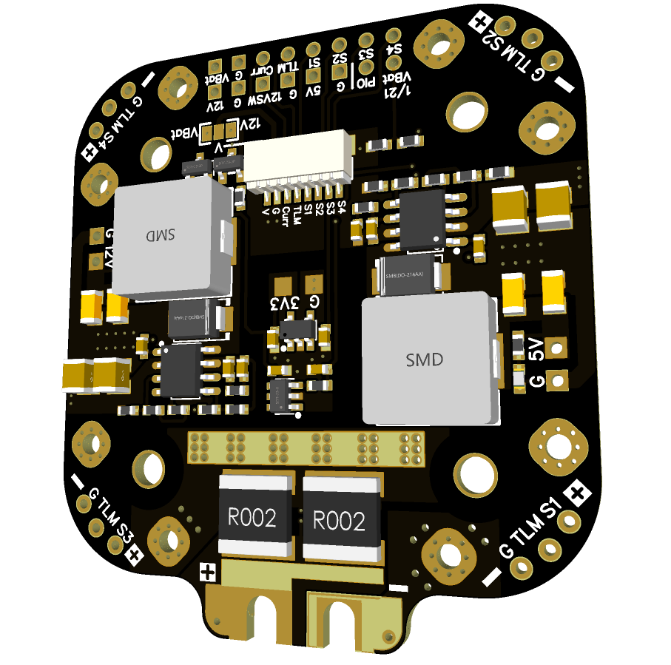
 |  |  | - FlyingRC® H7D Pro MK1 H743 FPV Flight Controller with Dual Gyro  Fully Upgraded & More Powerful  Manual：https://www.kdocs.cn/l/ctcekCy676Ez |  |  |  | 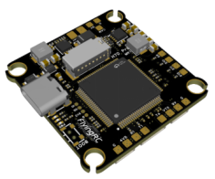
 |  |  | - FlyingRC® H7D MK1 H743 FPV Flight Controller with Dual Gyro  Powerful computing, stable and precise flight, rich interfaces, smooth control.  Manual：https://kdocs.cn/l/cqMh1I0RwAoD |  |  |  | 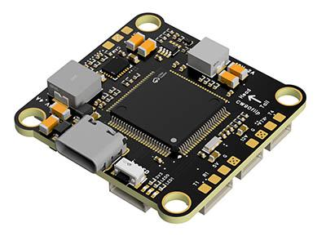
 |  |  | - FlyingRC® F420 MK1 F405 FPV Flight Controller (20/30.5mm Mounting)  Dual mounting holes, all connectors, no soldering required, compliant with Betaflight interface standards.  Manual：https://kdocs.cn/l/ctGeLiN9ZYKj |  |  |  | 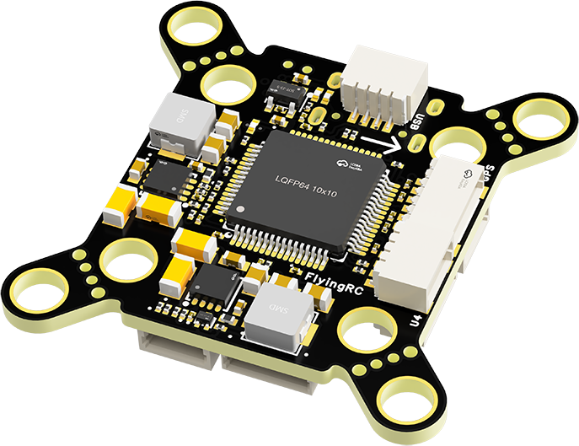
 |  | - FlyingRC® 4-in-1 75A V3.2 Gold-Sealed FPV ESC  Infineon gold-package MOSFETs, superior heat dissipation & over-current capability, premium choice.  Manual：https://kdocs.cn/l/ceLilc8Gaa21 |  |  |  |  | 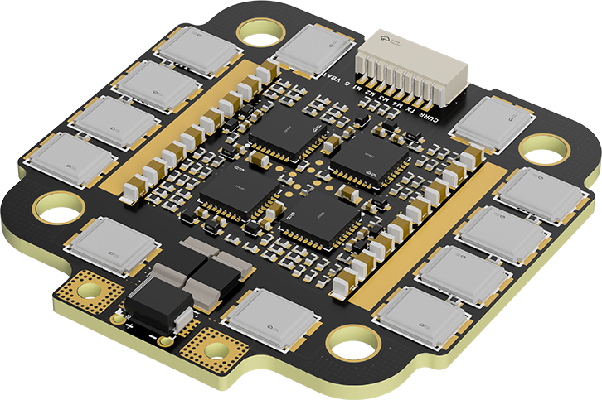
- FlyingRC® Stack Combo: H743 Flight Controller + 4-in-1 75A Gold-Sealed ESC  Professional flight choice, flagship materials & craftsmanship, reasonable price.  Manual：https://www.kdocs.cn/l/ctcekCy676Ez  https://kdocs.cn/l/ceLilc8Gaa21 |  |  |  |  |  |  | 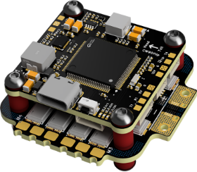
 |  | - FlyingRC® Stack Combo: F405 Flight Controller + 4-in-1 75A Gold-Sealed ESC  Best-selling combo, excellent performance, affordable price.  Manual：https://kdocs.cn/l/ctGeLiN9ZYKj  https://kdocs.cn/l/ceLilc8Gaa21 |  |  |  |  | 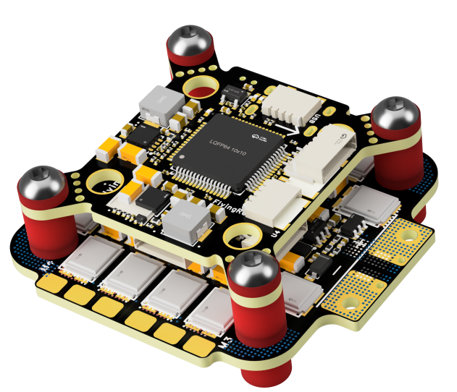
 |  | - FlyingRC® Stack Combo: H743 Flight Controller + 4-in-1 45A ESC  Winning combo: great performance, budget-friendly price  Manual：https://www.kdocs.cn/l/ctcekCy676Ez  https://kdocs.cn/l/ceLilc8Gaa21 |  |  |  |  | 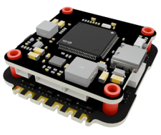
 |  | - FlyingRC® Stack Combo: F405 Flight Controller + 4-in-1 45A ESC  Hit combo, great value, budget-friendly  Manual：https://kdocs.cn/l/ctGeLiN9ZYKj  https://kdocs.cn/l/ceLilc8Gaa21 |  |  |  |  | 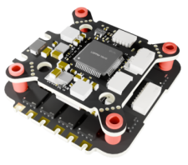
 |  | - FlyingRC® Stack Combo: F4WSE Pro - F405 Fixed-Wing Flight Controller + AM32 Dual ESC 40A 2-in-1 ESC  Unique Design • Exclusive Offer • Bestselling Bundle  Manual：https://www.kdocs.cn/l/cavm9EoVEq5A  https://www.kdocs.cn/l/cjwNtsKK6HeR |  |  |  |  | 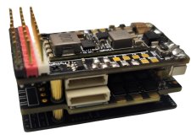
 | - FlyingRC® ELRS 2.4G Diversity Receiver  True diversity reception, temperature compensation, high-sensitivity reception.  Manual：https://kdocs.cn/l/cbvlOlShmsPS |  |  |  |  |  | 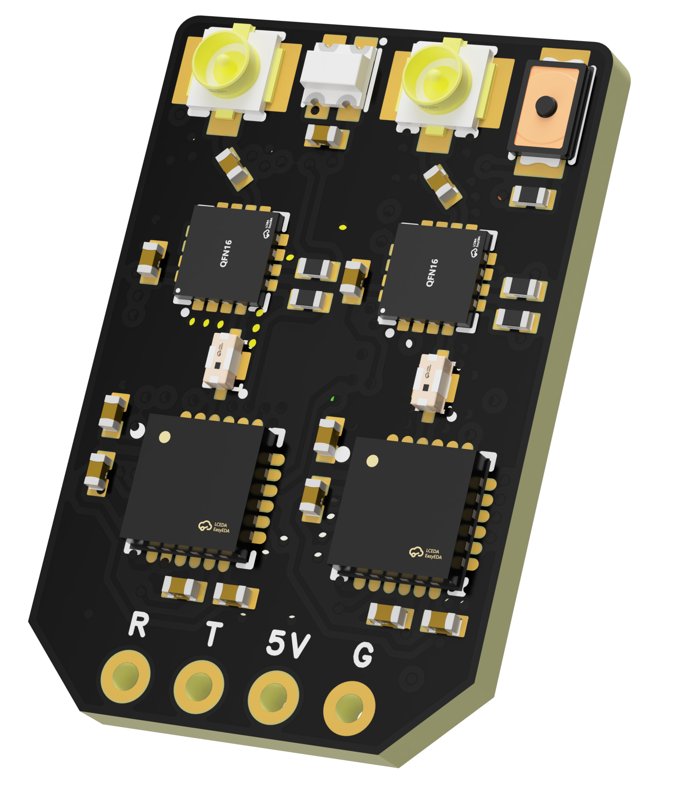
 | - FlyingRC® RM3100 SPI Module 罗盘模块  Ultra-high Resolution • Low Power • Industry Top Choice  Manual：https://www.kdocs.cn/l/cdGuHvBVyndC |  |  |  |  |  | 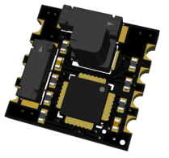
 | - FlyingRC® 10A 12S BEC Step-Down Module  Wide voltage input, high power, compact size, multiple voltages available, 10A continuous output.  Manual：https://kdocs.cn/l/clssNCKgNhLV |  |  |  |  |  | 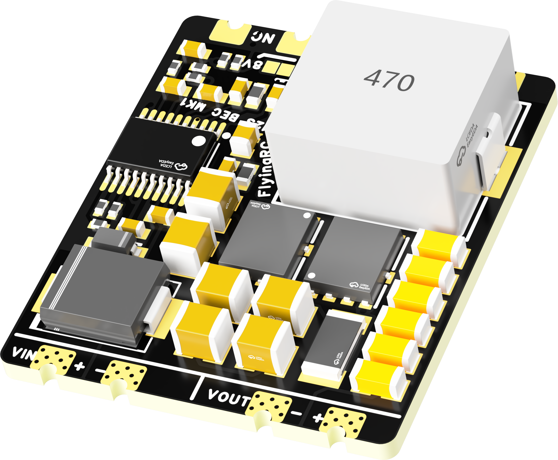
 | FlyingRC® 5A BEC Step-Down Module  Ultra-small size, multiple voltages available, 5A continuous output.  Manual：https://kdocs.cn/l/cb9VdNywqCKA |  |  |  |  |  | 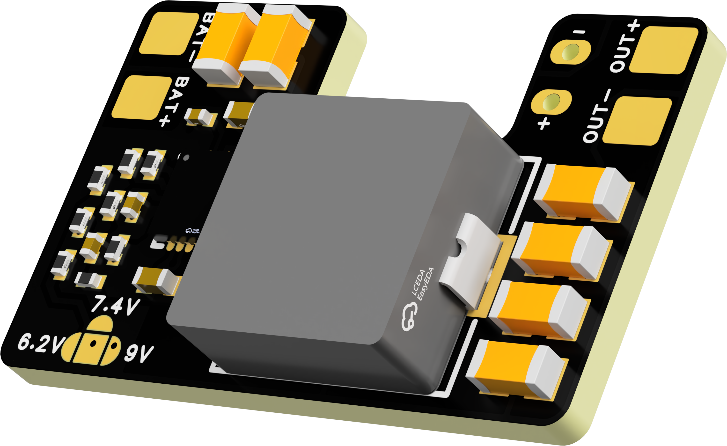
 | FlyingRC® Mini BEC For DJI O4  Easy wiring, ultra-small size, stable power supply.  Manual：https://www.kdocs.cn/l/ckkebieur37K |  |  |  |  |  | 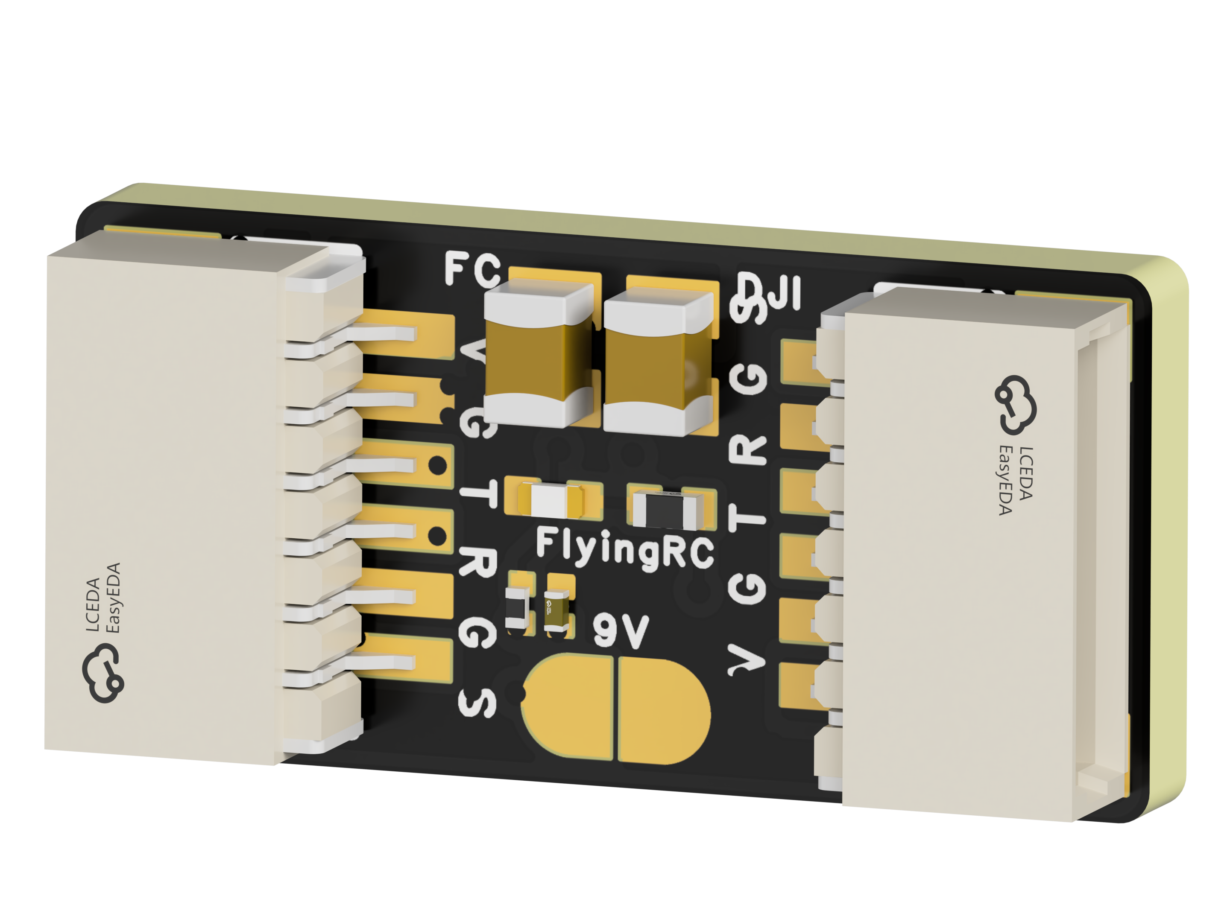
 | FlyingRC® CAN Bus Serial & PWM Expansion Board  Long-distance transmission, high speed, excellent stability.  Manual：https://www.kdocs.cn/l/ckkebieur37K |  |  |  |  |  | 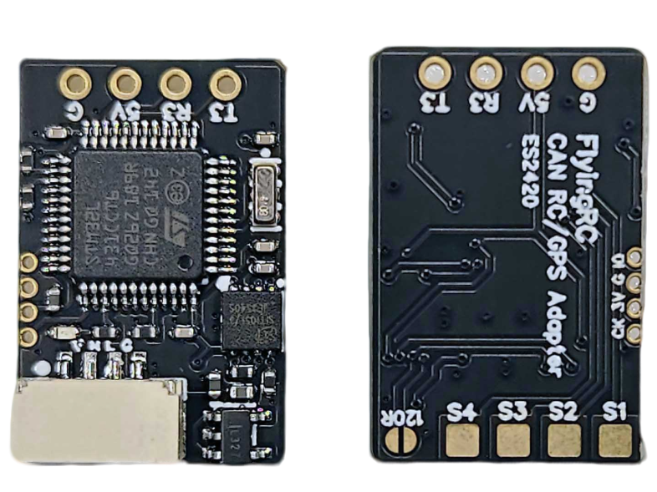
 | FlyingRC® AM3 2ESC Programmer  Supports BL, BL32, AM32. Simple and easy to use.  Manual：https://kdocs.cn/l/cogBSEBe67mE |  |  |  |  |  | 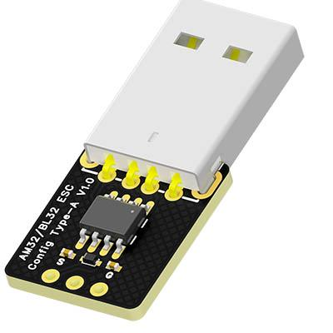
 | FlyingRC® Digital Airspeed Sensor without Pitot Tube  Integrated design, smallest on the market. MS4525D protocol, I2C interface.  Manual：https://www.kdocs.cn/l/clPvEEEcJgCC |  |  |  |  |  | 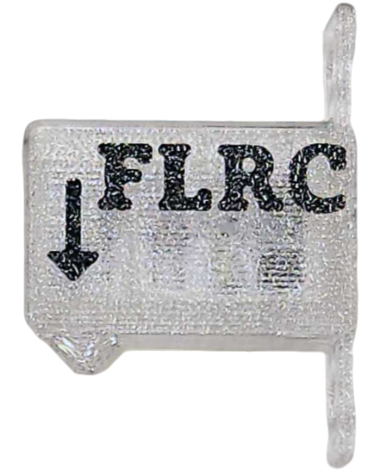
 | FlyingRC® U-Blox M10 GPS  Compatible with all open-source flight controllers.  Manual：https://www.kdocs.cn/l/cdSYQrzx74O8 |  |  |  |  |  | 