Product Manual of FlyingRC® 12S 440A Power Distribution Board for FPV Drones
FlyingRC® is a globally-oriented professional brand of electronic devices. We specialize in the R&D and sales of drone electronics, core robot circuits and sensors. Our design team is based in Singapore, and our products are sold worldwide.

Since launched in 2023, FlyingRC® products have gained widespread recognition from customers as well as strong market response. As of April 2026, our cumulative sales volume has exceeded 46,000 units. Our products are widely applied in industries, robotics, emergency rescue, environmental protection & inspection, aerial photography, public security, retail and many other fields. Above all, we are committed to distinctive design and superior reliable quality.

Our Chief Technology Officer Liu Yuhan possesses outstanding expertise in circuit design. Over the past four years, he has designed more than 80 circuit projects and contributed 39 to open-source platforms. Moreover, he won the Design Award on the open-source platform X.JLC.com twice in 2023 and 2024, and has become the youngest certified designer on this platform.

He holds the NUS (National University of Singapore, rank 8th worldwide) Science and Technology Scholarship, and is currently majoring in Electronic Engineering with a focus on Aerospace Technology. In addition, all members of our technical team are graduates from prestigious universities with extensive professional product experience.
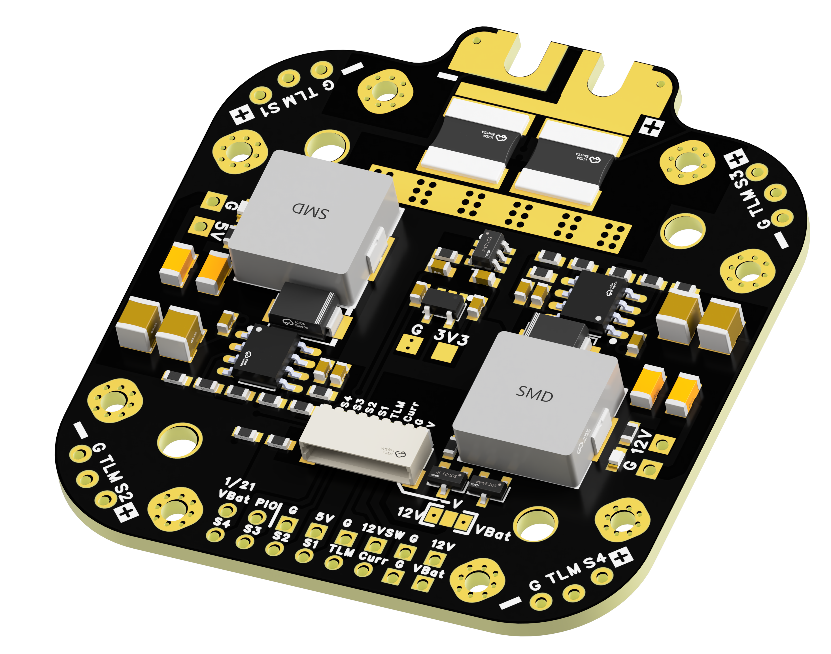
3D Rendering of the Product's Front Side
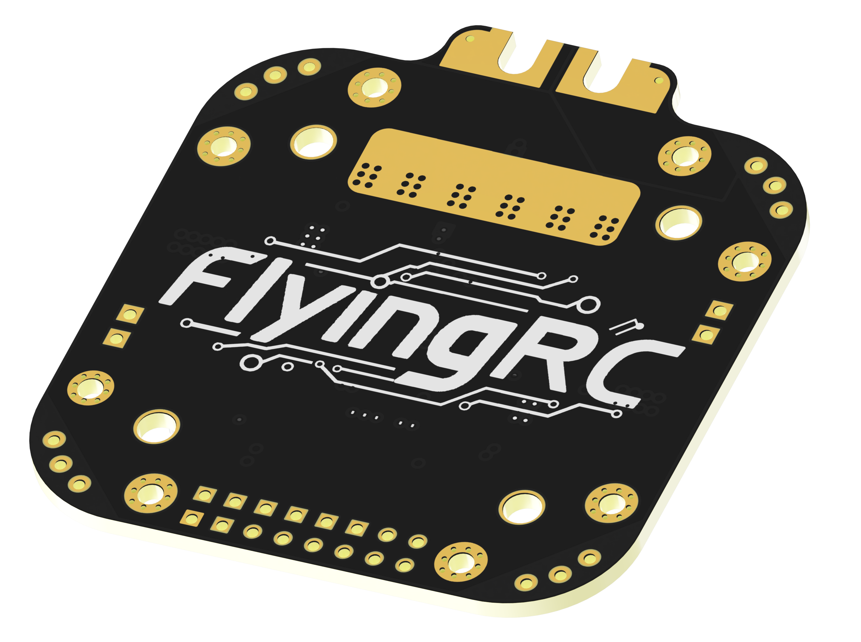
3D Rendering of the Product's Back Side
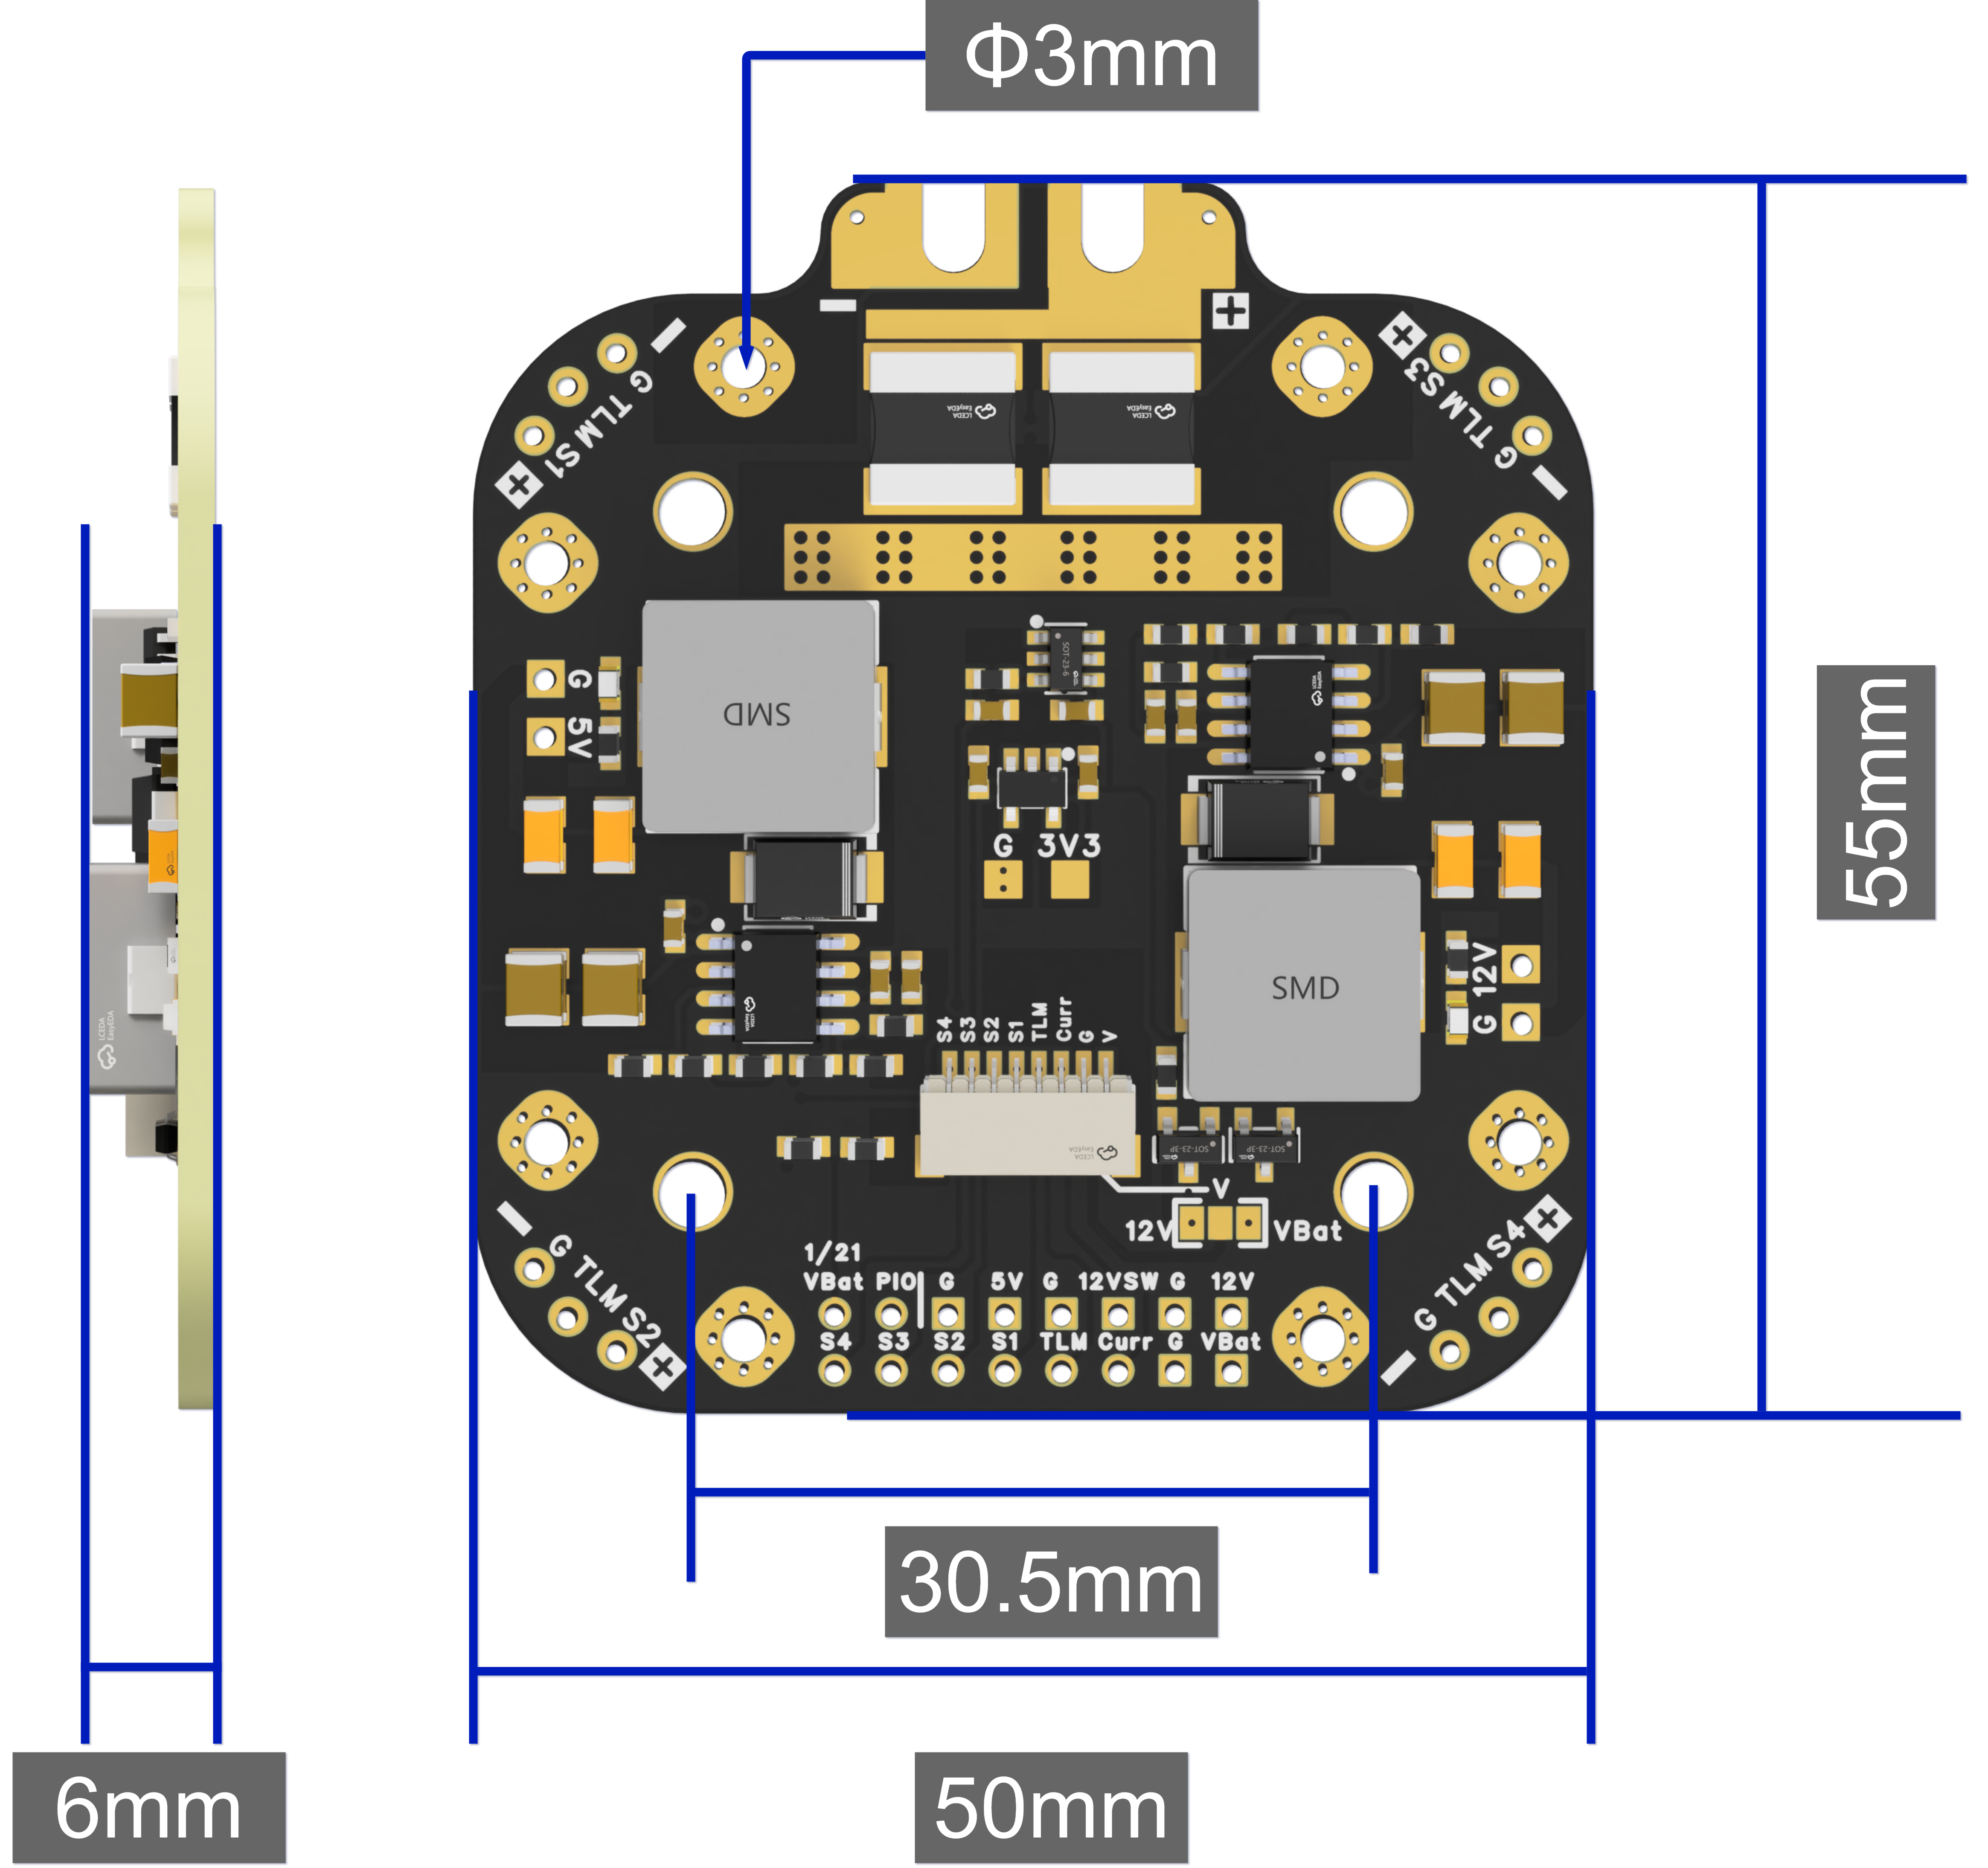
3D Dimensional Drawing of the Product
- Technical Parameters
Product Dimensions: 55mm x 50mm x 6mm
Mounting Hole Spacing: 30.5mm x 30.5mm, with 3mm aperture
Product Weight: 21.5g
PCB: 6-layer, 2oz copper (inner & outer), 2.0mm thickness, 1μm immersion gold
Input Voltage Range: 6-60V DC input (2-12S LiPo battery)
Power Distribution Board Max Output Current: 4 × (80A Continuous, 110A Peak)
Onboard BEC Output: 5V 5A & 12V 4A
Operating Temperature Range: -20~100℃

- Product Features
- Supports up to 12S input
- Large exposed copper areas for enhanced heat dissipation
- Onboard high-precision current sensor with a measurement range up to 440A
- Supports 4 ESC power outputs: 80A continuous / 110A peak per channel
- Integrated 1k:20k voltage divider
- 2 onboard red BEC operation indicators
- On-board SH1.0 8-pin connector for direct connection to flight controller, with solder pads for alternative FC wiring
- Dual onboard BECs with stable 5A @ 5V and 4A @ 12V outputs
- Controllable 12V output (12V output disabled when a high level is applied to the 12VSW pad)
- Onboard 3.3V LDO with a maximum output current of 500mA
- Equipped with "V" pads, allowing selection of 12V or battery voltage output via soldering jumper pads
- Soldering recommendation: 350-400°C, Sn63Pb37 solder

●

- Usage Instructions
Wiring Diagram of the PDB and Four individual ESCs (FlyingRC® AM32 75A ESC V2.5)
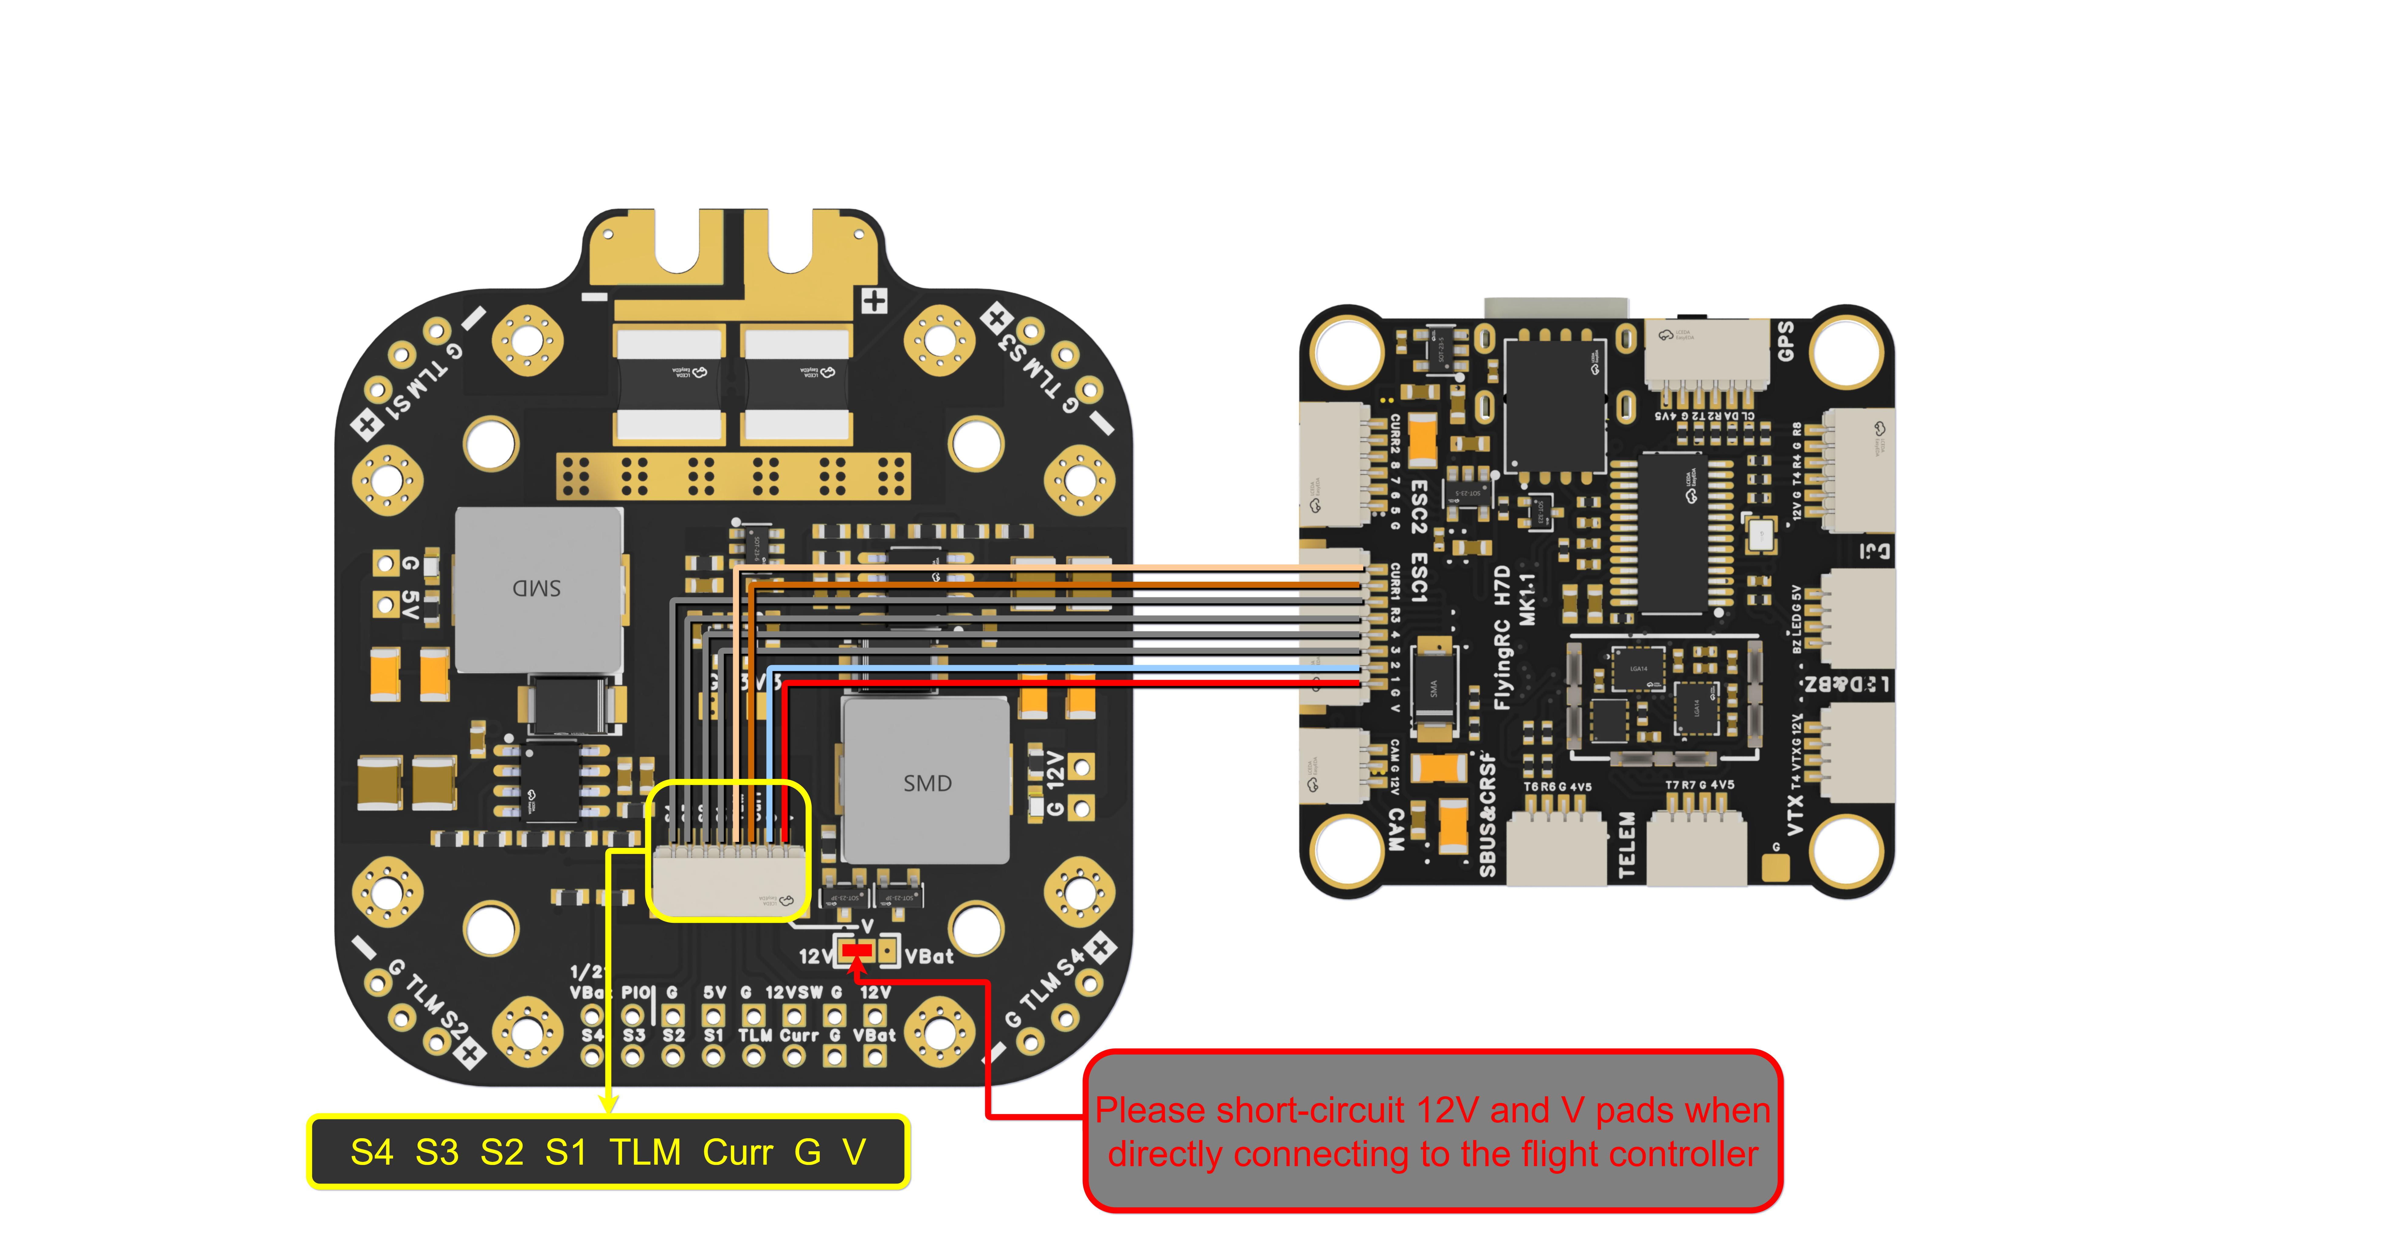
Wiring Diagram for the PDB and Flight Controller (FlyingRC® H7D MK1 FC)

- Voltage Meter Setting: 1/21V
- Current Meter Setting: 7.5mV/A

●

Other FlyingRC® Products
 |  |  |  | - FlyingRC® F4WSE Pro - F405 Fixed-Wing Flight Controller  Upgraded Version | Enhanced Performance  Manual：https://www.kdocs.cn/l/cavm9EoVEq5A |  |  | 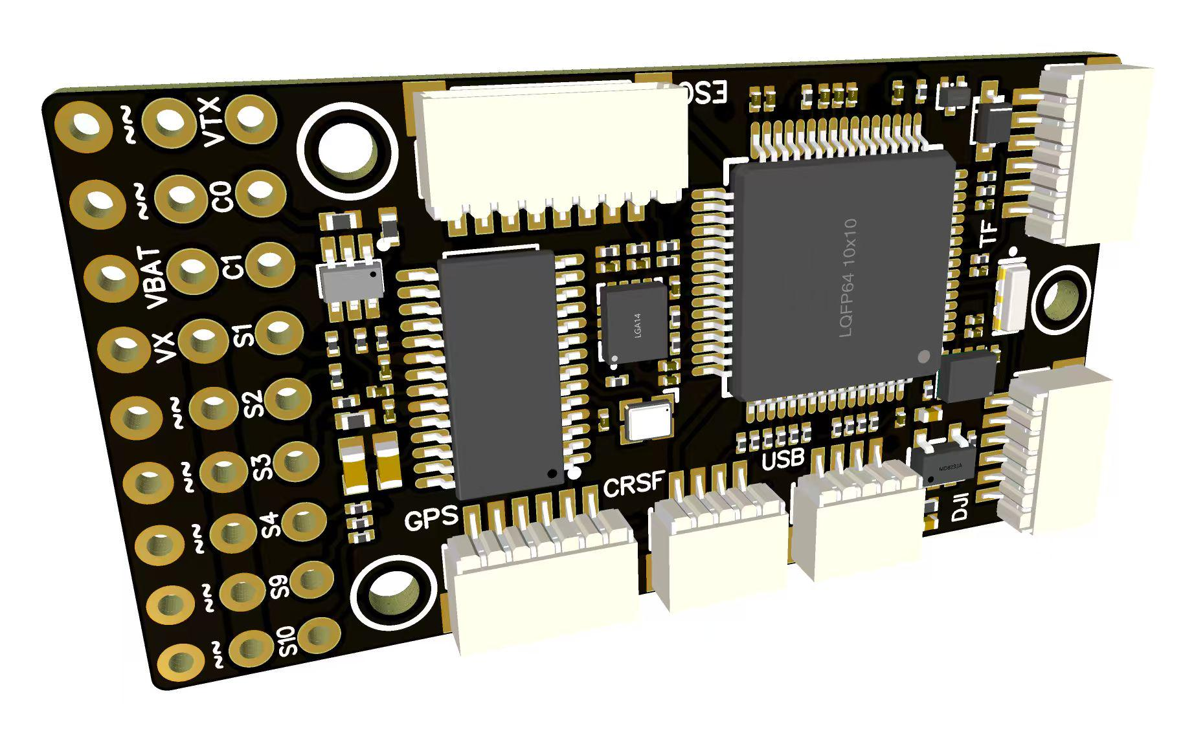
 |  |  | - FlyingRC® F4WSE MK1.5 - F405 Fixed-Wing Flight Controller  Classic model, unique design, highly acclaimed.  Manual：https://kdocs.cn/l/cpyd8MTS56DD |  |  | 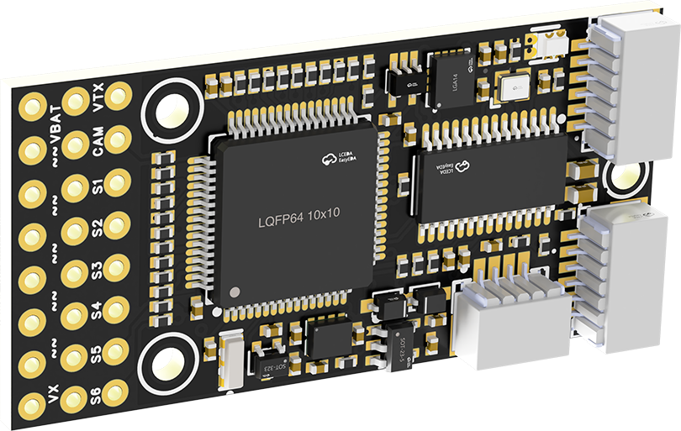
 |  |  |  | - FlyingRC® H7Wlite MK1 H743 Fixed-Wing Flight Controller  Flagship performance, full expansion, high-power BEC.  Manual：https://kdocs.cn/l/cpYaBiFKh8U1 |  |  | 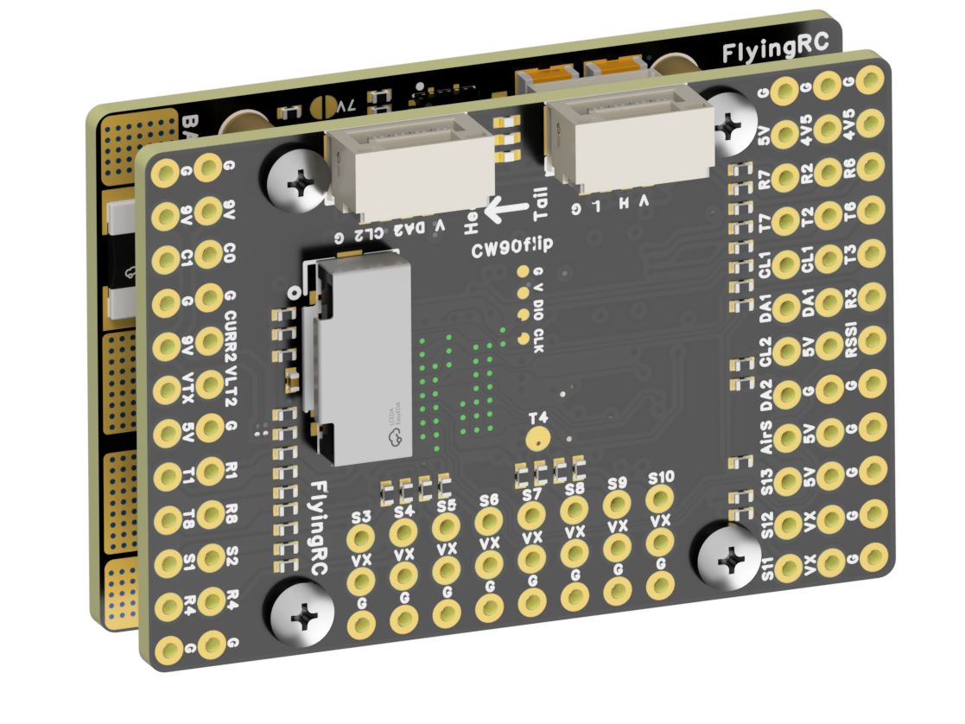
 |  |  |  | - FlyingRC® F4Wing Mini MK1 F405 Fixed-Wing Flight Controller  2025 bestseller, ultra-compact, smallest on the market, great value.  Manual：https://kdocs.cn/l/cdUIdmpSpW7J |  |  | 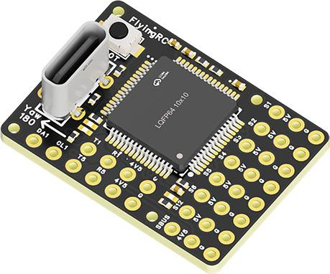
 | - FlyingRC® AM32 Dual ESC 40A 2-in-1 ESC  Unique design for dual-power aerial, land and water vehicles including drones.  Manual：https://www.kdocs.cn/l/cjwNtsKK6HeR |  |  |  | 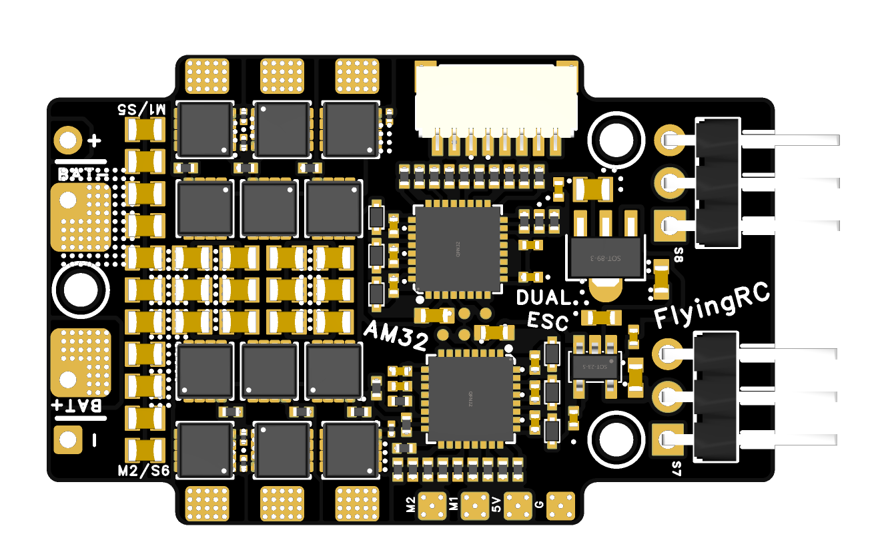
 |  |  | - FlyingRC® AM32 ESC V2.5 75A - Single ESC  Infineon gold-package MOSFETs, premium materials, superior heat dissipation.  Manual：https://kdocs.cn/l/cv6hUy67IdTJ |  |  |  | 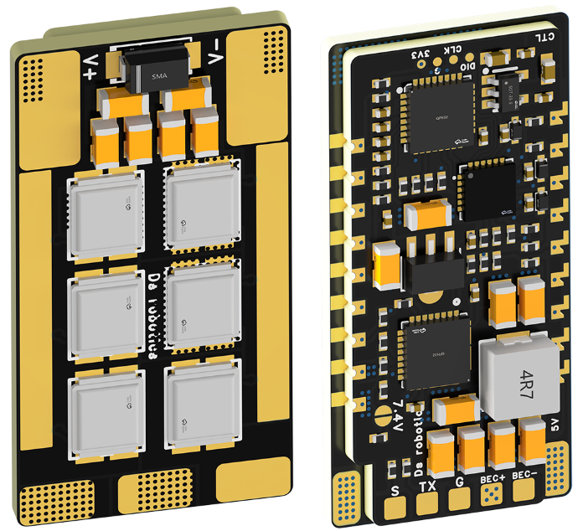
 |  |  | - FlyingRC® AM32 Mini ESC 40A V1.0 - Single ESC  Ultra-miniature, ideal for micro drones, high over-current capability, stable operation.  Manual：https://kdocs.cn/l/cqdLSysEyWFh |  |  |  |  | 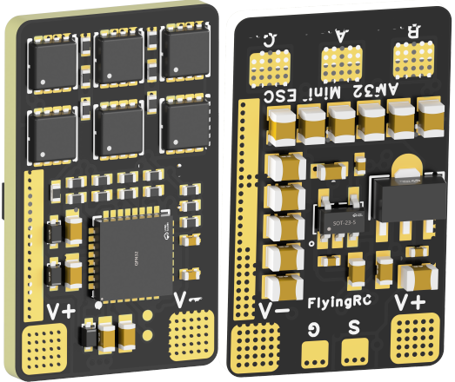
 |  |  | - FlyingRC® 10A 12S 440A Power Distribution Board for FPV Drones  Industry top choice, excellent quality and affordable price.  Manual：https://kdocs.cn/l/coel7OgrlCBP |  |  |  |  | 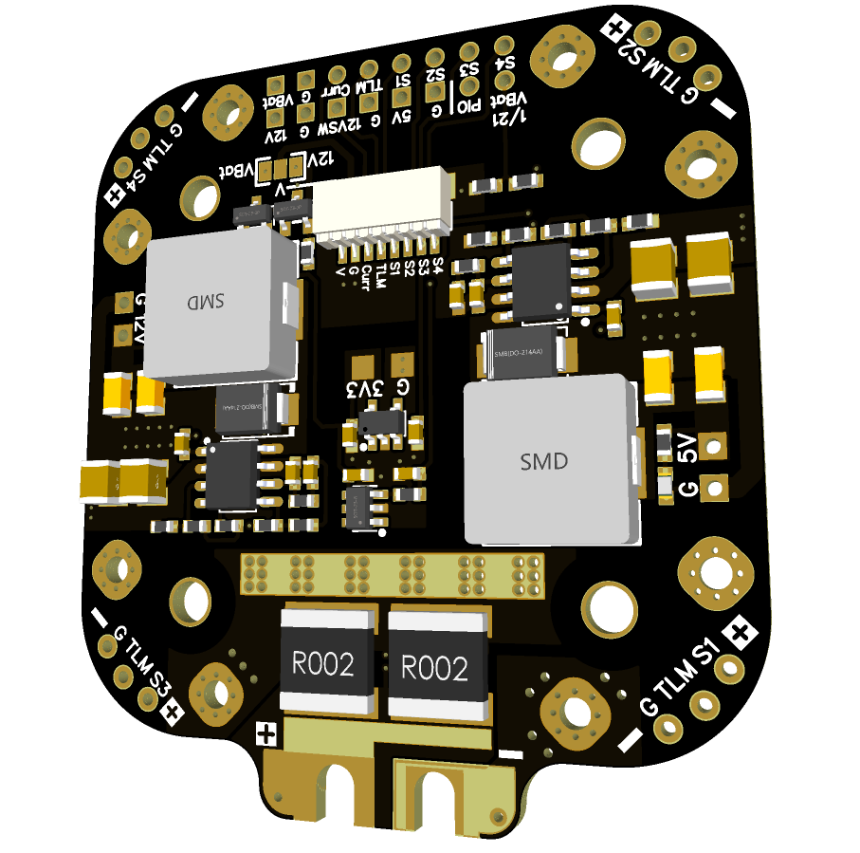
 |  |  | - FlyingRC® H7D Pro MK1 H743 FPV Flight Controller with Dual Gyro  Fully Upgraded & More Powerful  Manual：https://www.kdocs.cn/l/ctcekCy676Ez |  |  |  | 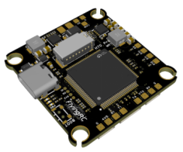
 |  |  | - FlyingRC® H7D MK1 H743 FPV Flight Controller with Dual Gyro  Powerful computing, stable and precise flight, rich interfaces, smooth control.  Manual：https://kdocs.cn/l/cqMh1I0RwAoD |  |  |  | 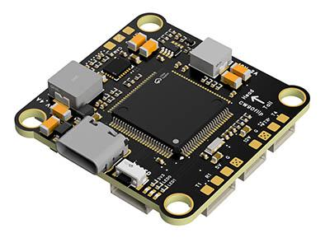
 |  |  | - FlyingRC® F420 MK1 F405 FPV Flight Controller (20/30.5mm Mounting)  Dual mounting holes, all connectors, no soldering required, compliant with Betaflight interface standards.  Manual：https://kdocs.cn/l/ctGeLiN9ZYKj |  |  |  | 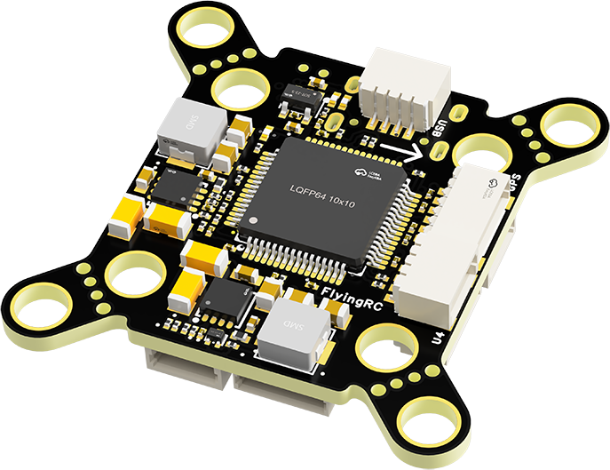
 |  | - FlyingRC® 4-in-1 75A V3.2 Gold-Sealed FPV ESC  Infineon gold-package MOSFETs, superior heat dissipation & over-current capability, premium choice.  Manual：https://kdocs.cn/l/ceLilc8Gaa21 |  |  |  |  | 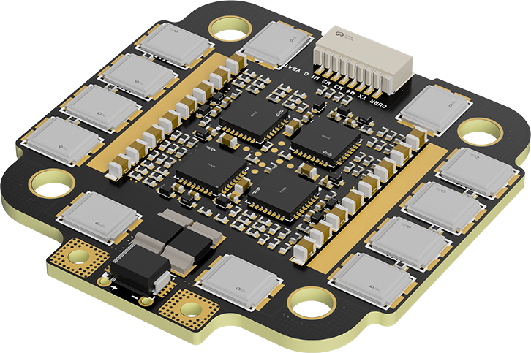
- FlyingRC® Stack Combo: H743 Flight Controller + 4-in-1 75A Gold-Sealed ESC  Professional flight choice, flagship materials & craftsmanship, reasonable price.  Manual：https://www.kdocs.cn/l/ctcekCy676Ez  https://kdocs.cn/l/ceLilc8Gaa21 |  |  |  |  |  |  | 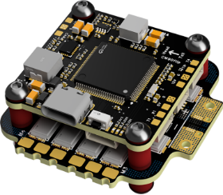
 |  | - FlyingRC® Stack Combo: F405 Flight Controller + 4-in-1 75A Gold-Sealed ESC  Best-selling combo, excellent performance, affordable price.  Manual：https://kdocs.cn/l/ctGeLiN9ZYKj  https://kdocs.cn/l/ceLilc8Gaa21 |  |  |  |  | 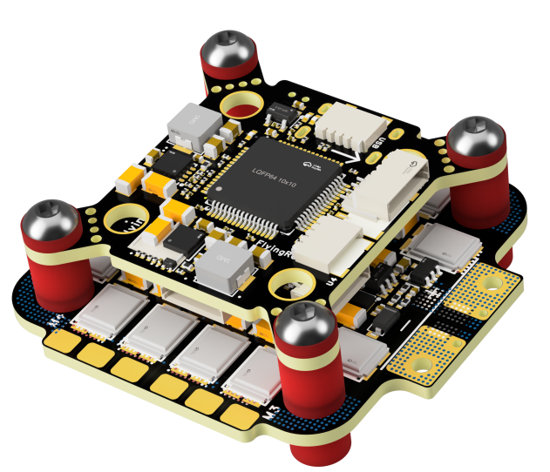
 |  | - FlyingRC® Stack Combo: H743 Flight Controller + 4-in-1 45A ESC  Winning combo: great performance, budget-friendly price  Manual：https://www.kdocs.cn/l/ctcekCy676Ez  https://kdocs.cn/l/ceLilc8Gaa21 |  |  |  |  | 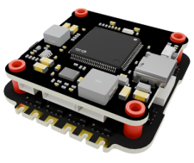
 |  | - FlyingRC® Stack Combo: F405 Flight Controller + 4-in-1 45A ESC  Hit combo, great value, budget-friendly  Manual：https://kdocs.cn/l/ctGeLiN9ZYKj  https://kdocs.cn/l/ceLilc8Gaa21 |  |  |  |  | 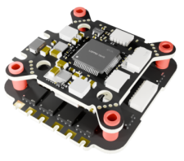
 |  | - FlyingRC® Stack Combo: F4WSE Pro - F405 Fixed-Wing Flight Controller + AM32 Dual ESC 40A 2-in-1 ESC  Unique Design • Exclusive Offer • Bestselling Bundle  Manual：https://www.kdocs.cn/l/cavm9EoVEq5A  https://www.kdocs.cn/l/cjwNtsKK6HeR |  |  |  |  | 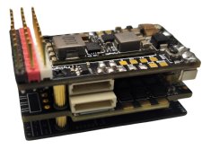
 | - FlyingRC® ELRS 2.4G Diversity Receiver  True diversity reception, temperature compensation, high-sensitivity reception.  Manual：https://kdocs.cn/l/cbvlOlShmsPS |  |  |  |  |  | 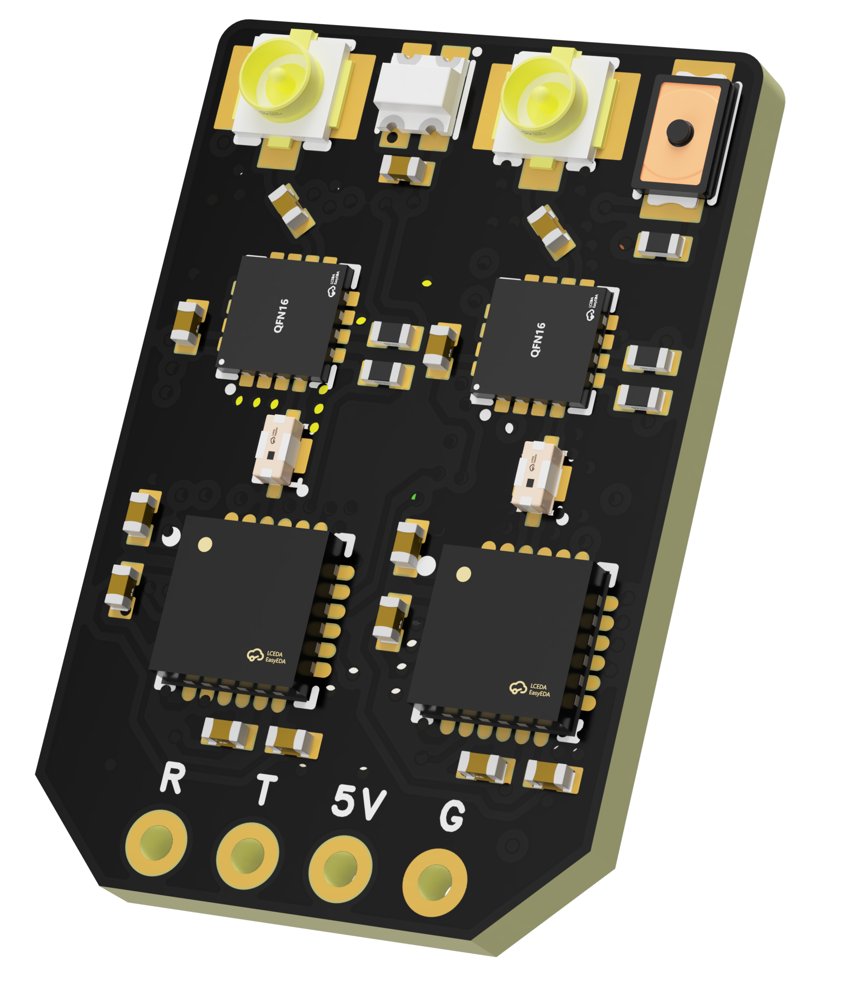
 | - FlyingRC® RM3100 SPI Module 罗盘模块  Ultra-high Resolution • Low Power • Industry Top Choice  Manual：https://www.kdocs.cn/l/cdGuHvBVyndC |  |  |  |  |  | 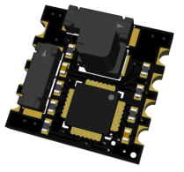
 | - FlyingRC® 10A 12S BEC Step-Down Module  Wide voltage input, high power, compact size, multiple voltages available, 10A continuous output.  Manual：https://kdocs.cn/l/clssNCKgNhLV |  |  |  |  |  | 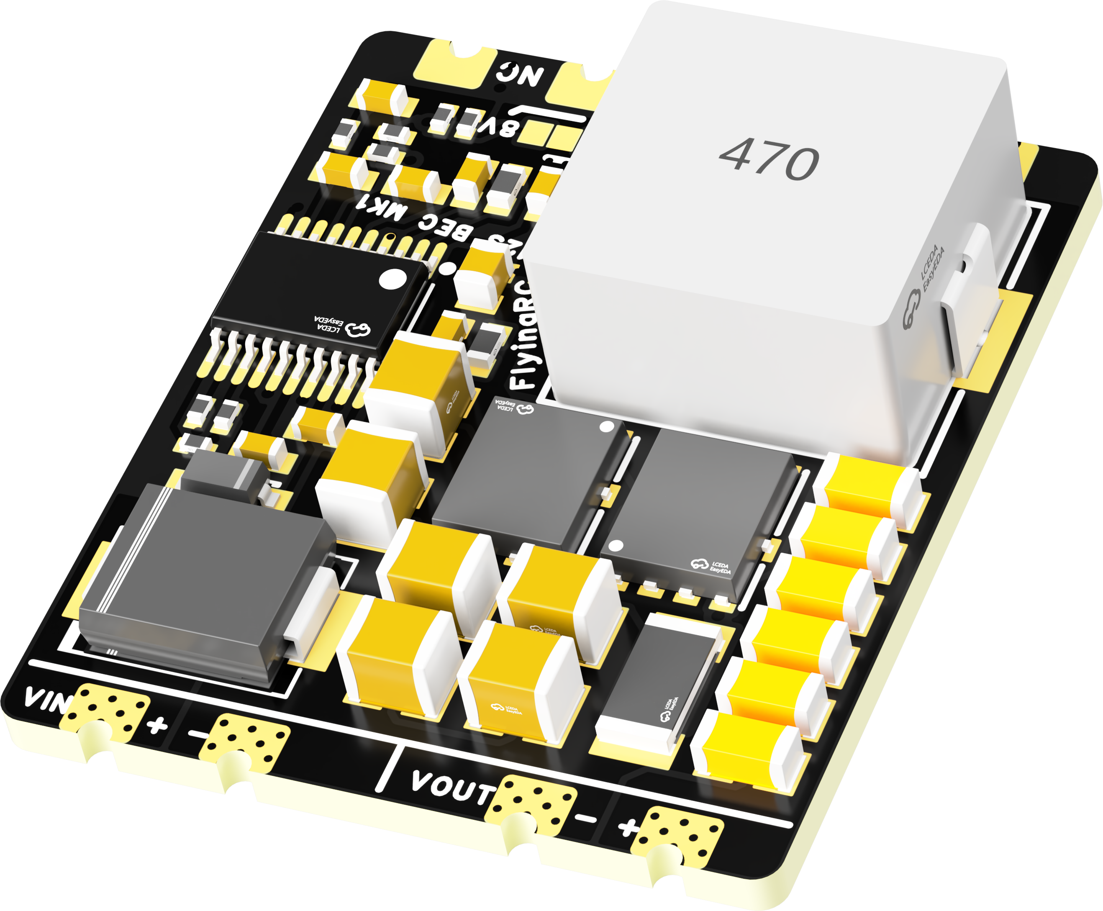
 | FlyingRC® 5A BEC Step-Down Module  Ultra-small size, multiple voltages available, 5A continuous output.  Manual：https://kdocs.cn/l/cb9VdNywqCKA |  |  |  |  |  | 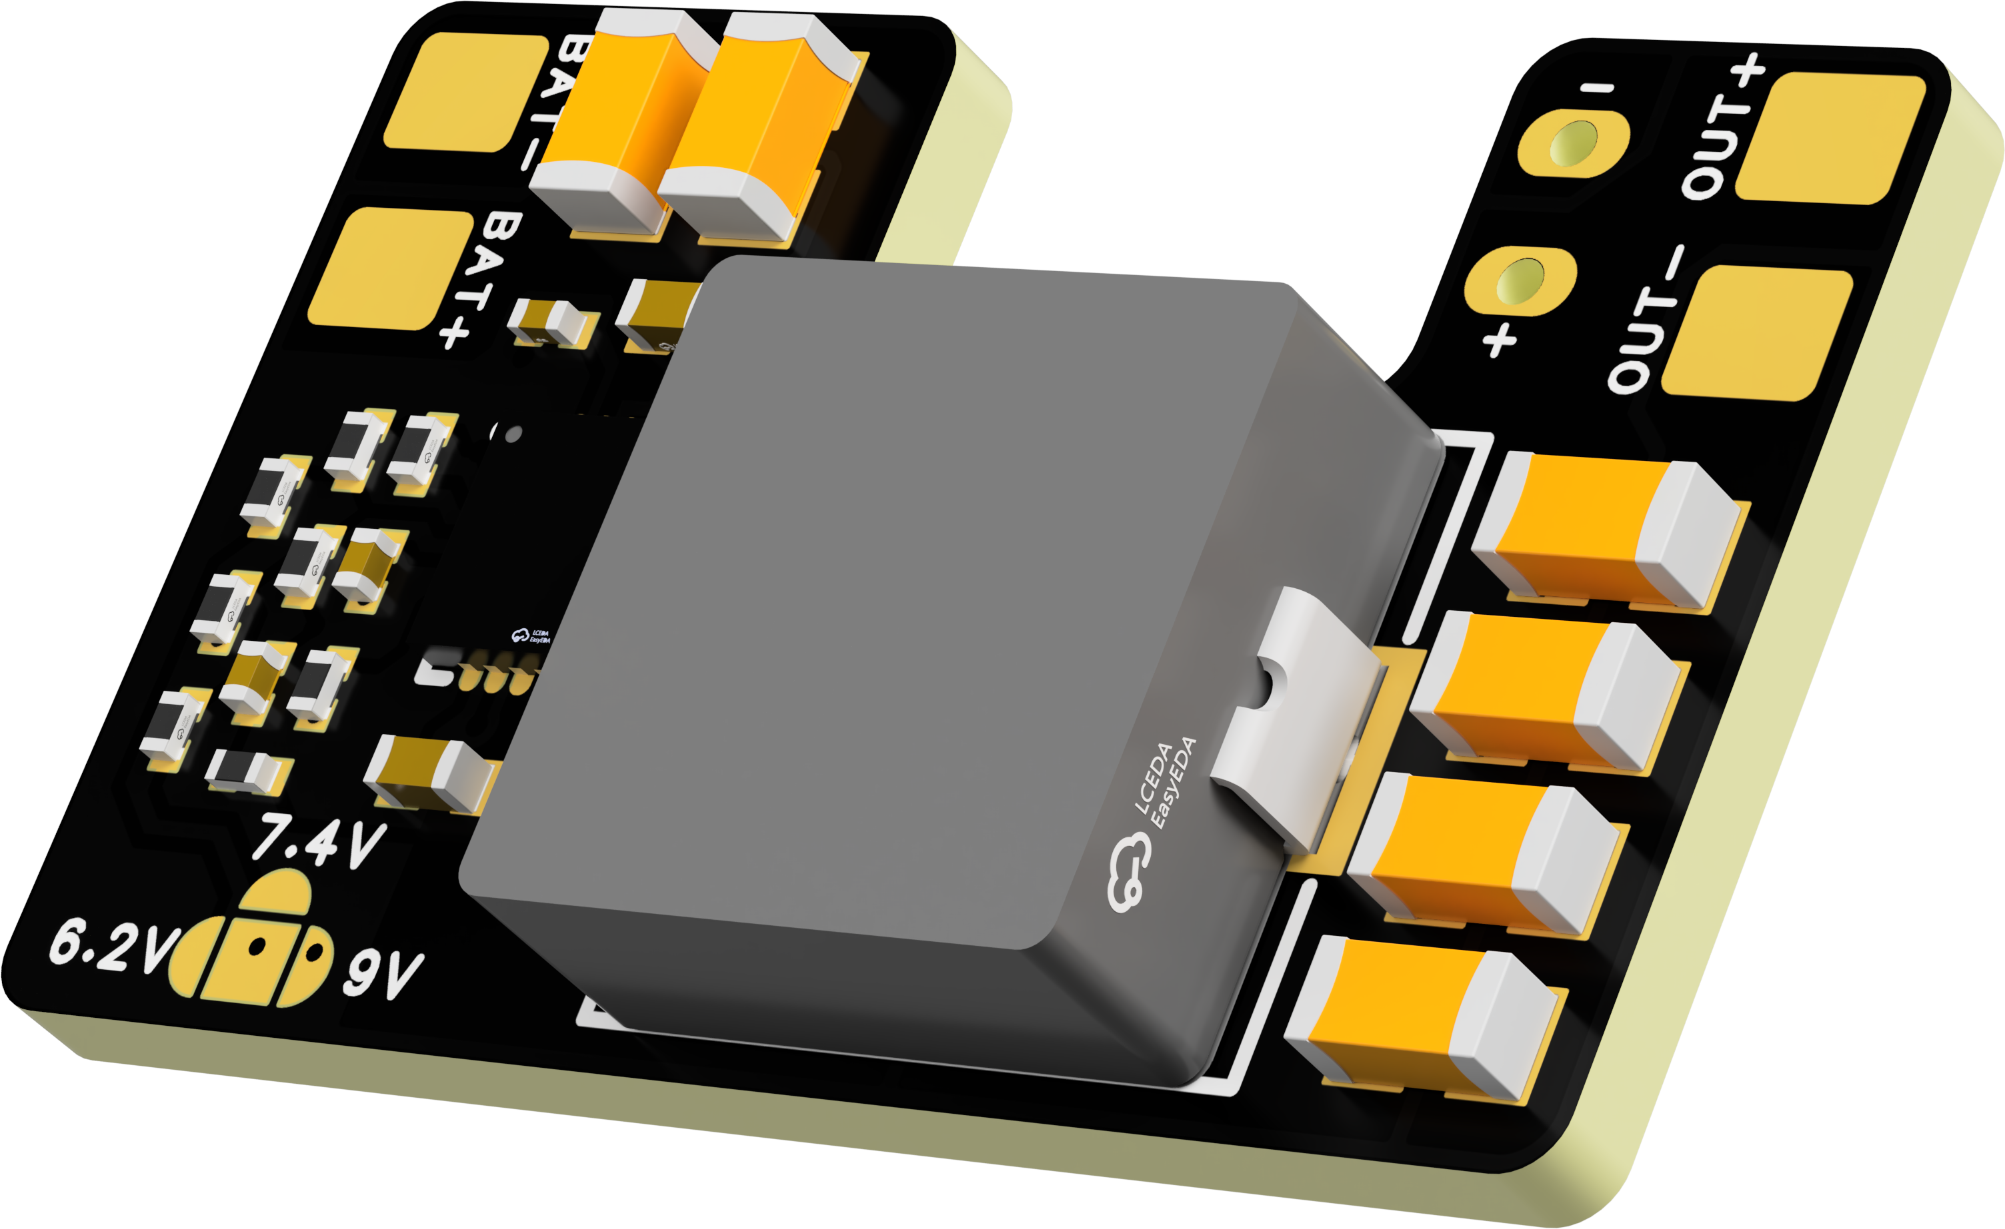
 | FlyingRC® Mini BEC For DJI O4  Easy wiring, ultra-small size, stable power supply.  Manual：https://kdocs.cn/l/cb9VdNywqCKA |  |  |  |  |  | 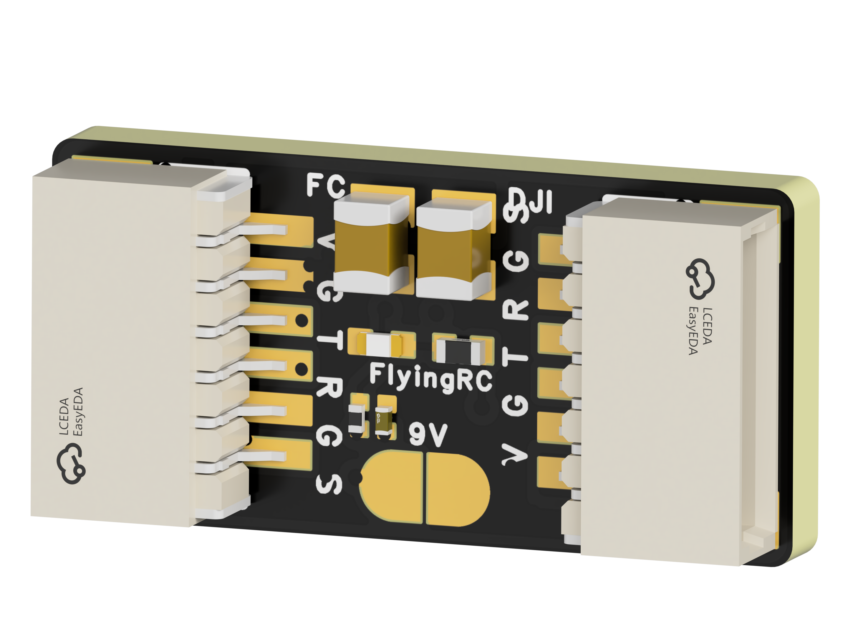
 | FlyingRC® CAN Bus Serial & PWM Expansion Board  Long-distance transmission, high speed, excellent stability.  Manual：https://www.kdocs.cn/l/cmxRyBnU4BXj |  |  |  |  |  | 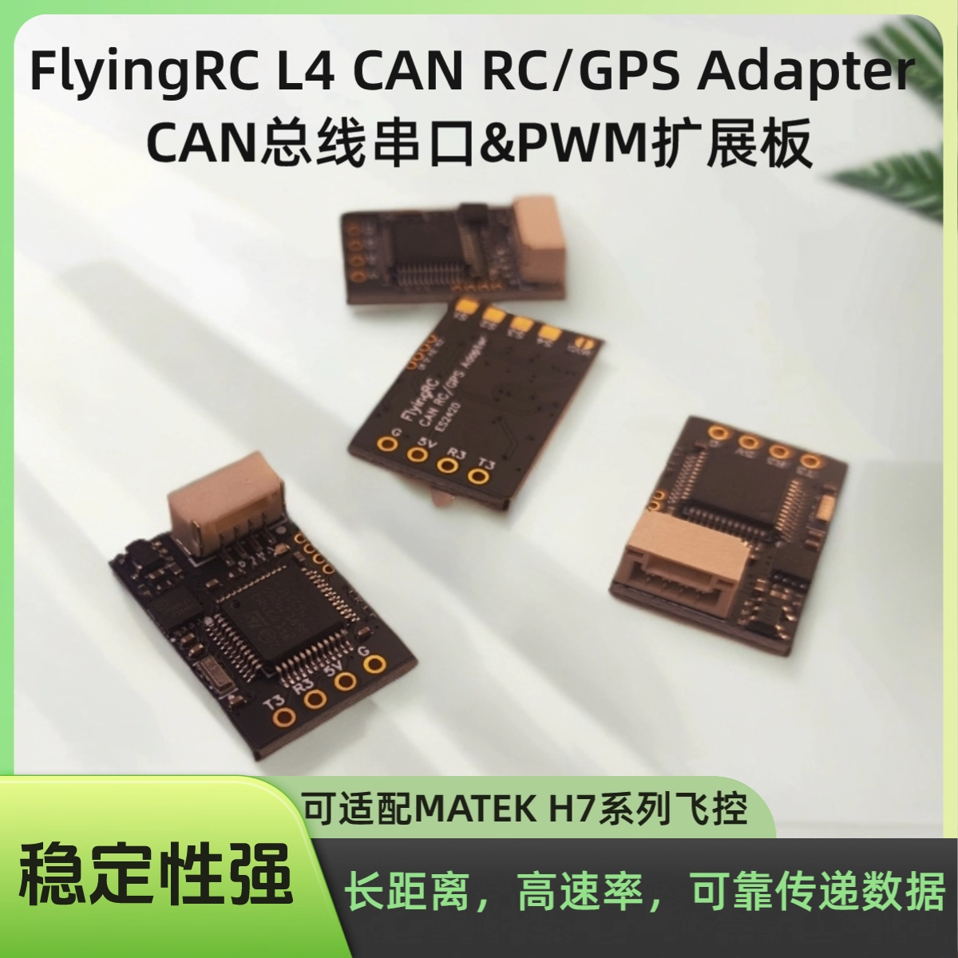
 | FlyingRC® AM3 2ESC Programmer  Supports BL, BL32, AM32. Simple and easy to use.  Manual：https://kdocs.cn/l/cogBSEBe67mE |  |  |  |  |  | 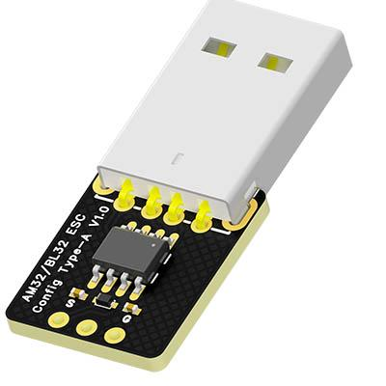
 | FlyingRC® Digital Airspeed Sensor without Pitot Tube  Integrated design, smallest on the market. MS4525D protocol, I2C interface.  Manual：https://www.kdocs.cn/l/clPvEEEcJgCC |  |  |  |  |  | 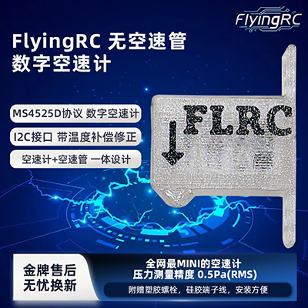
 | FlyingRC® U-Blox M10 GPS  Compatible with all open-source flight controllers.  Manual：https://www.kdocs.cn/l/cdSYQrzx74O8 |  |  |  |  |  | 